Nike: A Look Inside | June 22  2010
By Bobby Bedsole, Matt Currie, & Brady Stoker

Table of Contents
Executive Summery
External Analysis
- Industry/Competition- Five Forces
Current Rivalry opportunities/ Threats
Potential Entrant Opportunities/ Threats
Bargaining Power of Buyer Opportunities/ Threats
Bargaining Power of Supplier Opportunities/ threats
Substitute Products Opportunities/ Threats
- General External Environment
General Economic Opportunities/ Threats
Demographic Opportunities/ Threats
Sociocultural Opportunities/ Threats
Political-Legal Opportunities/ Threats
Technological Opportunities/ Threats
Internal Analysis
- Capabilities Assessment
- Assessing the Primary Activities in the Value Chain
a) Inbound and outbound Logistics
b) Marketing
c) Production
Support Activities in the Value Chain
a) Technological Development
b) Human Relations Management
c) Firm Infrastructure
3) Internal Audit of Functional Areas
a) Management
b) Information Systems
c) Research and Development
Financial Analysis- Conclusion
Executive Summary
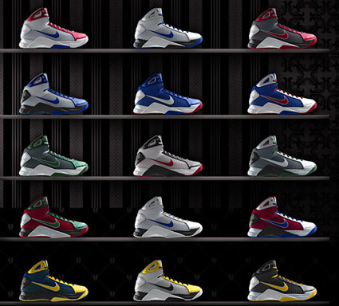
Nikes Mission Statement: Our goal is to carry on his legacy of innovative thinking, whether to develop products that help athletes of every level of ability reach their potential, or to create business opportunities that set Nike apart from the competition and provide value for our shareholders. Our world headquarters is located near Beaverton, Oregon, a suburb of Portland. So while the Pacific Northwest is the birthplace to Nike, today we operate in more than 160 countries around the globe. Through our suppliers, shippers, retailers and other service providers, we directly or indirectly employ nearly one million people. That includes more than 30,000 Nike employees across six continents, each of whom make their own contribution to fulfill our mission statement: to bring inspiration and innovation to every athlete* in the world.

Introduction
Nike was a viable suitor for a competitive and industry analysis from its unique standpoint in the footwear industry. The footwear industry grows on average between 4-5% per year, and is poised for future growth, recent economic factors included. Nike is the overall leader with 32% market share and continues to grow each year. Further details of industry analysis as well as Nike’s competitive standpoint are detailed below.

External Analysis - Industry/Competition & Porters Five Forces

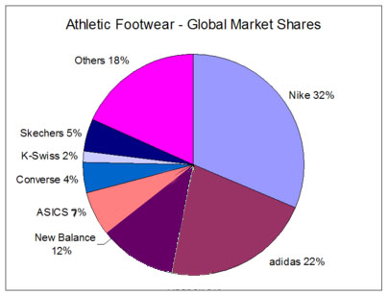
Current Rivalry Opportunities
Nike’s rivals are any firms in the athletic footwear category with main competitors being Adidas Group (which owns Reebok), New Balance, and K-Swiss. Of these three companies Adidas has the larger market share at 22%, however first and second quarter evidence for the Adidas Group indicates that due to its sponsorship of the world cup, sales revenue have jumped an astonishing 26% compared to the same quarters last year. New Balance shoes have jumped from 6% market share in late 2007 to 11.6% current market share in the footwear industry. K-Swiss in recent times has seen a downturn in revenues, but is still a viable competitor in the athletic shoe market.
Analysis would suggest that these companies are becoming larger rivals to Nike, however, the additional market share these firms are enjoying are due to a decrease from smaller competitors, or acquisitions of current competitors, such is the case of the Adidas Group, which purchased Reebok in late 2007. This transaction immediately increased its share in the athletic footwear market by around 6%. Rivals in this category have awakened to Nikes marketing techniques and have harnessed this opportunity to gain the attention of loyalist Nike supporters of the past. Evidence of this can be seen on YouTube via databases containing all Adidas and Nike commericals. New balance has enjoyed increased revenues and market share by incorporating a marketing plan targeted at casual athletic footwear as opposed to Nike and Adidas campaigns focused mainly on intense usage of their products via running, basketball, baseball, soccer, etc. Nike has paved the way in the athletic shoe market with its unique marketing objectives, and breadth of products available. Adidas has become aware and observed opportunities in the American soccer market, with sales in this category jumping 26% from the previous year as stated above. Adidas is primed to enjoy a stronghold in the soccer shoes industry in the near future if sales revenues continue to increase at this pace. Similarly, New Balance has recently entered the basketball shoe market, staking its reputation as a quality athletic shoe maker in the proposed anticipation of success. Shoe sales have been increasing at a rate of 4.6% since 2005, with athletic shoes increasing at a lesser rate. This information comes, contrary to Nikes increasing overall revenue by 14% from 2008 to 2009.

Current Rivalry Threats

The main threats in the footwear industry are numerous equally balanced competitors (or close to equal), high strategic stakes in the case of Adidas, diverse competitors, and high exit barriers
Numerous Equally Balanced Competitors
Although the competitors might not be on the same par with Nike as individual companies, Nike still has been losing market share from 1998 when it commanded 47% market share, down to most recent estimates of around 32%. Adidas controls the second highest market share, and is poised to grow, although currently lagging behind Nike, it’s margins are growing in 2010 at a pace much higher than analysts expected. New balance is a company determined for continued growth in 2010 as well. The footwear market is growing at 4.6% per year, with about 1% coming from increase in sales from athletic shoes.
High Strategic Stakes
High marketing costs have long been a catch in the shoe industry, “We know that our competitor is spending a lot of money, more than us, but we are still market leader, and I think there is a good chance to expand this leadership with the World Cup 2010,” said CEO Herbert Hainer in regards to Nikes increasing stakes in soccer footwear. This statement shows the commitment of Adidas in this particular area, and its continued investment. Due to the amount of fixed capital investment required to enter the footwear industry, even in the case of firms facing recent downturn, none are pulling up stakes yet. Continued investment in R&D have been a long standing strategic focus for both New Balance and Adidas. Adidas recently announced a new ultra light weight technology, adiZero, as well as New Balances entrance into the basketball shoe market.
Diverse Competitors
Each of the firms mentioned above has a different strategic approach. In terms of the general footwear market, names excluded, mere survival is a strategic approach, but as far as Adidas, New Balance, and K-Swiss go their main target markets are slightly different. Adidas is actually an acronym which stands for All Day I Dream About Soccer, which incorporates their main market segment. However, Adidas has a secondary market where it employs its adiZero light weight soccer shoe technology which is the running shoe market. New Balance shoes have been in good long standing relationship with high comfort walking shoes with an intended market of older adults, but has encountered an up and coming niche market of college students who walk long distances on campus, case and point being Texas Tech students. K-Swiss mainly focuses on tennis shoes, a market which Adidas, New Balance have yet to enter, but still have the upper hand in comparison to Nike.
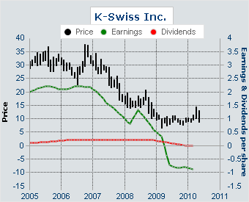
High Exit Barriers
Footwear industry in general has high overhead costs to enter the market. In the case of K-Swiss, it has endured a steady downturn in profits over the last five years, but has yet to divest, discontinue, or be acquired by a larger company. Since 2006, K-Swiss stock has seen stock prices devalue from a high of 36$ in 2006 down to a current price of 12.60. Although this information might cause some to assume they are on the down and out, K-Swiss still has managed to increase its share in the market of tennis shoes, which it competes directly with Nike. This recent downturn could lead to increased marketing efforts, or other extreme tactics for fear of devaluation beyond repair if they do not have an awakening soon.

Potential Entrant Opportunities

Due to the nature and size of the market, there are few viable entrance opportunities, cause being immense overhead costs.

Potential/Recent Entrants Threats

Considering the nature of the footwear industry and the lackluster technology innovation rate in the athletic shoe category, there have been few recent entrants that pose an immediate threat. One exception to the rule is Under Armour Inc. Under Armour is an established organization in the athletic apparel industry and has just recently, (first quarter 2009), decided to enter the U.S athletic footwear market. This firm is a potential threat due to its already widely known name, its sponsorship deals with universities across the country, and the fact that it was able to make a quality product from the very beginning. Since announcing its athletic shoe line, Under armour has seen its stock increase 33% from $27.10 to $37.54.

Bargaining Power of Buyer/Supplier

Footwear is a category which sells itself, there is a need for the product, and that need is met in the upper echelon by brand name products. The buyer, in most cases a retail store, must purchase what it is offered in order to compete. Wal-Mart is an example of a situation where buyer power did not work in its favor. Wal-Mart has been long known for its logistics and through these logistics as an intermediary, they are able to demand more and have more stipulations in the purchasing cycle. Wal-Mart does not carry any of the name brand shoes such as Adidas, Nike, K-Swiss, and New Balance due to the shoe industry being self sufficient in its relations with purchasers. This being the case the power lies with the suppliers. There is an inherent demand for a product such as shoes, and only a few brands that people are willing to buy considering they have the right amount of disposable income. Consumers crave the better shoe, and those that are demanded are the brands listed above, henceforth the reason they all can charge premium prices, and dictate to buyers the selling price and quantity. A factor working in favor of the major shoe companies is the fact the low variable cost for a pair of shoes. The retail price for a pair of shoes is in the $60-$80 range with costs of raw materials and labor estimated to be around $5 per shoe, or 10$ per pair. The fact of the matter is that purchasers stand to lose very little accepting massive quantities of shoes if they do not sell at retail price. Retailers can simply keep the shoe in stock for long periods of time due to the low cost of inventory associated. Shoe sales are widely heralded and marketed as saving money, when in fact, the retail stores are still making profit selling the shoes at a fraction of the cost, even with marketing, R&D, labor and all other expenses included.

Substitute/Alternative Threats

Substitutes in the shoe category are simply shoes in another category. Sandals, heels, boots, etc. are all substitutes, but don’t serve quite the same purpose. Threats of substitutes for the purpose of doing something athletic are subsequently meek in the footwear industry. It is an industry which has narrowed needs down to something so specific, that it cannot be broadened to accommodate the masses. Runners need running shoes, wrestlers need wrestling shoes, etc. therefore it would be absurd to assume that a runner would purchase a pair of boots because of the cost advantage compared to the running shoes she needs, however hilarious an image it may present. Alternatives to athletic shoes would be any mode of transportation which does not require a shoe. This concept would work well in sub-saharan Africa where shoes are not sold, however, law is not enforced either, so the big three footwear companies would not focus efforts there. Until the day humans start walking on their hands, shoes are an everyday part of life, and that will not change in our lifetimes.

General External Environment Analysis

Economic Opportunities/Threats

Opportunities
In light of recent times, economic opportunities would seem far from vast. The world economy has been in a downturn since late 2007, with the United States at the center. However, although the economy isn’t as proliferous as it once was, GDP continues to rise. Per capita income continues to increase at an average rate of about 1.1% per year excluding recent year’s job loss which caused a slight drop from 2008 to 2009. The U.S has been officially in a recession since September 2008, but analysts expect the recession will be declared over before the end of 2010. The beauty of the footwear business is that it is one that is highly inelastic, there are no substitutes or alternatives for walking, and even for those who don’t walk, they still have to wear shoes, barring unusual cases of course. As well as the return of the economy, arguably the world’s biggest sporting event, FIFA World Cup started June 12th and continues through July 11th; expected revenues for the world cup in the country of South Africa are expected to top $3.4 Billion.
Threats
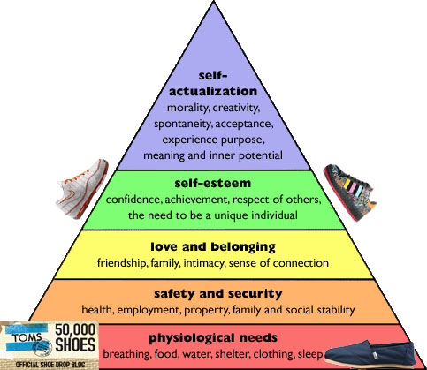
Unfortunately, with economic downturn comes loss of jobs, which means less disposable income, and more saving instead of investing. As well as the aforementioned casualties and the inherent decline that comes with any cyclical subject such as the economy comes loss; loss of jobs, loss of income, loss of well being, and purchasing confidence. In recent times the unemployment rate has been at an all time high, with the peak coming in October 2009 at 10.1%. Industry’s hit the hardest were those specializing in commodity goods, or goods that meet those needs in the higher order of Maslow’s hierarchy. Footwear is likely to fit the lower order of physiological needs, but expensive brand footwear is not, hence the graph explaining where brands like Nike, Adidas, and New Balance might fit in.
The U.S dollar, until recently, had seen an intense decrease in value where currency exchange rate was almost two to one dollars to Euros. This translates to consumers abroad garnishing more value, and exports from the U.S were likely to be higher due to the price advantage gained from those countries using the Euro. According the U.S. census the total amount of consumer debt in the United States stands at nearly $2.5 trillion dollars which works out to be nearly $8,100 in debt for every man, woman and child that lives here in the US, not taking into account the footwear markets around the world, which also are suffering recessions themselves. The footwear industry is fairly resilient, but the threats exposed by the debt ratio of the U.S and various other countries are threats of a lesser nature. The difference between consumer debt in America is the difference between purchasing a $100 shoe and purchasing a 50$ shoe. The same brands will be the major competitors, but less top end products will be sold.

Demographic Threats/Opportunities

Opportunities
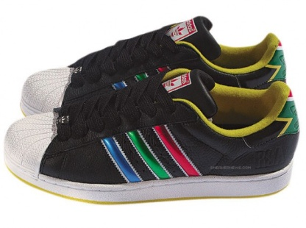
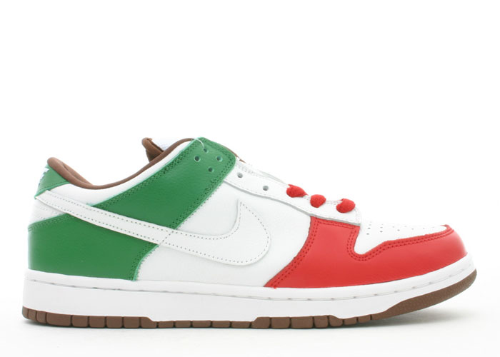
People under 20 years of age made up over a quarter of the U.S. population (27.6%), and people age 65 and over made up one-eighth (12.6%) in 2007. The national median age was 36.7 years.^{[10]} Racially, the U.S. has a White American majority. Minorities compose just over one-third of the population (102.5 million in 2007), with Hispanic and Latino Americans and African Americans as the largest minority groups, by ethnicity and race, respectively. Targeted market segments for firms specializing in athletic footwear range from pre-teens all the way to middle aged adults, with specific regards to the 14-20 range. Hispanic and Latino Americans accounted for almost half (1.4 million) of the national population growth of 2.9 million between July 1, 2005, and July 1, 2006. Immigrants and their U.S.-born descendants are expected to provide most of the U.S. population gains in the decades ahead. The Hispanic community has been a target market with increased emphasis due to its increasing viability as a purchasing group. Several footwear organizations have seen this opportunity and acted upon it creating specialized shoes for certain demographics, such can been seen by Adidas and Nike above.
Threats
As is stated in the book, an increasing worry for organizations in industries which rely mainly on disposable income, the increasing rate of debt in America is cause for concern. With the looming housing crisis and middle class Americans having previously unprecedented amounts of debt, commodities and unnecessary goods could take a back seat to the immediate physiological needs. As well as the housing crisis, a main target segment in the footwear industry, which is recent college graduates, are graduating with more debt in the form of student loans than ever before.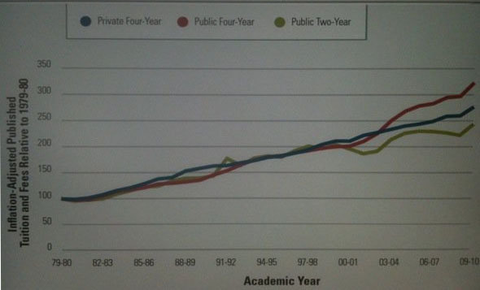
The above graph shows the increase in tuition since 1980, even with inflation accounted for; tuition has still tripled in the last 30 years. The need to repay student loans could take the driver’s seat in reference to the need or possibly the want of purchasing a new pair of sneakers.

Socio cultural Opportunities/Threats

Opportunities
VALS analysis indicates there are four main categories of buyers in the athletic footwear industry.
Innovator – Consumers interested in the newest products which are cutting edge, who have the highest incomes and fancy indulging in commodity goods and have high levels of disposable incomes. Image is important to them as an expression of taste, independence, character, and social status. Tend to focus on having the finer things in life. Specific target example: Trophy wives, rich golfers,
Achievers – Usually consistent of upper middle class social beings. These consumers are the high resource group of those who are motivated by achievement. They are successful work oriented people who get their satisfaction from their jobs and families. They are politically conservative and respect authority and the status quo. They favor established products and services that show off their success to their peers. Specific target example: Neighborhood dads, well-to-doers in the community, soccer moms.
Strivers – These are the lower income segment susceptible to the influence of role models and celebrities alike. This group tends to be motivated to achieve based on others accomplishments, they have values very similar to achievers but have fewer economic, social, and psychological resources. Style is extremely important to them as they strive to emulate people they admire. Specific target example: lower middle class with low disposable income total household income around $30,000.
Experiencers – This is the largest target segment of the footwear industry. They consist of consumers with ample resources whom are motivated by self expression and a unique sense of style. They are the youngest of all the segments, with a median age of 25. This group is characterized by former athletes, or the casual athlete with ample energy and an inherent need to look and feel good through exercise. They are avid consumers, spending heavily on clothing, music, and other youthful favorites, with particular emphasis on new products and services. Specific example: 25-35 age group unmarried males/females, younger couples without regard to savings or investment.
Opportunities
America is finding a sense of well being over the last couple of decades and this is only increasing over the last couple of years. Being fit is “In.” Five years ago, a one hundred calorie bar couldn’t be found on a grocery store shelf, and if it could, it wasn’t marketed to be a “one hundred calorie” pack, it was just a coincidence. The frugality of Americans has seen an increase in healthy purchasing habits and a cut down in the consumption of fatty foods high in carbohydrates, at least for the segment which prefers to shop at the grocery store as opposed to a taco bell. With this intensified need for health come an increased need for exercise and the number one means of exercise in America is running. Herein lays the opportunity. Specific activities require specific equipment and specialized shoes are the requirement in this case. The changing pattern of socially acceptable behaviors has tilted in the favor of the fitness industry over the years. Asking an individual to go for a jog in the 1960s had no meaning because the word jog didn’t exist.
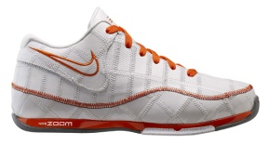
Another category adorning new interest in the last couple of years in both consumer interest and CSR interest from organizations is the concept of “Going green.” Shoemakers have a high need for raw materials, and an extremely low recycle rate. Recent efforts by both Nike and Adidas have revamped the recycling efforts in attempt to salvage some PR along with the recycled materials. Efforts to go green not only can enhance consumer relations and create positive image, they can serve the purpose of cost reduction. Nike has recently implemented a recycling program which is devoted entirely to creating 100% recycled shoes as opposed to implementation of old materials into new products.
Threats
It has been long known that labor stateside is thought to be over regulated, and unionized to an extent where moving factories abroad is the only way to create sustainable profit. The inherent problem lies within, due to the opposite being the case in foreign countries. Footwear manufacturers have come under fire over the last couple of decades concerning the increased usage of labor in foreign countries. This might not seem so bad, giving jobs to the less fortunate, however, a large portion of these jobs are going to children below the legal working age in the United States. The wages these workers command is pitiful in comparison to any manufacturing industry in the U.S. The average wage in India, Pakistan, and China, where the majority of the shoes are made, is in two weeks what even the lowest paid American makes in a day. Including purchasing power parity, this still is an extremely meager living, not allowing those who work in the factories to escape the poverty line. The effect it has on the American public can be seen by googling child labor in the shoe market. Although these organizations do not endorse child labor, they do not regulate the factories which are under their employ. Nike is quoted “Nike requires our suppliers to pay workers at least the locally mandated minimum wage and benefits, and any additional benefits outlined in individual employee contracts or collective bargaining agreements. We require contracted manufacturers to comply with a standard against which we can audit consistently. Where factories are found not to have met these standards, we require remediation action.” The problem lies within this statement. Those intelligent few who know the industry standards know that this statement has no meaning. The only benefits the foreign workers see is their meager paycheck because of the lack of regulations in the foreign labor sectors of India, Pakistan, and China. Child labor running rampant puts a damper on customer relations and although will not stop the vast majority of customers, can hinder profits in the long run if the system is not changed.
A recent social concern in the case of Nike, and has been the case in the past for other organizations, are the use of celebrity endorsements. Though most of the time, these endorsements serve their purpose to entice consumer demand through perceived power of the product by whose using it, the opposite can sometimes occur. Example being the case of Nike and their endorsement of Tiger Woods.

Political/Legal Opportunities and Threats

Political Opportunities
Although political opportunities in a business category narrowly defined such as this one are bleak, some do still exist. The nature of the textiles business which contributes many of the raw materials used in the shoemaking process is one much too vast and complex in its entirety. The once strong and numerous American textile factories have become the few and weak. Political actions have kept some of the factories active, but have not brought rest to those working in textiles. The laws in place in this industry have kept it afloat, but with specifications so detailed as far down as to what fraction of a percentage of what can be made in a country before it has to be shipped elsewhere for completion begs the question, why not bring a factory home? This is an opportunity to tie hand in hand PR with the patriotic American. Politicians can only do so much to manipulate the laws of the textile industry to keep some factories domestic, but they are fighting a losing battle. Although from a strictly financial standpoint, it would not be considered a wise move, the commitment to a domestic factory could spur growth in different areas, as well as positive image associated with the American consumer. This would also serve the purpose of increasing GDP and # of American jobs.
Threats
Political - With a nation bent on diversity and equality, an industry which utilizes child labor as a means to an end, that end being profit, could face the gauntlet in the near future. With labor regulations as steep in the United States as they are, one has to ask where the accountability is for American firms using foreign services. With continuing trends leaning towards fair treatment and human rights, it would not surpass logic to think that domestic regulation on foreign practices could be looming.
Legal – Patent infringement is a category faced by many of the top footwear companies, mainly consisting of design patent infringement. Although the cases themselves are usually a mute point when it comes to a court battle, the impending costs associated are cause for concern. Industry regulation of patent rights is non-existent in foreign sectors such as China and India. The cost of international design patents amongst all the economies in the WTO is in excess of 100,000$, this multiplied by a patent required for each design amounts to a hefty sum.

Technological Opportunities and Threats

Opportunities
The footwear industry is relatively simple in the fact that it is mere foot protection stemming back to the stone ages, but recent times suggest that firms are investing in R&D. New technologies allow for lighter weight materials which are more durable and easier to design with. The global market is ripe with opportunities for the new age of sneakers with the emerging global economies. If the rate of innovation continues in the shoe industry as it has, in the next fifteen years we will have shoes that weigh less than air. Currently, Nike has the opportunity to compete with Adidas which has recently created the lightest soccer shoe in the world. Adidas description reads”The most innovative technologies include their Sprint Skin and Sprint Frame technologies. The Adidas Sprint Skin technology provides single layer synthetic for dramatically reduced weight and provides excellent ball control. The Sprint Frame technology is a specific outsole construction that reduces weight and increases stability through geometry. This allows the F50 adiZero to remain extremely lightweight without sacrificing stability and performance.”
The use of technology is emerging in the global marketplace as well. The internet has seen an enlightenment of the consumer, and access to various markets is growing by the day. Nike shoes are available in 143 countries, and this is possible due to Al Gore inventing the internet<joke. Potential investment opportunities lie in the robotics industry and Cad design for engineers.
An additional point for opportunities is expanding current technologies. Nike has recently partnered with Apple creating Nike IPod technology. This technology allows users to play their favorite songs while running, with a personalized touch. Certain songs can be played at higher volumes depending on running speed, or certain genres can be played depending on the motivation needed.
Threats
An unfortunate truth in the footwear industry is that all the main players are virtually neck and neck in terms of technological advancements. The same technology that stands to make one brand unique will be a dead technology within six months. Translated, no one company will ever be more than a step ahead as far as the technology market is concerned. All of the comparison companies to Nike have the same resources due their vast size and revenues. The internet is widely accessible, as it has been for years, and the good firms have known this for awhile, seemingly entering the global markets as soon as there is an ISP provider in the area. When new technologies emerge in the footwear market, reverse engineering witnesses the demise of its differentiation within a matter of months.

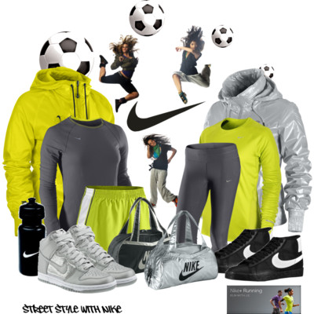

- Capabilities Assessment
- Assessing the Primary Activities in the Value Chain
a) Inbound and outbound Logistics
b) Marketing
c) Production
Support Activities in the Value Chain
a) Technological Development
b) Human Relations Management
c) Firm Infrastructure
3) Internal Audit of Functional Areas
a) Management
b) Information Systems
c) Research and Development

Components of an Internal Analysis
In doing an internal analysis you must know the organizations resources and capabilities. Organizational resources are the assets an organization has for doing whatever it’s in business to do. Resources include but are not limited to being financial, physical, human, intangible and structural cultural.
Assessing Strengths and Weaknesses: Internal Analysis

1) Capabilities Assessment
Organizational resources

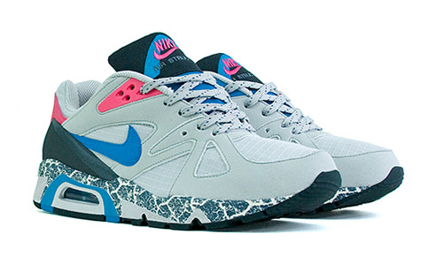
Intangibles Resources- NIKE is not limited to just brand equity but instead they have a long line of patented technology that helps them differentiate their market offerings as well as lead them as innovators. In 1996 Nike filed a patent according to the Securities and Exchange Commission that stated "The Company has an exclusive, worldwide license to make and sell footwear using patented "Air" technology. The process utilizes pressurized gas encapsulated in polyurethane. Some of the early NIKE Air patents expired in 1997, enabling competitors to use certain types of NIKE Air technology." With technologies like this they can differentiate new product lines or launch an exclusive product line for a particular patent.
Human Resources- These include judgment, skills, accumulated wisdom, experiences, and competencies of Nike Inc. In regards to Human resources Nike states,
“NIKE, Inc. has unlimited opportunities to fuel profitable growth and to drive competitive advantage. Our leaders work every day to ensure NIKE, Inc. realizes its potential by inspiring every one of our more than 30,000 employees to realize their potential. Human Resources professionals at NIKE, Inc. operate as stewards of organization effectiveness, talent and change. The function works to ensure that NIKE, Inc. has talented, diverse and inclusive teams organized effectively against our biggest opportunities of driving innovation and business performance.”
Financial Resources- These resources include debt capacity, credit lines, available equity (stock) cash reserves and other financial holdings. A global slowdown in retail sales and consumption, has hit Nike hard. In fiscal 2009 (ending May 31, 2009), Nike's revenue grew only 3% to $19.2 billion, with net income falling 21% to $1.5 billion, and the company expects lower revenues in the first half of 2010. Footwear is Nike's largest product category, representing 53.7% of the company's revenue. They use their financial resources to buy large advertising space whether it is on TV, billboards, or athletic stadiums. Expertise by marketing and advertising executives drives the creative aspects of the advertisements and endorsements to celebrities create an image for their product.
Physical Resources- Physical resources can be anything from buildings, manufacturing plants, machines, inventory, office supplies, or retail stores. The most important physical resource they have is their shoe lines.
Nikes main revenue generator is footwear, at 54% revenue but there are other areas in their product offerings that provide additional income.
Apparel: Accounts for 27% of revenue. This includes clothing, jackets, wrist bands and other non shoe products.
Equipment: Accounts for 6% of revenue. Balls, baseball bats, and footballs make up this product line.
Organizational Capabilities- Nike creates its core competencies by adding up all its resources and creating a dynamic web of value added practices. Every market offering asks the same question in order to obtain performance results. For example, if they launch a new product line Nike asks, can we market or use this shoe in a variety of ways? Is this shoe hard for Adidas or other competitors to copy? And is this shoe going to contribute to superior customer value. Every resource and attribute will answer that question and form a core competency. For example, Nike has a core competency and ultimately a competitive advantage in marketing its products through the media. Organizations such as Adidas Group might have the resources to compete but lack the capabilities to use them accordingly. Nike has the right resources and capabilities to gain core competencies over other competing firms.

Assessing Primary Activities in the Value Chain
- Inbound & Outbound Logistics: Strengths
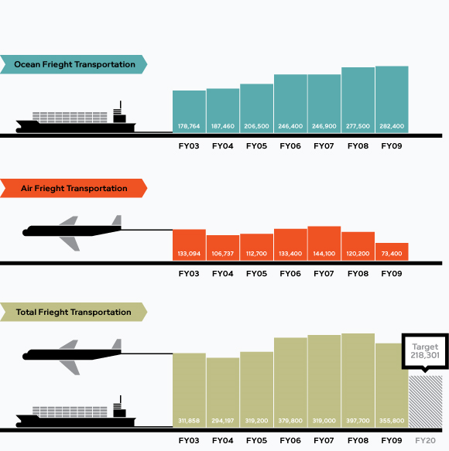
Nike Inc ships products to over 143 global destinations. They ship from factory origin to the receiving docks of a Nike distribution. Nike's logistics operations are complex, and involve three different product lines: footwear, apparel, and equipment. They also consist of four regions managing orders through the company's logistics service provider network. Setting up the network of providers is a collaborative process between the regions and Nike's corporate logistics group. Nike works together with its different regional areas to make a global mesh for its local consolidators, which consist of ocean carriers, airfreight forwarders, and a global currier. Nike started working with ocean consolidators more than 20 years ago. They have had as many as six but to cut cost decided to cap it at two. “The two consolidators , APL Logistics and Maersk Logistics, are responsible for physically handling the cargo from the factory, receiving the freight, loading the containers, communicating to destinations in planning shipment deliveries, collecting documents from the factory and forwarding them to the destination regions”, says Mike Vanderzanden, global account director inbound logistics for Nike. Nike has chosen to manage its logistics provider in-house rather than outsourcing management to a lead 4PL logistics provider. Due to a great understanding of supply chain management within the company they do not feel the need to put in a middleman. A large portion of our shipments are shipped directly to our customers rather that retailers due to our online ordering system. Rather than emphasize a 4PL they try and simplify it due to Nike distribution’s complex nature.
Firm Infrastructure-Over the past couple of decades the firm has implemented new tactics and developing top-flight information systems, logistics, and supply-chain management, as it does with marketing its products and cool sneakers. More and more, Nike is searching for the right balance between its creative and its business sides, relying on a newfound financial and managerial discipline to drive growth.
In the old days, Nike operated on a guess test basis. It took a guess as to how many pairs they needed and hoped it could make the way to retail stores. This gave Nike to reevaluate there operations. Nike has overhauled its computer systems to get the right number of sneakers to more places in the world at a quicker pace. By methodically studying new markets, it has become a cash cow in Europe as well as in new market segments that it once dared not compete such as soccer and Glamour. It has also beefed up its management team. And after stumbling with its acquisitions, Nike has learned to manage those brands.
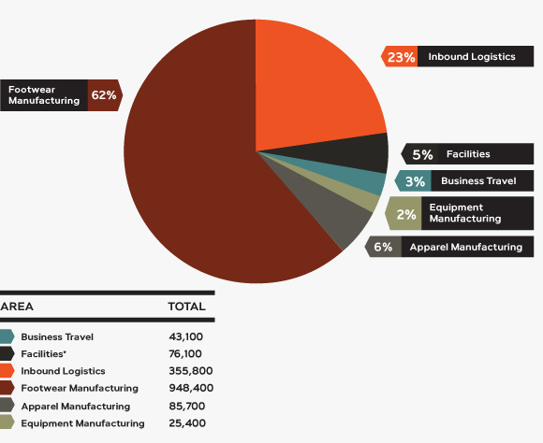
NIKE’s inbound logistics also reflects its moral climate of corporate social responsibility while still maintaining their bottom line. With the corporate social environment becoming more and more ecologically aware Nike has seriously reevaluated how its supply chain is handled.
Total Green House Gas Emissions
NIKE has answered the call to drastically reduce CO2 emissions while steadily increasing demand for their products. NIKE realized it could ship smarter in a global Setting in the 2009 fiscal year they noticed a total of over $8.2 million in distribution savings. They did this by optimizing the use of containers while shipping. This graph shows the emissions of NIKE’s inbound distribution. They have also been partnering with Maersk Logistics to monitor and analyze data elements so they can prescribe a solution to the channels adverse affects.
Weaknesses
Although the supply chain is large due to vast quantities of demand from consumers, this makes it very difficult to maintain. Competitor Adidas Group can gather and maintain up to date information on inventory levels which allows them to collaborate with customers on a real time strategy. In today’s global business environment, the firm that can compete on a reduced cost supply chain model will reign supreme because of heavy shipping expenses, tariffs, and duties associated with that downstream movement. NIKE also has to face the same barriers to entry as many other shoe makers face which is globalization. Even though NIKE has been very successful in distributing sneakers worldwide they have to still overcome geographic and demographic obstacles.

b) Marketing and Sales
Strengths
Nike’s brand images, including the Nike name and the trademark Swoosh, are considered to represent one of the most recognizable brands in the world. This brand equity translates into bottom-line revenues that no other company can compete with. The Nike name and associated trademarks have appeared everywhere from players' shirts, pants, and hats to TV commercials. Aggressive advertising campaigns, celebrity
Endorsements, and quality products enhance the brand by selling the image of fitness with quality fashion in mind. Nike primarily conducts marketing research on a continual basis to assist in maintaining company position as the leader in the athletic footwear and apparel industry. In 2009 Nike made up approximately 32% of market share with Adidas Group trailing at around 22%.
Nike has innovative advertising that allows them to tower above corporations such as Adidas Group, and K-Swiss. Not only does Nike dominate in advertising but they conquer in intellectual property. Their Intangible resources or Intellectual property include brand names, patents, trademarks, data bases, copyrights, registered designs and so forth. Most notable, Nike’s signature and treasured intellectual property is the Nike Swoosh. Arguably one of the most influential and recognizable brands in the world, the NIKE Swoosh generates brand equity as well as inspire people to buy their products. NIKE sells not only shoes, but an image of excellence and victory. The Swoosh symbolizes all that is great and when it is tied into the product itself it adds value by association. People look for the Swoosh when they enter the local footwear retailer not necessarily because they seek it out, but because it shines above the rest.
Weaknesses
Although Nike is the dominating leader in foot apparel they face many obstacles in newer markets such as athletic equipment and clothing. Entering new markets makes them face new competitors such as Adidas and K-Swiss. New developers are also creating brands to compete with Nike’s existing products. With new entrants to the market, Nike has to compete on a smaller playing field which translates to a dwindling cash inflow. When Star Basketball player Michael Jordan retired in 2003, Air Jordan’s were priced at $200 and were stagnating on store shelves as buyers wanting a new feel began switching to Skechers, K-Swiss, and New Balance shoes. Nike has also been accused of exploiting Asian factory workers and to make things worse did not hold themselves accountable for the mistreatment of workers in sweatshops. Both of these factors didn’t help things when Nike cranked out more shoes than the market was ready for.
c) Production-Operations
Nike’s in-house manufacturing put the “AIR” technology in play in two facilities, one in St. Louis, Missouri and the other outside of Portland, Oregon. “The team’s mission is to develop innovative, cost effective, proprietary materials and manufacturing processes that result in high quality materials and components.” Nike has everything from; a strong team of machine operators, industrial maintenance technicians, quality assurance specialists and leadership roles for each area. They also have engineering opportunities in the fields of Quality Assurance, Manufacturing, Design, and Development to ensure that every new air bag project is created and designed in the best possible way and is efficiently reproduced.
Strengths- In terms of manufacturing and production you cannot beat Nike’s superior quality. The current manufacturing practices of the sneaker industry, in businesses such as Nike, Reebok, Adidas, Converse, and New Balance, takes place throughout the world. With the industry saturated with competition, and the shoes needing diligent labor, has faced extreme difficulty to increase their profit margins by outsourcing. Nike can do either one of two things when manufacturing, they can own and operate the factories that produce their products, or outsource their products to other manufacturers. Firms that manufacture locally make it easier for them to monitor whether the work force is skilled, as well as economical/ government advantages. However it is substantially expensive to manufacture here because of higher wages to factory workers. In order for Nike to cut costs they ship jobs overseas to dwindle down wage expenses. A unique idea that Nike had was to add diversity in its suppliers. Not by product line but by gender and race. They strongly believe that diversity drives innovation. They want to work with high quality diverse suppliers and still meet quality standards, exceptional service, competitive pricing, providing on time service, and value-added products.
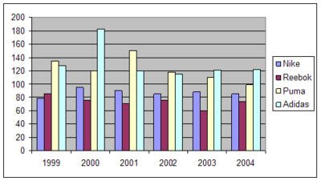
Average Athletic Footwear Inventory Days 1999-2004: Nike's inventory days for 1999-2004 were consistently lower than Adidas's or Puma's, but higher than Reebok's in every year since 1999, however. (In 2005, Adidas acquired Reebok to form Adidas Group.) Nike's low inventory days in part reflect its emphasis on retailing: factory outlet stores allow Nike sell products that have been piling up on the shelves at a low price. Although Nike has closed some factory outlets since 2004, they still represent almost half of all Nike's retail locations.
Weaknesses- Nike faces the difficult task of monitoring their products quality overseas as well as working conditions in small third world countries. In addition if Nike owns and operates their own factories then they have large capital expenditure costs. Nike has also face inventory control problems throughout the years. In 2000 inventory forecasting systems created demand for way to much sneakers costing the company about 100 million dollars in sales. Although this was a minor speed bump it taught Nike a lesson in proper inventory management.
Internal Audit of Functional Areas
a) Strategic Manager and Company Profile
Phil Night is the chairman and cofounder of NIKE, Inc. In 2004 he resigned as CEO, while still maintaining his role as chairman of the board. He ran track for Bill Bowerman, at the University of Oregon for with whom he cofounded NIKE with. Night later graduated and attended Stanford where he found his true passion in life, Entrepreneurship. Knight left for a trip to Japan where he found Tiger running shoes that of which were of good quality and at low cost. He made a cold call and became the first distributor in the western United States. Approximately one year later Knight shipped two pairs of shoes to Bill Bowerman in hopes of a sale but to his surprise he ordered them as well as became a partner in Blue Ribbon Sports which would later become known as Nike.
Strengths- When you think of revolutionary design, technological advancements, and marketing mastery Knight’s name comes to mind. In the early days, Knight significantly altered the playing field of athletic marketing with larger than life endorsement contracts and cutthroat advertising. No one had yet seen an advertisement that spliced popular culture with sports dawning the marketing inception of selling an image rather that a product. Phil Night might not be the CEO anymore but he is still the visionary behind Nike’s efforts throughout the world. He started a revolution and he is not contempt on quitting any time soon.
Weaknesses- In the late 90’s the senior executives lacked operating principles, financial management, supply-chain renovation, and inventory management. At one point they did not even have a chief Financial Officer.
c) Human Relation management Corporate Culture
Nike could not take off if it wasn’t for its people. They hire employees who are self motivated because they fit into the corporate structure and they excel faster. New hires that are athletic also learn quicker because they align themselves with Nikes goals faster than others.

Strengths
When you think of Nike’s public perception, one might think of strength or power. Well it is no different than their corporate culture. Inside the NIKE colossus they try to empower the world through their products and ideology. NIKE builds upon this statement by making sure that its deep heritage is taught from the ground up. NIKE has a group of executive story tellers that travel the vast network of NIKE distribution channels to teach the heritage of their business. “These stories aren’t about extraordinary business plans or financial manipulations but rather just getting things done” says Nelson Farris, Nike senior executive story teller. And like all great stories, the ones about Nike offer archetypes that people can learn from. A story such as how Bowerman utilized his waffle iron to make a running shoe for his track team conveys the essence of necessity innovation. Nike feels that if they can connect people to the roots at the company then the employees add value. This allows them to look at the company as not just another place to work but an integral part in their lives.
New Tech Employees have to run the famous track that Bowerman used to coach at and visit the fatal crash site of Steve Prefontaine. The story telling even extends to the customers. This is because when people understand why they exist they understand how all the products are still rooted in boosting performance while maintain constant innovation. Utilizing key aspects such as this allows Nike to excel over Adidas who does not have such a rich history of excellence.

Weaknesses
Their culture is a strong one; therefore, if you are not onboard you most likely will not fit in. For an organization to move forward and transcend innovation and quality you must have all the right people on the bus, the wrong people kicked out, and everyone in their right places. Nike’s culture is an important aspect to their success because it is about getting things done, which in many organizations is quite different.
b) Information Systems-Information Technology
Information technology helps provide advertising, sales, and other aspects of Nike to do business seamlessly around the world. The systems are used from a wide array of employees that help the inner workings of Nike tic like a clock. There is a system for all areas of the company. For example, supply chain management has a system that tracks inventory, as well as forecast demand for current products.
Nike's IT organization:
- Brand, Product, & Marketplace Solutions Delivery & Support
- Retail & eCommerce Solutions Delivery & Support
- Business Connectivity & Strategic Planning
- Enterprise Architecture & Tools
- Fulfillment Solution Delivery & Support
- IT Infrastructure Operations & Support
Strengths- Luckily for Nike they have made mistakes in the past regarding informational technology. Nike is on the fast track on innovative software that allows for real time integration with strategic management practices. Nike gathers information from more than 300 data mining sources as well as their own in depth strategic market analysis
Weaknesses- Bad implementation in the past has left some Nike executives a little sore, so information technology cannot be a future weak link in the company. This is because this time the minor speed bump of miscalculated demand forecasts might lead to bigger problems for Nike.
3) Research and Development
This is Nike’s bread and butter. This is how they stay on top as the leader in current markets as well as penetrate new ones. After endorsing golfing legend Tiger Woods Nike began making golf clubs to nail its spot in the golfing niche. Nike could not do it alone or without the proper tools. Nike Golf’s place of birth is nicknamed “The Oven”. This is a state of the art research and development facility in Fort Worth, TX. Here Nike does every R & D capability imaginable. They test the aerodynamics of golf balls, ergonomics of drive shafts and try the limits of durability in drivers. “The Nike brand is globally synonymous with innovation, performance and the pursuit of athletic excellence,” said Cindy Davis, President of Nike Golf. “The expansion of “The Oven” is an indication of Nike Golf’s commitment to our athletes as well as to solidifying our role as an undisputed leader in the research, design and development of clubs and balls.”
This is just one of many laboratories that allow Nike to come out with cutting edge products and apparel. Ever since the first waffle iron shoe that Knight made at his house the spirit of Nike research and development has lived on.
Strengths- Nike is constantly pouring money not just into new sports but sprinkling their cash around franchise centered players. They have assets such as Lebron James, Tiger Woods, and Derek Jeter. Each endorsement represents a product line to be catered to them and their respective sports. When trends go away, as they always do such as high-top basketball shoes, Nike was able to be agile in designing new lighter weight technology that reflected the consumer’s new trends and desires.
Weaknesses- If Nike fails to produce new innovation they might fall victim to new entrants. If sales are bad one quarter they might have to cut back on R & D budgets as a possibility. This happened in the past when they lost a large portion of sales due to bad product design. They lost sales to other shoes that were in the market such as Adidas and New Balance. Consumers were not going to wait around for Nike to place a better quality product on the shelves so they grabbed other brands as a substitute.

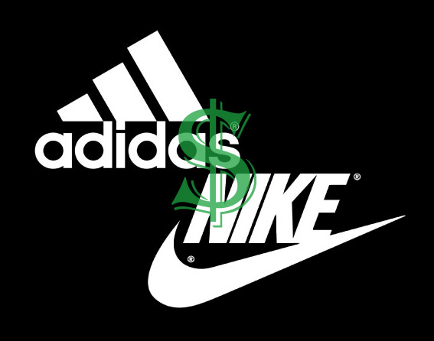

Accounts Receivable Ratio

 | Nike | Adidas Group | K-Swiss | Industry
2005 | 5.79 | 4.67 | 10.9 | 8.09
2006 | 5.75 | 4.4 | 9.27 | 7.29
2007 | 5.8 | 4.13 | 8.7 | 7.02
2008 | 6.13 | 5.1 | 6.2 | 7.44
2009 | 6.5 | 5.4 | 4.4 | 7.6

The account receivable ratio is used to determine how long a company takes before collecting payments. The larger the ratio the less time it takes a company to collect on the account. If the company has a receivable turnover of 1 or lower this means that the company has an equal amount of receivable and sales. Nike has a receivable ratio in the high 5’s which translates around 60 days for Nike to collect on accounts receivable. An increase in this ratio shows signs of improvement as were a decrease is a sign of regression. The competition shows similar numbers as Nike but in the case of K-Swiss dramatic decreases show a decline in there receivables which can accumulate to less cash in the near future.

Asset Turnover

 | Nike | Adidas Group | K-Swiss | Industry
2005 | 1.56 | 1.2 | 1.51 | 1.44
2006 | 1.52 | 1.11 | 1.66 | 1.64
2007 | 1.46 | 1.2 | 1.23 | 1.56
2008 | 1.4 | 1 | 0.88 | 1.51
2009 | 1.4 | 1.1 | 0.6 | 1.4

This ratio is calculated by taking the sales and dividing them by the company’s total assets. Asset Turnover measures the turnover of all the firm’s assets. The graph helps us conclude that Nike is following quite close to the trends of the industry average were their rivals are falling behind in their turnover rates. The higher the turnover the better chances that the company is using their assets efficiently and effectively. Shareholders like to see that a company can manage its assets better than the industry average.

Current Ratio

 | Nike | Adidas Group | K-Swiss | Industry
2005 | 3.18 | 15.1 | 6.67 | 5.24
2006 | 2.8 | 14.7 | 5.88 | 4.2
2007 | 3.13 | 15.87 | 5.57 | 3.8
2008 | 2.66 | 14.62 | 5.98 | 3.6
2009 | 3.5 | 12.33 | 6.5 | 3.5

The current ratio is a ratio that shows the number of current assets. Current assets that can easily converted to cash in comparison to the number of current liabilities that will be due within one year. When a company has a current ratio larger than one it tells the story of a company efficiently using its resources with the ability to pay off all current liabilities covered by current assets. On the other hand a current ratio to large like Adidas shows you’re not using the company’s assets to its potential. Nike has a current ratio between 2 and 3 which is slightly below the industry average which shows investors Nike has consistency in buying new assets but keeps the ability to pay off liabilities in a crunch.

Debt to Equity Ratio

 | Nike | Adidas Group | K-Swiss | Industry
2005 | 0.56 | 0.33 | 0.22 | 0.29
2006 | 0.57 | 0.35 | 0.28 | 1.12
2007 | 0.52 | 0.37 | 0.25 | 0.88
2008 | 0.59 | 0.41 | 0.24 | 0.73
2009 | 0.6 | 0.43 | 0.2 | 0.8

This ratio is also said to be the leverage ratio. It’s what a company receives from shareholders debt and equity to support the company’s assets. This ratio can be calculated by using your book value for debts and your market value to find the company’s equity. Nike has shown to stay consistent along with their competition but the industry has had some fluctuation between the years most likely due to new competitors coming in and out of the industry. Another possibility could be mergers or acquisitions that have taken place giving that company new amounts debt or equity to contribute to their D/E ratio.

Gross Profit Margin

 | Nike | Adidas Group | K-Swiss | Industry
2005 | 0.45 | 0.44 | 0.48 | 0.48
2006 | 0.44 | 0.48 | 0.46 | 0.47
2007 | 0.45 | 0.47 | 0.47 | 0.47
2008 | 0.47 | 0.49 | 0.41 | 0.43
2009 | 0.47 | 0.45 | 0.38 | 0.45

The Gross Profit Margin is found by subtracting cost of sales from sales and dividing that outcome by sales. The graph shows that all the companies are consistent on a year to year basis and show no major increases or decreases in the short or long term GPM. This shows that sales and cost of sales has been very steady. Nike is known to have lower GPM than competitors which could indicate they’re obtaining and producing products at a lower cost giving them the ability to demand a higher price premium since their products are seen as unique.

Inventory Turnover

 | Nike | Adidas Group | K-Swiss | Industry
2005 | 4.21 | 2.4 | 4.43 | 3.57
2006 | 4.03 | 2.13 | 3.89 | 3.19
2007 | 3.5 | 2.33 | 3.67 | 3.44
2008 | 4.5 | 2.8 | 3.2 | 3.78
2009 | 4.3 | 3 | 2.7 | 4.1

Inventory turnover shows how long a company keeps inventory on the shelf before it can be sold. The number given by the ratio turns in a year so for Nike they re-up their inventory about once a quarter. Inventory turnover is Cost of Goods Sold divided by Inventory. When the ratio comes out low this could mean overstocking or a deficiency in the product. When the ratio comes out high this could show signs of having scarce levels of inventory on hand.

Net Profit Margin

 | Nike | Adidas Group | K-Swiss | Industry
2005 | 0.09 | 0.05 | 0.15 | 0.11
2006 | 0.09 | 0.05 | 0.14 | 0.11
2007 | 0.08 | 0.05 | 0.15 | 0.12
2008 | 0.09 | 0.08 | 0.14 | 0.12
2009 | 0.09 | 0.02 | 0.13 | 0.13

The Net Profit Margin is a measure of profitability. You calculate net income by dividing it by the company’s revenues. This ratio is communicated in a percentage which represents how much the company keeps after production costs and taxes have been deducted. It is a representation of the companies pricing policy and/or how well a company is able to control cost. This graph shows that Nike’s consistently obtained NPM slightly increasing to present day around 9% bringing them closer to the Industry average of 12%

Operating Expense Ratio

 | Nike | Adidas Group | K-Swiss | Industry
2005 | 0.29 | 0.34 | 0.25 | 0.3
2006 | 0.28 | 0.35 | 0.25 | 0.3
2007 | 0.26 | 0.38 | 0.23 | 0.31
2008 | 0.29 | 0.39 | 0.27 | 0.33
2009 | 0.31 | 0.4 | 0.26 | 0.32

This ratio is found by dividing the company’s operating expenses by their sales. The calculation found from this ratio is a decimal but represents the percentage of revenue used for operations. As shown by the graph Nike uses between 25-30% of its revenue for operating expenses which is closely followed by their competitors who all tend to follow closely to the industry’s average. Keeping your operating expense low is a focus of Nike’s strategy by outsourcing most of their products to foreign companies they can maintain below the industry average that most companies seek to obtain.

Quick Ratio

 | Nike | Adidas Group | K-Swiss | Industry
2005 | 2.1 | 0.83 | 5.2 | 3.82
2006 | 1.87 | 0.79 | 4.22 | 2.84
2007 | 1.76 | 1.01 | 4.62 | 2.65
2008 | 2.11 | 0.78 | 5.3 | 2.8
2009 | 2.4 | 0.9 | 6.5 | 2.4

The quick ratio, also known as the acid ratio shows liquid assets that can be converted quickly into cash, short-term investments, and accounts receivable. You do this by taking your current assets subtracting inventory and prepaid expenses then dividing it all by your current liabilities. This graph shows some similar outcomes to the current ratio graph. The acceptable range for the quick ratio is between 1 and 2. Lower numbers are common for this ratio because there are less assets being divided by the same number of liabilities as the current ratio.

Return on Assets

 | Nike | Adidas Group | K-Swiss | Industry
2005 | 13.80% | 6.44% | 22.40% | 15.30%
2006 | 14.10% | 6.70% | 21.30% | 14.40%
2007 | 14.60% | 6.92% | 15.20% | 12.70%
2008 | 16.30% | 6.77% | 11.30% | 12.24%
2009 | 12.70% | 5.88% | 9.20% | 11.60%

Return on assets measures a company’s basic earning power they receive from assets before tax and debt. ROA is calculated by Net income divided by the company’s total assets. In relation to ROE, ROA is usually lower than ROE because the ratio incorporates total assets instead of total equity. In most cases your Assets will be higher than equity. This graph shows a steady flow of return for all the companies except K-Swiss who have declined dramatically which we can interpret to be a negative relationship to the general market.

Return on Equity

 | Nike | Adidas Group | K-Swiss | Industry
2005 | 21% | 16% | 27% | 20%
2006 | 24% | 16% | 29% | 37%
2007 | 22% | 17% | 25% | 31%
2008 | 25% | 18% | 22% | 24%
2009 | 21% | 18% | 19% | 19%

Return on Equity is calculated by taking the Net income and dividing it by Total equity. This graph can determine which companies are efficient in generating profit from their equities. A high ROE is not beneficial to a company in the short run. The long term effects come from shareholders reinvesting their money into a company with a high ROE rate. Nike has managed to keep a steady ROE rate in comparison to the industry’s change over the past five years. This shows good signs of investing from the shareholders and being able to profit from those investments.

Working Capital Turnover

 | Nike | Adidas Group | K-Swiss | Industry
2005 | 3.15 | 5.6 | 1.91 | 2
2006 | 3.16 | 5.82 | 2.18 | 4.69
2007 | 3.11 | 6.76 | 1.56 | 3.9
2008 | 3.04 | 8.38 | 1.12 | 4.78
2009 | 2.97 | 6.3 | 0.92 | 3.27

Working Capital Turnover is sales divided by working capital (current assets-current liabilities). This ratio is a measurement of dollars that are generated from each dollar that is invested in working capital. A high number is desired for this ratio showing that there is money coming from the money being invested in working capital. The graph shows the industry’s working capital is much more volatile than most of the companies in the market. Nike has kept itself on a dead even track for the last decade in working capital which shows a large sum of money is being invested properly which stockholders like to see from power house companies.

P/E Ratio

To calculate the P/E ratio you take price per share and divide it by earnings per share. In 2009, Nike reported their P/E ratio at 21.4% in comparison to the industry average of 22.5%. Having a lower P/E ratio in most cases translates to an undervalued corporation or having a low intrinsic value in were people value your company at X. Meaning they are willing to purchase your company’s stock at X price anymore and they don’t feel your company will raise in value enough to risk the investment of buying stock in that company. The P/E ratio is very important to the buyers and how they will act within the market buying or selling your stock. Take the company Under Armour who has been a recent hit in the past decade competing within the shoe industry recently and who have reported a P/E ratio above 37%. Most investors would see this company as overvalued in the market and if the industry can’t support reason for a company to have such a higher P/E ratio then the average shareholder won’t buy. Under Armor hit the public market like a bullet being fired from a chamber reaching P/E ratios of 50% while the industry average never reached above 25%. Since then the buyers have put waste to the idea of purchasing such stock and have put their money into companies like Nike who tend to stay below the radar of such industry averages.

P/B Ratio

Price to book ratio is calculated by taking the price per share and dividing it by the book value per share. In 2009, Nike reported a P/B ratio of 3.86% while the industry reports showed an average of 3.76%. This ratio show the liquidity of a company and how much they would have left over if the company were to hit bankruptcy. This particular ratio shows Nike being right where they want to be in the market just above the industry average. We wouldn’t say they were overvalued or undervalued but were they needed to be to keep a competitive advantage in the buyer’s marketplace. The purpose of this is to compare the market value to the value of the company’s equity. Investors will be keen to buy the stock as long as Nike stays consistently close to the industry average and continues to stay a strong competitor within the industry.

Final Recommendation

Nike has proven itself within the U.S industry and globally competing in the sports apparel market for the past 5 decades. It would be a difficult task to find somebody living outside of a cave who hasn’t heard of the brand Nike much less own something made by them. In part this is due to a genius marketing campaign held by the massive 800 pound gorilla we’ve come to know over the course of our lives. Outsourcing with every branch they can afford to cut from the states to reduce labor, variable, and fixed costs from every shoe manufactured. Nike has remained a stable competitor within their industry and has slowly become the strategy to follow for up and coming sports apparel companies. With a market share reaching over 30% within the U.S. and 7% globally Nike has refused to step down or reduce their strides in innovating new technology into their shoes. Nike’s growth potential keeps buyers coming back for more, with product differentiation and quality of their products only improving it’s hard to say how far Nike could soar. Signing giant endorsement deals with professional athletes has only made their name bigger and with events like World Cup to support such a shoe hunger they will continue to evolve their global domination goals. Through our examination of Nike we’ve analyzed the company internally and externally finding many strengths and what few weaknesses they have to overcome. Nike seamlessly finds ways to keep improving their ratios even through times where the industry seems weakened. Their P/E ratios and P/B ratios seem to be right on track where the company wants them and the shareholders value them. With all this information we conclude that Nike is an undervalued company and would recommend to buy. Not only stock options but buy into the beliefs, values, and standards that Nike has set for the rest to follow within the industry. This analysis has been giving with all things held constant without change in policies, management, or products.
Nike customer service mission: To represent the highest service standard within and beyond our industry, building loyal consumer relationships around the world.

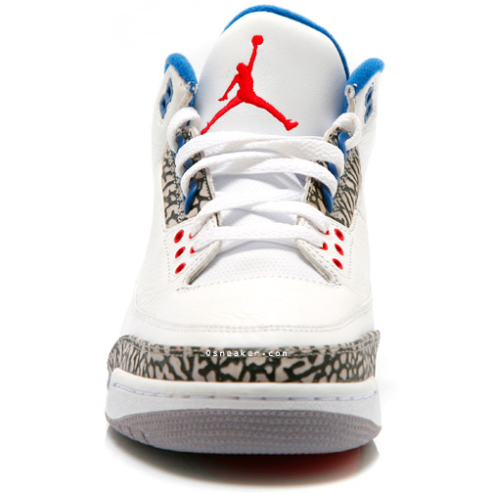

Just Do it!

Data

Nike’s Income Statements  Sales | 2009  19,176.10 | 2008  18,627.00 | 2007  16,325.90 | 2006  14,954.90
Cost of Sales | 10,188.40 | 9,918.10 | 8,895.20 | 8,077.00
Gross Operating Profit | 8,987.70 | 8,708.90 | 7,430.70 | 6,877.90
Selling, General, and Administrative Expenses | 6,149.60 | 5,953.70 | 5,028.70 | 4,477.80
Research & Development | 0.00 | 0.00 | 0.00 | 0.00
Operating Income before D & A (EBITDA) | 2,838.10 | 2,755.20 | 2,402.00 | 2,400.10
Depreciation & Amortization | 383.30 | 321.50 | 270.20 | 290.90
Interest Income | 9.50 | 152.20 | 67.20 | 36.80
Other Income - Net | 88.50 | (7.90) | 0.90 | (4.40)
Special Income / Charges | (401.30) | 0.00 | 0.00 | 0.00
Total Income Before Interest Expenses (EBIT) | 1,956.50 | 2,578.00 | 2,199.90 | 2,141.60
Interest Expense | 0.00 | 75.10 | 0.00 | 0.00
Pre-Tax Income | 1,956.50 | 2,502.90 | 2,199.90 | 2,141.60
Income Taxes | 469.80 | 619.50 | 708.40 | 749.60
Minority Interest | 0.00 | 0.00 | 0.00 | 0.00
Net Income From Continuing Operations | 1,486.70 | 1,883.40 | 1,491.50 | 1,392.00
Net Income From Discontinued Operations | 0.00 | 0.00 | 0.00 | 0.00
Net Income From Total Operations | 1,486.70 | 1,883.40 | 1,491.50 | 1,392.00
Extraordinary Income/Losses | 0.00 | 0.00 | 0.00 | 0.00
Income From Cum. Effect of Acct. Change | 0.00 | 0.00 | 0.00 | 0.00
Income From Tax Loss Carry Forward | 0.00 | 0.00 | 0.00 | 0.00
Other Gains / Losses | 0.00 | 0.00 | 0.00 | 0.00
Total Net Income | 1,486.70 | 1,883.40 | 1,491.50 | 1,392.00

NIKE FINANCIAL RATIOS
 | Company | Industry
Valuation Ratios
P/E Ratio (TTM) | 21.40 | 22.50
P/E High - Last 5 Yrs | 23.20 | 24.70
P/E Low - Last 5 Yrs | 12.60 | 10.80
Beta | 0.85 | 1.15
Price to Sales (TTM) | 1.95 | 1.92
Price to Book (MRQ) | 3.86 | 3.76
Price to Tangible Book (MRQ) | 4.15 | 4.52
Price to Cash Flow (TTM) | 17.20 | 17.20
Price to Free Cash Flow (TTM) | 17.30 | 15.90
Dividends
Dividend Yield (%) | 1.40 | 1.20
Dividend Yield - 5 Yr Avg (%) | 1.70 | 0.90
Dividend 5 Yr Growth Rate (%) | 17.20 | 14.04
Payout Ratio (TTM) | 29.00 | 20.00
Sales (MRQ) vs Qtr 1 Yr Ago (%) | 6.60 | 10.00
Sales (TTM) vs TTM 1 Yr Ago (%) | 2.90 | 0.60
Growth Rates (%)
Sales - 5 Yr Growth Rate (%) | 7.27 | 6.69
Net Income (MRQ) vs. 1 Yr Ago (%) | 103.60 | 122.80
Net Income (TTM) vs. 1 Yr Ago(%) | 103.60 | 122.80
EPS - 5 Yr Growth Rate (%) | 13.53 | 6.25
Capital Spending - 5 Yr Growth Rate (%) | 6.63 | 3.47
Financial Strength
Quick Ratio (MRQ) | 2.40 | 2.40
Current Ratio (MRQ) | 3.50 | 3.50
LT Debt to Equity (MRQ) | 0.05 | 0.07
Total Debt to Equity (MRQ) | 0.06 | 0.08
Interest Coverage (TTM) | 801.10 | 71.40
Management Effectiveness (%)
Net Profit Margin (TTM) | 0.09 | 0.09
Net Profit Margin - 5 Yr Avg | 9.00 | 8.90
Return on Assets (TTM) | 12.70 | 11.60
Return on Assets - 5 Yr Avg | 13.60 | 12.70
Return on Investment (TTM) | 17.50 | 16.00
Return on Investment - 5 Yr Avg | 19.70 | 17.90
Efficiency
Revenue/Employee (TTM) | 543,735.00 | 391,692.00
Net Income/Employee (TTM) | 50,327.00 | 34,128.00
Receivable Turnover (TTM) | 6.50 | 7.60
Inventory Turnover (TTM) | 4.30 | 4.10
Asset Turnover (TTM) | 1.40 | 1.40

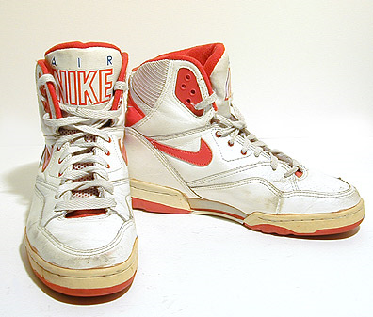
Assets
Cash and Equivalents | 2,291.10 | 2,133.90 | 1,856.70 | 954.20
Receivables | 2,883.90 | 2,795.30 | 2,494.70 | 2,395.90
Inventories | 2,357.00 | 2,438.40 | 2,121.90 | 2,076.70
Sale Of Short-Term Investments | N.A. | N.A. | N.A. | N.A.
Other Current Assets | 0.00 | 0.00 | 0.00 | 0.00
Total Current Assets | 9,734.00 | 8,839.30 | 8,076.50 | 7,359.00
Property, Plant & Equipment, Gross | 4,255.70 | 4,103.00 | 3,619.10 | 3,408.30
Accumulated Depreciation & Depletion | 2,298.00 | 2,211.90 | 1,940.80 | 1,750.60
Property, Plant & Equipment, Net | 1,957.70 | 1,891.10 | 1,678.30 | 1,657.70
Intangibles | 467.40 | 743.10 | 409.90 | 405.50
Other Non-Current Assets | 0.00 | 0.00 | 0.00 | 0.00
Total Non-Current Assets | 3,515.60 | 3,603.40 | 2,611.80 | 2,510.60
Liabilities & Shareholder Equity
Total Assets | 13,249.60 | 12,442.70 | 10,688.30 | 9,869.60
Accounts Payable | 1,031.90 | 1,287.60 | 1,040.30 | 952.20
Short Term Debt | 32.00 | 6.30 | 30.50 | 255.30
Other Current Liabilities | 86.30 | 88.00 | 109.00 | 85.50
Total Current Liabilities | 3,277.00 | 3,321.50 | 2,584.00 | 2,623.30
Long Term Debt | 437.20 | 441.10 | 409.90 | 410.70
Deferred Income Taxes | 842.00 | 854.50 | 668.70 | 550.10
Other Non-Current Liabilities | 0.30 | 0.00 | 0.00 | 0.00
Minority Interest | 0.00 | 0.00 | 0.00 | 0.00
Total Non-Current Liabilities | 1,279.80 | 1,295.90 | 1,078.90 | 961.10
Total Liabilities | 4,556.80 | 4,617.40 | 3,662.90 | 3,584.40
Preferred Stock Equity | 0.00 | 0.00 | 0.00 | 0.00
Common Stock Equity | 8,692.80 | 7,825.30 | 7,025.40 | 6,285.20
Common Par | 2.80 | 2.80 | 2.80 | 2.80
Additional Paid In Capital | 2,871.40 | 2,497.80 | 1,960.00 | 1,451.40
Cumulative Translation Adjustment | 0.00 | 356.40 | 234.30 | 0.00
Retained Earnings | 5,451.40 | 5,073.30 | 4,885.20 | 4,713.40
Treasury Stock | 0.00 | 0.00 | 0.00 | 0.00
Other Equity Adjustments | 367.20 | (105.00) | (56.90) | 117.60
Total Capitalization | 9,130.00 | 8,266.40 | 7,435.30 | 6,695.90
Total Equity | 8,692.80 | 7,825.30 | 7,025.40 | 6,285.20
Total Liabilities & Stock Equity | 13,249.60 | 12,442.70 | 10,688.30 | 9,869.60
Total Common Shares Outstanding | 485.50 | 491.10 | 501.70 | 512.00

NIKE Balance Sheet 2009 2008 2007 2006

Adidas Group Income Statements

 | Currency in  Millions of Euros | As of: |  |  | Dec 31  2006 | Dec 31  2007 |  | Dec 31  2008 | Dec 31  2009 |  | 4-Year  Trend
 | Revenues |  |  |  | 10,084.0 | 10,299.0 |  | 10,799.0 | 10,381.0
 | TOTAL REVENUES |  |  |  | 10,084.0 | 10,299.0 |  | 10,799.0 | 10,381.0
 | Cost of Goods Sold |  |  |  | 5,589.0 | 5,417.0 |  | 5,543.0 | 5,669.0
 | GROSS PROFIT |  |  |  | 4,495.0 | 4,882.0 |  | 5,256.0 | 4,712.0
 | Selling General & Admin Expenses, Total |  |  |  | 1,592.0 | 1,705.0 |  | 1,508.0 | 1,376.0
 | Other Operating Expenses |  |  |  | 2,012.0 | 2,246.0 |  | 2,703.0 | 2,794.0
 | OTHER OPERATING EXPENSES, TOTAL |  |  |  | 3,604.0 | 3,951.0 |  | 4,211.0 | 4,170.0
 | OPERATING INCOME |  |  |  | 891.0 | 931.0 |  | 1,045.0 | 542.0
 | Interest Expense |  |  |  | -184.0 | -166.0 |  | -178.0 | -138.0
 | Interest and Investment Income |  |  |  | 37.0 | 27.0 |  | 37.0 | 16.0
 | NET INTEREST EXPENSE |  |  |  | -147.0 | -139.0 |  | -141.0 | -122.0
 | Currency Exchange Gains (Loss) |  |  |  | 2.0 | 7.0 |  | -25.0 | -25.0
 | Other Non-Operating Income (Expenses) |  |  |  | -13.0 | -2.0 |  | -- | -3.0
 | EBT, EXCLUDING UNUSUAL ITEMS |  |  |  | 733.0 | 797.0 |  | 879.0 | 392.0
 | Merger & Restructuring Charges |  |  |  | -- | -- |  | -- | -21.0
 | Impairment of Goodwill |  |  |  | -- | -- |  | 21.0 | --
 | Gain (Loss) on Sale of Assets |  |  |  | 1.0 | 21.0 |  | 10.0 | 3.0
 | Other Unusual Items, Total |  |  |  | -11.0 | -3.0 |  | -6.0 | -16.0
 | EBT, INCLUDING UNUSUAL ITEMS |  |  |  | 723.0 | 815.0 |  | 904.0 | 358.0
 | Income Tax Expense |  |  |  | 227.0 | 260.0 |  | 260.0 | 113.0
 | Minority Interest in Earnings |  |  |  | -13.0 | -4.0 |  | -2.0 | --
 | Earnings from Continuing Operations |  |  |  | 483.0 | 551.0 |  | 642.0 | 245.0
 | NET INCOME |  |  |  | 483.0 | 551.0 |  | 642.0 | 245.0
K-Swiss IS  Sales |  | 2009  240.73 | 2008  340.16 | 2007  410.43 |  |  | 2006  501.15
Cost of Sales |  | 150.40 | 201.20 | 218.27 |  |  | 262.25
Gross Operating Profit |  | 90.33 | 138.96 | 192.16 |  |  | 238.90
Selling, General, and Administrative Expenses |  | 118.30 | 147.87 | 157.50 |  |  | 137.53
Research & Development |  | 0.00 | 0.00 | 0.00 |  |  | 0.00
Operating Income before D & A (EBITDA) |  | (27.97) | (8.91) | 34.66 |  |  | 101.37
Depreciation & Amortization |  | 4.16 | 3.60 | 2.30 |  |  | 1.69
Interest Income |  | 2.01 | 7.18 | 9.59 |  |  | 7.00
Other Income - Net |  | (1.25) | 30.00 | 5.23 |  |  | 0.00
Special Income / Charges |  | (4.83) | 0.00 | 0.00 |  |  | 0.00
Total Income Before Interest Expenses (EBIT) |  | (36.20) | 24.67 | 47.19 |  |  | 106.69
Interest Expense |  | 0.96 | 0.22 | 0.00 |  |  | 0.00
Pre-Tax Income |  | (37.16) | 24.46 | 47.19 |  |  | 106.69
Income Taxes |  | (9.66) | 3.57 | 8.11 |  |  | 29.83
Minority Interest |  | 0.00 | 0.00 | 0.00 |  |  | 0.00
Net Income From Continuing Operations |  | (27.50) | 20.88 | 39.07 |  |  | 76.86
Total Net Income |  | (27.96) | 20.88 | 39.07 |  |  | 76.86

References
External Analysis
Company Overview http://www.nikebiz.com/company_overview/
2 http://www.mcafee.cc/Classes/BEM106/Papers/2009/Adidas.pdf
3 http://www.marketwatch.com/story/adidas-profit-jumps-26-after-world-cup-us-orders-slip
4 http://www.wikinvest.com/stock/Nike_(NKE)#Market_Share
5 http://www.slideshare.net/thats4u83/new-balance-final
6 http://www.finfacts.com/irelandbusinessnews/publish/article_10002786.shtml
7 http://www.apparelandfootwear.org/UserFiles/File/Statistics/ShoeStats2008_0808.pdf
8 http://www.unc.edu/~andrewsr/ints092/vandu.html
9 http://www.ft.com/cms/s/0/4aa0739a-731c-11df-ae73-00144feabdc0.html
10 http://www.google.com/finance?q=NASDAQ:KSWS
11http://www.corporateinformation.com/ImageSvr/Chart.ashx?T=SS&C=482686102
12http://www.google.com/finance?q=NYSE:UA
13 http://bber.unm.edu/econ/us-pci.htm
14 http://www.eufootball.biz/finance/7151-2010_world_cup_expected_revenue.html
15 http://www.bls.gov/eag/eag.us.htm
16 http://factfinder.census.gov/servlet/STTable?_bm=y&-qr_name=ACS_2007_1YR_G00_S0101&-geo_id=01000US&-ds_name=ACS_2007_1YR_G00_&-state=st&-_lang=en&-redoLog=false
17 http://www.census.gov/newsroom/releases/archives/population/011910.html
18 http://www.census.gov/Press-Release/www/releases/archives/population/010048.html
19http://www.collegeboard.com/prod_downloads/press/cost06/trends_college_pricing_06.pdf
20 http://www.inhabitat.com/wp-content/uploads/nash.jpg
21 http://www.nikebiz.com/crreport/content/workers-and-factories/3-4-0-wages.php?cat=wages
22 http://www.ipwatchdog.com/patent/design-patent/

Internal Analysis References
23 http://sneakers.pair.com/airtech.htm
24 Nikebiz.com
25 http://www.wikinvest.com/stock/Nike_(NKE)
26 From Tactical to Strategic:
The 3PL Continuum http://www.inboundlogistics.com/articles/features/0704_feature01.shtml
27 The New Nike
28The New Nike http://www.businessweek.com/magazine/content/04_38/b3900001_mz001.htm
29http://webcache.googleusercontent.com/search?q=cache:HE3H9lJI_OgJ:www.inboundlogistics.com/articles/features/0704_feature01.shtml+NIKE+inbound+logistics&cd=1&hl=en&ct=clnk&gl=us
30 Nikebiz.com
31 Production manufacturing Nikebiz.com
32 http://webcache.googleusercontent.com/search?q=cache:GKtT_HOBPt0J:www.wikinvest.com/stock/Nike_(NKE)+nike+available+equity&cd=4&hl=en&ct=clnk&gl=us
33 http://www.estateswest.com/editorenroute/golf/nike-golf-rd-expansion

Financial
http://seekingalpha.com/article/210754-nike-earnings-preview-five-factors-to-consider?source=yahoo
http://caps.fool.com/Ticker/NKE/Ratios.aspx?source=icasittab0000007
http://caps.fool.com/Ticker/NKE/Statements.aspx?source=icasittab0000009
http://media.corporate-ir.net/media_files/irol/10/100529/AnnualReport/nike-sh09-rev2/docs/Nike_2009_10-K.pdf
http://www.wikinvest.com/stock/Nike_(NKE)/Data/Key_Metrics
http://www.marketingteacher.com/SWOT/nike_swot.htm
http://www.docstoc.com/docs/7937512/Athletic-Footwear-Industry-Analysis
  - http://investing.businessweek.com/businessweek/research/stocks/financials/financials.asp?ticker=ADDDF:US

Company Overview http://www.nikebiz.com/company_overview/
http://www.mcafee.cc/Classes/BEM106/Papers/2009/Adidas.pdf
http://www.marketwatch.com/story/adidas-profit-jumps-26-after-world-cup-us-orders-slip
http://www.wikinvest.com/stock/Nike_(NKE)#Market_Share
http://www.slideshare.net/thats4u83/new-balance-final
http://www.finfacts.com/irelandbusinessnews/publish/article_10002786.shtml
http://www.apparelandfootwear.org/UserFiles/File/Statistics/ShoeStats2008_0808.pdf
http://www.unc.edu/~andrewsr/ints092/vandu.html
http://www.ft.com/cms/s/0/4aa0739a-731c-11df-ae73-00144feabdc0.html
http://www.google.com/finance?q=NASDAQ:KSWS
http://www.corporateinformation.com/ImageSvr/Chart.ashx?T=SS&C=482686102
http://www.google.com/finance?q=NYSE:UA
http://bber.unm.edu/econ/us-pci.htm
http://www.eufootball.biz/finance/7151-2010_world_cup_expected_revenue.html
http://www.bls.gov/eag/eag.us.htm
http://factfinder.census.gov/servlet/STTable?_bm=y&-qr_name=ACS_2007_1YR_G00_S0101&-geo_id=01000US&-ds_name=ACS_2007_1YR_G00_&-state=st&-_lang=en&-redoLog=false
http://www.census.gov/newsroom/releases/archives/population/011910.html
http://www.census.gov/Press-Release/www/releases/archives/population/010048.html
http://www.collegeboard.com/prod_downloads/press/cost06/trends_college_pricing_06.pdf
http://www.inhabitat.com/wp-content/uploads/nash.jpg
http://www.nikebiz.com/crreport/content/workers-and-factories/3-4-0-wages.php?cat=wages
http://www.ipwatchdog.com/patent/design-patent/
http://sneakers.pair.com/airtech.htm
Nikebiz.com
http://www.wikinvest.com/stock/Nike_(NKE)
From Tactical to Strategic: The 3PL Continuum http://www.inboundlogistics.com/articles/features/0704_feature01.shtml
The New Nike
The New Nike http://www.businessweek.com/magazine/content/04_38/b3900001_mz001.htm
http://webcache.googleusercontent.com/search?q=cache:HE3H9lJI_OgJ:www.inboundlogistics.com/articles/features/0704_feature01.shtml+NIKE+inbound+logistics&cd=1&hl=en&ct=clnk&gl=us
Nikebiz.com
Production manufacturing Nikebiz.com
http://webcache.googleusercontent.com/search?q=cache:GKtT_HOBPt0J:www.wikinvest.com/stock/Nike_(NKE)+nike+available+equity&cd=4&hl=en&ct=clnk&gl=us
http://www.estateswest.com/editorenroute/golf/nike-golf-rd-expansion

