Industry Analysis: Nike, Inc.

By Team 1
Alex Jouganatos, Shawnee Moreland, Matthew Pastrano, and Mami Yamamoto

Company Overview
Nike, Inc is a leader in the design, development, marketing, and distribution of athletic clothing, footwear, equipment, accessories, and services worldwide. The company was founded in 1964 in Oregon by Phil Knight and Bill Bowerman. The company’s products can be broken down into these categories: running, NIKE basketball, the Jordan brand, football, men’s training, women’s training, action sports, sportswear, and golf. One of the company’s major strengths lies in partnership and licensing deals with many collegiate and professional athletic programs. The recent example is 1 billion dollar deal to serve as the official apparel provider of the NBA, WNBA, and NBA development league for the next eight years. Additionally, the company’s wholly owned subsidiaries including Converse Inc., which designs and distributes casual footwear, apparel and accessories. Converse sales was reported as $2,042,000,000 in revenue during 2017, which accounted for 5.94% of overall company earnings.

Competitive Advantages
Nike’s industry is an industry in demand. Where money is being made there are other forces that come in to try and make money as well. Where there’s cash flow there’s competition, and Nike is not the only one that is trying to dominate the industry. Adidas and Under Armour are two of the top companies in the industry along with Nike. A big competitive factor for Nike would be Adidas’ hold on soccer. Every year during the World Cup Adidas’ stock skyrockets about 7 percent give or take depending on the year. Nike is a definitive soccer contender and they compete neck and neck with Adidas, but Adidas has a contract with the World Cup to provide the official World Cup ball until 2030, also last year Adidas supplied shirts to 12 of the 32 nations while Nike supplied 10. However, Adidas supplied 60 percent of players with boots. Nike has been heavily involved with the world cup since 1994, but has still yet to pull ahead of Adidas when it comes to soccer buzz.
On the other hand, Under Armour has a unique competitive advantage over Nike. Under Armour focuses more on usefulness over branding, which in itself is a brand. Under Armour was invented when a retired football player figured out a way to get rid of sweat soaked heavy t-shirts that would get in the way, when he used the wicking in women’s lingerie to create a material that was durable and game changing. Under Armour focuses on solutions, using garments to solve problems. Under Armour took on Nike’s “Just Do It” mantra by suggesting that everyone has hurdles to overcome and obstacles that are encountered, but with Under Armour’s solutions, they can help anyone be the best they can be. Nike and Under Armour are fierce competitors, where one is lacking the other prevails, the key with these two companies is that they can learn from each other and use that information to get a leg ahead.

Company Situation Analysis
Analytical Steps
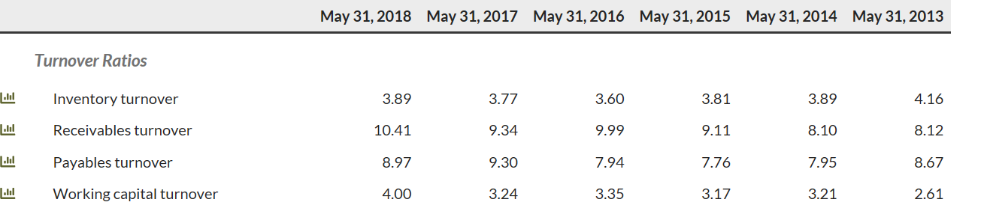

The figure above shows the turnover ratios for Nike for the past six years. Inventory turnover is the indicator of how many times a company has sold and replaced inventory during a given period. This figure is consistent with retail and grocery stores, representing high volume and low margins. As the graphic above shows the ratios have been very consistent over the past 6 years which is good to see as a manager and investor in the company. Receivables turnover ratio is a measure of how often receivables are collected within a period this can be on annual basis or quarterly. The above graphic depicts annual basis, in the case of Nike this is a good ratio size given the scale of the company overall. Keeping the number low and manageable is key in maintaining a successful business where the recipients of goods pay their obligations quickly. As the graphic above shows Nike has increased their overall company size the past few years and the receivables ratios has increased each year, which is a good indicator that the sales and collections are moving proportionally. The accounts payable ratio is the measure of how quickly the company pays it obligations to suppliers and other distributors in the supply chain of the company. This ratio has a bit more movement but does not need to follow a certain expectation despite given the size of the supply chain that Nike has and the markets that they reach keeping this ratio consistent the past 6 years is a strong indicator that the company keeps it liability obligations limited and under control. The working capital turnover ratio is a figure that can show how efficiently the company is using its short term assets to cover its liabilities efficiently. The number has been increasing showing that the managers are utilizing their resources accordingly and have more resources to put forth to keep the short term handheld. From a overall standpoint the turnover ratios provide a great snapshot for a retail and apparel based company such as Nike because they are a sales based company. The turnover ratios have a direct relation to the sales revenue the smoother and more liquid turnover ratios are will result in greater sales and greater profits because it means the supply chain is being managed effectively.
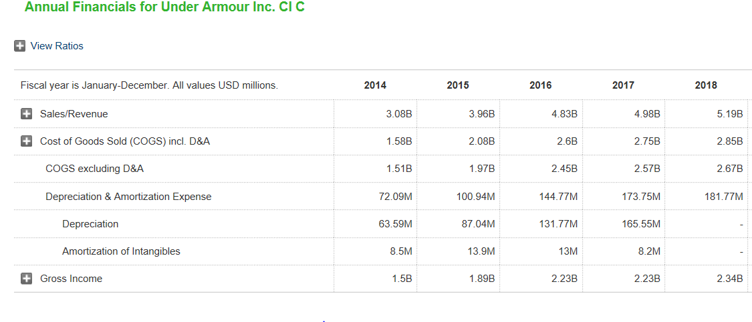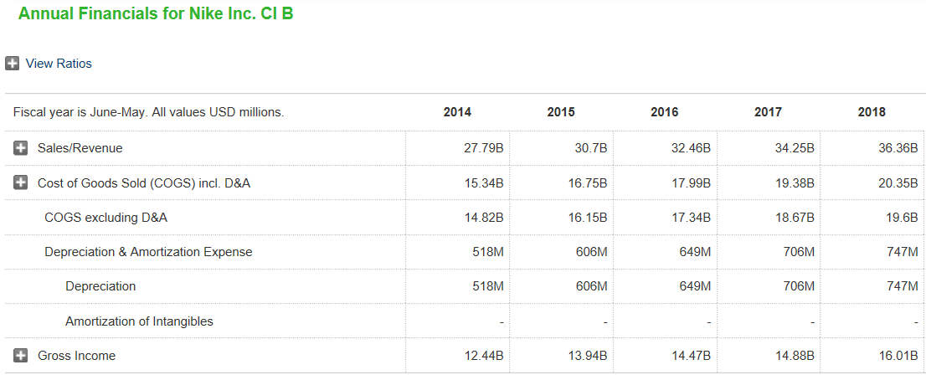
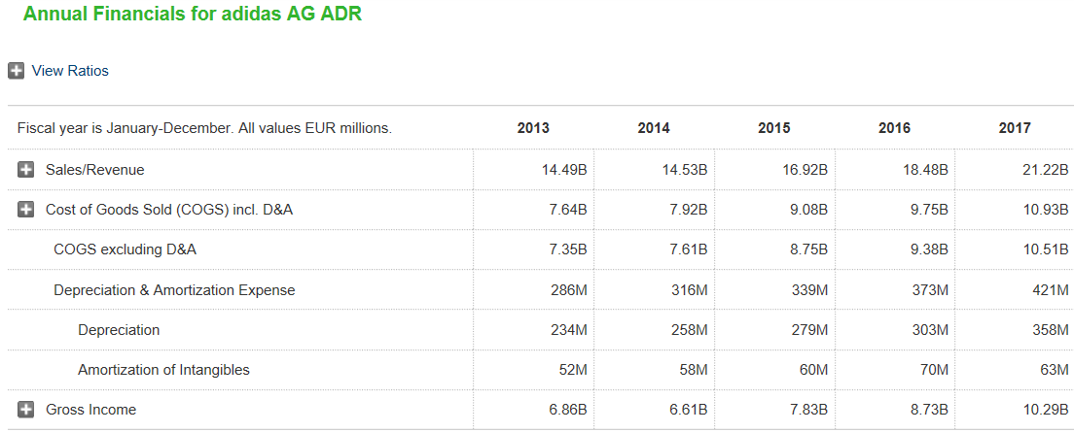

The three graphics above depict Nike, Under Armour and Adidas Income statement, particularly the sales revenue and gross income being the standout figures for the past 5 years. Nike has the highest sales revenue over the three companies over this time span, with Adidas in second and Under Armour last. The industry has still remained competitive mostly between Adidas and Nike despite the greater revenue of Nike the gross income between the two is only about a 5 billion dollar gap, which in the greater scheme of things is close competition. Nike has greater depreciation expense than Adidas which is mostly just and indicator that they have been around longer and have incurred more projects that require debt and equity financing than Adidas, which as a shareholder is a positive indication of the companies prolonged success. In the athletic footwear and apparel market Under Armour is definitely a step behind the two and is susceptible to competition from lesser companies such as Asics and Puma who are gaining more name recognition and market share.

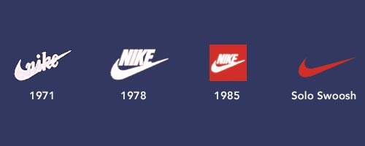

The Nike swoosh progression over time shows that the Brand wanted to clean up the look of the highly recognizable logo. SWOT analysis of Nike. Strengths of the company as followed are Nike is the number 1 shoe maker in the world, it employs a made to stock philosophy in which the order from a consumer is immediately pulled from the available stock. Nike has superior research and development to its competitors always innovating and never falling behind the competition. Weakness of the company include that its income is still heavily dependent on its share of the footwear market despite mostly dominating it. If the shoe market ever erodes this will leave the company highly vulnerable. Retail sector is also highly price sensitive despite Nike being globally diverse in its markets. Opportunities of Nike, the consumers of wearers of Nike highly defend the fact that their shoes are not only a fashion statement but highly effective in the sports and athletic realm of their lifestyle. There is opportunity for Nike to expand even further into sportswear, sunglasses and jewelry for the athletic individual. High value items will bring high profits for the company. Global marketing events are also highly opportunistic for the company such as the World Cup and the Olympics. Athletes that wear Nike brand in the Olympics have dominated when it comes to getting gold medals. Threats of Nike include that its exposure to international trade, the market for sports shoes is highly competitive and they are developing alternative brands. The main threat for Nike in my opinion is the high legal pressures it faces which require higher enforcement of ethics as well as regulatory standards that come with operating globally as heavily as the company does. The current overlap between success factors of the company are that they rely heavily on supply chain factors that are not domestic to the United States which contributes to the threats of the company. The core capabilities of the company exist within their ability to market strategically and better than its competitors. It is the premium brand and provides costly products to its consumers.
Nike was once under brutal criticism regarding its poor working conditions. Over the past 20 years Nike has taken measure to improve conditions and has overall done a good job of it. However, even with these improved word environments, many of its factories in developing nations still do not meet even Nike’s own standards. Low wages and safety are a major concern with these factories, and if a disaster would occur it would no doubt be a huge blow to Nike’s image. Another weakness might be that Nike is heavily dependent in the footwear market, if for any reason this market should falter, Nike would face a devastating decrease. Along with this, Nike partakes with international trade. Nike buys and sells in different currencies and so over a long period of time costs and margins may not be stable. This could mean that Nike may be manufacturing or selling at a loss.

Business and Economic Characteristics
Nike is a unique company to where the American economy does not affect it as much as it would most companies. Nike remains virtually unaffected by negative turns in the economy because 60% of their sales are international. Therefore, when one economy is not performing up to the standard that is deemed successful, Nike does not worry because it is geographically diversified. For example, Nike has become increasingly popular in China, especially with the youth. The sales in the youth Chinese market have been increasing at approximately 25-30% this year. Due to the large increase in Demand from the Chinese market, Nike has revamped shipping and distributing centers in and near China to make the delivery of shoes faster. Nike relies on this motto, “During times of economic challenge, consumers will go to brands that they trust and can connect with. We have not seen the economy have a dramatic impact on the sales of our products, not just in the high end, but also in the mid-priced range”
The corporate structure of Nike is also heavily influenced by the need to address differences among regional markets. Such as the specific demands of customer bases, with variations in apparel as well as climate apparel needs. Nike is one of the leading players in athletic footwear, apparel and sports equipment. The corporate structure must reflect that and it does, showing how regional variations must be included in the business strategies. Structural and strategic alignment are one of the competitive advantages that Nike has over the industry, when it comes to penetrating regional market environments.

Driving Changes
The footwear industry is a place where you would least expect technology as something that impacts change. However, Nike has used technology to its advantage and has benefited greatly from it. In fact, all companies in the footwear industry have been forced to use innovative technology for the growth of their business. For example, Nike, Adidas, and Under Armour all have a websites that make up a large amount of their revenue from sales. In 2017, Nike made $3 Billion in online sales and have goals to reach $7 Billion in 2020. Adidas led the way with online sales and made just under $7 Billion and Under Armour fell behind greatly making only around $770 Million.
Another aspect of technology that is affecting the footwear industry is through innovation in the sole of the shoe. Nike and Adidas have both come up with their own take on how the sole should be constructed. Nike has come up with their own technology called the 4% and Adidas has its ultra boost technology. The 4% is used for Nike’s running shoes and has an 85% energy return which makes it both lightweight and comfortable. Nike claims that because of this new technology, the athlete can expect to see a 4% boost in performance hence the name. Adidas introduced Ultra Boost in 2013 as its own revolutionary cushioning system. The Ultra Boost sole stores and releases energy and have become notorious for their comfortability.
Nike has also introduced some new technology that neither Adidas or Under Armour can even compete with, the self lacing sneaker. Nike first introduced this technology in 2017 with the HyperAdapt. The HyperAdapt first retailed for $720 which is a very steep price, but Nike is introducing a new self lacing sneaker in 2019 called the Adapt BB which is retailing for $350. This massive cut in price shows that Nike has found a cheaper and more efficient way to produce this technology and makes it more available to consumers. On the other end, Adidas and Under Armour both do not want to invest their time in this technology. Under Armour CEO, Kevin Plank, thinks that the innovation that Nike is showing is a “joke” and “laughable”. Adidas has also moved in a whole other direction by just making shoes fit better without laces, basically making them slip ons.

Future predictions
Nike has focused recently on expansion in China and other emerging markets. This focus on foreign markets has led Nike to position themselves to expand their business. The company earns its greatest revenue from footwear which contributes to 62% of overall revenue. Footwear sales grew 12.35% in Greater China, and 12.12% in Latin America, while it only grew 2.95% in Europe and in North America. This data shows that Nike has been focusing on expansion and higher revenue in Asia and in Latin America. From that trend, the company will be focusing on this geographic area to expand their business and popularity.
Equipment has the smallest contribution to Nike’s overall revenue at 4%. Equipment in North America has a negative sales growth proving to be a concern for Nike. If Nike were forced to focus their business on a profitable segment, Nike would most likely discontinue equipment. Nike stopped making golf clubs recently due to competing companies golf sales rendering the Nike golf line unprofitable and unnecessary.
Significant changes are taking place in Nike’s distribution channels and its customer preferences. These changes are encouraged by the increasing convenience of online shopping. Online shopping will continue, and will likely grow as a percentage of overall consumer expenditure. This trend is affecting Nike’s sales in its retail stores significantly. Major athletic footwear and apparel wholesaler, Sports Authority, declared bankruptcy in 2016. Foot Locker and Finish Line have also been struggling as well. Due to the trend, this will decrease Nike’s distribution options. Nike will likely shift their focus to their online web page in the future.
As the market is becoming red, it is very important to focus on Research and development. Nike’s CEO, Mark Parker said “The future of sport will be decided by the company that obsesses the needs of the evolving consumer - through the Consumer Direct Offense, we’re getting even more aggressive in the digital marketplace, targeting key markets, and delivering product faster than ever.” From his words and the trend of the consumers, nike will work on accelerating innovation. In order to do so, Nike has created the President of Categories and Product role. It aims to increase the speed of designing, marketing, and selling of the products. Nike will likely spend more resources on research and development to keep up with the rapid change in the trend. In addition, if the company comes up with new products, it will help them sell their products at a premium instead of discounted price which will have a positive impact on their margins.

Industry Attractiveness
Nike is in an extremely attractive position if other startups of similar companies in the industry are viewing their success as a benchmark. Financial statements of the company are not accurately reflecting the company’s success and current financial position. The brand name of Nike is something that does not show up on the balance sheet as a asset. Nike is a global brand that has instant name recognition and is hands down one of the most universally identifiable logos, up in the ranks of the golden arches of McDonald’s and the Apple logo. Nike was founded in 1964 by Phil Knight who had $1200 in the bank when he started this company. Nike is now a 3.75-billion-dollar market cap. Anyone with basic understanding of return on investment can figure out that, this industry has prospects for above average profitability. Given the fact that the industry of sports apparel and athletic footwear is largely dominated by about five companies, this clouds the barrier to entry for smaller companies that have bigger dreams. But with that being said Under Armour, was founded by a Maryland University former football player who began by making shirts in his grandmother basement. What the founders of the successful companies in this industry have in common is that they see a need for innovation and want to provide a product that has not been done before. To reflect how sports are played, athletes are always wanting to push themselves and be the next best thing. That is the mindset of these companies in athletic apparel and that is what leads to the profitability and attractiveness of the market because innovation is the key driving factor.

