Industry Analysis

An analysis of the home improvement industry as it relates to Home Depot and two major competitors.
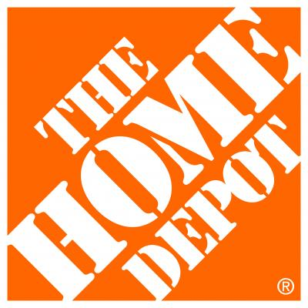

By Group 1: Eric Baker, Joshua Benjamin, Tiffany Jesko, and Berkley Stell
Table of Contents
- SWOT Analysis………………………………………………………………………….2
- Industry Standing………………………………………………………………………..7
- PEST Analysis…………………………………………………………………………13
- Environmental Threat and Opportunity Profile (ETOP)……………………………16
- Competing Markets……………………………………………………………………18
- Industry Assessment
  - Factors determining environmental stability (ES)…………………………..19
  - Factors determining industry strength (IS)………………………………….23
- Industry Figures……………………………………………………………………..…27
- Five Forces Models……………………………………………………………………29
- Recommendations for Home Depot…………………………………………………31
- Works Cited………………………………………………………………………....….35

1) SWOT analysis

Strengths:
When referring to the strengths of a business, the primary focus of the SWOT analysis is to notice key factors that allow Home Depot to excel, grow, and make more of an impact on the market over other businesses. Shabbar Suterwala wrote that “it is important to know what your advantages are, what the company as a whole and individually does well in. It’s crucial to consider different viewpoints from both people within the company as well as others outside of the company. Never be modest, but only realistic when it comes to understanding strengths and areas that your business stands out in. If finding strengths of the business is difficult, try considering it as writing down characteristics or a business, then determining if it helps the image of the business, or hinders the area of the business.”
Many things contribute to the success of Home Depot and the impact that Home Depot has had on their consumers. A few examples might be their high structured leadership programs, and the quality of work performance that is provided for each consumer. Home Depot is a brand that is respected and valued, they use a relationship oriented work approach that is devoted to gaining a relationship with each consumer. Home Depot provides a heterogeneous product mix that allows consumers to shop at their stores for multiple purposes, while also offering them the option to use online portals to scroll through the merchandise and easily have it delivered. These are just a few, small glimpses of why Home Depot stands out and makes a huge impact within the market.
Weaknesses:
After performing the SWOT analysis on Home Depot and noticing the strengths, it is just as important to understand the significance of weakness that Home Depot has as well. Suterwala wrote that determining weaknesses of a business can be as simple as pinpointing areas that need to be improved. This is done by looking at the areas in your business that are done either badly or with little excellence. Detecting weakness will allow a form of discernment to grow in order to avoid further hindrance in the future with consideration from both intrinsic and extrinsic views. When facing the weaknesses of a business, being upfront and honest is often hard; in spite of this, a weakness cannot be improved until it is confronted. Weaknesses are not always obvious failures that are blunt and easily seen, they can also be anything that hinders growth or reduces the amount of impact that Home Depot has on the market, prompting them to fall behind on their competitors.
As previously stated Home Depot has strong strengths, but they also have recognizable weakness as well. One major weakness of Home Depot is its sole dependency on the economic pattern of the U.S. market. The U.S. economy is cyclical, meaning it’s never constant, always up or down. If the Economy is doing well, Home depot is doing well. If the economy is low, income and reports come in low for Home Depot as well. Another weakness of Home Depot’s is its high debt that has been built up over time. Home Depot’s accumulation has built up so much that it now results in 65% of their balance sheet being debt. Although Home Depot does budget shareholder returns into each balance sheet, other income and revenue is scarce. Being that Home Depot is involved in so much dept., this prevents growth and expansion within the company, resulting in a major weakness.

Opportunities:
The third thing to analyze regarding the SWOT analysis is the opportunity of the company and the potential growth that Home Depot can have on the market if acted upon appropriately. Home Depot predominantly focuses within the United States market, rather than international markets. One major growth opportunity for Home Depot is its ability to be both domestically and internationally involved. Another potential opportunity related to Home Depots strengths, is the ability to constantly grow the product line and product mix. Since Home Depot already has a high rate of diversification, it allows them the opportunity to keep growing the product mix even farther, which consequently brings in more consumers and increase consumer return.
Like it was previously stated, one of Home Depot’s major strengths is its online portals which allow customers to easily view and purchase the products they have. With growths in technology continuing to incline, Home Depot has plans to expand their online tools even farther, allowing income to increase from online shopping as well as in-store purchases.

Threats:
The last factor of the SWOT analysis is threats of the business, meaning anything that can potentially be detrimental, or cause failure within the company. While Home Depot still holds the most dominating role over the home improvement industry, their competitors are a major threat that is forced to overcome every day. A few of Home Depot’s biggest competitors include Lowe’s, Wal-Mart, Ace Hardware and Sutherlands as their successes threaten potential growth and income for the Home Depot’s company. In the book Foundations of Strategy, Rich D’Aveni argues that the “general feature of industries today is hyper competition: ‘intense and rapid competitive moves, in which competitors must move quickly to build new advantages and erode the advantages of their rivals. If industries are hypercompetitive, their structures are likely to be less stable than in the past, superior profitability will tend to be transitory and the only route to sustained superior performance is through continually recreating and renewing competitive advantage” (pg. 68).
Another threat Home Depot fights against is other products that are used as substitutes to the products they offer. If other companies produce substitutes that function the same way at lower costs, Home Depot will view that situation as a threat. Lastly, a major threat that Home Depot continuously fights against is online theft. While online security is continuing to improve overtime, in 2014 their online portals got hacked, resulting in a loss of trust and customer loyalty following their business brand.

SWOT summary:
Once a business has successfully determined their strengths, weaknesses, opportunities, and threats- the business as a whole has a better understanding on how to successfully plan for the future and map out more improved ways to succeed within the marketplace. Understanding the SWOT analysis of your business is important, but worth nothing if the business isn’t willing to create an action strategy in order to determine a way of improvisation in areas that need improvement. Turning the SWOT analysis into an organized set of data is the next step to making the business more successful.
After gathering all the information regarding the SWOT analysis, the next step to have a successful business is to prioritize the information by categorizing them in order of severity. There are multiple ways to appropriately organize data such as using templates, excel spreadsheets, or any other techniques in order to separate the different categories of information. Once the data is relevantly organized, it becomes easier to zone in on each specific category in order to come up with an action plan to follow through on.
An action plan should be created in a way that implements a promotion of the strengths within a business. It should provide a method in order to improve on weaknesses, while also opening up new ways for opportunities. In these things, it should consequently better prepare the company of threats towards the business. The action plan will not only help build a better foundation for the company, but will also allow the company to be more prepare for future involvement within the market.

Industry Standing

1. Potential rate of growth of industry (in real terms)
Potential rate of growth refers to how fast both the market and the industry are growing, and the amount of impact it makes within its economy. There are four contributing factors regarding the potential growth rate of the industry starting with personal consumption, the second being investment from other people within the company, third being government involvement, and fourth being trade. Depending on the level of involvement regarding the four elements, the gross potential rate of an industry is determined. Home depot has potential growth rate, and plans to act within a blue oceans strategy for future growth.

0-3% ____ 9-12% ____ 18-21% ____

3-6% ✅(4.46%) 12-15% ____ >21% ____

6-9% ____ 15-18% ____

2. Ease of entry of new firms into industry
Home Depot is operating within a red ocean, which means the market is already well established and filled with competitors. The cost of entering into the home improvement industry is low, which encourages even small, sole proprietor stores to open up and compete. Along with Home Depot, stores like ACE Hardware’s, Lowe’s, and Walmart have over 14,000 stores in North America alone. While it is possible for new, small firms to create serious competition for a well-established company such as Home Depot, it is unlikely to happen with the high expenses that go along with creating a big brand name. Therefore, the threat of new entries does exist, but at a weak force.
No barriers - ____:____:____:____:____:____:_✅_:____:____ - Virtually impossible to enter

3. Intensity of competition among firms
The intensity of competition refers to how well other competitors are competing within the same marketplace. This can be measured by anything that makes one firm be above other firms within competition. Referring back to the SWOT analysis, one of the major threats Home Depot faces is its vast amount of competitors that work to compete within the marketplace. Home Depot currently holds the dominating role within the marketplace; however, there are several of businesses that compete within the market as well. A few of these competitors would include Lowe’s, Walmart, Ace Hardware and Sutherlands.

Extremely competitive - ____:_✅_:____:____:____:____:____:____:____ -Almost no competition

4. Degree of product substitutability
The degree of product substitutability refers to the amount of products that function in the same manner, yet at different prices. Ideally, the goal for consumers is to find a product that functions how they need it to, but is sold at a lower price. For example, products that are offered by Home Depot may function the same as other products at Lowe’s or Ace Hardware, but if they can find it cheaper at a different store they will chose to purchase it there. The goal of Home Depot is to compete in a market with products that operate the same, yet are being sold at a much lower cost. The product substitutability is high for Home Depot due to the amount of competitors, however Home Depot still holds a dominating role within the marketplace.

Many substitutes available - _✅_:____:____:____:____:____:____:____:____
-No substitutes available
5. Degree of dependency on complementary or supporting products and services
The Degree of dependency on complementary or supporting products and services refers to the amount of dependency that a business has towards a certain product or a certain object to maintain operation or increase sales. Home Depot is similar to most businesses in the means of dependency within the U.S. market, but does not depend on many other firms or products for the success of their business. Home Depot is independent when it comes to bringing in their own product mixes and expanding product diversification.

Highly dependent - ____:____:____:____:____:____:____:_✅_:____ -Virtually independent

6. Degree of bargaining power buyers and customers possess
The majority of the bargaining power lies with the buyers/customers. Due to the large number of competitors, Home Depot primarily competes on cost, by offering items at the same or lower price than their competitors. Home Depot even offers a price-match guarantee, giving customers even more control by allowing them the opportunity to argue the price down if they find a lower price anywhere else.

Buyers dictate terms - ____:_✅_:____:____:____:____:____:____:____ -Purchasing firms dictate terms

7. Degree of bargaining power suppliers and vendors
The influence of home improvement suppliers is weak due to how many different supplier brands exist. On top of this, Home Depot’s large size and well established brand name gives them even more control over these suppliers. Suppliers would suffer a major loss if a big company such as Home Depot were to drop them and find a new supplier to work with; it is because of this that Home Depot has a small amount of power over them. However, even with this knowledge, suppliers can have some sense of security because it is easier for a big brand industry to maintain long term relationships with trusted suppliers.

Suppliers dictate terms - ____:_✅_:____:____:____:____:____:____:____-Purchasing firms dictate terms

8. Degree of technological sophistication in industry
The degree of technological sophistication in the industry refers to the amount of technical involvement within the business and what tools they use to operate and gain growth in sales. Home Depot is a very low involved company regarding their technological performances. Home Depot does offer an online software for the use of their consumers to shop online, but does not incorporate any other technological tools or benefits when operating their day-to-day business.

High-level technology - ____:____:____:____:____:____:_✅_:____:____ -Very low-level technology

9. Rate of innovation in industry
Over the past few years, Home Depot has centered their innovative attention on developing and improving their online capabilities, as well as their mobile app, and advanced shipping features. Home Depot has focused on making their website and mobile app secure and easy to navigate. Home Depot offers a “ship to store” feature free of charge, which allows people to pick up online orders at their nearest store (almost 45% of online orders are picked up in store). While there were many improvements made over the past few years, none of them are very significant or “game changing.”

Rapid innovation - ____:____:____:____:____:____:_✅_:____:____ -Almost no innovation

10. General level of management capability
The general level of management capability often refers to the amount of involvement from their leadership team, their management approach, or even corporate involvement. Home Depot recruits mid-to-low level management straight from their staff members. Therefore, most managers have ample knowledge and experience with Home Depot, and thus require minimal training. Multiple corporate offices in China, and India also allows Home Depot to strengthen relations with its suppliers.

Many very capable mgrs. - ____:_✅_:____:____:____:____:____:____:____ -Very few capable mgrs.

PEST ANALYSIS
A PEST analysis has recently become a popular environment scanning framework for an industry. This analysis identifies different environmental factors that might affect a firm externally. These four different factors are political, economic, social, and technological. It is through analyzing these basic forces that a business is able to better understand how their company might transform through already existing competitive conditions within the industry.

Political: Besides the middle-class, a large portion of Home Depot’s customer base consists of government contractors. Therefore Home Depot susceptible to political stability and changes in city infrastructures. While Home Depot offers products made locally here in the United States, a large portion Home Depot’s product are made overseas, meaning Home Depot can be vulnerable to and affected by international trade laws, barriers and tariffs. Currently, Home Depot hasn’t seen too much of an effect from things such as trade barriers. However, with a large portion of Home Depot’s products coming from China, if trade relations between the United States and China get continue to decline, Home depot could seriously be affected.

Economic: Following the real estate crash and the recession, the economy in general is making a healthy recovery. Even more so, the housing market is in a vast recovery, so things like home repair products and services are in a high demand. However, millennials in the economy pose a problem for Home improvement stores such as Home Depot, as big name publications such as CNBC, show that most millennials are not buying homes. Some can’t afford down payments, mortgages or credit, and others are simply choosing to rent or apartment living. While this is not a huge issue for Home Depot currently, Home Depot’s future consumers are the generation of Millennials. Therefore, Home Depot needs to find a way to target millennials. Permarket their smaller products for things like DIY projects that are gaining popularity with millenials that want to embrace their independence, but not take on such large projects.

Social: Because Lowe’s operates in many of the same locations as Home Depot, the social aspect of consumer preferences can be a big factor. When consumers have the choice to shop between the two stores social factors may be the determining factor. Positive or negative public relations can make or break a major industry competitor due to readily available substitutes. Middle class families make up the majority of Home Depot's target market. The problem is, the middle class is getting poorer and smaller. Recent studies show that the top 20% of US households hold over 84% of the nation’s wealth, and the bottom 40% only make up a mere .3%. With home improvement projects becoming more and more popular, the demand for higher quality products that will last have increased as well. However, with the buying power of the United States middle class decreasing, Home Depot’s target market is becoming less able to buy higher quality, more expensive items. Currently, Home Depot provides sub-premium products to compensate. (Home Depot could consider expanding their products to higher quality, premium products for consumers would be interested. Wouldn’t carry them in-store, but could offer them online and then use their ship to store feature)

Technological: Changes in technology have a major impact on every business that uses software or any online utensil for the use of their business or the growth or their companies. For example, Home Depot has established “rapid deployment centers” all over the nation. These centers have the ability to service up to a hundred stores, distributing and restocking products faster than ever before. Home Depot also developed a mobile app, catering to millennials, and the future market of Home Depot. Additionally, Home Depot has refined their website and online ordering processes, as well as their “ship to store” feature, with next day delivery capabilities in 90% of the nation.

Environmental Threat and Opportunity Profile (ETOP)

Factors | Impact  of Factors | Importance  of Factors
Political | 5 | 5
Economic | 7 3 | 6 4
Social | 5 | 10
Technological | 10 | 7
{Impact from 10 (strongly positive) to 0 (strongly negative).}
{Importance of each factor ranked from 0 (unimportant) to 10 (very important).}

Our basis for the rankings on impact vs. performance was related to our PEST analysis. Political factors have had impacts on Home Depot in the past and this is the reason for the rating of 5 in impact and performance. Trade policies like NAFTA have made it easier for international expansion into both Mexico and Canada. Tariffs also can impact the costs of goods sold by Home Depot but have historically not had much impact. Economics have a little higher importance and impact on Home Depot as with any business. The social aspect of the home improvement industry is extremely important as shown by the rating of 10, and the impact is rated as a 5 because effects can be either positive or negative. Lastly technology has impacted the home improvement industry in a very positive way through optimizing supply chains and enabling online sales. The advances of mobile technology allow consumers to now store inventories in real time and make purchases.

Two Types of Competing Markets:
- The market for inputs:
Market inputs consist of the raw materials and labor used in order to produce the products and services within an industry. Home depot is unique in the aspect that they sell raw materials to others, leaving their cost for labor as one of their biggest overall expenses. Of course, they still have to purchase the products from suppliers as an overhead expense. They also have the cost of store buildings, trucks for deliveries, and tools/equipment for employees as well. It’s through these expenses that they are able to make an income in the end.
- The market for outputs:
Market outputs are the goods and services that an industry distributes out to customers. For Home Depot the goods being supplied are aimed to satisfy customers who like to take on projects themselves. These good would consist of appliances, lumbar, carpet, tools, equipment, or other similar products. The services they offer would be delivery, installation, and repairs. These two different categories of goods and services are how they receive income from customers.

Industry Assessment

1. Factors determining environmental stability (ES)
a) Technological changes: The graph below shows a e-commerce at about a steady 20% growth rate. Home Depot currently has the fifth most e-commerce sales in the U.S, just behind Amazon, eBay, Apple, and Walmart. Even through these high rates of digital sales, Home Depot’s in-store traffic has been boosted as 47% of those orders are picked up in store.

b) Rate of inflation: 1-2%
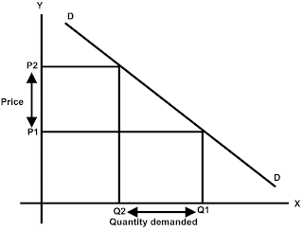
c) Demand variability: Demand for home improvement goods is fairly unit elastic. The demand factors facing consumers are income, prices of related goods, tastes and preferences, and the expected future price. Only income and tastes/preferences largely impact Home Depot consumers because home improvement items are typically either luxury goods or necessities depending on whether you are looking to re-decorate your home or replace a broken faucet.

d) Price range of competing products: Home Depot has a “lowest price guaranteed” system, where they will meet the lowest price no matter what. The large size of Home Depot’s company has put them in a position to negotiate low prices with suppliers, which in return allows them to already have some of the lowest prices to offer.

e) Barriers to entry into market: Low barriers to enter the market on a small scale but large barriers to be a big player. The largest barrier is the need for a wide range of products and brand. This requires lots of product and customer base knowledge. Connections must be made with suppliers of all the goods within the store which draws a lot of time and money from potential retailers.

f) Competitive pressure: Home Depot is under very high pressure from their competitors. Each of their top 3 competitors have stronger footing in North America than Home Depot in terms of retail stores. Walmart has over 5,300 stores in North and Central America, and ACE has 4,400, with 5,000 stores globally. Lowe’s and Home Depot both have about half that many stores in North America and Central America, with Lowe’s having just above 2,300 stores, and Home Depot having just under 2,300 stores. 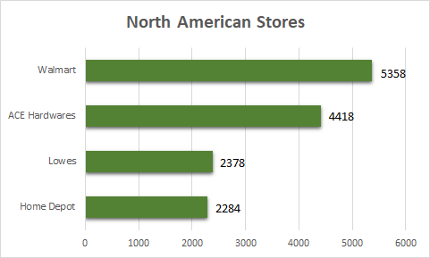

g) Price elasticity: Highly elastic for most products that are not necessities but rather inelastic for necessary home supplies. Similar to the demand elasticity for home good products, many products are affected by changes in prices such as decorations or flowers which are not necessity goods for consumers. Other products like repair parts and appliances are more crucial for everyday use and therefore less price elastic as compared to decorations.

2. Factors determining industry strength (IS)
a) Growth potential: Currently, Home Depot is Operating within a Red Ocean and applying Red Ocean strategies, limiting their growth potential. However, if Home Depot were to expand outside of North America, and focus on exploring the blue oceans of Asian and European markets, substantial growth is possible. 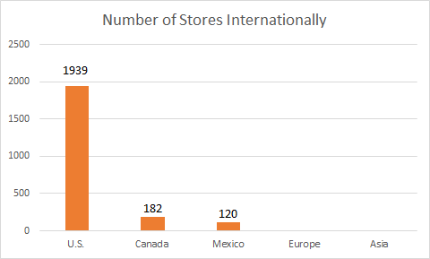
b) Profit potential: Bound to the margins created from suppliers of goods. Home Depot currently captures more than twice the percentage of profits when compared to Lowe’s. If Home Depot can expand their product line and gear more towards online sales they should be able to keep expansion costs low while increasing sales. This would undoubtedly increase the overall profits of Home Depot in the long-run. Extending long-term partnerships and contracts with suppliers may also allow Home Depot to lock in prices at a lower cost than otherwise possible.

c) Financial stability: In the year 2015, Home Depot fell into a substantial amount of debt. With over 65% of their balance sheet resulting in debt, Home Depot continuously struggles to gain financial growth as well as industry growth. Home Depot is facing a large amount of debt but they have financial support from shareholders and a decent range of diversification within the home improvement industry. As shown in the chart below, historically Home Depot’s debt to equity ratio has been on a constant increase which is not particularly promising for their long term goals.

d) Technological know-how: The technological know-how aspect of home improvements has been perfected by Lowe’s and Home Depot though their supply chain management, inventory management, and websites. The ledge Home Depot has on top of Lowe’s is their partnership with SmartWay Transportation. The SmartWay “program helps companies advance supply chain sustainability by measuring, benchmarking, and improving freight transportation efficiency”.
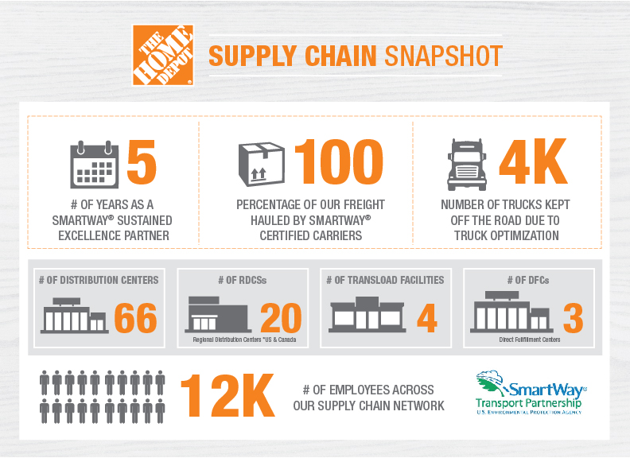

e) Resource utilization: Larger home improvement industry companies like Lowe’s and Home Depot have a large amount of resources available to allocate towards business endeavors due to their large network of offices and business locations nationwide. In Home Depots case they even have international offices.

f) Capital intensity: (amount of capital required to enter and compete in the industry) A mid-level of capital intensity is required to compete in the home improvement industry. Most commonly home improvement items are sold at storefront because customers prefer to see what they are buying or check payment before purchase. Storefronts also make it easier to return items that won't work for customer’s projects. The means the option of creating a solely online based store will likely be unsuccessful. This leaves a storefront as the best option for the competing market. Storefronts require a large amount of capital to purchase/rent and operate due to size and the need for large inventory on hand.

g) Ease of entry into market: Relatively easy to enter the market at a small scale such as a mom and pop hardware store. Due to the sheer size of Home Depot and Lowe’s, becoming a large player within an already crowded domestic market would likely be next to impossible. Lowe’s, Home Depot, and Ace Hardware currently have most of the American market on lockdown.

h) Productivity; capacity utilization: Productivity as related to Home Depot and other home improvement stores is largely based on supply chain management. The largest impact of productivity is education and technology. Home Depot utilizes both education and technology in nearly every aspect of their business from supply chain management to their online inventory and purchasing options. The industry itself is focused on capturing the consumer and does so by trying to make the buying experience as easy and accessible as possible.

Total sales of home centers in the United States from 2013 to 2022 (Billion USD)

- 2013-2017 Industry growth rate: 4.95%
- 2018-2022 Predicted growth rate: 4.46%

United States GDP Growth Rate

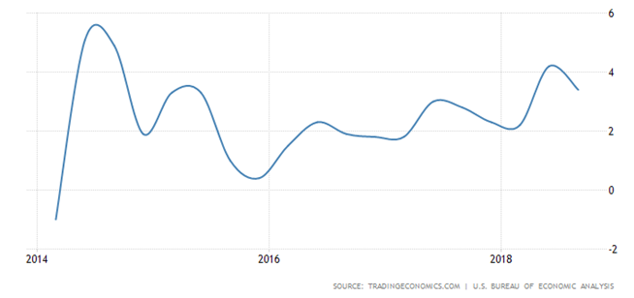
- Average GDP growth rate: ~2% growth rate of the U.S. economy.

Porter’s Five Forces:

Porter’s five forces is a guideline created by a Harvard business student, Michael Porter, to analyze the severity of competition within different industries. It bases the profitability of an industry based on five different forces including the competition from substitution, the threat of entry, rivalry between established competitors, bargaining power of buyers, and bargaining power of suppliers. The strength of these competitive forces is then used to determine the overall attractiveness of the market.
The competition from substitution imposes a big threat to Home Depot’s customer segment. Home Depot is in the industry of home improvement retail goods and services; the exact same industry as their biggest competitor, Lowe’s, as well as Ace Hardware. There is a strong force in external factors causing the threat of substitution for Home Depot including the high availability of substitutes, low switching costs, and high performance-to-price ratio of substitutes.
The threat of new entries is a moderate force for Home Depot. The cost of creating a business in the home improvement market is low, so even small businesses can become competitors. However, Home Depot has developed their brand so well that it is hard for those small businesses to seriously compete. Therefore, the high expenses of brand development weaken the threat of new entries for Home Depot.
Home Depot has a strong force of rivalry between established competitors. Their closest competitor would be Lowe’s, as their concentration is the exact same. However, other smaller brands have grown in significance as well, such as Ace Hardware. Home Depot remains a top home improvement store because of its high brand popularity that has been built through customer satisfaction and the quality of customer service found in their stores.
The bargaining power of buyers is a growing strong force for Home Depot. As technology has advanced it has given customers more power to find a tremendous amount of information before making a purchase. Customers know that they can view the several options available to them from competitor store and then compare to find the best prices with the best quality. There is also no brand loyalty for customers, so once they find the better deals, they will switch to that store rather than sticking with Home Depot.
Finally, the bargaining power of suppliers force is weak for a large company like Home Depot. There are not any large, influential suppliers in the home improvement industry, which gives a big brand such as Home Depot more control over the supplier. While suppliers are still ultimately in control of themselves, they can’t afford to lose big brands, which gives those brands a small portion of control. Most big brands like to maintain long term relationships with trusted suppliers, so it is unlikely that they would ever switch to a new one, yet it is still an easy option if they see reason to.

Recommendations for Home Depot Based on Industry Analysis:

Create a geographic blue ocean: Because growth potential within the United States is shrinking it has become increasingly important for Home Depot to expand internationally. Home Depot currently has stores the U.S., Mexico, and Canada. Home Depot also operates procurement offices within India and China. If Home Depot were to expand storefronts or even just distribution centers for online orders and shipping in China they could significantly lower their storefront costs while expanding sales to new markets thus creating a blue ocean opportunity. This would satisfy the current CEO’s strategy of "enhancing the core, extending the business and expanding the market" although previous such expansions have proven unsuccessful. In past years Co-founders Arthur Blank and Bernie Marcus expanded the company to Chile and Argentina which ultimately led to failure. Although Home Depot failed to expand in South America, the potential Asian and European markets where consumer preferences are more aligned with American pop culture. For expansions into domestic blue oceans Home Depot can expand to smaller towns and cities which lack larger home improvement stores.
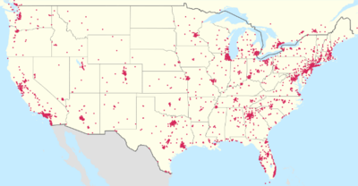
(Current Home Depot operations in the United States)

Wider product Variety offered online: Home Depot primarily competes with its top competitors through offering average quality items to their consumers at a low cost. This approach is directed towards their middle to low class target market which is unable or unwilling to pay higher prices for premium products. The current product line of faucets, for example, is comprised of brands such as Delta, Moen and Kohler which are largely common and affordable. If Home Depot can implement higher quality designer fixtures such as Mac, Hudson Reed or Watts they can expand their customer base and profit potential. A strategy we suggest Home Depot to implement would be to offer higher priced, premium products online to customers who are interested. Home Depot would not necessarily carry these in store, taking up more inventory space on the shelves, rather, premium products would be offered via their app or website, and would use their “ship to store” capabilities to have the product ready for pick up the next day.

Wholesale prices and products for contractors only: Home Depot already offers a wide range of benefits to its contractor members but expansion of products as related to the previous point would benefit contractors and provide incentives for more contractors to get onboard. Currently contractors receive; commercial credit, bulk pricing, tool rental, shipping/delivery options, expanded inventory and mobile coupons. If Home Depot expands specifically on the available expanded inventory to designer brands and styles contractors could in turn provider for a wider range of home construction projects and customers. If these types of products were limited to contractors only it would give contractors the feeling of exclusiveness and incentive to work with Home Depot over Lowe’s or another construction supplier.

Advertisement tailored for millennials: Another strategic alteration which we would advise Home Depot to implement is their marketing strategy for their future consumers: millennials. Currently, studies show that the vast majority of millennials now living independently are opting out of home ownership, instead they are choosing rentals and apartment living. This poses an issue for Home Depot in the industry of home improvement for the future. With the majority of millennials renting, the demand for large home improvement projects is becoming smaller. While Home Depot doesn’t solely offer materials/products for large projects, most of their advertising does depict people performing large scale home renovations or landscaping projects. Projects such as these fail to attract millennials that do not own homes. The current trend of millennial consumers is smaller, do-it-yourself (DIY) type crafts and projects, which Home Depot has the capability and products to provide for. Even though Home Depot provides some similar products, stores like Hobby Lobby and Michael’s are known for providing the goods most used for apartment decoration. If Home Depot were to expand their product line to include more products for smaller projects, such as “dorm decorations,” they would be offering more products that would be appealing to the younger generation of consumers. It would also help Home Depot to tailor some of their advertising towards millennials, demonstrating smaller DIY projects while offering more craft goods, as it might attract younger consumers. These small DIY projects will get millennials foot in the door to the larger DIY projects that Home Depot caters towards, and in turn will create return business to Home Depot.

Works Cited

Grant, R. M., & Jordan, J. (2015). Foundations of strategy. Hoboken: Wiley.

Amadeo, K. (n.d.). How to Calculate the GDP Growth Rate.
https://www.thebalance.com/what-is-the-gdp-growth-rate-3306016

What is SWOT analysis (strengths, weaknesses, opportunities and threats analysis)? - Definition from WhatIs.com. (n.d.). Retrieved from https://searchcio.techtarget.com/definition/SWOT-analysis-strengths-weaknesses-opportunities-and-threats-analysis

https://www.statista.com/statistics/239795/total-sales-of-home-centers-in-the-us/

https://tradingeconomics.com/united-states/gdp-growth

https://courses.lumenlearning.com/boundless-economics/chapter/comparing-real-and-nominal-gdp/

http://www.in2013dollars.com/inflation-rate-in-2018

https://www.statista.com/topics/1732/home-improvement/

https://blog.jda.com/managing-demand-variability-jda-software-supply-chain/

https://www.google.com/search?q=diy+demand+variability&oq=diy+demand+variability&aqs=chrome..69i57.6416j0j7&sourceid=chrome&ie=UTF-8

https://www.homedepot.com/b/Kitchen-Kitchen-Faucets/N-5yc1vZar0k

http://floridaexportdirectory.com/Search/CompanyDetail.aspx?HierarchyId=132601&companyId=15193

https://www.floordaily.net/flooring-news/home-depot-looking-at-europe-asia

https://www.marketplacepulse.com/stats/us-ecommerce/us-e-commerce-growth-rate-55

https://www.thebalance.com/five-determinants-of-demand-with-examples-and-formula-3305706

https://sites.google.com/site/economicsbasics/unitary-elastic-demand

https://www.homedepot.com/c/professional_contractor

https://en.wikipedia.org/wiki/The_Home_Depot

https://www.tutor2u.net/economics/reference/strategies-for-improving-business-profitability

https://www.fool.com/investing/2017/01/20/how-home-depot-inc-has-changed-in-the-last-5-years.aspxhttps://www.fool.com/investing/2017/01/20/how-home-depot-inc-has-changed-in-the-last-5-years.aspx

https://investinganswers.com/financial-dictionary/ratio-analysis/quick-ratio-924

https://www.macrotrends.net/stocks/charts/HD/home-depot/debt-equity-ratio

https://www.macrotrends.net/stocks/charts/HD/home-depot/quick-ratio

https://corporate.homedepot.com/newsroom/smartway-2017-clean-transportation

https://www.epa.gov/smartway/learn-about-smartway

https://www.scientificamerican.com/article/economic-inequality-it-s-far-worse-than-you-think/

http://www.pewresearch.org/fact-tank/2014/12/17/wealth-gap-upper-middle-income/

https://www.statista.com/statistics/269425/total-number-of-walmart-stores-in-the-united-states-by-type/

https://www.statista.com/statistics/240033/total-number-of-home-depot-stores-in-canada-by-province/

https://www.businessinsider.com/home-depot-lowes-ace-hardware-best-home-improvement-store-2018-8

http://ir.homedepot.com/~/media/Files/H/HomeDepot-IR/2018_Proxy_Updates/HD_AR_Soft-Copy.pdf

http://ir.homedepot.com/~/media/Files/H/HomeDepot-IR/2018_Proxy_Updates/HD_AR_Soft-Copy.pdf

https://www.cheshnotes.com/home-depot-porters-five-forces-analysis/

http://panmore.com/home-depot-five-forces-analysis-porters-model

https://www.fool.com/investing/2018/10/17/better-buy-the-home-depot-inc-vs-lowes.aspx

https://www.fool.com/investing/2016/07/05/3-reasons-to-buy-home-depot.aspx

https://www.fool.com/investing/2017/08/12/how-home-depot-inc-makes-most-of-its-money.aspx

https://sproutsocial.com/insights/social-media-conversion/

