Competitive Analysis

An analysis of the home improvement competition as it relates to Home Depot and two major competitors.
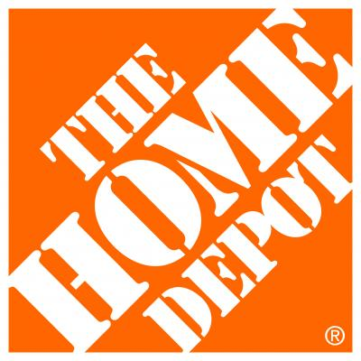

By Group 1: Eric Baker, Joshua Benjamin, Tiffany Jesko, and Berkley Stell

Table of Contents
- Competitive Factors...……………………….………………………………………….2
- Competitive Strength Assessment…………..………………………………………..3
- Competitors Objectives and Strategies.………………………………………………5
- Weighted Competitive Strength Assessment…………...……………………………8
- Strategic Posture....……………………………………………………………………10
- SWOT Analysis:
  - Home Depot……………………………………………………..……………..11
  - Lowes………………………………………………………………..………….17
  - Ace Hardware…………………………………………………………...……..23
- Competition Intensity...……………………………………………………………..…28
- Competitive Pressure and Strength……….…………………………………………29
- Competitive Advantage Factors……………………………………………………...32
- Financial Strength Factors…..…………………………………………………..……41
- Recommendations for Home Depot…………………………………………………43
- Works Cited………………………………………………………………………....….47

Color Codes: Home Depot
Lowe’s
Ace

Competitive Factors 0% Weak Neutral (50) Strong 100%
1. Product Strength, Quality, Uniqueness | HD  Lowe’s  Ace
2. Customer Loyalty and Satisfaction |  |  | HD  Lowe’s | Ace
3. Market Share |  | Ace | HD  Lowe’s
4. Low Selling and Distribution Costs |  | Ace | Lowe’s | HD
5. Use of Experience Curve for Pricing |  |  | Lowe’s  Ace | HD
6. Use of Life Cycle of Products and Replacement Cycle | HD  Lowe’s  Ace
7. Investment in New Product Development by R&D |  | HD  Lowe’s  Ace
8. High Barriers to Entry into the Company’s Markets |  |  | Ace | HD  Lowe’s
9. Advantage Taken of Market Growth Potential |  |  | HD  Lowe’s  Ace
10. Supplier Strength and Material Availability |  |  | HD  Lowe’s  Ace
11. Customer Concentration |  |  | Ace | HD  Lowe’s
12. Other

3. COMPETITIVE STRENGTH ASSESSMENT

Rating Scale: 1 = Very weak; 10 = Very strong

Key Success Factor / Strength Measure |  | Home Depot | Lowe’s | Ace Hardware
Quality / product performance |  | 8 | 8 | 8
Reputation / image |  | 9 | 8 | 9
Raw material access / cost |  | 9 | 7 | 6
Technological skills |  | 6 | 5 | 4
Manufacturing capability |  | 6 | 6 | 6
Marketing / distribution |  | 8 | 8 | 7
Financial strength |  | 8 | 7 | 8
Relative cost position |  | 8 | 6 | 4
Ability to compete on price |  | 9 | 7 | 5
Total possible points | 90
Overall strength rating |  | 75/90 | 62/90 | 57/90

4. CONCLUSIONS CONCERNING COMPETITIVE POSITION AND STRATEGY

Home Depot appears to stack up quite well against the competition although there is still plenty of room for improvement as they tied in many areas with Lowe’s and Ace and nobody scored a perfect 10 in any category. Home Depot biggest advantage is their ability to compete on cost. Home Depot has one of the lowest costs due to their low cost suppliers, this when compounded with their price match guarantee, makes Home Depot’s prices virtually impossible to beat. On top of that, Home Depot has a fantastic reputation with the public for being knowledgeable, helpful and friendly, giving it an advantage over its competitors.

5. MAJOR STRATEGIC ISSUES/PROBLEMS THE COMPANY MUST ADDRESS

Home Depot must address their diversification plan through expanding their available products and moving into new markets. Ace Hardware has lead the industry in location diversity through operating in over 60 countries with 600+ stores. Home Depot and Lowe’s only operate in the North American market. Home Depot must address its expansion strategy to increase its 2,200 stores in 3 countries to many more stores in many more countries to explore blue oceans with untapped potential.

CATEGORIZING THE OBJECTIVES AND STRATEGIES OF COMPETITORS

Home Depot
Competitive Scope | Strategic Intent | Market Share Objective | Competitive Position / Situation | Strategic Posture | Competitive Strategy
Local  Regional  National  Multi-country  Global | Be the dominant leader.  Overtake the present industry leader  Be among the industry leaders (top 5)  Move into the top 10  Move up a notch or two in the industry ranking  Overtake a particular rival (not necessarily the leader)  Maintain Position  Just survive | Aggressive expansion via both acquisitions and internal growth  Expansion via internal growth (boost market share at the expense of rival firms  Expansion via acquisition  Hold onto present share (by growing at a rate equal to the industry average)  Give up share if necessary to achieve short-term profit objectives | Getting stronger; on the move  Well-entrenched; able to maintain its present position  Stuck in the middle of the pack  Going after different market position (trying to move from a weaker to a stronger position)  Struggling; losing ground  Retrenching to a position that can be defended | Mostly offensive  Mostly defensive  A combination of offense and defense  Aggressive risk-taker  Conservative follower | Striving for low cost leadership  Mostly focusing on a market niche  - High end  - Low end  Geographic  Buyers with special needs  Pursuing differentiation based on:  Quality  Service  Technological superiority  Breadth of product line  Image/ reputation

Lowe’s
Competitive Scope | Strategic Intent | Market Share Objective | Competitive Position / Situation | Strategic Posture | Competitive Strategy
Local  Regional  National  Multi-country  Global | Be the dominant leader.  Overtake the present industry leader  Be among the industry leaders (top 5)  Move into the top 10  Move up a notch or two in the industry ranking  Overtake a particular rival (not necessarily the leader)  Maintain Position  Just survive | Aggressive expansion via both acquisitions and internal growth  Expansion via internal growth (boost market share at the expense of rival firms  Expansion via acquisition  Hold onto present share (by growing at a rate equal to the industry average)  Give up share if necessary to achieve short-term profit objectives | Getting stronger; on the move  Well-entrenched; able to maintain its present position  Stuck in the middle of the pack  Going after different market position (trying to move from a weaker to a stronger position)  Struggling; losing ground  Retrenching to a position that can be defended | Mostly offensive  Mostly defensive  A combination of offense and defense  Aggressive risk-taker  Conservative follower | Striving for low cost leadership  Mostly focusing on a market niche  - High end  - Low end  Geographic  Buyers with special needs  Pursuing differentiation based on:  Quality  Service  Technological superiority  Breadth of product line  Image/ reputation

ACE Hardware
Competitive Scope | Strategic Intent | Market Share Objective | Competitive Position / Situation | Strategic Posture | Competitive Strategy
Local  Regional  National  Multi-country  Global | Be the dominant leader.  Overtake the present industry leader  Be among the industry leaders (top 5)  Move into the top 10  Move up a notch or two in the industry ranking  Overtake a particular rival (not necessarily the leader)  Maintain Position  Just survive | Aggressive expansion via both acquisitions and internal growth  Expansion via internal growth (boost market share at the expense of rival firms  Expansion via acquisition  Hold onto present share (by growing at a rate equal to the industry average)  Give up share if necessary to achieve short-term profit objectives | Getting stronger; on the move  Well-entrenched; able to maintain its present position  Stuck in the middle of the pack  Going after different market position (trying to move from a weaker to a stronger position)  Struggling; losing ground  Retrenching to a position that can be defended | Mostly offensive  Mostly defensive  A combination of offense and defense  Aggressive risk-taker  Conservative follower | Striving for low cost leadership  Mostly focusing on a market niche  - High end  - Low end  Geographic  Buyers with special needs  Pursuing differentiation based on:  Quality  Service  Technological superiority  Breadth of product line  Image/ reputation

WEIGHTED COMPETITIVE STRENGTH ASSESSMENT

Rating Scale: 1 = Very weak; 10 = Very strong

Key Success Factor / Strength Measure | Weight | Home Depot | Lowe’s | Ace Hardware
Quality / product performance | 0.10 | 8/0.80 | 8/0.80 | 8/0.80
Reputation / image | 0.10 | 9/0.90 | 8/0.80 | 9/0.90
Raw material access / cost | 0.10 | 9/0.90 | 7/0.70 | 6/0.60
Technological skills | 0.05 | 6/0.30 | 5/0.25 | 4/0.20
Manufacturing capability | 0.05 | 6/0.30 | 6/0.30 | 6/0.30
Marketing / distribution | 0.05 | 8/0.40 | 8/0.40 | 7/0.35
Financial strength | 0.10 | 8/0.80 | 7/0.70 | 8/0.80
Relative cost position | 0.35 | 8/2.80 | 6/2.1 | 4/1.40
Ability to compete on price | 0.15 | 9/1.35 | 7/1.05 | 5/0.75
Sum of weights | 1.00
Weighted overall strength rating |  | 8.55 | 7.55 | 6.10

Competitive strength summary
Overall Home Depot has the strongest competitive strength from our estimations. Lowe’s is closely behind Home Depot by only one point. Ace hardware has the lowest competitive strength with a rating of 6.10 compared to Home Depots 8.55.

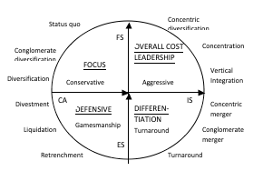

Strategic Posture as  Determined by  SPACE | Strategic Position and Action Evaluation  Appropriate Generic Strategy
Aggressive Posture | Cost leadership through  concentration, concentric  diversification, or vertical  integration
Competitive Posture | Differentiation, e.g., through  strong R&D effort funded  by merger with cash-rich  company
Conservative Posture | Focus and selective  diversification through  acquisition of companies in  other market segments
Gamesmanship Posture | Defensive, particularly  survival tactics, such as  retrenchment, divestment,  or liquidation
Strategic posture summary
Home Depot reflects a more aggressive posture compared to Ace Hardware and Lowe’s who display a more competitive posture. Home Depot is all about being the low cost leader while Lowe’s differentiates through its unique customer service and Ace differentiates through its size, convenience and spread of locations.

SWOT analysis for Home Depot

Strengths:
When referring to the strengths of a business, the primary focus of the SWOT analysis is to notice key factors that allow Home Depot to excel, grow, and make more of an impact on the market over other businesses. Shabbar Suterwala wrote that “it is important to know what your advantages are, what the company as a whole and individually does well in. It’s crucial to consider different viewpoints from both people within the company as well as others outside of the company. Never be modest, but only realistic when it comes to understanding strengths and areas that your business stands out in. If finding strengths of the business is difficult, try considering it as writing down characteristics or a business, then determining if it helps the image of the business, or hinders the area of the business.”
Many things contribute to the success of Home Depot and the impact that Home Depot has had on their consumers. A few examples might be their high structured leadership programs, and the quality of work performance that is provided for each consumer. Home Depot is a brand that is respected and valued, they use a relationship oriented work approach that is devoted to gaining a relationship with each consumer. Home Depot provides a heterogeneous product mix that allows consumers to shop at their stores for multiple purposes, while also offering them the option to use online portals to scroll through the merchandise and easily have it delivered. These are just a few, small glimpses of why Home Depot stands out and makes a huge impact within the market.

Weaknesses:
After performing the SWOT analysis on Home Depot and noticing the strengths, it is just as important to understand the significance of weakness that Home Depot has as well. Suterwala wrote that determining weaknesses of a business can be as simple as pinpointing areas that need to be improved. This is done by looking at the areas in your business that are done either badly or with little excellence. Detecting weakness will allow a form of discernment to grow in order to avoid further hindrance in the future with consideration from both intrinsic and extrinsic views. When facing the weaknesses of a business, being upfront and honest is often hard; in spite of this, a weakness cannot be improved until it is confronted. Weaknesses are not always obvious failures that are blunt and easily seen, they can also be anything that hinders growth or reduces the amount of impact that Home Depot has on the market, prompting them to fall behind on their competitors.
As previously stated Home Depot has strong strengths, but they also have recognizable weakness as well. One major weakness of Home Depot is its sole dependency on the economic pattern of the U.S. market. The U.S. economy is cyclical, meaning it’s never constant, always up or down. If the Economy is doing well, Home depot is doing well. If the economy is low, income and reports come in low for Home Depot as well. Another weakness of Home Depot’s is its high debt that has been built up over time. Home Depot’s accumulation has built up so much that it now results in 65% of their balance sheet being debt. Although Home Depot does budget shareholder returns into each balance sheet, other income and revenue is scarce. Being that Home Depot is involved in so much dept, this prevents growth and expansion within the company, resulting in a major weakness.

Opportunities:
The third thing to analyse regarding the SWOT analysis is the opportunity of the company and the potential growth that Home Depot can have on the market if acted upon appropriately. Home Depot predominantly focuses within the United States market, rather than international markets. One major growth opportunity for Home Depot is its ability to be both domestically and internationally involved. Another potential opportunity related to Home Depots strengths, is the ability to constantly grow the product line and product mix. Since Home Depot already has a high rate of diversification, it allows them the opportunity to keep growing the product mix even farther, which consequently brings in more consumers and increase consumer return.
Like it was previously stated, one of Home Depot’s major strengths is it’s online portals which allows customers to easily view and purchase the products they have. With growths in technology continuing to incline, Home Depot has plans to expand their online tools even farther, allowing income to increase from online shopping as well as in-store purchases.

Threats:
The last factor of the SWOT analysis is threats of the business, meaning anything that can potentially be detrimental, or cause failure within the company. While Home Depot still holds the most dominating role over the home improvement industry, their competitors are a major threat that are forced to overcome every day. A few of Home Depot’s biggest competitors include Lowe’s, Walmart, Ace Hardware and Sutherlands as their successes threaten potential growth and income for the Home Depot’s company. In the book Foundations of Strategy, Rich D’Aveni argues that the “general feature of industries today is hypercompetition: ‘intense and rapid competitive moves, in which competitors must move quickly to build new advantages and erode the advantages of their rivals. If industries are hypercompetitive, their structures are likely to be less stable than in the past, superior profitability will tend to be transitory and the only route to sustained superior performance is through continually recreating and renewing competitive advantage” (pg. 68).
Another threat Home Depot fights against is other products that are used as substitutes to the products they offer. If other companies produce substitutes that function the same way at lower costs, Home Depot will view that situation as a threat. Lastly, a major threat that Home Depot continuously fights against is online theft. While online security is continuing to improve overtime, in 2014 their online portals got hacked, resulting in a lost of trust and customer loyalty following their business brand.

How important are the strengths?

It is crucial for a company to know their strengths because strengths go hand-in-hand with opportunities and out of opportunities, brings growth. Strengths are known to set one business apart from another and give that business more header than other businesses. For Home Depot, major strengths involve their high structured leadership programs that bring quality work performance given to each consumer, their respected brand loyalty achieved by implementing a relationship oriented work approach devoted to gaining a relationship with each consumer, their heterogeneous product mix that allows consumers to shop at their stores for multiple purposes as well as online portals to scroll through the merchandise and easily have it delivered. These strengths are important because they set Home Depot apart from other businesses and most of the time give Home Depot the upper hand.

How vulnerable are the weaknesses?
It is common for a business to have weaknesses within their company. In fact, if a business has weaknesses, some would actually consider that to be healthy. If a company didn't have weaknesses, there would be no room for improvement in the company, and it could potentially rob the chance of opportunity growth. Weaknesses are very vulnerable, but not so much a threat if taken care of and dealt with appropriately. For Home Depot, the weaknesses are very minimal, but can always exist. There is no way to successfully remove all weaknesses from a company - errors and mistakes are a part of life and will continue to occur. With that being said, the weaknesses of Home depot are vulnerable because of its sole dependency on the economic pattern of the U.S. market causing its income and cash flow to be cyclical parallel to the U.S. market and the debt level that Home depot has occurred over time weighing heavy on financial priorities. Home Depot being dependant on the economic pattern of the U.S. market isn't necessarily an easy fix and can't really be avoided, the answer lies within the way Home Depot handles the problem and operates accordingly. Home Depot is centered in a lot of debt, however there equity far outweighs their debt and in fact, home depot uses there debt level as leverage.

What is the cost of not responding?
The cost of not responding to the SWOT analyses simply means missing out on forecasting for the future and strategically planning for your business in ways that bring success. If a business does not act accordingly by implementing their strengths within a business and operating off of what they excell on, the business will then become complacent, not stand out compared to their competitors, start to lose ground on productivity, profitability, and growth. If a business does not respond to the weaknesses of their company those weaknesses could potentially become threats and in turn harm the business. Denis Waitley once said “Failure should be our teacher, not our undertaker. Failure is delay, not defeat. It is a temporary detour, not a dead end. Failure is something we can avoid if we say something, do something, and be something. Failure if only considered failure if we simply do not act.” The cost of failing is detrimental and can hinder the growth and success of a business.

SWOT analysis for Lowe’s
Strengths:
As one of the leading companies in its industry, Lowe’s has multiple strengths that help it thrive in the marketplace. These strengths not only help Lowe’s protect its dominance within its respective markets, but it aids them in penetrating any new markets down the road. Lowe’s is one of the largest and oldest home improvement retailers around. It’s been publicly listed since 1961. Being one of the second-largest home improvement retailers in the world (second only to Home Depot), Lowe’s size, and market dominance are its key strengths. First and foremost, on any given week, Lowe’s can serve over 14 million customers throughout all of their of stores in North America and Mexico. Lowe’s is also in the top 50 countries the global Fortune 500 list, ranking at 40th overall highest revenues ($68 Billion). Their great success and high revenues make Lowe’s a powerhouse in terms of their financial standing. As one can imagine, Lowe’s financial power and success fall under the category of one low Lowe’s greatest strengths. Attributing to their great success, is another on of their strengths, their strong brand reputation as a company. Lowe’s employees are known for being knowledgeable and helpful, and all in all, the company has a very positive image in the eyes of the public. Lowe’s has been in business for almost a generation, and with that has come expertise and knowledge of how to operate within the industry, and well-established Lowe’s within its market. Lowe’s now has a very large and reliable distribution method, which can meet the majority of Lowe’s potential market with ease. With its large market share, positive branding, and large base of customers nationwide, Lowe’s has established itself to be one the first companies people think of to meet their home improvement needs.
Weaknesses:
Weakness are the areas where Lowe’s can improve upon. While Lowe’s has many strengths, it must not neglect minimizing its weaknesses, as companies like Ace Hardware and Home Depot look to exploit these weaknesses to gain an advantage over Lowe’s. One of Lowe’s primary weaknesses is its lack of a globalized presence. Like Home Depot, Lowe’s is mainly established in the United States, with only a handful of stores in Canada and Mexico. While its primary competitor is not overseas either, Lowe’s lack of globalization is a something that Lowe’s would greatly benefit from fixing. Another weakness of Lowe’s is their weak, poorly worded price match guarantee. Following the trend set by Home Depot, Lowe’s established a price match guarantee for their customers. This would be great if it weren’t for the ambiguity and poor execution of the price match guarantee. Lowe’s price match guarantee has a reputation through countless reviews of being “hassle-filled.” Unlike Home Depot (who does the price match very well), Lowe’s has review after review stating that their price match guarantee is not very accurate or honest, and that there is a lot of inconsistency and unfamiliarity among Lowe’s staff with the price match guarantee. This has led to many believing Home Depot to be the superior price matcher and is something Lowe’s will need to fix if it hopes to keep pace with Home Depot. Another weakness of Lowe’s is their lack of capital and revenue compared to Home Depot. While Lowe’s is ranked in the top 50 in the Fortune 500 list, Home Depot, its primary competitor, is almost 20 ranks high than Lowe’s and nets approximately $30 billion dollars more in revenues. Even though Lowe’s is one of the leaders in its respective industry, Lowe’s has many weaknesses, especially when compared to Home Depot, whose performance is far superior to Lowe’s. If Lowe’s ever intends on becoming the top dog and dethroning Home Depot
Opportunities:
Opportunities are ways the company can grow or exploit external factors to increase growth. These are imperative to the business, as exploiting such opportunities in the industry may be key to giving a company a “leg up” on its competitors. First and foremost, one of the greatest opportunities Lowe’s has is the virtually untapped global market. Lowe’s is centralized mainly here in the United States, with a few stores in both Mexico and Canada. Clearly, these new markets are a huge opportunity for Lowe’s to get out in front of its competitor Home Depot. On top of Lowe’s, Home Depot has yet to expand its business overseas. This may prove to be a difficult endeavor, but the pay offs could be substantial. If Lowe’s beats Home Depot to foreign markets, it would give them time to gain a foothold in the new markets and would be an influx of cash and revenues that its competitors would not be receiving. There’s no doubt if Lowe’s moved overseas their competitors would quickly follow suit, but by being the first one overseas they would have time needed to establish themselves in these foreign markets. Lowe’s also has a great opportunity in its online presence and capabilities. Social media is something that has been yet to be utilized in an innovative way to attract millennials to their business. If Lowe’s can increase their presence and attraction on social media, as well as follow up and create an online store that is on par with Home Depot, they will take drastic steps closer to becoming the top dog among home improvement stores.
Threats:

Threats are external factors that can negatively affect Lowe’s. Once determining what its threats are, Lowe’s must work to find ways to minimize the effect of its threats. One of Lowe’s greatest threats is Home Depot, not only is Home Depot grossing higher revenues than Lowe’s, but even with Lowe’s higher margins, Home Depot is still much more profitable due to their low-cost providers. So no only is Home Depot outselling Lowe’s but they’re making more off of each sale. The higher costs Lowe’s pays for their inventory is a major threat, as Home Depot is currently dominating the industry due to their low-cost suppliers. Another threat to Lowe’s would be the current trend of millennials to opt out of home ownership and instead choosing apartment living or renting. Due to this, Home improvement and landscaping goods are not currently in demand for millennials, which will be the majority of Lowe’s market in the near future. Currently, the trend for online shopping still poses a bit of a threat for Lowe’s. Amazon has revolutionized the game when it comes to online shopping. Consumers can get almost anything online and have it delivered right to their door in a matter of days. Lowe’s needs to find a way to streamline their online purchasing orders and offer innovative methods such as next day delivery and installation for their online orders.

How important are the strengths?

Lowe’s strengths give Lowe’s a major advantage over the its smaller competitors, and have kept it in the running when competing against its industry’s powerhouse: Home Depot. The great financial strength that Lowe’s possesses gives it the ability to invest back into the company in attempt to further grow the company. None of this would be possible though if it weren’t for their large amounts of customers and strong, positive brand reputation. Lowe’s knowledgeable employees keeps customers satisfied, and creates return business to Lowe’s

How vulnerable are the weaknesses?

No matter how vulnerable Lowe’s is due to their weaknesses, they could greatly benefit from flipping their weaknesses and turning them into strengths. First and foremost, Lowe’s is not globalized, it’s centered primarily here in the states. This is not something too vulnerable for Lowe’s, as their primary rival isn’t globalized yet either. However, this could spell big trouble for Lowe’s if Home Depot successfully establishes branches overseas. Another big weakness of Lowe’s is their ambiguous price match guarantees. In order to keep up with Home Depot, Lowe’s developed a price match guarantee similar to Home Depot’s. The problem with Lowe’s price match guarantee is its reputation of being unclear, and not as strong as Home Depot’s, as well as Lowe’s employees not being very knowledgeable about the price match guarantee, causing customers to feel robbed or cheated when getting their price matched.

What is the cost of not responding?

Currently the cost of not responding is not too severe. Lowe’s has done a pretty good job putting themselves in a position similar to Home Depot. Currently, there would be no consequences if Lowe’s doesn’t expand to overseas markets because Home Depot, their primary competitor, has yet to move overseas either. So while it could probably benefit Lowe’s greatly to move overseas, it’s not hurting them by neglecting to make the expansion. Similarly, Lowe’s is not being hurt too badly by the price match guarantee. While many people have had problems with Lowe’s price match guarantee, it has not been a problem consistently enough for Lowe’s to gain a bad reputation. If the problems continue or get worse, it could begin to push customers away from Lowe’s and towards to more comprehensive price match guarantee of Home Depot.

SWOT analysis for Ace Hardware
Strengths: Ace Hardware is a brand well known across the United States as the local old school hardware store thats has all your repair basics. Founded in 1924 they now have 4,850 stores, 650 of which are outside of the United States. Being in over 60 countries makes Ace the largest home improvement franchise and among the top 100 most recognized brands. This recognition has allowed Ace to charge a premium compared to Lowe’s and Home Depot who compete on cost. Ace almost has more stores than both Lowe’s and Home Depot combined giving them a large power as first movers. The brand is also expanding fairly aggressively internationally when compared to it competitors. This will give Ace a much broader range of operation and allow it to keeps its edge as a first mover. The franchise structure of each store allows for easy expansion with little risk to corporate. The franchise structure also helps new Ace stores to gain store credibility within the local market by giving customers a sense of local ownership and management. Ace also has an exclusive partnership with U-haul to bring rental vehicles and trailers to communities without a designated U-haul location. This is a service which is offered by the big name home goods stores but not through as big a name as U-haul. Ace has a strong philanthropy of giving back to the community, the corporate gives to the children's miracle network. Ace Hardware is also a pretty profitable company, in the 2018 fiscal year had a gross profit of $634.2 million, an increase of $9.9 million from the previous year.
Weaknesses: Because Ace hardware stores are tailored around your basic home needs and hardware, they lack the scope of products that larger stores offer. This is a big weakness for Ace because potential new customers and even loyal customers may choose the bigger name store like Home Depot for all of their needs at a lower price. Another one of Ace’s weaknesses is its lack of diversification. Although they do have the strongest diversity as far as store locations and geographic range, they are still largely dependent on the U.S. market and do not have as broad of a product or service mix as Lowe’s or Home Depot. Similar to the competition however they lack a diversification strategy outside of the home goods industry. This is a weakness that could not necessarily be exploited by competition but by economic forces. In this case it comes down to the economic stability of each corporation. Another area of weakness is the store structure, which can easily be replicated by mom and pop stores making it difficult for Ace hardware expansions into many rural areas where such stores are already present. Smaller company structure also makes it harder to offer employee growth opportunities that Home Depot or Lowe’s could offer. The lack of customer services such as installation and contractors also gives Home Depot and Lowe’s a leg up on Ace.
Opportunities: Because Ace has the first mover advantage they already possess loyalty in far more locations allowing them to expand and maintain dominance. Because they possess international dominance they should consider further expansion in current and new markets that make sense. This will give Ace more storefronts within blue oceans. If Ace stores can grow in size to compete with stores like Home Depot and Lowe’s that focus on large selections at low cost they may be able to become unstoppable. Ace hardware also has the opportunity to expand into the services sector much like its competition. Offering installation on appliances and other products may bring more value to the brand. Ace customers may become more loyal and current Home Depot/Lowe’s customers would be likely to convert if such services were offered through a local Ace Hardware. Ace can also offer tool rentals for those customers who may not have the right tool for the job or the means to afford the tool. This is another service which the big retailers have already caught onto. Currently Home Depot is the only big home goods retailer to offer this service even though it is a common service in the auto parts industry. Most auto store like Autozone, O'reillys and Advance auto parts will rent you tools and even for free in most cases. This is something which could be a large opportunity for Ace Hardware for additional revenues, services expansions and customer loyalty.

Threats: Ace hardware should be concerned with the expansion of big box competitors like Lowe’s and Home Depot who compete on cost while offering a far larger spectrum of products and services. The expansion of e-commerce and platforms such as Amazon will likely impact the sales of the home improvement industry as a whole. Another threat that Ace may be faced with in the near future is laws regarding international business such as international trade compliances and taxes. Another threat to Ace is its current debt situation. Cash flow at the end of the year was $25.1M, Debt was $1.5B while Assets were $2B. This gives Ace a cash flow to debt ratio of .00167 or the theoretical ability to pay ~1% of its debt every year with cash flows.

How important are the strengths?
Ace Hardware’s strengths are extremely important to the overall success of the business within a crowded industry. The large number of stores compared to the competition make Ace a major force to compete with. Being in over 60 countries is also extremely important for blue ocean opportunities as well as market diversification. The partnership with U-haul is also largely important because it brings in more business for Ace as well as diversifies its business.

How vulnerable are the weaknesses?
The Ace Hardware way of doing business has worked for nearly 100 years but as shown by Sears no company is too big or old to fail. This does not necessarily mean that Ace has to become a low cost strategist like Home Depot to compete in the red ocean though. Because Ace stays differentiated through its locations, convenience, and customer loyalty they have been able to succeed while not competing on cost. As with any business constant adjustments and improvements should always be made which is why Ace should look into expanding its services so that other competitors do not beat them out.

What is the cost of not responding?
Although Ace has such a strong customer loyalty and following with local communities through their giving if they do not adapt to the changing world they can easily become history. Addressing the weak points within Ace hardware could not only prevent the competition from smothering Ace out but also help Ace to outperform its competition.

SWOT summary:
Once a business has successfully determined their strengths, weaknesses, opportunities, and threats- the business as a whole has a better understanding on how to successfully plan for the future and map out more improved ways to succeed within the marketplace. Understanding the SWOT analysis of your business is important, but worth nothing if the business isn’t willing to create an action strategy in order to determine a way of improvisation in areas that need improvement. Turning the SWOT analysis into an organized set of data is the next step to making the business more successful.
After gathering all the information regarding the SWOT analysis, the next step to have a successful business is to prioritize the information by categorizing them in order of severity. There are multiple ways to appropriately organize data such as using templates, excel spreadsheets, or any other techniques in order to separate the different categories of information. Once the data is relevantly organized, it becomes easier to zone in on each specific category in order to come up with an action plan to follow through on.
An action plan should be created in a way that implements a promotion of the strengths within a business. It should provide a method in order to improve on weaknesses, while also opening up new ways for opportunities. In these things, it should consequently better prepare the company of threats towards the business. The action plan will not only help build a better foundation for the company, but will also allow the company to be more prepare for future involvement within the market.

Intensity of competition among firms
The intensity of competition refers to how well other competitors are competing within the same marketplace. This can be measured by anything that makes one firm be above other firms within competition. Referring back to the SWOT analysis, one of the major threats Home Depot faces is its vast amount of competitors that work to compete within the marketplace. Home Depot currently holds the dominating role within the marketplace; however, there are several of businesses that compete within the market as well. A few of these competitors would include Lowe’s, Walmart, Ace Hardware and Sutherlands.

How customers buying power affects competition
The majority of the bargaining power lies with the buyers/customers. Due to the large number of competitors, Home Depot primarily competes on cost, by offering items at the same or lower price than their competitors. Home Depot even offers a price-match guarantee, giving customers even more control by allowing them the opportunity to argue the price down if they find a lower price anywhere else.

Price range of competing products: Home Depot has a “lowest price guaranteed” system, where they will meet the lowest price no matter what. The large size of Home Depot’s company has put them in a position to negotiate low prices with suppliers, which in return allows them to already have some of the lowest prices to offer.

Competitive pressure and strength: Home Depot is under very high pressure from their competitors. Each of their top 3 competitors have stronger footing in North America than Home Depot in terms of retail stores. Walmart has over 5,300 stores in North and Central America, and ACE has 4,400, with 5,000 stores globally. Lowe’s and Home Depot both have about half that many stores in North America and Central America, with Lowe’s having just above 2,300 stores, and Home Depot having just under 2,300 stores. As shown by the strength analysis Home Depot has a strong force of competition which keeps the ocean extremely red.

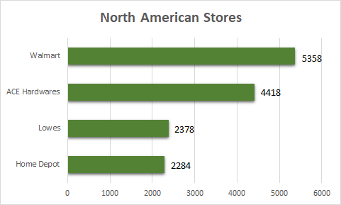

Growth potential: Currently, Home Depot is Operating within a Red Ocean and applying Red Ocean strategies, limiting their growth potential. However, if Home Depot were to expand outside of North America, and focus on exploring the blue oceans of Asian and European markets, substantial growth is possible.
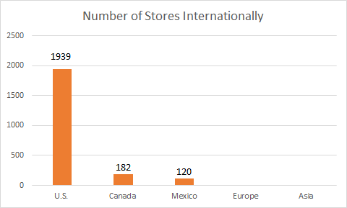
Productivity; capacity utilization: Productivity as related to Home Depot and other home improvement stores is largely based on supply chain management. The largest impactors of productivity are education and technology. Home Depot utilizes both education and technology in nearly every aspect of their business from supply chain management to their online inventory and purchasing options. The industry itself is focused on capturing the consumer and do so by trying to make the buying experience as easy and accessible as possible.

Factors Determining Competitive Advantage (CA):

Market Share: Market shares are calculated by taking a company’s sales over a specific period of time, and dividing it by the total sales within the industry over the same period of time. This information then shows the portion of the market that is controlled by that particular company. Home Depot is the leading home improvement store for the Fall of 2018, which is easily seen when looking at these market shares. Home Depot hold 27.96% of the market shares, while their leading competitor, Lowe’s, holds 18.42%. Another growing competitor that is rising up, is Ace Hardware, which currently only holds 1.32% of the market shares.

Product Quality: Home Depot does not majorly compete in the product quality department; however, they do carry brands who compete in here. Home Depot is known for having lower prices, long store hours, and good customer service. While these low prices can sometimes lead to lower quality items, they still carry those higher quality options. What most people don’t know, is that there is a Home Depot Product Quality and Engineering Laboratory. This is an area where they test out different types of tools, to show their real quality, a feature they can look at before making a purchase. One example they have on their website is that of different wrenches. The Husky wrenches, which are sold exclusively at Home Depot, happened to withstand a lot of test. When the wrench inevitably did give, it bent, rather than shattered, which is a good feature to look for when tool shopping.
Their competitors, Lowe’s, also has a tool brand that is exclusively sold with them, Kobalt. These tool sets are a fairly new brand, that launched in 1998, while the Husky brand has been around since 1924. Each tool set is sold at very comparable prices; however, the Husky set give you a few extra tool pieces. In the end, there is more product value and quality that comes from Home Depot’s brand, rather than Lowe’s.

Product Life Cycle: The product life cycle of businesses will tell where a company stands within their own company’s life. There are four different categories that a business can be under- launch, growth, maturity, or decline.
Home Depot is currently bordering both the growth stage, and the maturity stage in its life cycle. The company is still making leaps within their sales growth, especially now that the markets have gone up. The rates of people who are interested in home improvement items/DIY items is increasing rapidly as the popularity of HGTV shows increases, as well as apps such as Pinterest. While they have been established for a while, it’s easy to assume that they might already be leveling out into the mature stage, however there is still so much growth occurring within their company.
Lowe’s has been established for 57 years longer than Home Depot has been. When knowing this knowledge, as well as how well Home Depot has been doing within the industry, it is absolutely assumed that Lowe’s would be within the mature stage for their company. However, the spike in home improvement through television and social media has affected their company, just as it has Home Depot’s. When looking at how much their sales growth has increased within the past years, you can tell that Lowe’s is also in the growth category.
Ace Hardware has taken a different approach than both Home Depot and Lowe’s. They have lean towards attracting people who want to go into a small store and easily locate what they need without feeling overwhelmed. Ace Hardware is located in smaller towns, while Home Depot and Lowe’s are only in bigger cities. While they definitely are a smaller business than they’re competitors Lowe’s and Home Depot they still are a successful, growing business. Ace Hardware’s, much like their competitors, are still in the growth stage of their life cycle. This is apparent in their sales, which continually increase overtime.
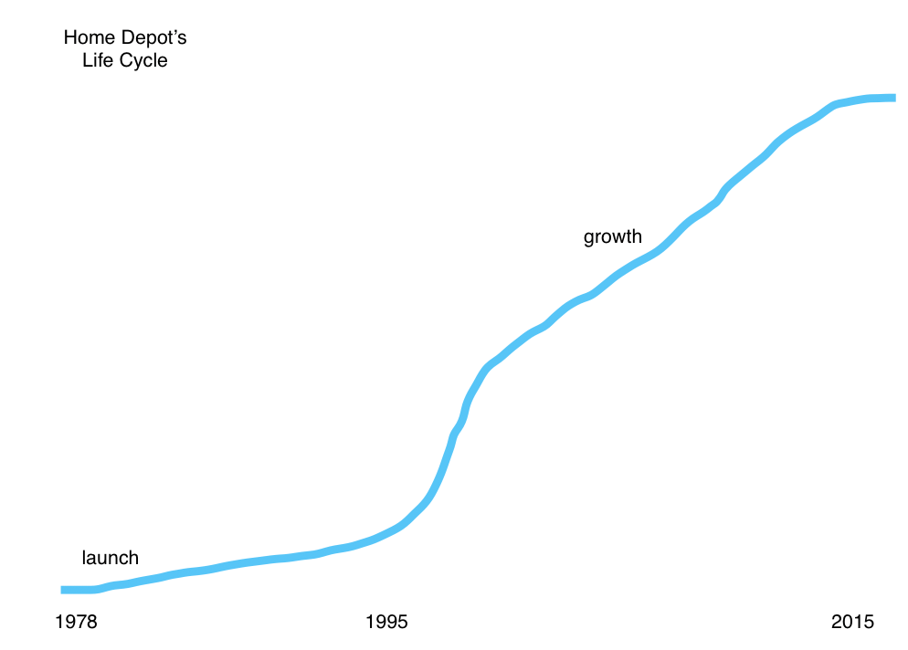

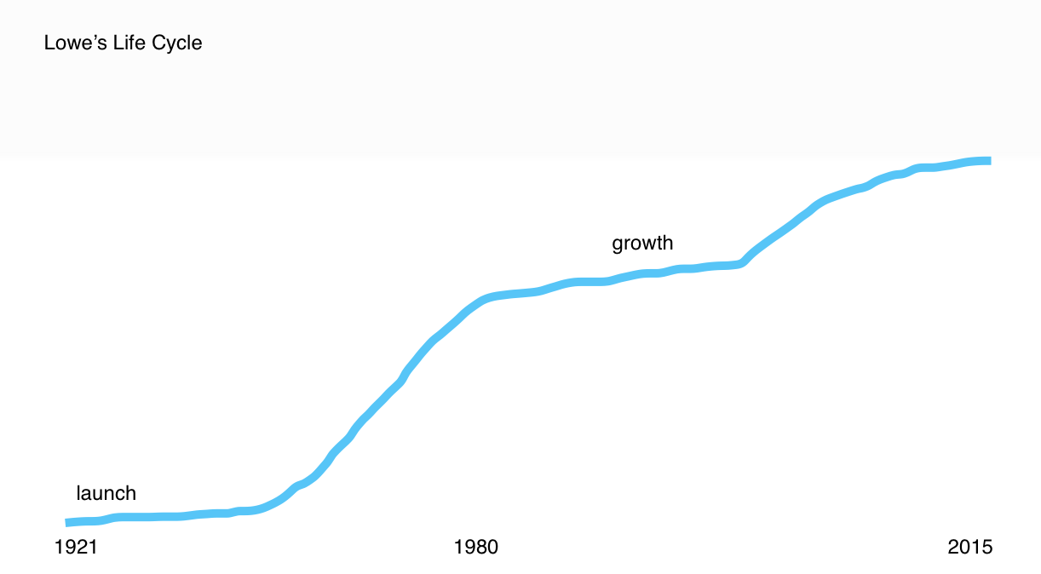

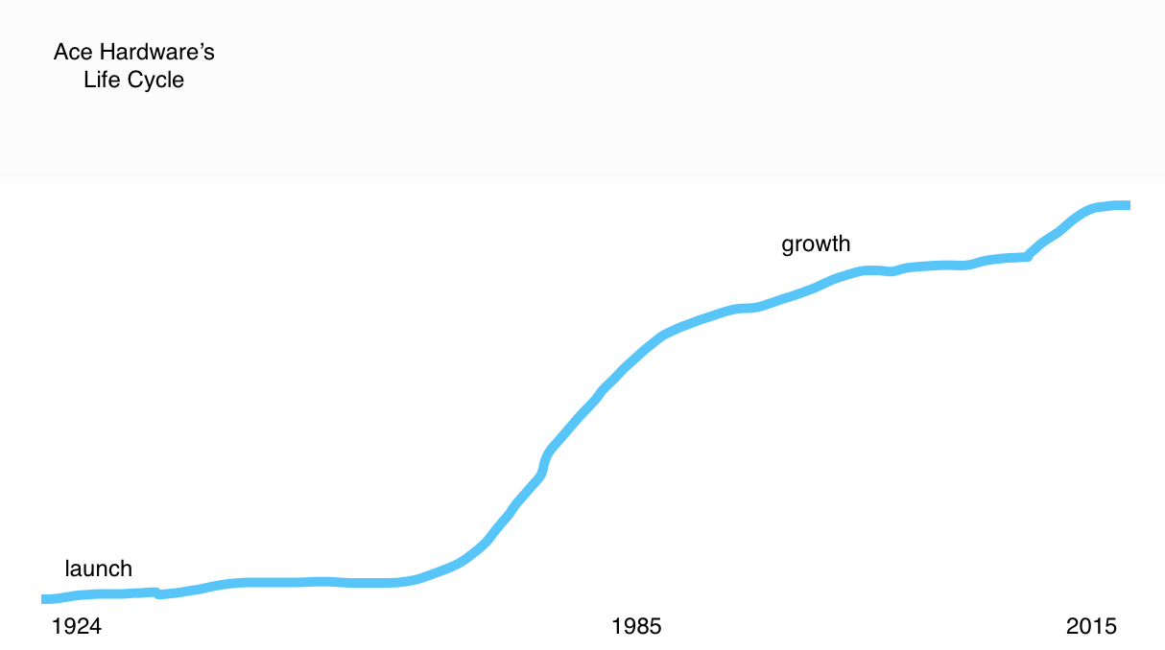

Product Replacement Cycle: Home Depot offers warranty that gives customers a confidence boost when purchasing high budget products. Home Depot does a full reimbursement or replacement on any covered items with a Home Depot gift card, or check, for the price of your purchased item plus the tax. Their typical warranty plan covers the functional parts and labor for incidents caused by normal wear and tear at no deductible. They also cover damages caused by power surges, dust, heat, or humidity, while also allowing you to add on additional benefits which vary by plan.
Lowe’s also offers a similar protection plan for their customers; however, theirs does not cover as much. Lowe’s has no deductible, and covers the normal wear and tear as well. Lowe’s also offers a 50% reimbursement of preventative maintenance items including fuel additives, belts, blades, batteries, and more.
Ace Hardware, being the smaller store that it is, does not offer as many warranty opportunities as these bigger companies. Rather than offering their own options, you have to go directly through the manufacturer. They do however, have a way of making it easy to get ahold of the manufacturer by adding their number through their website.

Customer loyalty: Home Depot is known very well for having good customer service, which draws customers into their stores. To know of Home Depot, is to know about the orange aprons. They have employed their store very well, in a way that it is super easy to find help in every single section of the store. This makes it much less intimidating for people who actually have no idea what they need when it comes to repairing the problem within their house. While there is no real reason for a person to feel loyal to a home improvement store, their customer service is a key point for why there are returning buyers. One of Home Depot’s main target customers is the professional home improvers. It is easy for them to put their order in online, and then swing by early in the morning to pick it up on their way to work. The layout of their business in the easy way it’s ran is what continually attracts this customer segment.
Lowe’s attracts a completely different customer segment into their store, the first time DIYers. Their store is laid out in a much less intimidating manner. Rather than walking into Home Depot, where you automatically get the industrial feel, Lowe’s will typically have patio furniture or holiday decorations on display when you first walk in. This lets those new home renovators to truly feel less threatened when they shop at their stores, which also encourages them to continually shop at their store. However, this feel does not appeal to the professionals, who would have more of a loyalty with their business. Therefore, making it harder to attain customer loyalty within the industry.
Ace Hardware aims for a different customer segment yet again. Their company typically consists of a smaller home improvement store that is located in a smaller town. This attracts small town people to shop at their store, usually because it is the only store option they have unless they travel to a bigger town nearby. Their loyalty comes from those people who live in these small towns, and continually use their store when they need something quickly.

Competition’s capacity utilization: Capacity utilization is determined by calculating the rate of output that is being met or used. The capital utilization rate is also often called the operating rate. You find this number by dividing the actual level of output by the maximum level of output, and then multiplying it by 100 in order to receive a percentage.
This information is really important for people high in the company to know in order to see how their business is doing, versus how well it can do. Which in turn allows them to make improvements for their company. This is typically not information that is given to the public, but what we do know is how many employees each company has, and how much revenue they are receiving per employee.
Home Depot receives the highest annual revenue of $108.2B, while they have 413,000 employees. This means that they generate $262K per employee.
Lowe’s receives $71.3B in annual revenue, while employing 190,000 different employees. This means that they are able to generate $375K per employee.
Ace Hardware’s annual revenue is much smaller at $5.1B, with 8,200 employees. This shows that they are able to generate $622K per employee. Looking at this information we see that Ace Hardware is actually benefiting the most from the use of their employees.

Technological know-how: “Technology know-how” refers to the ease or difficulty of being able to transfer the knowledge of the technologies of a company. Home Depot does really well in this department. Their newest advancements through their technology includes enhanced voice search, easy chatting, 3D augmented reality, in store mapping, and machine learning.
The enhanced voice search, simply allows users to talk conversational questions or commands into their devices, which allows for better, more relevant search results through the app. Easy chatting allows customers to message a Home Depot employee through the app, and then receive automatic responses. This feature allows customers to engage with customer service, without the hassle of staying by the phone or computer. 3D augmented reality allows customers to visually see an item in their house by using their camera, which allows them to see how it will really look in their house before making the big purchase. Store mapping, shows exactly where the item you are looking for in the store is located through a mapping tool located in the app. While the machine learning feature has detailed tutorials on how to run a machine, for after when you need help getting started after the purchase.
Lowe’s technologies are advancing at a quicker rate than the others, as they recently iterated the “Holoroom How To.” This allows customers to virtually experience using a tool before they purchase it. While this is beneficially is helping them to see whether or not they like the product, it also helps to teach those first time DIYers to do the task. This is a perfect addition when looking at their target customers. While this new technology is useful to the customers, it is also useful in training employees, as they are now able to virtually experience a first day on the job. This helps to reduce the amount of mistakes that typically occur with new employees, as they get the full experience before actually working with customers.
Ace Hardware is behind when it comes to technology. While they do have a good website to purchase items off of, that is about the extent of their technology. They do offer an app; however, most of the reviews show that the app is really dysfunctional. They still have some updating to do with technology as it advances even more in the future.

Vertical integration: Ace, Home Depot and Lowe’s all utilize vertical integration through their supply chain. Each company produces own-brand products that give the company more differentiation and control of what hits their shelves. Ace Hardware is especially good at this through their Ace specific tools and other products. Home Depot and Lowe’s utilizes brand names like husky and kobalt to accomplish similar results with their exclusives. This gives the company not only more control of product development but also higher margins on sales.

Factors Determining financial strength (FS):

Return on investment: Home Depot’s return on investment was 40.76% for 2018, which is 10% up from the previous year. Lowe’s only made a 12.06% return on investment which is about a third of Home Depot. This has been more or less the trend between Home Depot and Lowe’s ROI for the past 5 years. Ace Hardware did even worse producing a -4% return on their investments meaning their return were less than the amount they put into the into their investments. This shows us that Home Depot has been wise in their choices for investments and been extremely efficient.

Leverage: Home depot is a relatively highly leveraged firm when compared to Lowe’s but relatively low compared to Ace. In 2018 Home Depot carried a 27.88% debt to equity ratio while Lowe’s only had a 5.86% and Ace had a 72.4% ratio. It is generally considered that a ratio of 50% or less is a good amount of debt to equity, this means that both Lowe’s and Home Depot have reasonable leverage ratio while Ace Hardware’s is relatively concerning.

Liquidity: Liquidity is a company's ability to meet short-term financial obligations. The liquidity ratios we look at below are the best indicators of our 3 companies ability to meet these financial obligations. Based on our findings Home Depot and Ace hold the tops spots for liquidity. Home Depot beats Ace out with its cash ratio but Ace has both a better current and quick ratio although not much better than Home Depot.

Cash flow: Free cash flows are the cash available to pay investors after a company has paid off its costs of doing business and invests in short-term assets like inventory, long-term assets like property, stores or equipment. The firm's investors include both bondholders and stockholders.

Ease of exit from market: Each of the three competitors have a lot of capital tied up in their stores, although Home Depot and Lowe’s have fewer stores than Ace the relative size is much larger. Exiting the home goods market would likely mean shutting down all stores and selling off the retail space.

Risk involved in business: Similar to the ease of exit from the market all of these businesses have large amounts of capital tied up in these businesses. In some aspects Ace hardware has minimized their risk by structuring as a franchise.

Recommendations for Home Depot Based on Competitive Analysis:

DECISION CRITERIA:

· Helps to achieve good fit with the overall strategy

· Helps build competitive advantage

· Contributes to higher company performance

Create a geographic blue ocean: Because growth potential within the United States is shrinking it has become increasingly important for Home Depot to expand internationally. Home Depot currently has stores the U.S., Mexico, and Canada. Home Depot also operates procurement offices within India and China. If Home Depot were to expand storefronts or even just distribution centers for online orders and shipping in China they could significantly lower their storefront costs while expanding sales to new markets thus creating a blue ocean opportunity. This would satisfy the current CEO’s strategy of "enhancing the core, extending the business and expanding the market" although previous such expansions have proven unsuccessful. In past years Co-founders Arthur Blank and Bernie Marcus expanded the company to Chile and Argentina which ultimately led to failure. Although Home Depot failed to expand in South America, the potential Asian and European markets where consumer preferences are more aligned with American pop culture. For expansions into domestic blue oceans Home Depot can expand to smaller towns and cities which lack larger home improvement stores.
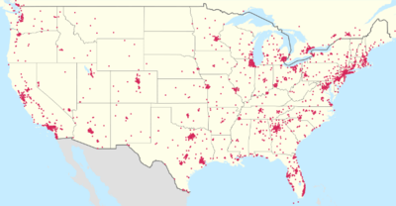
(Current Home Depot operations in the United States)

Wider product Variety offered online: Home Depot primarily competes with its top competitors through offering average quality items to their consumers at a low cost. This approach is directed towards their middle to low class target market which is unable or unwilling to pay higher prices for premium products. The current product line of faucets, for example, is comprised of brands such as Delta, Moen and Kohler which are largely common and affordable. If Home Depot can implement higher quality designer fixtures such as Mac, Hudson Reed or Watts they can expand their customer base and profit potential. A strategy we suggest Home Depot to implement would be to offer higher priced, premium products online to customers who are interested. Home Depot would not necessarily carry these in store, taking up more inventory space on the shelves, rather, premium products would be offered via their app or website, and would use their “ship to store” capabilities to have the product ready for pick up the next day.

Wholesale prices and products for contractors only: Home Depot already offers a wide range of benefits to its contractor members but expansion of products as related to the previous point would benefit contractors and provide incentives for more contractors to get onboard. Currently contractors receive; commercial credit, bulk pricing, tool rental, shipping/delivery options, expanded inventory and mobile coupons. If Home Depot expands specifically on the available expanded inventory to designer brands and styles contractors could in turn provider for a wider range of home construction projects and customers. If these types of products were limited to contractors only it would give contractors the feeling of exclusiveness and incentive to work with Home Depot over Lowe’s or another construction supplier.

Advertisement tailored for millennials: Another strategic alteration which we would advise Home Depot to implement is their marketing strategy for their future consumers: millennials. Currently, studies show that the vast majority of millennials now living independently are opting out of home ownership, instead they are choosing rentals and apartment living. This poses an issue for Home Depot in the industry of home improvement for the future. With the majority of millennials renting, the demand for large home improvement projects is becoming smaller. While Home Depot doesn’t solely offer materials/products for large projects, most of their advertising does depict people performing large scale home renovations or landscaping projects. Projects such as these fail to attract millennials that do not own homes. The current trend of millennial consumers is smaller, do-it-yourself (DIY) type crafts and projects, which Home Depot has the capability and products to provide for. Even though Home Depot provides some similar products, stores like Hobby Lobby and Michael’s are known for providing the goods most used for apartment decoration. If Home Depot were to expand their product line to include more products for smaller projects, such as “dorm decorations,” they would be offering more products that would be appealing to the younger generation of consumers. It would also help Home Depot to tailor some of their advertising towards millennials, demonstrating smaller DIY projects while offering more craft goods, as it might attract younger consumers. These small DIY projects will get millennials foot in the door to the larger DIY projects that Home Depot caters towards, and in turn will create return business to Home Depot.

Sources:
https://www.consumeraffairs.com/homeowners/ace_hardware.html
http://blueoceanuniversity.com/frontpage/swotcoanalysis/12412-ace-hardware
http://www.managementparadise.com/forums/principles-management-p-o-m/208277-swot-analysis-ace-hardware-corporation.html
https://www.uhaul.com/Articles/About/6211/Ace-Hardware-Builds-Partnership-With-U-Haul/
https://newsroom.acehardware.com/ace-hardware-reports-fourth-quarter-and-full-year-2018-results/
https://www.linkedin.com/company/ace-hardware-international/about/
https://www.homedepot.com/c/tool_and_truck_rental
https://www.google.com/search?q=auto+stores+that+rent+tools&oq=auto+stores+that+rent+&aqs=chrome.1.69i57j0l2j69i64.6050j0j4&sourceid=chrome&ie=UTF-8
https://velocityglobal.com/blog/international-business-law-legal-aspects-of-doing-business-overseas/
https://www.forbes.com/sites/ekaterinawalter/2013/12/30/30
com/terms/c/cash-flowtodebt-ratio.asp
https://csimarket.com/stocks/HD-Annual-Return-on-Investment-ROI.html
https://csimarket.com/stocks/LOW-Annual-Return-on-Investment-ROI.html
https://www.marketwatch.com/investing/stock/hd/financials/cash-flow
https://www.marketwatch.com/investing/stock/low/financials/cash-flow
https://corporatefinanceinstitute.com/resources/knowledge/economics/capacity-utilization/
https://www.owler.com/company/homedepot
http://panmore.com/home-depot-operations-management-10-decisions-areas-productivity
https://www.acehardware.com/customer-service#mz-cs-top
https://www.homedepot.com/c/The_Home_Depot_Protection_Plans
https://corporate.homedepot.com/newsroom/5-technologies-changing-how-we-shop
https://www.thebalance.com/what-is-vertical-integration-3305807
https://managementmania.com/en/space-analysis
https://www.acehardware.com/departments/tools/hand-tools/ball-pein-hammers/2191773
http://www.lowesinnovationlabs.com/holoroomhowto
http://www.lowesinnovationlabs.com/testdrive
https://www.google.com/search?q=when+did+lowes+open&rlz=1C5CHFA_enUS834US835&oq=when+did+lowes+open&aqs=chrome.0.69i59j0l5.14830j1j9&sourceid=chrome&ie=UTF-8
https://www.google.com/search?rlz=1C5CHFA_enUS834US835&ei=la22XLjWHIiKtQXQiqnoCw&q=when+did+home+depot+open&oq=when+did+home+depot+open&gs_l=psy-ab.3..35i304i39i70i251j0i7i30l3j0i13j0i7i30.15985.17826..18029...0.0..0.410.2240.2j1j3j2j1......0....1..gws-wiz.......0i71j0i8i7i30.RA4C1SWwk6Q

