Competitive Analysis
Apple Inc.
Group 2 - 10 AM
Emilye Webb, Maddie Campbell, Christian Todd

Apple Inc. is the leading company within the Electronic Computer Manufacturing Industry but even though they are the leading company does not mean they do not have any competition. Dell Technologies is a close second with Intel Corporation following slightly behind. The electronic computer manufacturing industry is highly competitive industry and it can be hard for a company to rise above the competition and succeed within the competition. Within this competitive analysis, we will touch on Apple’s current strategy and assess the relative competitive strength of the company and its competitors. We will also touch on the strengths, weaknesses, opportunities and potential threats of Apple Inc., Dell Technologies, and INtel Corporation.
The market for Apple Inc.’s services and products is indulged in intense competition in every aspect of the business. The consistent advancement of technology and introduction of new products that enhance the use of mobile devices, computers, tablets, etc. define this market. Based on total assets and revenue, Apple Inc. is the largest information technology company in the world. Apple’s business strategy is based on its capability to create and develop unique hardware and operating systems that are constantly being innovated to provide consumers with both products and solutions. Apple is brilliant in pursuing business strategies in premium pricing and product differentiation. For example, Apple created a business acquisition of Beats Music, LLC., and by doing this, the two companies created a music streaming service (csimarket).
Apple Inc.’s business strategy can be defined in several different ways, one being vertical integration, due to the fact that Apple is experienced in services, software, and hardwell all together. Apple Inc.’s vertical integration is a huge aspect that allows them to stand ahead of competition, because they are able to step into other industries and ecosystems, giving them a competitive advantage. Additionally, Apple Inc.’s competitive advantage comes from staying one step ahead of competing companies. With that being said, it is difficult to look at Apple’s competitive advantage long-term. Apple’s competitive advantage could be damaged if management falls behind on product/service innovation (csimarket).
Recently, Apple Inc. has put a large emphasis on the service aspect of their business. With that being a huge factor of their business strategy, service revenues have constantly increased within the past several years. As shown below, Apple’s service revenues, the app store, icloud, and apple music, have created a new level of revenue for the company.

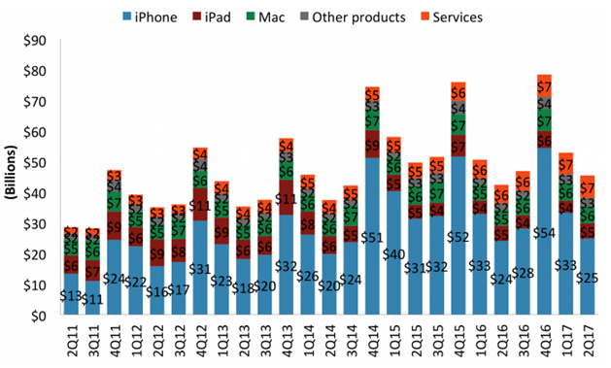
(csimarket.com)

In 2018, Apple inc. reached its highest annual revenue ever accomplished by the company, generating an impressive 265.6 billion dollars. The sale of the iPhone can take responsibility for 82 percent of the company’s annual revenue of 2018, generating about 218 billion dollars. Because of the revenue brought in by the iPhone, Apple Inc. still leads the smartphone industry in sales. The sale of iPads also increased in 2018, earning Apple Inc. 5.9 billion dollars in revenue. With that being said, the iPad sales contributed 6.6 percent to Apple Inc.’s revenue in the first quarter of 2018. Due to increased competition from Samsung and Lenovo, iPad shipments have dropped in recent years. The table below visually represents the success Apple Inc. acquired in the past year.
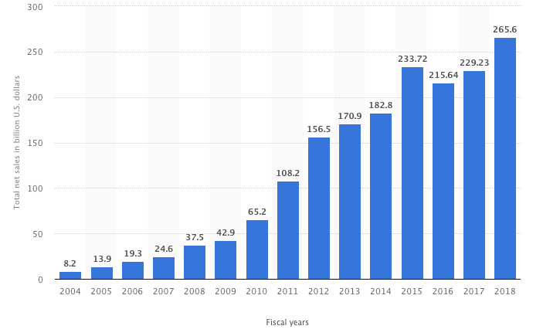 (statistica.com)

As an extremely successful and well-known company, Apple Inc. “is one of the most elegant advertisers” in the IT world (Marketing91). Apple Inc. represents its brand and message in a crisp and clean manner, creating a sense of intelligence and prestige. To this day, Apple Inc. continues to uses Steve Jobs’, the company’s founder, marketing philosophy. The marketing strategy is based on the idea that the customer does not know what he/she wants. Instead of participating in research to learn customers wants, needs, and desires, Apple Inc. “prefers to install innovative features and capabilities in the products, making customers to want Apple products” (Dudovskiy). Apple Inc.’s marketing approach is designed to target consumers of premium products. Moreover, they tend to communicate through media advertising as well as personal sales that take place in Apple Stores, allowing consumers to personally communicate with the company. Although Apple, Inc.’s marketing strategy is not based on consumers needs and wants like most companies, its unique approach has allowed Apple to build one of the largest consumer bases in the industry.
Since the creation of the company, the upper management of Apple has highlighted the importance of both innovation and creativity. Apple bases its success “on the strength of its employees” (Bohatala). Apple’s HR strategy has proven to be the reasoning behind its continual evolution and exceptional performance within the market. Apple’s management strives to hire a talented workforce, consisting mainly of technical, staff, and marketing positions. Using human resource practices, Apple is eager to hire skilled professionals and use their talents as a competitive advantage within the market. To ensure brand loyalty, Apple trains its employees to be fully knowledgeable of the services and products the company offers. Due to Apple’s human resources approach, the company “has become the most innovative firm in the consumer electronics industry” (Bohatala).

Apple Inc. is a very successful company in terms of what technology has been able to overcome in the last 25 years. Although Dell Technologies and Intel Corporation are Apple’s two biggest competitors, Apple Inc. has pushed passed barriers that people thought would take technology years to accomplish. Apple Inc. is “involved in the computing technology (hardware and software), consumer electronics, cloud computing services, and online digital content distribution services industry” (Smithson). Apple has not always been the top technology and electronic company, but Apple has continued to overcome weaknesses and turn them into strengths and to take advantage of the opportunities right in front of them while their threats are constantly at their back door. Apple Inc.’s strengths, weaknesses, opportunities and threats are what make Apple an amazing company and what helps Apple thrive within the Electronic Computer Manufacturing Industry.
Knowing a company’s strengths and knowing how to use them can help the company go above and beyond and leave the competitive behind them. Apple Inc.’s strengths “enable the company to overcome weaknesses, take advantage of opportunities, and withstand threats in its business environment” (Smithson). Apple has many strengths but a strong brand image, high profit margins, and effective rapid innovation processes are the three that stick out to me. Having a strong brand image is ideal to Apple (Smithson). Apple has one of the strongest brand images in the world and it is definitely one of the most valuable ones. Apple can constantly create new products and have them sell rapidly because its brand image is so strong and most everybody is interested in having the newest apple product. Almost everybody knows Apple’s logo is a white apple with a bite taken out of the side. Apple Inc. also has high profit margins. Apple’s profit margin as of December 2018 was at 37.99% (Apple Gross Profit Margin (Quarterly)). Apple has a very effective rapid innovation process and with that they are able to continuously come out with new products. They are able to fix and improve their current products and with their rapid innovation process, it helps Apple Inc. thrive in a very competitive environment. Dell Technologies has many strengths as well, including a large portfolio, a strong customer foundation, and unique customization options. Dell Technologies has built a strong foundation between the company and its customers and they are known for being “a staple in everyone’s home” (Frue). Intel Corporations has many strengths that keeps them as one of Apple’s top competitors as well. Brand recognition and constant innovation are just two of the key strengths Intel can lean on to keep their company up and running (Bhasin).
A company’s weaknesses can cost the company many things including yearly profits and the opportunity for growth within its industry. Apple is a great company but does have some weaknesses including a limited distribution network, high selling prices, and the dependence of sales on high-end market segments (Smithson). Apple has a limited distribution network, and some may not believe this because Apple products seem to be everywhere you look but they are very exclusive with who they work with and who sells their products. Another weakness, as stated, is the selling prices Apple puts on their products. The prices are ridiculously high when the products are made for a much relatively cheaper price. When prices are so high, it makes it much harder for the common person to buy their products and ultimately just reaches high-end market segments. Although they sold around 46 million iPhones in the fourth quarter of 2018, if they lowered the prices by a few hundred dollars, they could reach an even wider audience (Apple IPhone Sales 2018). When the prices are so high, the end up depending on high-end market segments because those are ultimately the only people who will be able to afford any of Apple’s products. Dell also has a few weaknesses within its company. Dell has offshore customer support and low spending on research and development (Apple IPhone Sales 2018). Off-shore customer support may be cheaper but is not always a good thing, because it can cause confusion and frustration is there is a language barrier. Intel has some weaknesses as well within the industry including decreasing profits and their products are not diverse (Bhasin). Intel has slowly been losing business and profits over the years and they have a “habit to over produce semiconductor chips” and that causes a flood in the market which is not beneficial to Intel (Bhasin).
There are always opportunities that companies can take advantage off to better their organization for their customers and the company’s well-being. Apple is always improving, and it has many opportunities that they need to take advantage of. Three opportunities that apple has are the expansion of the distribution network, higher sales volumes based on rising demand, and development of new product lines (Smithson). They need to expand their distribution network, and this was previously mentioned in Apple’s weaknesses. If they expand their distribution network, they will be able to reach a greater audience and generate more profits coming in. They have a very high demand for their products, and they need to act on that and have more of their products readily available for purchase. Apple also has the potential to develop several more product lines and be very successful and that is an advantage and opportunity they have over many other companies. With these opportunities Apple has the potential to grow far beyond measure and they should definitely think about capitalizing on these opportunities because it could help Apple survive in the industry and become a lot more profitable in the long run. Dell Technologies has some great opportunities to advance their company as well. These opportunities include more diversity in their products and to branch out and be involved in more than hardware (Frue). Dell currently just focuses mainly on hardware but there are countless opportunities for Dell to advance and possibly stay relevant in the upcoming years in the Electronic Computer Manufacturing industry. Intel Corporation, Apple’s second biggest competitor, has many opportunities to better their company’s future with. Intel has potential to go into the smartphone business, drone business, and automatic cars (Bhasin). Intel produces processors and all of those opportunities depend on processors. Intel has loads of potential to be at the top of the Electronic Computer Manufacturing industry.
Companies such as Apple have many potential threats that cause the company to be on the lookout around the clock. There is aggressive competition, imitation, and in various countries, there is rising labor costs (Smithson). Aggressive competition and imitation go hand and hand with Apple and many other companies. There is aggressive competition in this industry because people want to have the best of the best smartphone, tablet or computer. Dell has many potential threats that are possibly keeping the company from growing. There is a booming smartphone and tablet industry and Dell does not really have a name in the smartphone and tablet industry (Frue). People are constantly overlooking Dell because a huge majority of the population wants smartphones and small tables that Dell does not provide. Intel has many threats because their company is not number one in the industry. Competitors are definitely a threat to Intel in the industry (Bhasin). Every industry has tough competitors, but Intel definitely needs to try and keep up with its competitors.

Apple’s biggest competitive strength is brand strength. According to Forbes, Apple’s brand strength has actually been the highest in the world for the last 8 years, currently at $182.8 billion in 2019, 8% higher than in 2018. Apple also will lock in customers because it sets a high transition cost for customers to switch to a different platform by forcing them to use ITunes and the App Store therefore they don't want to lose all of their paid apps, movies, and music library.
Apple owns many companies such as software and hardware companies that they use to make their products inhouse and not have to outsource if not necessary. This also helps them make products cheaper, faster, and more customizable in order to better satisfy customers. These assets are more rare because most companies don't have the money to buy the companies that make the parts, whether it be software or hardware, that they need. This enables Apple to be able to provide not only knowledgeable but also excellent customer service.
Having this strong brand strength demonstrates that customers will buy almost any product you throw at them as long as it has that tiny little Apple logo. It's hard to believe but the customers don't buy Apple products such as the Apple Iphone because it has the a Liquid Retina HD display or because it has 4GB of ram, they simply buy it because it is an Apple. They trust that they are going to get a good product since it is an Apple therefore they remain loyal to Apple and continue to purchase their new products without always considering what new features have been added or what technological advancements have been made.
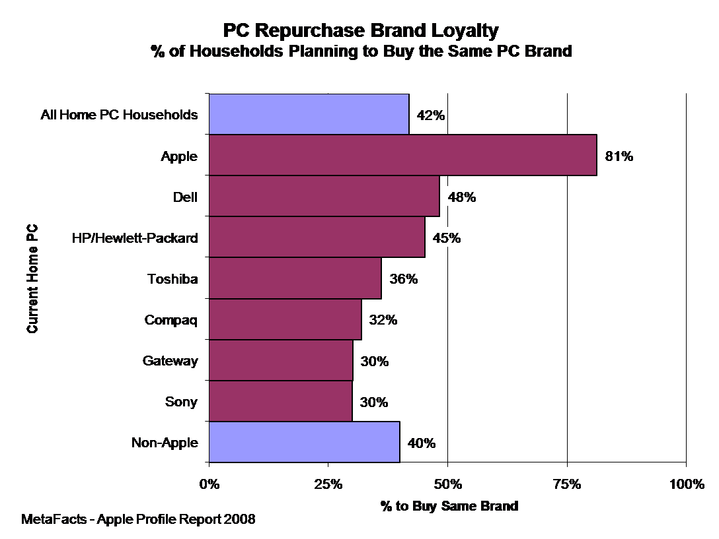
(Apple Loyalty – Still Faithful?)
Apple has been one of the most (if not the most) expensive products on the market since the creation of its first computer. But Apple doesn't strive to be a low cost products, instead they focus on
- Offering a small number of products.
- Focusing on the high end products
- Give priority to profits over market share
- Create a halo effect that makes people starve for new Apple products
Infact, they even practice a minimum advertised price (MAP) strategy that prohibits resellers and dealers from advertising their products below a certain minimum price(Market Realist). But even though Apple practice these strategies of offering higher end products and only producing few products, they are still able to do it at a “lower cost” as mentioned by Tim Cook. Product differentiation plays a major role when it comes to being able to charge more for their products than their competitors. Apple tends to make products that are unique, attractive to the consumers, and ahead of the curve and therefor they have the ability to have a lot higher cost position than the competitors. But once you get to where you are at a high cost point, you have to be able to maintain it as well, in order to do this, Apple offers some of its retailers such as Walmart or Best Buy wholesale discounts therefore they get a slight savings but not enough to where they can discount their prices enough to be able to compete with Apple’s stores. With Apple offering high end products and continuously improving from year to year, the prices also continue to rise as new products are made. But these higher prices do not hold back customers, almost every year their unit sales increase drastically. Like it or not, Apple has the power to price their products high because they know their brand has the power to pull in the sales from their tremendous amount of followers.
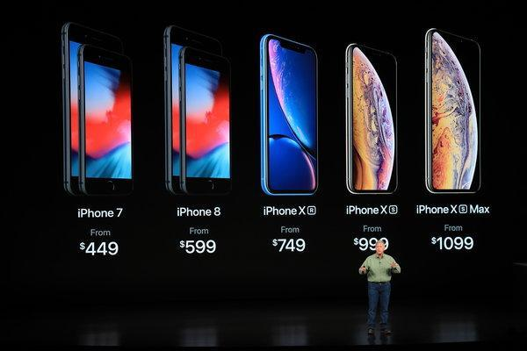(Tim Cook on IPhone Prices)
“We never had an objective to sell a low-cost phone. Our primary objective is to sell a great phone and provide a great experience, and we figured out a way to do it at a lower cost.” -Tim Cook
Apple has reported that Mac sales have flatlined and that is hurting Apple much more than they anticipated. Apple has also reported that iPad sale are also down tragically. Apple has a much bigger issue than macbooks and ipads not selling and it is that iphone sales are down tremendously but also, smartphone sales are down in general.
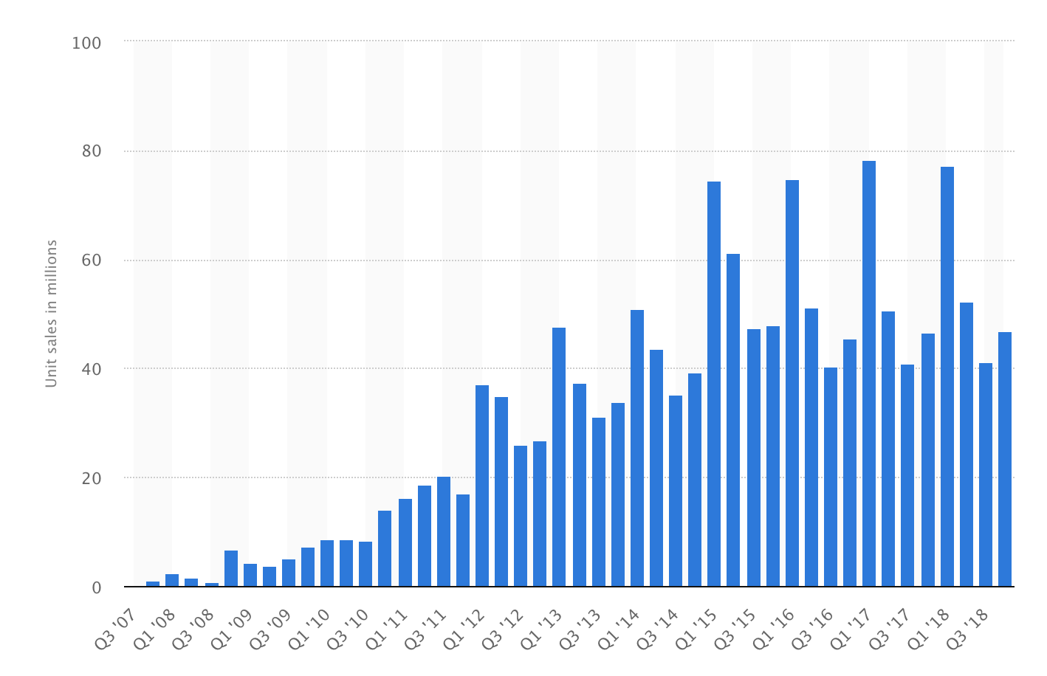
(Apple Iphone Sales 2018)
As you can see in the graph below, smartphone sales are still growing but at a declining rate and companies cannot seem to figure out why. We believe this all goes back to Apple Inc.’s weaknesses dealing with high prices and people not wanting to pay $1000 or more for a new smartphone.
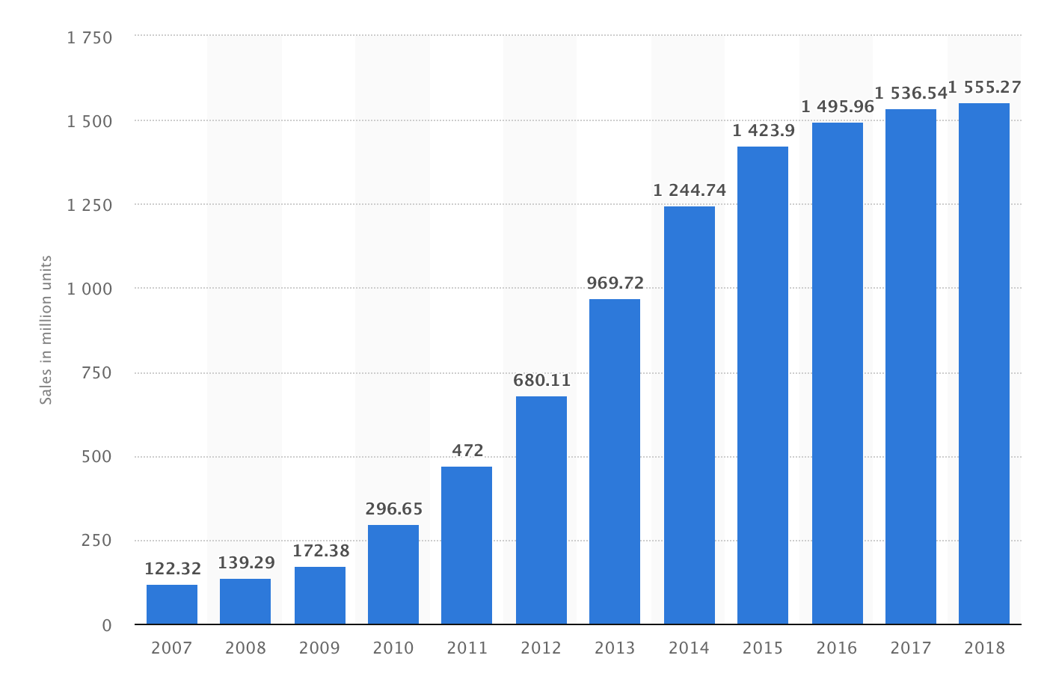
(Apple Iphone Sales 2018)
Apple needs to focus on what their customers want and give the customers lower prices but continue to come out with new products and versions of their current products. Customers and clients drive these companies success right behind the innovation process. People need to want to buy companies products and the things they have to offer their clients and customers. If Apple wants to continue to grow and continue to stay on top of the Electronic Computer Manufacturing Industry, they need to start paying attention to their strengths, weaknesses, opportunities, and threats as well as their competitions in order to stay ahead of the decline in the industry.
Although there is vast competition within the Electronic Computer Manufacturing Industry, Apple Inc. continues to lead in innovation and creativity. Apple Inc. has a different and unique method of thinking that enables the company to draw in all different types of consumers. Apple Inc. has paved the way for the Electronic Computer Manufacturing Industry, making competition a constant factor between Apple Inc., and its two top competitors, Dell Technologies and Intel Corporation. By constantly creating new products and updating its current products, Apple Inc. has set the high standard for the industry. As the future approaches, Apple Inc. will continue to advance its competitive strategy, which will depend mainly on its ability to continuously innovate.

Works Cited

“Apple: Annual Revenue 2018.” Statista,
www.statista.com/statistics/265125/total-net-sales-of-apple-since-2004/.
“Apple Gross Profit Margin (Quarterly):” YCharts, ycharts.com/companies/AAPL/gross_profit_margin.
“Apple Inc's.” CSIMarket, csimarket.com/stocks/compet_glance.php?code=AAPL.
“Apple IPhone Sales 2018.” Statista, www.statista.com/statistics/263401/global-apple-iphone-sales-since-3rd-quarter-2007/.
“Apple Loyalty – Still Faithful?” MetaFacts' Findings, 3 Feb. 2017, technologyuser.com/2009/04/29/apple-loyalty-still-faithful/.
“Apple's Premium Pricing Strategy and Product Differentiation.” Market Realist, 20 Mar. 2015, articles.marketrealist.com/2014/02/apples-premium-pricing-strategy-product-differentiation/.
Bhasin, Hitesh, et al. “Marketing Strategy of Apple Inc - Apple Marketing Strategy.” Marketing91, 11 Jan. 2019, www.marketing91.com/marketing-strategy-apple/.
Bhasin, Hitesh, et al. “SWOT Analysis of Intel - Intel Corporation SWOT Analysis.” Marketing91, 21 Dec. 2017, www.marketing91.com/swot-analysis-intel/.
Broussard, Mitchel. “Tim Cook on IPhone Prices: 'We Want to Serve Everyone'.” Apple, Mac, IPhone, IPad News and Rumors, MacRumors.com, 13 Sept. 2018, www.macrumors.com/2018/09/13/tim-cook-on-iphone-prices/.
Dudovskiy. “Apple Marketing Strategy: A Brief Overview - Research-Methodology.” Research, 26 Jan. 2018, research-methodology.net/apple-marketing-strategy-an-overview/.
Frue, Kiesha. “SWOT Analysis of Dell Technologies: Is the Declining Laptop Market a Major Threat?” PESTLE Analysis, 20 Nov. 2018, pestleanalysis.com/swot-analysis-of-dell/.
Smithson, Nathaniel. “Apple Inc. SWOT Analysis & Recommendations.” Panmore Institute, 14 Feb. 2019, panmore.com/apple-inc-swot-analysis-recommendations.
“Strategic Human Resource Activities at Apple Inc.” Bohat ALA, 31 Mar. 2019, bohatala.com/strategic-human-resource-activities-at-apple-inc/.
“The World's Most Valuable Brands.” Forbes, Forbes Magazine, www.forbes.com/powerful-brands/list/2/#tab:rank.

