Final Paper

10:00am
Team 3
April 15, 2019
Kaitlyn Thompson, Jess Francis,
Marcos Acosta, Anthony Greer

In any given industry there are multiple variables that come into play. A properly ran organization will be able to discover the many variables and how to correlate them together to execute a successful business strategy. Our group spent the semester researching Altus group and all of the moving parts that go along with running it. We looked at the industry, the competitors, and who it’s customers are. We also dove in deep to create innovative ideas that will help Altus to stand out amongst its competitors. Studying Industry Analysis helped us to come up with an in depth analysis of who Altus is and the industry it is in, thus allowing us to perform an in depth company analysis.
Altus is a Canadian commercial real estate services and software company, based in Toronto, Ontario. There are many moving parts that move along with the company meaning various kinds of competition for each moving part. Altus focuses mainly on providing software for large real estate firms, known as Altus Analytics, as well as actually being a commercial real estate consulting firm, and Geomatics. These three main components lead to multiple different forms of competitors. We chose to look at each type of competitor to form an in-depth analysis. Altus recognizes that there are many challenges when it comes to commercial real estate, or CRE. In the software aspect, they work to tackle those challenges. According to Altus website, “ leaders in the industry are focused on faster assimilation of data, deeper insights, and application of new technologies.” Altus states that they, “ Bring it all together and enable commercial real estate professionals to connect to the market with greater speed, visibility, and efficiency to deliver greater performance and growth.”
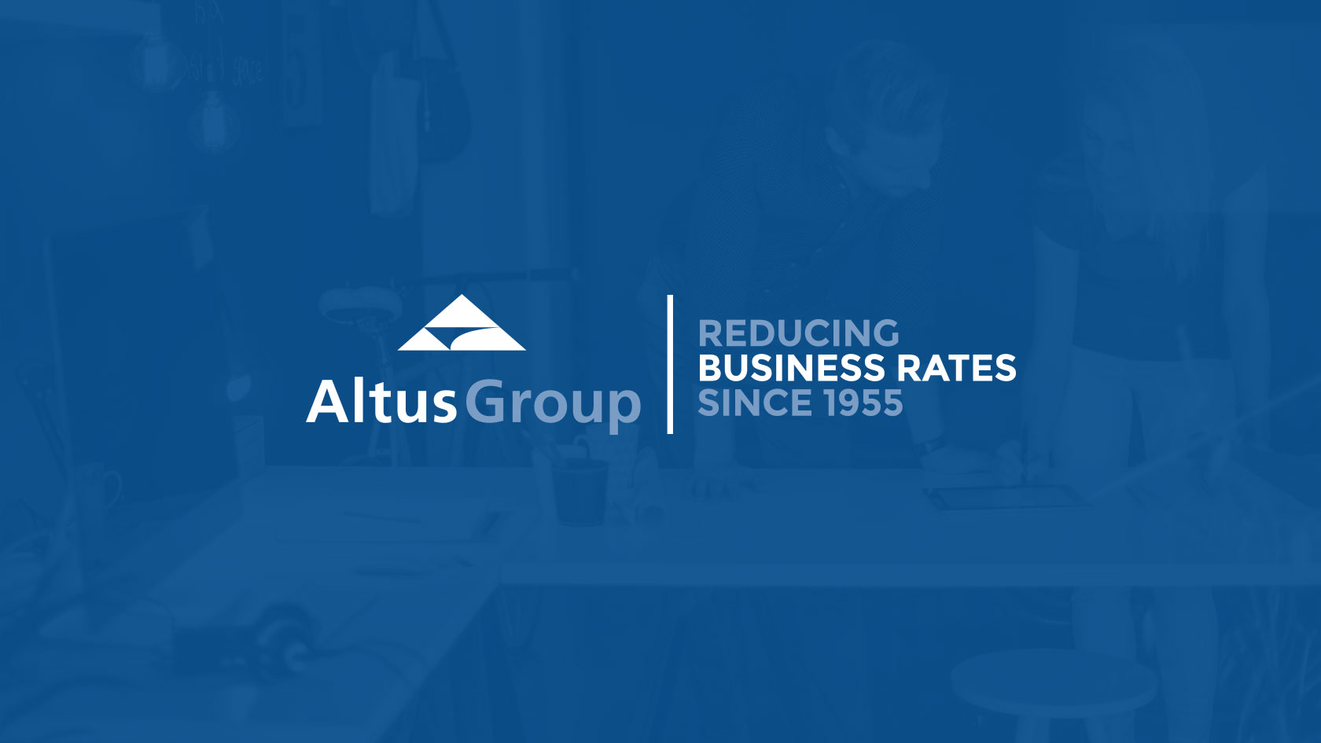
Figure 1.
When focusing on the software provided for large real estate firms the main competitors discovered were Accenture and IBM. These are all technology or consulting companies that have the potential to compete with Altus Group. Altus, however, supplies forty-six out of the fifty top real estate owners with it’s products or services.
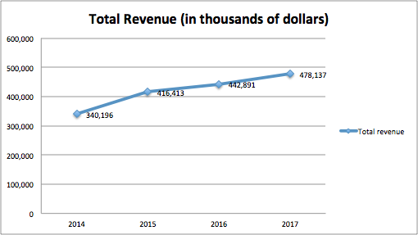
Figure 2.
Above, is a graph of Altus Group’s total revenue from 2014 to 2017. You can see an upward trend when looking at its revenue made from software sales. The following pages will list graphs demonstrating the revenue in the same time period shown as Altus. You will be able to see how Altus stands out amongst its competitors and brings in more revenue than that of it’s competition.

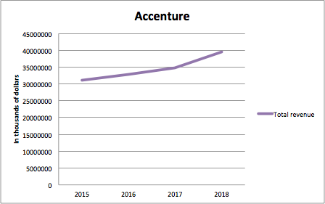
Figure 3.
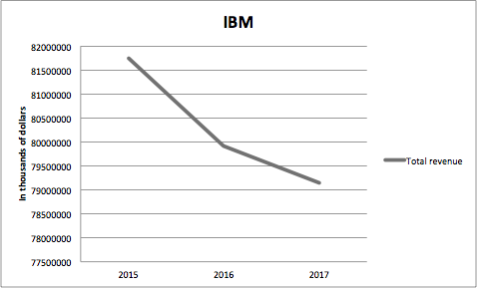
Figure 4.
As you can imagine, with Altus supplying its products to forty-six out of the fifty top real estate firms, it leaves little space for software focused competitors to take over the CRE industry. The Altus website confirms that since 2005 they’ve, “had over 50 acquisitions and are continuing to invest in technology and data that provides clients with greater vision to take advantage of opportunities and drive their investment forward.” It is clear that Altus Group has zero intentions of going anywhere. They have set the precedent for software companies alike and are only looking to adopt the newest and innovative technologies to provide their clients with.
Accenture is a global management consulting and professional services firm that provides strategy, consulting, digital, technology and operations services. They provide their services to all sorts of industries all over the world. The reason for their total revenue being so close to Altus group is due to the operation of technology platforms being provided for so many different forms of businesses. They provide technology and consultation for banking, energy, public service, health, life sciences, and even insurance agencies. They are providing this platform and service to so many industries that they are able to make a total revenue that is considered competition to Altus group. The difference between the two is that Altus Group is able to make more than Accenture’s total revenue by providing its service to the Commercial Real Estate industry alone rather than focusing on so many different industries. With Altus Group’s technology taking over the CRE industry, it is apparent that their competition must look to provide technology elsewhere.
IBM, or International Business Machines Corporation is an American multinational information technology company. They are a company that, again, operates in multiple different forms of industries. They provide technology to the education, chemical, construction, manufacturing, aerospace, and even travel and transportation industries. They offer technology to so many industries yet you can see that they have been on a downward trend since 2015. Their website states, “IBM Services works with the world’s leading companies to reimagine and reinvent through technology to build smarter business.”
Blue Ocean Strategy contains a chapter than is very adamant about ways to avoid red ocean traps. IBM seems to be participating in a certain red ocean trap which may be causing its downward trend in revenue. Trap two discusses the belief that to create blue oceans, you must venture beyond your core business. It is a common misconception that a company must venture into other industries outside of their core in order to break out of a red ocean. Doing this multiplies risk when blue oceans can easily and more readily be created right in the middle of an organization's existing core business. It seems as though IBM is dipping its toes in too many different industries rather than focusing on a select few and mastering how to cater to them.
The software and technology consultation of Altus Group, also known as Altus Analytics, is tough to compete with in the CRE industry. Altus Group chose to venture into a blue ocean and provide for one type of industry where there would be little competition for the specific industry. Accenture, IBM, and many others chose the route of providing for all different forms of industries in order to widen their range of industry distribution. This choice can either be very good for an organization, or lead to the downfall of it. Throughout this paper we will provide a competitive analysis of Altus Group, and some of its top competitors in order to provide in depth feedback on what we have learned throughout the semester.
CBRE is a commercial real estate and investment service firm founded in august 27th, 1906. CBRE specializes in many areas similar to that of Altus Group including property management, investment management, appraisal, valuation, consulting, property sales and other ventures such as mortgage and development services. CBRE stated in their 2017 annual report that their services are used in more than ninety of the top one hundred fortune five hundred companies operating activities. Clearly they pose a threat to Altus Group as they are a main competitor in the commercial real estate (CRE) realm, as Altus focuses largely on consulting services and technology for CRE. Like Altus Group, ever since the creation of CBRE their have been many acquisitions over the years as well as name changes. Over this time CBRE has become a CRE giant, proving its worth to be a multi-billion dollar company generating revenues of about $4,000,000 per quarter in the Americas alone.
CBRE has can be seen as living in a moderately blue ocean, seeing as that the CRE environment is not crowded with hundreds or thousands of small companies, but rather two or three giants that make up over half the market, or ocean if you will, while the rest of the stragglers compete for dear life. Having to compete with so few companies may seem easier than having many competitors, but the problem of staying ahead in the game quickly arises. Since Altus Group and CBRE compete in largely the same areas it makes it particularly hard to compete in innovation. In their case it is exceptionally hard to do given that both companies use each others services in everyday operating activities. It is interesting to see how they feed off of each other while still trying to make themselves stand out. The property that is tough to win on and is more difficult to replicate is value. Yes, both companies provide similar services and even work together at times doing so, but using value to the consumer to fuel their innovation is what will allow one to win over the other. 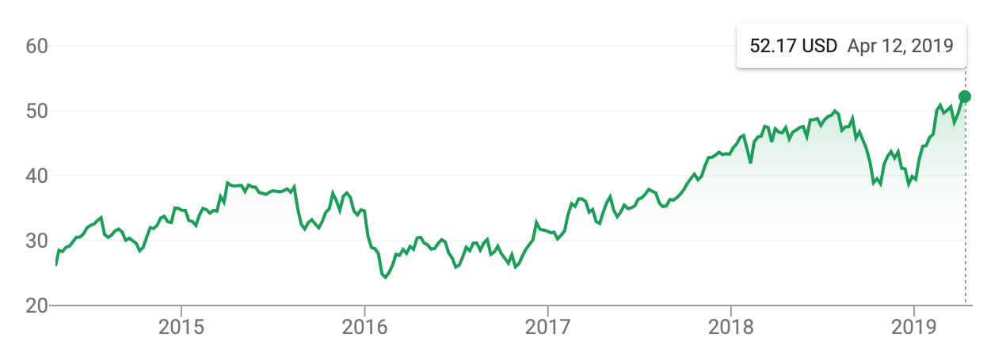
Figure 5.

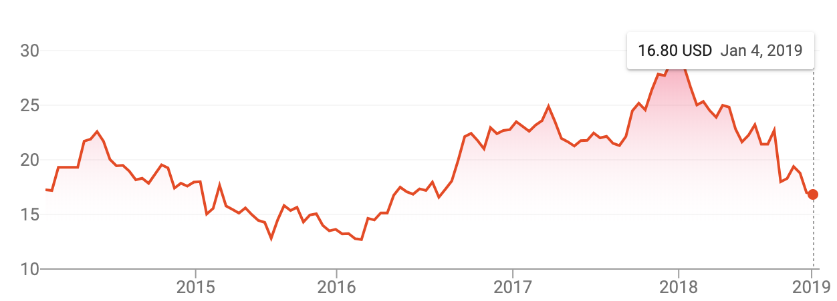
Figure 6.

In figure 5 you can see the five year trend of CBRE’s stock prices. Just over a decade ago CBRE was introduced to the S&P 500 index (2006) and has had an upward trend ever since. In 2013 they acquired Norland Services, a management firm that specialized in facilities, energy, and project management based in the UK and Ireland. Just before this acquisition, other than the 2008 financial crisis, was their lowest price since their 2006 IPO. Though their first internationally acquired company was in the early 2000’s, their saving grace to be as widespread as they are now was Norland Services. Since that transaction they have been on an upward trend in their stock price. In 2015 CBRE purchased Global Workplace Solutions, which provided integrated global management services and allowed CBRE’s revenue to exceed $10 billion for the first time. Finally, in 2018 CBRE launched their own space solutions site; an easy to use space finder for offices and things of the like.
Similar to Altus, you can see that both companies made themselves a superpower through acquisition throughout their timeline. Almost all of Altus Groups purchases were made prior to the last five years of operation but they affected growth in the same way as it did with CBRE. International growth was a huge spur for both companies which boosted them to “superpower” status. They also both compete heavily in the technology area of CRE consulting. This is where they feed off of each others analytics mentioned earlier. However, within the last year Altus’ stock price has collapsed by nearly half of its value, which was previously its all-time high. In 2018 Altus Group recorded a loss of $18.4 million. The reasoning for the loss can be found in their 2018 year-end report which reads “Profit (loss) for the year ended December 31, 2018 was $(18.4) million, down 116.8% or $127.8 million from $109.4 million in 2017. In addition to the impacts on Adjusted EBITDA (Earnings before interest, taxes, depreciation, and amortization) as discussed above, profit (loss) was impacted by an impairment charge of $13.7 million booked in Geomatics, in addition to higher amortization of intangibles from recent acquisitions, and offset by a decrease in income tax expense. Additionally, for the year ended December 31, 2017, there was a gain of $115.2 million related to the partial deemed dispositions and re‐measurement of our retained interest in Real Matters Inc. (“Real Matters”) that did not reoccur in 2018.” According to Blue Ocean Strategy it is important for companies attempting to create a blue ocean find ways to expand their innovation through value and to be sure not to chase new sectors by cutting out full portions of your operation to fund a new venture. Altus purchased three new CRE and consulting groups in 2018 for roughly $30 million, and sold off their shares of Real Matters for $54.2 million leaving a gap of near $20 million which they claim to have used to pay toward their bank debt of $129 million. Altus seems to be struggling in finding new ways to create blue oceans for themselves and should certainly keep in mind what their main competitors are doing. Blue Ocean strategy also mentions three tiers of non-customers that are ranked by each of their willingness/readiness to enter your market. Recently, Altus had a chance to win over tier one and tier two non-customers. As a brief background, tier one non-customers are those who are already somehow involved in your industry but are willing to make a switch at any moment given the opportunity. These are people who may be using Altus’ services but are not loyal and may switch to CBRE given the chance perhaps from the result of new technology or even lower pricing. Tier two non-customers are those who are aware of your offerings but have consciously voted against partaking. This group could be made up of potential investors who choose not to associate with the real estate market because they see no ease of entry of ease of use for their needs. With CBRE’s release of Hana, Altus immediately lost what would have been a relatively easy new sector of real estate to enter which would have allowed them to pry into both tier one and tier two non-customers. Even though CBRE beat Altus to a new ocean it doesn’t mean it is too late. This relates back to the idea of creating quality through innovation. As long as Altus can ultimately replicate what Hana is doing and find a way to gain leverage through value, they can still have a share of that market, versus currently where they have none at all. Another solution to this problem could be to mimic the actions of CBRE; Introduce a new sector. Altus could more than likely break into the private real estate sector and offer services similar to those they already have and create a behemoth of a company to disrupt the market given the private sector is largely small companies.
As for CBRE’s SWOT analysis, their strengths are currently prevailing right now as mentioned before. Their stock price has had an upward linear trend since 2008 and just four years ago their company reached a worth exceeding $10 billion. Currently their strengths are prevailing in the size of the company, meaning they are constantly acquiring new outside firms, and more recently expanding their horizons. This was done through the creation of Hana, their space solutions subsidiary. The impact felt by the creation of Hana is still yet to be determined, but will be released with the first quarter shareholders report come May 8th, 2019. In any case, in the 4th quarter report of 2018 CBRE recorded $21.3 billion in revenues for the year. In just over five years CBRE has more than doubled their yearly revenue. CBRE also has brand recognition as a strength. With such a large share of the market it is easy for most newcomers to see a name they recognize and run with it. Apple has this same effect with smart phones just as nike has it with sports wear. CBRE is also a well ranked Fortune 500 company (somewhere in the 200’s range) and is the highest ranked CRE company. This is just a complement to brand recognition. Although there are few weaknesses to CBRE, there are some worth noting. Since most of their revenue comes from the Americas, if something were to negatively affect the CRE market or if unfavorable news were to unveil about the group certain trouble could possibly arise that might come along with doomsday repercussions. The same could be said for their foreign sectors in each of their respective regions. This also goes hand in hand with operating in a wide range of countries. Clearly, not all nations have the same political views, procedures, or standards. This could be a problem when creating new policy in your home country that does not translate well into other regions. Though this is not a new issue, it is something to always keep in mind when going international. CBRE’s opportunities for growth seem to be constantly realized by them. They are always taking advantage of buying up other firms to add to their management or consulting power and even venturing into the technology realm. CBRE even has fleet vehicles on the ground that go out to sites and do physical labor. They are very keen about jumping on new opportunities as they have already gone global, and as previously mentioned, growth via acquisition. The group has also recently taken advantage of creating new ventures of their own (Hana) which sound promising considering how well backed they are and given their ongoing successes. Threats that CBRE faces are similar to their weaknesses. In the global market there is always the threat of financial markets crashing or entering a recession. The same can be said for the Americas with the 2008 financial crisis. For example, you can see in Figure 7 below CBRE was a relatively new public company when the crisis began and their stock price clearly reflects the impact it had on them.
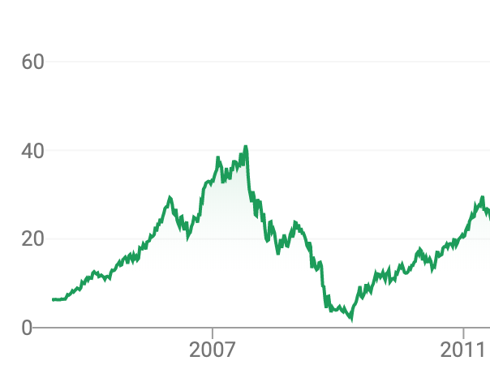
Figure 7.
Another notable threat and one that is present in most any given market is competition. Clearly Altus Group is a rival in the market as well as others, but the threat of being outworked and outsmarted is always there. Obviously Altus is doing something right in Canada that CBRE is not; that is why Altus holds 60% of the market share there. There are many factors that could cause this including speed to the market as mentioned earlier. It could be unlocking a potential customer base, undercutting prices, finding value in pre-existing services or products and things of the like. The CRE industry is also highly cyclical, so there are always ups and downs with few stretches of long growth toward one end of the spectrum versus the other. One last threat is tied to previously mentioned political constraints. If a government suddenly decides to re-write its CRE policy or a new official is elected that highly dislikes current policy, that could mean painful costs in the end. There is also the “follow the leader” effect with policy, meaning if one government decides to implement a new policy or law it is possible that an ally country will follow suit. This could be especially harmful if this happens when your operations are in both countries. An example of this would be restrictive gun laws. The trend toward banning guns and gun components from citizens is becoming increasingly popular throughout developed nations and seems to have captured quite a few countries. If some form of policy were to be as popular in the CRE realm it would be absolutely devastating to CBRE and Altus Group alike.
Reflectively, Altus is currently losing against one of its core competitors, CBRE, and this loss appears to be very ill-timed considering the new expansion of Hana and the reported loss for the year end 2018. Given that Altus Group is a time-tested company with a rich history it is likely they will find a way to keep themselves competing at the highest level in the CRE consulting realm.
As mentioned in in the beginning part of this analysis, An analysis on the company level is crucial in understanding where a company lies in relation to its competitors. This information can then be used to analyze that company’s industry as a whole. One of the ways we can perform this company analysis is by utilizing the SWOT analysis tool. SWOT: Strengths, Weaknesses, Opportunities, Threats can all be used to analyze where a company sits among its competition as well as understand a potential strategy to reposition themselves in hopes of trying to establish a competitive advantage. We can apply the SWOT analysis to Altus Group as well as its competitors.
For Altus Group, Overall they themselves have set themselves in a good spot, allowing for healthy growth among its competitors by establishing a competitive advantage. Altus Group dominates the CRE consulting industry claiming roughly 60% of Canada’s CRE market share, as well as a sizeable percentage of the U.S. Market share with it’s biggest direct and indirect competitors being CBRE, Accenture, and IBM. This would undoubtedly be one of Altus Group’s many strengths as this large share of the industry market allows not only enough room for competition to allow innovation, but also a healthy amount of growth within the industry. Being that Altus also supplies 46/50 top real estate owners in the world, one can see just how Altus Group is able to set such a competitive advantage. Another strength Altus Group would consider to have in addition to its impressive market share, is its diversification and its quest to expand blue oceans. Altus has three main parts to its company: Altus Analytics, Real Estate Consulting, and Geomatics. Altus Analytics focuses on appraisal and valuation, RE consulting focuses of property management and figuring out the best ways to organize a commercial property and Geomatics, this focuses on the land and property management for the oil and gas industry, a goliath industry itself. One of the ways Altus Group has diversified itself is by acquiring Argus Software solutions. Through Argus, key programs such as Argus Enterprise is used extensively in the valuation portion of Altus Analytics. This acquisition in turn, allows for Altus to maintain an industry competitive advantage overall being that Argus has become the industry standard in CRE analytical software. This ensures Altus Group is on the forefront of technology updates within the CRE industry as well as the company that spearheads new ideas to create new technology. This contributes to Altus Group’s strategy to maintain blue oceans and to avoid red ocean traps. A way for Altus Group to maintain its competitive advantage is to capitalize on its strengths as to ensure it maintains its place in the commercial real estate industry.
With the strengths of Altus Group allowing it to maintain its competitive advantage overall, there are a few weaknesses that could jeopardize Altus Group’s placement in the commercial real estate industry. As mentioned above for CBRE, a financial crisis could affect real estate development and the US economy in a drastic way. In 2008, Altus Group felt the effects of the financial crisis, (as represented by Figure 8)
Figure 8.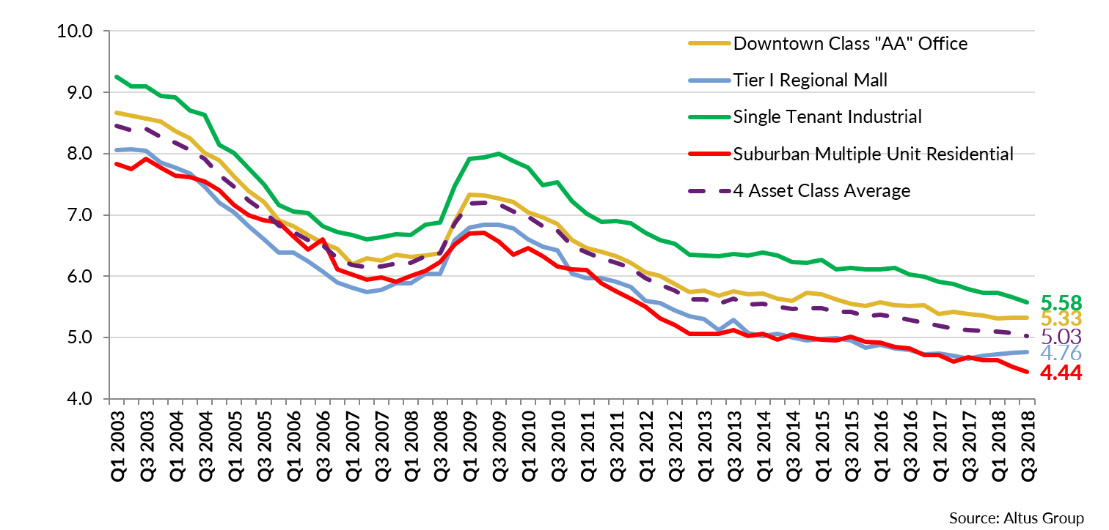
that originated in the real estate and banking industries that eventually led to one of the worst economic downturns since the Great Depression. The graph above reflects the effects the financial crisis had on the canadian commercial real estate market, the market in which Altus Group claims 60% of market share. This is a weakness that could significantly damage the commercial real estate industry as a whole. This weakness can be a result of real estate being so tied up into the financial industry. This relationship, based on the premise of a fragile system, can be mitigated if Altus provided services outside of real estate as well. Altus Group’s attempt to diversify as stated above via the Geomatics aspect of the company is a step in the right direction in order to address a potential weakness. If not addressed, with the theory of competition, another competitor will figure out a way to outperform Altus where it is most weak. Another weakness of Altus Group would be its brand recognition. Although Altus Group has one of the largest market shares between all of its competitors, one place it is lacking is in brand recognition. Unlike some of its competitors such as IBM or CBRE, Altus Group is somehow less known amongst the three, although they own quite an impressive share of the market despite this. This weakness should be addressed as Altus might be able to maximize its market demand simply by adjusting its marketing strategy. Being that both IBM and CBRE are household names, if Altus Group were to potentially have this same amount of brand recognition, they could have an even greater competitive advantage as greater brand recognition could potentially add more business increasing market demand. These weaknesses could be used to draw up a strategy to avoid red ocean traps.
With a few of these weaknesses in mind, Altus Group has a real opportunity to set itself apart within the CRE industry, and as a company. Altus Group, being that it dominates a large part of the market with its 46/50 real estate owners, has real room to grow with a track record to confirm its competence. Altus Group has started to capitalize on certain opportunities within its Geomatics part of the company. The Geomatics aspect of Altus Group takes a slightly different approach to the traditional commercial real estate industry. Instead of normal building structure management. Geomatics focuses on the land and real property associated with oil and gas excavation. This unconventional real estate market is just the idea Altus Group could use to create new blue oceans or to maintain existing blue oceans by decreasing industry crowding. This decrease in crowding will allow for a more healthy flow of ideas and innovation. Another opportunity Altus Group has within the real estate industry, is not only Commercial Real Estate, but also residential. Although Altus Group mainly focuses on commercial properties, which is mainly due to the portfolio size and the value of assets being dealt with, there are residential real estate owners on large scales that could potentially see Altus Group’s services as useful to them.
It really comes down identifying those 2nd tier non-customers and appealing to them in a way that would stress importance for Altus Group to provide services for potential clients. This opportunity to potentially tap into the residential market in addition to the commercial market opens up endless business opportunities. By creating new business opportunities Altus Group can make blue oceans even more blue and doing this would allow Altus to establish a competitive advantage within this sector of the real estate industry.
The final component to the SWOT analysis tool is any potential threats that may arise either within the industry itself or within the industry competitors. With Altus Group being in the commercial real estate and consulting industries, there are certain competitors that have the potential to steal a significant portion of Altus Group’s market share. Altus Group’s biggest competitor and largest threat would be CBRE. CBRE is a large commercial real estate consulting and management company with a significantly large market share within the american CRE industry. Not only this, but CBRE is also, for the most part, a household name within the commercial real estate world. CBRE is also a very close competitor to Altus Group, so close in fact that Altus uses a lot of CBRE’s real estate analysis tools. This relationship is delicate in that there is a balance between cooperation and healthy competition to spur innovation. Another threat, as mentioned in the weaknesses of Altus Group is the industry itself. The industry is prone to change and is sensitive to market changes or financial changes. These threats have the potential to shift a blue ocean to red and allow for another company to take hold of the competitive advantage. It is crucial for Altus Group to maintain a blue ocean as to keep margins high and growth consistent if it is to achieve competitive advantage.
After understanding the strengths, weakness, opportunities, and threats of Altus Group it is important to consider these factors for their competitors such as CBRE, IBM, and Accenture.
International Business Machines, better known as IBM is a multinational corporation in the technology sector. IBM’s services include consulting, enterprise software, as well as financing solutions. IMB has hundreds of thousands of employees and ranks amongst the top 10 corporations in the technology sector.
IBM has many strengths that have helped them continue to grow and remain competitive in developing and servicing businesses around the world. One of the strengths of IBM is the value associated with their brand. Over the past few years there has been many adaptations made to the company that has allowed them to provide timely expertise in providing software and consulting. This in turn has led to many new customers wanting to use IBM’s services. The second strength of IBM is its business model. IBM’s Business model can be broken down into two aspects. The first aspect of its business model is to put a focus on helping clients become more efficient by applying its expertise in production processes and database solutions. The second aspect is to create and sustain an organizational culture that promotes long term value by motivating employees to continue to grow and cultivate their skills. Lastly, IBM’s R&D budget ultimately allows them to remain committed to the mission of creating long lasting success and developing new and innovative products and services.
Although with these strengths IBM unfortunately also has many weaknesses. IBM over the past decade has remained viable but has not had as much desired success as hoped. Prior to a couple years ago IBM’s brand image took a major hit. As previously mentioned in this analysis of IBM one of its strengths is brand value. However, for many years IBM has been suffering due to weaknesses relating to creating imitable products, and a shrinking range of products. Although IBM spends millions of dollars on R&D this has not always provided the company with the ability to gain profits and attention of new customers. The latest products have not been as innovative thus leaving the door open for competitors to develop similar products which in turn shrink the space for IBM to turn a profit. The technology sector is constantly growing by the day and because IBM is struggling to create innovative processes combined with the fact that its product mix is shrinking there are real threats to be dealt with.
The growth of the technology sector is a two-pronged sword. With the massive changes in the market IBM has suffered nevertheless it also provides IBM the opportunity to diversify and explore product options that can branch out to other markets. IBM can focus its product development on cloud-based technology as well as data analytics. With the creation of Watson IBM can tackle both of these needs and penetrate new markets. Watson is a question and answer computer system that incorporates data analytics from various sources of information and allows the user to receive that information at a rapid speed. This product is the key for IBM returning to its former high value brand image.
The threats of external factors such as product imitation and competition pose a real dilemma for IBM. Due to the lack of diversification of its products IBM could face many problems entering new markets and competing with current companies in the technology sector. Altus Group is one of the competitors that is biting on the heels of IBM and could eventually surpass them as database and financing consulting group. Continued innovation from Altus Analytics and its impressive market share are going to make it difficult for companies like IBM to compete in providing optimal consulting and developing enterprise software and financial solutions.
Accenture company provides management consulting, technology and outsourcing services. Accenture strategy, Accenture digital, Accenture technology, Accenture operations, and Accenture consulting are the five main businesses of the company. Accenture is one of the largest consulting firms in the world and recorded 34.9 billion dollars in revenue at the end of 2017. Although the company has sustained great success it is imperative to analyze the business moving forward and understand how it is going to continue to compete with top companies like Altus Group.
The size of Accenture has allowed it to develop many strengths against its competitors in the market. One the greatest strengths of Accenture is its global delivery model. This model has allowed the company to integrate its employees and resources around the globe. It serves clients in North and South America as well as different regions in Europe. The wide range of clientele has allowed Accenture to maximize all of its businesses capabilities to tackle large projects. The extensive number of clients has also led to Accenture capturing three quarters of the Fortune Global 500 and building lasting relationships, some lasting over five years.
Accenture’s weaknesses result from its massive size and the challenge to transform its reputation of being known just as a consulting firm. Accenture’s scale and global reach has led to many organizational challenges these include things such as standards, organizational culture, strategies and goals. These challenges are also met with the fact that Accenture is widely known for its consulting services. This is a big weakness for the company because it inhibits the ability of Accenture to carry out and market its other core abilities to potential new customers. The consulting service provided by the company draws in major amounts of revenue thus leaving management to keep a strong focus on the consulting aspect of the business instead of advocating more for the other services it can provide. The large-sized projects also pose a problem for Accenture. The continued focus on large projects around the globe has proved to be a big problem in gaining market share. These projects bring in a huge portion of revenue but its allows for competitors and venture in many more small and medium sized projects in the market which can lead to big portions of revenue just alike.
Expanding the businesses and services the company offers would prove to greater their opportunities around the world. By branching out and diversifying its current operations Accenture would be able to target small and medium sized projects to gain the market share it has neglected. This would also lead to greater technological advances that could help the company profit in other developing markets and economies.
Accenture does have a wide range of capabilities it can offer its clients, but the presence of competitors is steadily increasing. Companies like Altus Group pose an enormous threat because they too have an enormous presence and services to offer to clients around the globe. The threat of an economic downturn also poses a great threat because Accenture’s tendency to focus on large projects could lead to poor revenues if a negative economic event would occur.
Resources
https://s22.q4cdn.com/564468338/files/doc_financials/quarterly/2018/q4/CBRE-2018.Q4-Earnings-Release.pdf

https://mikesmoneytalks.ca/article-and-commentary/todays-best-money-making-ideas/wealth-building-strategies/22360-canadian-commercial-real-estate-trends-altrus-group-report.html

https://www.nyse.com/quote/XNYS:CBRE

“Accenture SWOT & PESTLE Analysis.” SWOT & PESTLE.com, 13 Mar. 2018, www.swotandpestle.com/accenture/.

Bhasin, Hitesh, et al. “SWOT Analysis of IBM - IBM Strengths Weaknesses Opportunities Threats.” Marketing91, 25 Aug. 2018, www.marketing91.com/swot-analysis-ibm/.

Bhasin, Hitesh, et al. “SWOT Analysis of Accenture - Accenture SWOT Analysis.” Marketing91, 25 Jan. 2019, www.marketing91.com/swot-analysis-of-accenture/.

“History.” CBRE, www.cbre.com/about/corporate-information/history.

Rowland, Christine. “IBM SWOT Analysis & Recommendations.” Panmore Institute, 12 June 2017, panmore.com/ibm-swot-analysis-recommendations.

“SWOT Analysis of Accenture.” Free SWOT Analysis, 27 Dec. 2014, www.freeswotanalysis.com/information-technology-swot/675-swot-analysis-of-accenture.html.

https://www.altusgroup.com/wp-content/uploads/2019/02/Sedar-Year-End-2018-Annual-Report_Altus-Group-Limited.pdf

