Tesla

Industry Analysis

Andy Rogers, Bowie Wynne, Richard Kelly, Miller Peaden

Group 3

Initially starting this semester, we immediately went into the two different types of business strategies.  The first of the two being the Blue Ocean strategy, which is an uncontested market space that is characterized by new demand seen in the marketplace.  Tesla was at one point in the “blue ocean,” where they set the standard and realistically had no competition due to other manufacturers staying focused primarily on their gas-powered vehicles.  Tesla created this blue ocean by innovating the car market not only in the sense of what powers the vehicles but also by how they sell their product to the public but by skipping the middleman in the car dealership.  Making the vehicle after someone has ordered it instead of having their inventory shipped out another way they created this blue ocean to car dealerships. A key driver for the blue ocean strategy is the use of new technology to produce the product or within the product.  Tesla is the industry leader in the Electric vehicle market with little to no competition. On the opposition, they could also be considered to be in a red market in the sense that they are competing in the vehicle marketplace with industry leaders like GM, Ford, Toyota, Volkswagen who have experimented with the electric car market as well as the hybrid market. Since Tesla does work in both a blue and red ocean they have different strategies to grow within the vehicle manufacturing industry but to also maintain their competitive advantage in the blue market

After looking at the concepts of both ocean strategies and how they differentiate, we can begin to break down those differences into two parts.  When first looking at the foundation of strategies we conclude that it is the means by which individuals or organization achieve their objectives.  The strategy is not necessarily a detailed plan nor does it come with instructions but is actually based on the success of the business. The strategy sets short and long term goals from the company to focus on as they are operating.  When you evaluate Tesla it is evident that they don’t necessarily focus on profitability in their short term goals. The company’s long term goals are to change the world by increasing the use of electric vehicles which will decrease the use of non-renewable resources. The corporate strategy defines the scope of the firm in terms of the industry analysis and markets it competes in. Tesla’s strategy was to actually flip the market on its head and in doing so make the EV the status quo for average people not just the rich.  Tesla is without a doubt the most highly valued electric motor vehicle company in the world. Tesla has competed in the EV market which has been a blue ocean but, it is extremely limited due to the majority of large manufacturers producing primarily gas-powered vehicles to see the possible growth and gains that can be made with EV. Another aspect of their business strategy is to maintain the competitive advantage they currently have with the green movement that appeals to younger generations and also being seen as the safest vehicle in the marketplace.  The Tesla Model X is actually the only SUV to ever receive a perfect safety score, which is even more impressive since they came out with this vehicle 3 years ago. Another part of the company’s strategy is diversifying products into different markets such as Tesla creating their own batteries. The future creation of a gigafactory in China will expand their foreign market, and also decrease costs incurred by selling vehicles to China. Most strategies are focused on profitably and creating a good investment for shareholders to create a good ROI. In the case of Elon Musk and Tesla he is in the business for more than just profitability he’s wanting to help the world lean away from fossil fuels.

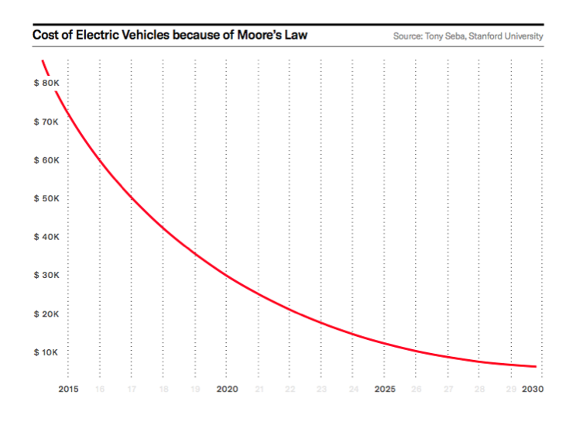(2017, May 03).

When conducting an industry analysis on Tesla Motors, the microenvironment for this business is mainly focused on the internals of the business and stays focused on Tesla itself.   Tesla does this in focusing on sales of electric vehicles, solar panels, and even the batteries used to power their vehicles. They are also doing this by increasing the productivity of their factories, and even by developing new products like the Tesla model 3 which is the cheapest model that they are attempting to bring to market for $35,000.  They recently made cuts in the manufacturing costs of this vehicle to take the price down, now it is approaching the $40,000 mark and is projected to continue to decrease as they find more efficient ways to produce this vehicle. Another way Tesla is growing within the micro level is by producing a gigafactory in China which will then be the main producer of the model 3 which will be mass produced not created after the customer had ordered the vehicle like they currently provide with the Model S.  With the constant innovation and increase in effectiveness we realize that the cost of the lower end electric vehicles will actually be much more affordable in the next 10 years.

The macro environment is seen more of the total aspect of the industry and the growth in the economy and within the industry as a whole not just within Tesla.  When looking at the macro environment for Tesla we start off by looking at the suppliers for the company. One thing that Tesla has done that is very different than other businesses typically do is that Elon Musk created a battery producer that creates the battery to use in their vehicles.  The Macro aspect also looks at the environment as a whole so in doing so we look at the finances of other industry leaders. Toyota is the industry leader of car sales in the world but they also produce much cheaper vehicles, which also allow them to reach the lower income families across not only the US but also the world.  When seeing this and seeing the data it would only make sense for Tesla to use this information and expand into other markets with more affordable vehicles that still provide the sense of helping the environment in using the fully EV. When looking at the macro environment you would also need to look at the overseas markets to see the possibility of growth in these areas and in doing so you would take into consideration the possible sales and growth in the foreign market as well.  Every projection that has been used statistically to show the probable growth in the EV industry has seen astronomical growth not just in the US but across the world.

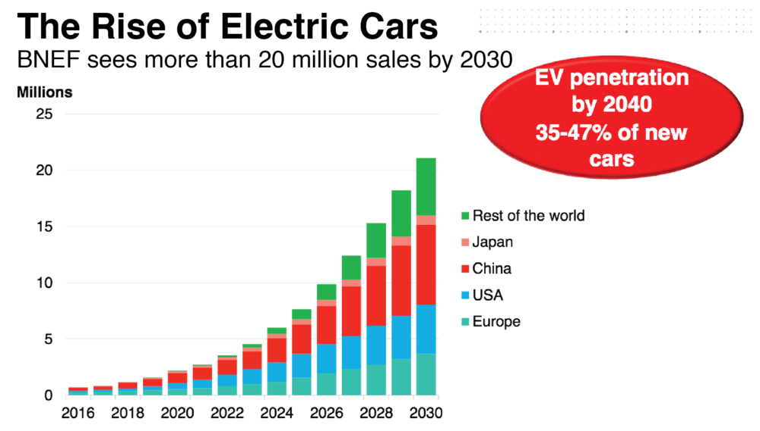

The state of competition for Tesla isn’t only the motorized vehicle market but also the blue ocean they currently set the standards for in the EV market.  Toyota is the industry leader in sales and in the size of the business itself. Toyota is worth over 4 billion dollars more than its next largest competitor Mercedes-Benz.  Tesla is currently listed as the 8th largest auto manufacturer in the world behind Toyota, Mercedes, BMW, Ford, Honda, Nissan, and Audi. When you look at these industry leaders you notice that vast majority of their market being in the sales of gas-powered vehicles whereas Tesla is changing the status quo in producing the only EV and taking the industry by utter shock and essentially turning the automotive industry on its head since so many people are turning towards the green movement in an attempt to cut down on pollution and ultimately lean away from fossil fuels altogether.

. 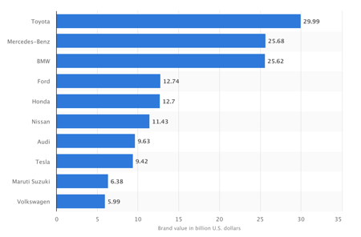Kantar Millward

When looking at the external factors of the industry as a whole you immediately think of the government and the regulations that are required to produce a vehicle.  Just looking at the PEST analysis for our industry we immediately think of the trade regulations and tariffs placed on products. The economic factor is also seen as an external factor of the industry as well.  This can be seen as an external factor since the shift in the economy can help boost or decrease sales in this industry. For example, if gas prices skyrocket and reach $5.00 a gallon you would see a lot fewer people buying new vehicles and if they do it would be a lot more likely to be a hybrid or a fully electric powered vehicle.  We then look at the social issues around the industry and with this, we think of it being a social justice to use electric vehicles over gas-powered vehicles, which ultimately helps Tesla maintain their position as the leader of EV sales across the US. The most important of all the PEST analysis would have to be the technology aspect and when looking at this you understand that Tesla is as successful as they have been with their growth as a business and the stock value is all due to the advanced technology they have implemented into everyday vehicles that no other major manufacturers have been able to copy.

The threat of potential entrants into the automotive production industry seems to be gaining some headway in the production of electric powered vehicles. Due to the presence of major leaders in the industry such as Tesla the difficulty to enter this market has been realized and the success rate in this specific industry has proven difficult.  The startup capital for a business of this caliber would be astronomical as well. Tesla came into the game not by competing with everyone else in the red ocean but by venturing out and introducing a fully electric stylish, fast, and safe vehicle. If another auto manufacture were to try and enter the market they would need to take a similar route by bringing something to market that hasn’t been done before.  Something like an electric pickup truck that can compete with other trucks in pulling capability but also run strictly off of electricity. The substitute products for the automotive industry would be not just products but services as well. Uber, Lyft, and even taxi services could be seen as a substitute for buying a new vehicle. This aspect of substitute products for this industry specifically makes the consumer susceptible to other options for transportation due to demographics. For Example in New York, people tend to live close enough to their work or other avenues in which they spend their time so they can either walk or take a cab. As opposed to a place like New York, if you lived in a rural area you would need the commodity of a vehicle in order to carry out everyday life activities.

The diversity of competitors is also an aspect that should be considered when looking at industry analysis. For example, we look at the different EV’s that are provided by the competitors.  Chevrolet produces the Volt, Toyota created the Prius Prime, Volkswagen with the e-Golf, Kia with the Soul EV, and even Hyundai Tucson Fuel Cell. Just 5 days ago General Motors released a new project they have called the ARIV, which is an electric bicycle that is said to have a 40-mile range.  This is one way GM has planned to diversify their possible income streams instead of leaving it just to their cars trucks and SUVs. All vehicles listed are competitors in the EV market in the United States but none have the range or technology input that Tesla has implemented in their vehicles. The Hyundai Tuscon Fuel Cell is a hydrogen-powered SUV that is being released in some parts of California but is restricted to areas surrounding the hydrogen-refueling stations.  This could be a major competitor for Tesla, and could also help Hyundai create a blue ocean with this new innovative technology. One way Tesla has diversified their business is by producing the electric batteries and even selling them. They have also brought the first ever fully electric 18-wheeler to market. They will have the towing capacity of the diesel-fueled trucks but leave a much lower carbon footprint behind. They also diversify their possible sales by introducing their up and coming to Tesla Roadster which is the only true performance vehicle in the EV market.

As we continue to dive into Tesla’s position in the automobile industry we first must evaluate the art of transportation as a whole. In order to do so, the history of the automobile must be referenced in order to fully grasp how Tesla is revolutionizing the automobile and the way people transport themselves from place to place. The first car that established the automobile industry was the Model T created by Henry Ford in 1908. Over the past one-hundred years, automobiles have evolved from just a means of transportation to a revolutionary commodity that has set continuous precedents in establishing social status. The way people view automobiles currently is very different than in the early 1900s because we as a society have put a label on the individual and tied it to the type of car they drive. Luxury over longevity has become the trend to follow due to the materialistic pedestal we place people on because they own the “latest and greatest,” technological advancement. Yet, due to this ongoing trend in the automobile industry and other technology-driven industries, we have been able to determine where the revolutionary products end and the evolutionary products begin.

Going further into the evaluation of Tesla’s corporate strategy and performing an industry analysis, an important aspect that is under consideration are the resources available and also the capability of those resources. It is crucial to be aware of the technology available to the automobile industry and the role that those technological resources play in revolutionizing the automobile industry as a whole. In a market where consumer preferences are specified to each unique consumer and average marginal propensity to consume is low, Tesla must identify its sole customer base and predict future changes in the industry that could lead to instability or replication of their product. In the case of Elon Musk who is the face of Tesla, who has clearly stated the purpose as a company which is to revolutionize the automobile industry in a manner that helps rid the earth of toxins that are harming the earth. With Tesla’s core competencies being noted, they have proven through action that they are willing to share any information that assists in their cause by releasing their patents to the public. In most industries, new entrants do not enter the market on the same level as established firms within that industry. In terms of industries as a whole, being able to effectively enter into a new market depends on the capital capabilities and resources available to them. For Tesla, the incorporation of several factors existed before becoming the industry leader they are today. In order for Tesla to become an established firm within an industry that in essence is a new branch of the market in the car industry, they had to ask themselves several important questions. The first question that had to be evaluated is the financial requirements needed to enter into this blue ocean segment of the automobile industry. To answer this question vaguely Tesla issues shares of common stock just as any other corporation would in order to receive funding for research and development of new products. The initial stock price for Tesla began at 17$ in 2010 and has increased at an alarming rate that has exceeded its expectations. For example,  if you were to have invested $1,000 in Tesla in 2010 when they made there initial public offering you would see a 2000% increase on your initial investment that would total around $22,000 today. Because of Tesla’s mission to revolutionize the automobile industry investors are willing to inhabit the risk of an unknown market in order for a technological breakthrough to continue in a vertical trend.

The next question that must be answered is the scale at which Tesla is operating. According to the Foundations of Strategy, “one of the main sources of economies of scale is new product development. Thus, developing and launching a new model of car typically costs over 1.5 billion”  (Pg 50). Due to high and consistent research and development costs, Tesla initially accepted high “per-unit” costs while operating on a large scale. While operating in such manner Tesla’s initial model the Tesla Roadster sold for an average price of $130,000. This model appealed to the high-end consumer and offered a very unique differentiation among other products but was not a reasonable initial price for the average consumer. This high cost of the car was the product of high initial start-up costs that Tesla was accountable for but did not prove to be detrimental to the overall success seen so far. The old saying is that “there is no such thing as bad press,”  proved to be true for Tesla allowing them to establish themselves as an industry leader of (EVs). It propelled them forward in terms of brand recognition that has made them well-known, but consistent evaluation is key in order to thrive in any industry. With other companies within the industry such as Ford and Toyota recognizing the precedents set forth by Tesla, they have tried to establish themselves into the electric car market. The threat of new entries into the electric car market has left Tesla with the issue of maintaining their competitive advantage they once solely controlled. With the threat of new entries into the market leads to suppliers becoming a more integrated part of the process. As history has shown there are pioneers in every industry and there are imitators who take the work of the pioneers and restructure it to fit their own corporate strategy. With that being said, access to channels of distribution for suppliers becomes an integral part of the conversation. With more companies joining into the market the need for materials that cost-effectively assist in the production process become a necessity, thus allowing for a new market to emerge in form of outsourcing certain aspects of the production process. Necessity breeds profit, therefore if the electric car market becomes the evolutionized product many people believe that it will the bargaining power of suppliers will rise and the industry itself will monetize in a way that steers away from the reason’s Elon Musk founded Tesla. The battle for the limited capacity in the automobile industry’s distribution channels will lead to a further disadvantage for Tesla because people are reluctant to buy new products until all of the beta testing is completed and the faults in the new product are worked out. In order to bypass this barrier to entry, the Internet has played a key role in allowing new businesses like Tesla to circumvent this barrier to distribution. Not only does the internet assist in competitively impacting these forms of distribution, but it has allowed for Tesla to set a foundation based upon the core principles that Tesla stands for. Tesla has set yet another precedent in the automobile industry in terms of production because they manufacture all electric cars “in-house,” with unique designs and features not found in any other vehicle on the market. Continuing further Tesla does not follow the conventional way of selling and distributing its vehicles that other automobile manufacturers follow. In order to cut manufacturing overhead costs, they work on custom ordered Tesla models that are not produced until requested for purchase.    Due to the precedents set, Tesla is trying to appeal to the consumer in other ways that are not monetized. Through innovating this new product they have reached new consumers in a way that appeals to them while offering something new to old customers that inhabit continue to inhabit the market.

The next topic of debate is government and legal barriers to entry, which in the case of Tesla could pose an issue due to the intellectual property that they possess. Elon Musk has released his patent’s to the public which allows for anyone to take the ideas that Tesla has brought to the industry and mass-produce electric cars if they were capable. Because Tesla has opened its technological advances to the public sector we can infer that the timetable has been set for other manufacturers to imitate their products uniquely to fit their own personalized business model.  A good example of continuously innovative intellectual property being a vital component within an industry is Apple in the cell phone Industry. Apple has set its own respected precedent for all others to follow making them the pioneer in that market that all other competitors look too. It is important to keep in mind that the pioneers in any industry are under enormous pressure to innovate new products but also maintain a competitive advantage over the rest of the market. Therefore the issue at hand is not that of intellectual property, but the time frame in which markets are entered into. Industries such as the electric car market are protected by high barriers to entry because of the financial and intellectual capabilities that must accompany the production phase which leads to high level earning of profit. Due to those high level of profits being earned along with their intellectual property being public,  if and when Tesla attempts to enter foreign markets will they be able to? If they are capable of entering into foreign markets, will it profitable to do so? After those questions have been answered another thing to consider is the regulations set forth by the Organization of the Exporting Countries (OPEC). This organization regulates the number of motor vehicles that can be input into the market each year because of carbon monoxide regulations. Tesla’s core competencies are to change the automobile industry in an environmentally friendly manner that outdates the gas engine. If and when the entire industry becomes entirely electric then this agreement will have to be restructured and tailored towards electric cars.

When considering the profitability of an industry it is important to keep in mind of underlying extrinsic factors that could impact how profits are originally forecasted. The uncertainty of not knowing how changes in an industry will affect the rest of the industry tends to yield questions that must be answered. For example, in the automobile industry the threat of “global warming,” is a primary concern for the future of the industry. Producers of gas-powered vehicles are left asking themselves about if the industry will consolidate into a fully electric market? If that question were to come to fruition what will the impact on consumer preference be? From there the obvious answer is that new players in the electric car market will begin to form and so on. Tesla has done a good job at placing themselves as a front runner in the EV market but the goal is to incorporate business practices that create sustainability. If we look further into the history of the automobile industry we can infer future changes within the market itself, but there are certain things that are not directly related to the industry as a whole, but have an inverse effect nonetheless. During the most recent recession in 2008 when the mortgage crisis was taking place the automobile industry was the second most affected Industry behind the banking Industry. The health of the economy has been said to be directly correlated to the production automobiles, due to the fact that people have more disposable income to spend on a vehicle. Tesla must consider the inevitability for another recession to occur and be able to establish themselves in a position where even when marginal sales are low they can continue operation. Consequently following a recession Tesla has to be prepared for the majority of their consumer base to be affected if a recession were to take form. In order to account for a recession, Tesla has to be prepared to cut operating costs in a way that won’t affect their bottom line.  Throughout analyzing the factors that affect a firm’s environment, one must consider the internal and external factors. The internal environment refers to the factors that happen inside your organization. Examples include your organizational culture, organizational structure, human resources, physical assets, profit, and cash flow, and management team. For the external environments, one must consider the economy, technology innovation, political, legal, competition, and trends. These are just a few of the factors you need to constantly be observing in order to be successful and strategic when running your business. Though, while scanning these factors is very important, you must not create an information overload on the external factors. Information overload on the external factors could result in actions taken in the least important aspects of the environment. For example, micromanaging would be considered an information overload and results in you not focusing on the big picture, or the vital elements. In conclusion, the key to having an effective environmental analysis is to differentiate the vital factors from the merely important.

There are three main factors to understanding your company’s success path, which is to create value for your customers, understanding your suppliers, and understanding the intensity of your competition. The first factor, creating value for your customers, means that you need to first understand them. Your product or service needs to have a great value, in fact, a greater value so that the price the customer is willing to pay is greater than your costs. Though, this does not necessarily mean that this creates pure profit. The surplus, or difference of value to consumer and cost to you, the producer, spread out amongst the consumer and producer. In cases of high competition, the more surplus would go to the consumer instead of the producer. This is because as firms compete, they need to give more of their allocated value-surplus to the consumer in an attempt to have them prefer your product over the competitors. In Tesla’s case, some of the value added to the consumer would be their safety, efficiency, performance, and luxury. Currently, these features of Tesla’s products are unique and provide an incentive for consumers to purchase. As competitors enter the market, they are going to have to exchange some of the value surpluses to the consumer. This can be in the form of a price drop or added performance. The second factor is understanding your suppliers. It is important to understand your suppliers and build good relationships with them because, after all, they are one of the most crucial aspects of your business. For example, if you do not understand how your supplier operates or maintain a healthy relationship with them, you can get taken advantage of or get blackballed from future deals. The third factor, understanding the intensity of your competition, is very crucial for maintaining profits. If you and your competition compete for the same value-adding opportunities, it is necessary to understand them. You need to understand what values they are attempting to add and how you can maintain a higher value surplus than your competitors.

Understanding industry attractiveness is, if not, one of the most important concepts that you need to consider when deciding to enter into a market. How attractive is your industry? What are the barriers to entry, and how big are they? What is your strategic or competitive edge? These are a few questions that one should consider. As previously mentioned in industry analysis factors, what is the value added to the consumer? It is important to understand the consumer and know how inclined they are to prefer your good or service over your competitors. The systematic influences of the industry’s structure are the basic premise that determines profitability. For example, the pharmaceutical industry and the automobile industry have two very different structures and products. The pharmaceutical industry relies on high capital costs of research and development and patenting. They have highly differentiated products and depend on consumers who are very price insensitive. As a result, they create a monopoly or oligopoly on their industry and maintain high profits and consumer retention. On the other hand, the automobile industry produces many commoditized products and has high production costs. This means that they are in a very large industry containing many competitors and low customer retention, resulting in less profitability. Tesla being in the electric car market, a component of the auto industry, currently maintains a first mover advantage. Though their industry is not as desirable as the pharmaceutical industry in relation to profitability, they maintain their attractiveness. For example, the market is still relatively small, meaning that Tesla has the potential to maintain a temporary monopoly due to their desirable features of safety, performance, and luxury, which is difficult to copy. Due to how small the market is, the room for exponential growth is left to the pioneers who lead the front towards a more sustainable future

When classifying and analyzing the factors that determine industry competition, a very useful and commonly used tool is the Porter’s Five Forces Model, which was developed by Michael Porter of the Harvard Business School in 1979. This framework portrays the profitability of an industry by determining the five main sources of competitive pressure. These five forces are categorized by three horizontal factors of competition which are competition from substitutes, competition from established rivals, and competition from new entrants. The two vertical forces are the bargaining power of suppliers and the bargaining power of buyers. By determining the strength of each force, one can come to a conclusion of the overall industry attractiveness. Below is an illustration of Porter’s Five Forces Model. 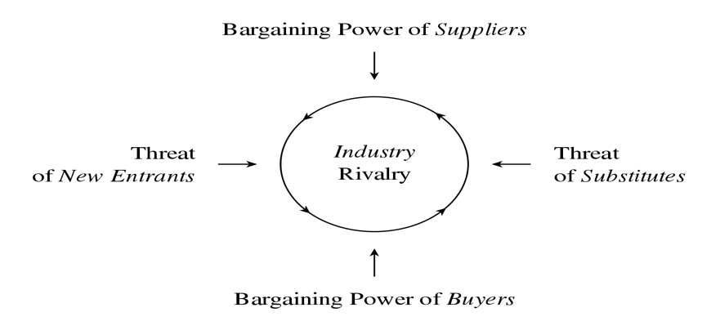

The competition of substitutes refers to how many substitutes your consumer considers when they are purchasing a product in your industry. The price that a customer is willing to pay for your product depends on the availability of substitutes. The absence of product substitutes results in a customer who is relatively insensitive to price. This means that the demand is inelastic with respect to the price. On the other hand, when a customer is in the presence of available substitutes, they will most likely be inclined to purchase the substitute if it is at a cheaper price than yours. This means that the demand is elastic with regards to the price. In the presence of technological innovation, the internet has produced a new source of substitute competition which has completely enhanced the way consumers shop. Within seconds, they can have many available substitutes at the touch of their finger. For Tesla, the current threat of substitutes is moderately low. There are few options to consider when shopping for an electric sports vehicle, but none provide the same amount of value to the consumer. In regard to the consumers price sensitivity aspect, Tesla has an alternative that is much more affordable. The Model 3 provides the same safety standards as the more expensive models and still provides high luxury and performance value, for a fraction of the cost. In conclusion, the extent to which these substitutes decrease profits and prices depends on the buyer’s behavior or inclination to switch to the substitute. In the technology industry, which Tesla is deeply rooted in regard to their innovations, rare earth materials are necessary for production. This high demand results in increased supplier power and can be a competitive disadvantage when attempting to reduce production costs due to high competition and substitutes.

Another horizontal factor of the Five Forces Model is the threat of new entrants. As a firm succeeds in profitability in their industry, it serves as a magnet for potential companies to enter the industry. Many firms will attempt to follow the pioneer (Tesla) in attempts to maintain a similar amount of profitability. If the barriers to entry are low, the profitability of the industry will decline towards a competitive level due to new entrants. In most cases, new entrants have a tougher time entering an industry with an established firm. Some of the most popular barriers to entry include capital requirements, economies of scale, absolute cost advantages, product differentiation, access to channels of distribution, governmental and legal barriers, retaliation, and effectiveness of barriers of entry.

In regard to Tesla, the capital requirements have been obtainable initially through private investments, and then through an initial public offering in 2010. The high cost of capital discourages many small firms from entering an industry, but in Tesla’s case, it was manageable. The economies of scale refer to the ability to produce your product while maintaining a profit. In new entrants, they have the option to enter on a small scale and face higher unit costs or the option to enter at a large scale and face the costs of under-utilized capacity. In Tesla’s case, they initially entered on a small scale and faced higher unit costs, and gradually maintained a larger scale operation over time thus improving their under-utilized capacity. Absolute cost advantages are a high barrier for a firm that chooses to enter an industry. It means that established firms maintain a unit cost advantage compared to a new entrant. For Tesla, they had to overcome this barrier due to established firms such as Chevrolet and Ford who have established and maintained relationships with their resources and suppliers for over a century. The barrier of product differentiation is crucial for maintaining a broad variety of customers and loyalty. Established firms with many differentiated products maintain a competitive edge with brand awareness and loyalty, as well as the ability to reach multiple target markets. For Tesla’s case, they have recently come out with differentiated products such as an SUV, Sedan, 18-wheeler, & Supercar. These prices also differentiate to attract multiple consumer target markets. Government and legal barriers are also very important to consider when entering a market. Patents, copyrights, and other legal forms of intellectual property are high barriers to entry but can also be a core competitive edge. In some cases, the government and legal barriers can result in a competitive edge for costs; for instance, tax deductions on environmentally friendly businesses like Tesla. Retaliation of existing firms towards a new entrant is a barrier one must consider. Often, when a new entrant exists in an industry, the established firms will attempt to force them out of business through aggressive marketing, price-cutting, or litigation. The last element of the threat of new entrants is the effectiveness of barriers to entry. This means the established industries have a high entry barrier entry results in them earning above-average rates of profit. The effectiveness a firm has on overcoming the barriers of entry depends on its capabilities and resources. In other words, if a firm has high capabilities and resources, they are more likely to overcome a barrier than a firm which lacks those.

The rivalry between established competitors is a horizontal force in Porter’s Five Forces Model. In an industry, the level of profitability that can be achieved determines on the state and intensity of the industry-wide competition. For example, if an industry containing many firms aggressively competing, it will result in price drops that snowball below the level of costs and everyone in the industry loses. In some cases, however, industries choose to leave price competition out of their aggressive sustainability efforts in order to prevent everyone from hurting financially. As a result, they focus aggressively on product innovation and marketing tactics. There are some factors to consider when evaluating the rivalry between established competitors. They are seller concentration, diversity of competitors, product differentiation, excess capacity, and exit barriers, and cost conditions. In the case of Tesla, the electric vehicle industry currently has a low concentration, resulting in a high-concentration ratio, especially for luxury electric vehicles. Their diversity of competitors is also low, meaning that their competitors have very little product diversity in terms of objectives, costs, and strategies. Tesla maintains a high diversity in these costs and strategies. The factor of excess capacity and exit barriers are bittersweet for Tesla’s situation. While they do not have excess capacity (demand is currently too high for supply in Model 3) they are facing a barrier in lack of resources for production, and currently trying to solve manufacturing logistics. In terms of Tesla’s cost conditions and structure, they are juggling their fixed costs in relation to their variable costs.

The bargaining power of buyers is one of the two vertical forces in Porter’s Five Forces Model. It refers to the level of buying power that firms deal with from their customers, and it depends on two factors: relative bargaining power and price sensitivity. As previously stated, the buyer’s price sensitivity is the degree in which consumers are delicate to the prices set by a firm in an industry. If an item is a necessity and makes up a majority of a firm’s costs, they are to be more sensitive to price increases. For example, Tesla’s previous outsourcing of their batteries resulted in a gradual cost increase, as a result, they are beginning to produce their own batteries. The intensity of competition between a firm’s consumers results in pressure for firms to reduce their pricing. The relative bargaining power of the buyer depends on the refusal to engage in transactions with the other party. This factor incorporates the size and concentration of buyers relative to suppliers, buyer’s information, and the ability to integrate vertically. The size and concentration of buyers is a considerable factor for Tesla. This means that with a small number of customers in relation to the size of their purchase, the greater the risk of losing the customer. With an expensive product like a vehicle, most customers will only purchase one at a time. This high cost for a one-time purchase results in the customer considering many substitutes, giving the buyer an upper hand in a potential purchase. This leads to the buyer’s information, which with an extensive amount of knowledge on a product, results in increased bargaining power. The ability to integrate vertically is the third factor of consideration in the bargaining power of buyers. If a buyer is unsatisfied with their options to purchase, they may do it themselves as a resort. As previously stated, Tesla was unsatisfied with their options for battery suppliers, so they decided to supply their own batteries.

When using the SWOT analysis on Tesla it shows the detailed internal and external factors that are present in this company. SWOT standing for strength, weakness, opportunity, and threat covers many different aspects while analyzing a company.  Tesla being a relatively new company, established in 2003, compared to others they have a large customer base. As Tesla continues to show growth in their industry they will start to pull away from large companies such as Ford, and Chevy in the electric car markets. Tesla’s greatest strength is its innovative technology, and energy storage in their vehicles. The ability of the company to continue to improve on their electric car design allows for cheaper options, and longer distances to be traveled in each trip. These innovative designs are constantly being tested, and reapplied to new models such as the Model X which has room for seven passengers compared to the Model S that only fits five. As Tesla leads in innovation, and design they are constantly setting new standards for all electric cars to follow. Customer base has been steadily increasing over the years, and future growth is expected from the release of the Model 3 Sedan. The model 3 sedan is expected to be sold at around $35,000 which will be the company’s least expensive model. Introducing this more affordable vehicle allows Tesla to tap into new markets that they couldn’t reach before.

When you evaluate the company you do find that there are weaknesses throughout such as a lack of profitability which is due to high research and development costs, and limited market presence. Currently Tesla struggles with their market share due to the high cost of the vehicles they are offering compared to other companies. Last year in November Tesla hit its highest market percentage topping out at “2.15% of the US car and light truck market” (GoodCarBadCar.net). Putting those numbers into perspective last year on average Ford was at 14.4% market share. Another weakness of Tesla’s is their struggle to operate at a profit. Tesla posted their 3rd ever profitable quarter in 2018 due to the popularity of the model 3 sedan. Operating at a loss makes things hard for the company such as continuing innovation, and design when they are struggling to increase their profits.

The most important part of Tesla’s SWOT analysis is their opportunity to increase US market share, global expansion, and business diversification. Improving on the company’s weaknesses and using them as opportunities rather than negative factors will increase company growth immensely. Many opportunities are present for Tesla, one of the biggest being the chance to expand their product line to global markets such as China. China has one of the largest markets in the world, also has high pollution which could be reduced with the implementation of electric vehicles.  Increasing the companies market size could also lead to global supply chain expansion which will lessen the costs of each model. Once the company has increased their supply chain globally, they can create a more diverse product line that can tailor to the new markets they enter. New demographic regions throughout the world will need different vehicle styles compared to those in the United States. In Asia vehicles are commonly smaller than those that are sold in the US due to greater population density. Being an electric car company Tesla has the competitive advantage of using no fossil fuel in their vehicles. The lack of fossil fuels consumed for their products increases the attention of consumers who are environmentally aware, and proactive. While creating luxury vehicles they are also selling a superior product that will help save the environment by decreasing emissions that are released into our atmosphere. Tesla has the opportunity to become the face of environmentally friendly vehicles if they continue to dominate the industry in electric cars.

Although it may seem that Tesla is the only electric car manufacturer in their industry they are not. Tesla faces many threats in their industry due to the fact that it could quickly switch from a blue ocean to red in a day. Once other companies master the design of their own electric vehicle they can start to compete. The automobile industry is a very well established, and highly competitive on all platforms. With that being said any of the large companies such as Ford, Chevy, or Toyota could create a fully electric car with capabilities similar to Tesla that would decrease their market share. While facing dominant companies that have the resources necessary to last long term, and have the ability to cut prices to decrease Tesla’s sales you have to be careful. Aggressive competition will make price cuts on their product to sell more vehicles than Tesla trying to saturate the market with electric cars so that less people will spend more money on a Tesla. While dealing with competition they also have to find more suppliers of the materials they need for production. With limited suppliers for production components Tesla faces issues with reduced bargaining power of supplies. Reduced bargaining power allows for the suppliers to increase the cost of the goods they are selling to Tesla without fear that they will switch companies.  Along with the lack of bargaining power, Tesla also faces the threat of the United Kingdom leaving the European Union. Currently Tesla is operating their European business from Netherlands including sales, manufacturing, and logistics. Tesla stated that they will increase prices by five percent in the United Kingdom due to the fluctuation in currency outside the European Union. Increasing the price of an already rather pricey vehicle could slow down the demand for Tesla’s in this foreign market. The threat of over producing vehicles that were previously sold in the United Kingdom could affect the company’s yearly production estimates. This SWOT analysis report shows all the potential changes that Tesla could encounter throughout the company’s growth. Whether or not the company chooses to improve on their weaknesses, and take hold of the potential opportunities is up to them. This company has many strengths that can carry them to success, and continue to make them a leader in electric vehicle innovation.

A SWOT analysis focuses on strengths, weaknesses, opportunities, and threats which is a very good way to analyze a company but it is not the only way. A PEST analysis is another way to identify factors that will positively or negatively affect an industry. Breaking down a PEST analysis shows each individual aspect such as political, economic, social, and technological factors that will shape an industry. Industries are influenced by many factors that can allow them to thrive, or quickly shut them down. Political factors can vary on impressions they make on industry changes depending on the impact they have on all factors throughout the industry. Political changes such as new government regulations on trade policies such as limiting imports and exports of vehicles can largely affect an industry. If the government implements a new policy that limits the number of vehicles imported or increases the import taxes on foreign competition it reflects on other companies. If a foreign competitor supplies fewer vehicles to the United States, it allows for more American companies to sell their vehicles here which increases their market share. When companies increase their market share or sales in the US it leads to increased revenue which could cause a domino effect. If the government passes a law than incentivizes those who use electric vehicles in the US Tesla would see a large increase in sales. External factors such as government incentives allow for consumers to get money back essentially when buying vehicles that are environmentally friendly, and all Tesla makes is fully electric cars.

Brexit, the UK leaving the EU, has already had many political effects on the automotive industry especially impacting Tesla. The Brexit has led to increased prices on imported goods, and also products that are made domestically that use components from overseas. A Tesla Model 3 that was pre-ordered in the UK has now seen a 500 sterling (UK’s new currency) increase due to the increased costs to get the vehicle to the UK. Although the buyer of that vehicle was not bothered by the increase others could be which could negatively affect Tesla’s sales in the UK’s markets.

Political impacts can be very restrictive and restraining on companies within an industry, but economic factors can sometimes help balance them out. Economic factors include many different things such as market growth, currencies, trade levels, and other factors that affect the automotive industry. Tesla will now face a new currency as we mentioned previously while talking about the Brexit and have to adapt to all changes that will occur within the country. Tesla will see future market growth due to factors such as decreasing battery costs because the company expanded its resources to start creating their own batteries rather than from a supplier. While this seems like a risky investment to start creating lithium-ion batteries, it now allows Tesla to cut costs that they previously were paying for batteries by a significant amount. Tesla is claiming that they have reduced the cost of the batteries at the Gigafactory where they are being produced by 35%. By integrating vertically Tesla will continue to save more money in the future than having to rely on a supplier for their needs.

As renewable energy costs continue to decrease with the increase in popularity of these innovative technologies more people become interested in electric automobiles. From this point, it is expected that there will be only a decrease in the cost of electric batteries as innovative engineers continue to design more powerful batteries. With the economy steadily improving throughout the world there will be a steady rise in investments in electric vehicle technology. “Investments in electrified vehicles announced to date include at least $19 billion by automakers in the US, $21 billion in China and $52 billion in Germany” (Lienert, 2018)

Social and Sociocultural factors have a large influence on an industry especially in an industry that has such a large effect on pollution in our world today. This aspect of the PEST analysis closely relates to trends in social markets they are involved in. Social changes must be shadowed by the company’s marketing strategies, and implementation of new product design to stay relevant in growing industries. A good manager knows his customer and is able to adapt to the changes that occur in the social environment to continue to maximize profits for the company. Most of the social factors Tesla is currently facing are all positive opportunities including Increasing popularity of electric vehicles which produce fewer emissions, more consumers are starting to realize the importance of renewable energy source, and more developed markets that have increased the amount of wealth being distributed.

With the increase in popularity of electric vehicles, there has been continuous growth in the electric market including vehicles, their batteries, and also the technological production that goes along with it. Social awareness of the effects that the auto industry has caused our environment is becoming more, and more apparent. This social awareness will lead to an increased number of electric vehicles that are bought by consumers which will cause Tesla’s sales to increase. A large reason that Tesla has shown growth due to environmental awareness is the fact that CEO Elon Musk has intentions of bettering our environment. He focuses on how the company can create a vehicle that does little to no harm to the environment, and less on profits throughout the year. Trends of wealth distribution steadily increase in new developing markets which allows more consumers to afford the vehicles that Tesla is currently offering. As developing markets continue to grow they are reducing poverty throughout the economy while new jobs are being created. Economic growth allows for companies to find new ways to follow the patterns, and create new opportunities.

The number one driving factor of Tesla is without a doubt the innovative technology they have created, and continue to produce. Tesla is highly advanced in their creations of fully electric vehicles and now continues to expand its product diversity to batteries for the cars. The automobile industry is changing rapidly in all aspects, but the biggest change has been the switch from gas vehicles to electric. There are many threats going into such a new industry, and market due to the fact of many unknown factors that will influence it. Tesla has created cars that are electric, but they can also drive themselves in autopilot mode which allows hands-free driving. This new technology does come with new risks such as wrecks from system glitches, or user error of not keeping their hands on the wheel while in autopilot. Tesla implemented radars that reach 160 meters ahead of the vehicle for protection, and 12 ultrasonic sensors to detect any hazards while in autopilot mode for safe driving. The vehicles are becoming highly advanced not only in their fuel sources but also the operational features they continue to add to them.

Tesla as a company has also made very big technology advancements in its production by increasing the robotic production of the products. Adding more assembly lines by creating new factories such as one referred to as “the tent” which was a quick building they made out of a small number of resources so that they could expand their production model to meet deadlines for the Model sedan. Tesla continues to find ways to cut costs and increase their profit margins. New technology will continue to separate Tesla from its competitors as they continue to lead the way of innovation on new electric vehicles.

Analyzing the automotive industry as a whole is a very broad topic, but if we break it down into electric vehicles, and non-electric vehicles we can see different patterns. Focusing on the electric vehicle industry we can see that there has been continual progress over the years that is starting to make waves. The EV industry is currently small but has the potential to become much larger within the next few years. Once Tesla implements the new Model 3 Sedan it will allow for more middle-class families to be able to afford electric vehicles which will create a much larger market. While many factors point toward the success of the EV industry which includes all aspects of the PEST analysis there are some setbacks. The biggest issue this is industry is facing is creating electric vehicles at a low enough cost to make a profit. Once the growth of the EV market increases Tesla will start to make a profit, and change in the world.

Tesla has made many smart moves throughout its growth in the automobile industry but is only getting started. Tesla has found a rather unique way to create vehicles, sell them, and promote them through marketing. Tesla has not made it hard for other competitors to join them in the electric vehicle industry, but they have made it very hard to keep up at the pace they are moving. Threats of new companies joining the industry are always present while continually creating new technology to match Tesla. EV markets are small which makes it hard for competitors with a lesser product to compete against such a high quality and luxury vehicle. Competitive advantages Tesla holds over other companies is their ability to now create lithium-ion batteries for their vehicles, cut costs while avoiding third-party dealerships, and consistently leading the industry in electric vehicle innovation.

As a pioneer in its industry, Tesla has struggled with creating profits over the years, but now their future looks promising due to the implementation of new strategic management practices. Bargaining power of each company will continue to increase the more competitors we see join this industry. Tesla has accounted for future advancements in the electric car market by establishing a position on the supply side and the production side of the Industry. Their positioning within this industry correlates to their mission of accelerating the world’s transition into the use of more sustainable energy sources.









Works cited

Brown. (n.d.). Most valuable brands within the automotive sector worldwide as of 2018, by brand value (in billion U.S. dollars). In *Statista - The Statistics Portal*. Retrieved February 18, 2019, from <https://www.statista.com/statistics/267830/brand-values-of-the-top-10-most-valuable-car-brands/>.

Financials & Accounting. (n.d.). Retrieved February 20, 2019, from http://ir.tesla.com/financial-information/quarterly-results

GoodCarBadCar.net. (n.d.). Tesla's estimated U.S. market share from January 2018 to December 2018. In *Statista - The Statistics Portal*. Retrieved February 20, 2019, from <https://www.statista.com/statistics/519579/market-share-of-tesla-in-the-united-states/>.

Grant, R. M., & Jordan, J. (2015). *Foundations of strategy*. Hoboken: Wiley.

Hyundai Tucson Fuel Cell. (n.d.). Retrieved February 19, 2019, from <http://suvs-rankings.com/hybrid_and_electric_cars_2018/hyundai_tucson_fuel_cell>

Lienert, P. (2018, January 16). Global carmakers to invest at least $90 billion in electric vehicles. Retrieved from <https://www.reuters.com/article/us-autoshow-detroit-electric-idUSKBN1F42NW>

Tesla Competitor Analysis: Automotive Industry – Hackerbay Blog. Retrieved February 19, 2019, from <https://blog.hackerbay.com/tesla-competitor-analysis-automotive-industry-4397ff782657>