Company Situation Analysis

Ford Motor Company

MGT 4380 10:00am

Team 4:
Brooks Garner, Alex Mills, Grayson Watson

In the 2017 Annual Report, CEO and President Jim Hackett laid out five objectives that would set the course for Ford Motor in 2018. Headlining those objectives is the idea of becoming the “world’s most trusted mobility company”. On the ground floor, Ford is a automobile manufacturer. But due to the ever changing landscape caused by the Great Recession and rapid development in new technology, this industry is not what it used to be.
Ford’s strategy in 2017 was focused around change and transition. In order for the company to maintain its competitive edge, Ford was forced to reduce its American sedan line to only one model, the Focus, while also keeping the iconic Mustang. The new car market is heavily favoring larger crossovers and SUV’s along with trucks. However, as the market moves towards these larger vehicles, MPG and the emissions created by those vehicles is a major concern. That is why Ford is committed to creating 40 fully electric vehicle models by 2022. These 40 vehicles will be sold in various regions of the world as Ford focuses on another key objective: connectivity. Ford believes that people want to be connected, and in order to facilitate that, Ford is in the process of creating technology that will allow 90% of all new cars to be connected globally by 2020. This is due to Ford’s goal of creating and mass producing a fully autonomous vehicle that can be used for ride-hailing services and package delivery. Overall, in 2017 Ford made a lot of changes for the better. But in analyzing their financials, things don’t look so inspiring.
Ford has been able to maintain a profit even through the recession. But what we are seeing is not what we expected the comeback to look like. Revenues and profits have still not been able to reach the record numbers that were posted in 2005. Gross profit has been declining since 2016, posting a 5.44% decrease between 2017 and 2018. When looking at net income, the numbers are even worse. The net income in 2018 was $3.677B, 52.44% less than in 2017. Ford also took on around $10B in long term debt in 2017, increasing to $102.666B.
Now, as Ford continues to restructure, they also continue to invest in software and R&D. They have also partnered with Lyft in order to create the safest and most reliable autonomous ride-hailing service. Ford is investing heavily in AI that will allow people to utilize driverless cars to reach their destinations. In order to do this Ford and lyft are working to merge two operating systems into a fully functioning fleet of vehicles that will work side-by-side with Lyft’s current pool of drivers. However, Ford is not the only auto manufacturer competing for the autonomous taxi; Chevrolet is also quickly developing their own form of driverless transportation which could prove to be even more profitable considering Chevrolet owns 75% of Cruise, the company spearheading autonomous taxi services. On the other hand, Ford recognizes that this is where the market is heading, but instead of focussing on being first, they are working more towards safety and reliability. Additionally, Ford is investing in “first- and last-mile” transportation. Ford recently acquired Spin, a San Francisco-based electric scooter firm. Similar to the Lime’s we see all over campus, Spin is operating in about a dozen U.S. cities. After Ford’s acquisition, it was reported that Ford wants to push them into over 100 U.S. cities in 1.5 years. Additionally, Ford is already making a profit and cutting costs with their other ride-hailing services such as Chariot and Go-Ride which helps non-emergency patients get to their doctor’s appointments. Now, to determine if these ventures are successful? The answer will depend on who you ask. Strategic management should be very happy with these decisions because it directly correlates with their key objectives, and it provides shareholders with the confidence that Ford is capable of being more than just a car manufacturer.
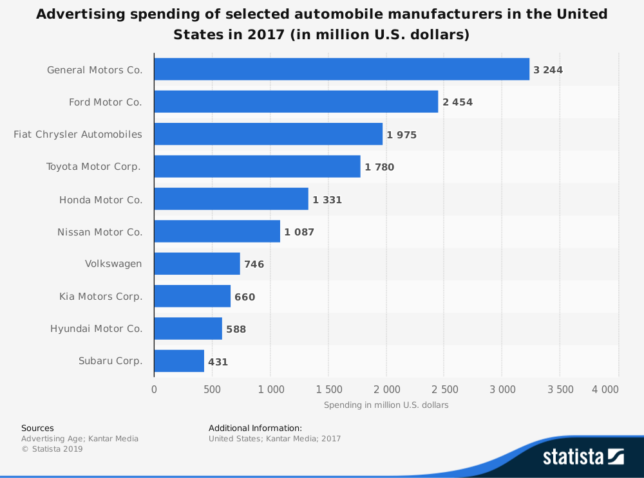
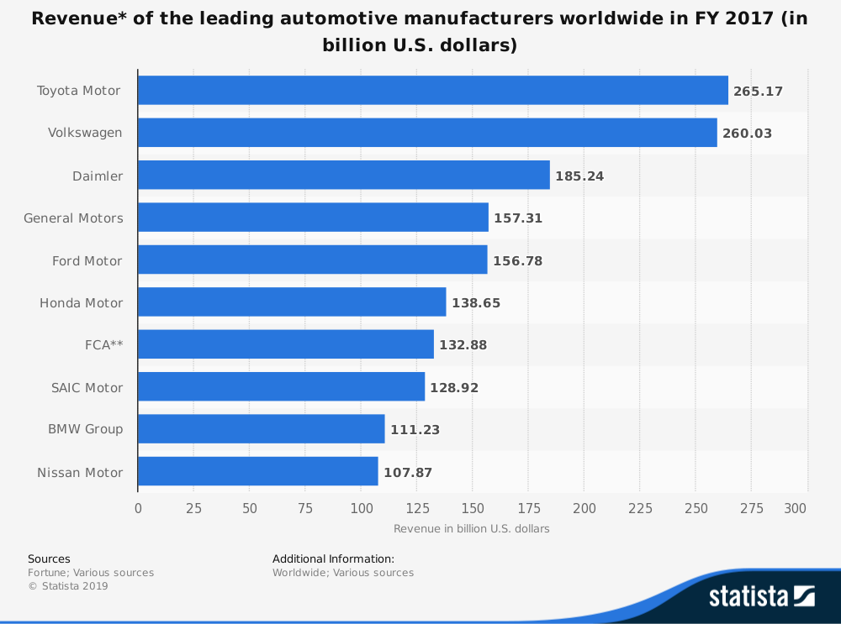
Next we’re going to look at Ford’s marketing strategy. Over the past 5 years Ford has spent right around $2.5B strictly on advertising. However, when you look at how much is spent on advertising each year, there is no solid correlation between revenue and advertising dollars. In the graphs, you can see the advertising dollars compared to revenue for various manufacturers across the globe. It’s interesting that GM who spends the most, $3.244B (~$800M more than Ford), on advertising is only making $53M more than Ford. However, the real outlier is Toyota. They rank fourth in dollars spent on advertising (less than $2B) and earn more than $100B in revenue. As we can see Ford needs to revitalize their advertising program in the coming years. And they have. After having the same major ad agency for 75 years, Ford has named BBDO as their new primary ad agency. This change was surprising to many, but BBDO hit the ground running and released a strong new ad that focuses on “building” the future.
Next we need to assess the success of Ford through the eyes of those closest to the company: the employees. Ford employs nearly 200 thousand employees across 40 countries and recognizes that without them, Ford would cease to exist. In order to attract and retain the best people, Ford has taken a Human-focused approach to understanding and fulfilling the needs of their employees. Employees requested a more intuitive and open line of communication that is open to them in the most stressful of time. Ford responded and will be launching “Life@Ford” this year. This portal will allow full-time digital access to policies, channels to that allow employees to connect through telephony, chat or email, with professionals. It also has a process that allows employees to have an open and continuous dialogue with management about growth, development, and the employee/supervisor relationship. Ford is doing this in an effort to increase the number of employees who are satisfied with the company, 71%. Ford is also trying to reduce the voluntary quit rate of salaried employees which is on the rise several key regions of the world.
Ford Motor Company appears to heading in the right direction. Jim Hackett is changing Ford in a very positive way and I believe that the goals he has put in place will be met. Now we’re going to discuss what makes Ford strong, and what threats are on the horizon.
Ford Motor Company is known for many things. Their name is most noteworthy of those things. In 1903 Henry Ford started this company with the idea of providing affordable transportation to anyone and everyone. Today, Henry Ford lives on inside of each and every vehicle that Ford produces. Because of this one of Ford’s primary strength is that name. Ford ranks among the top five most recognizable brands in the world. Ford has become an icon of cost leadership and dependability.
Ford’s next key competitive strength is the F-150 line of trucks. The North American arm of Ford has relied heavily on the profitability of the F-150 truck for many many years. In 2018 the Ford F-Series pickup trucks sold nearly double the number that GM sold. Ford has made many different improvements to their line of trucks in recent years. Mainly, switching from steel to aluminum for most body panels, creating the EcoBoost engine, and incorporating 6 speed transmissions with V6 engines in order to increase MPG.
Another strength that allows Ford to be so cost effective is their global supply chain. Ford is committed to transparency throughout their supply chain. With over 1200 suppliers worldwide, Ford makes it their priority to make sure raw materials are sourced responsibly. This not only fulfills corporate responsibility initiatives; but it also provides the assembly line workers with safer working conditions. Additionally, Ford is able to greatly reduce costs of shipping and material costs by having so many factories all over the world. Moreover, Ford makes it a priority to adequately train and improve their suppliers employees. This goes to show that Ford is investing from the bottom up.
Now on the other hand, Ford has several weaknesses. Primarily, Ford has higher costs and prices compared to those of their competitors. This can be attributed to the major increase in tariffs in the last three years. But it also has to do with the fact that Ford chooses to produce most of its vehicles with aluminum body panels instead of steel in order to reduce weight. When Ford chooses to do this, they must incur a higher cost for the metal; consequently, Ford is also even further affected by rising tariffs. However, Ford has made the decision to make strides to be sustainable and hold themselves responsible for reducing CO2 emissions created by their vehicles. The use of aluminum helps them achieve this.
Another weakness that Ford has is their low level of success in emerging markets like China and India. Until late 2018, Ford considered China just another country in ASEAN. However, that is quickly changing as Ford has recognized that China is a unique and formidable beast. Ford has decided to treat China as a separate business unit, as it does Brazil, the US, and the UK. In order to try to change this, Ford has upped its product mix in China in an effort to drive up sales and market share. Focussing primarily on midsize sedans and hybrids in this line, Ford hopes to compete with the established asian automakers.
Today, Ford is lucky to have the opportunities that this economy has to offer. Ride-hailing services are taking over in every major US city. Companies like Uber and Lyft have replaced Taxis but provided people with the ability to get rides anywhere at anytime without needing to own your own car. For many people in urban areas, owning a car is out of the question. But Ford has decided that even if you can’t own your own Ford, you should be able to ride in style. By partnering with Lyft Ford has placed itself in a position to potentially own a major market share in the autonomous ride hailing industry.
Which brings me us to the next opportunity for Ford, autonomous vehicle technology. One of Ford’s main objectives for 2018 is to create an operating system that connects drivers to their vehicles and vehicles to each other. By doing this, Ford is laying the groundwork that will allow for cars to communicate through AI and eventually remove the need for drivers all together. Ford has invested nearly $8B in R&D over the past year and is rapidly converting their product portfolio to run off of batteries instead of gasoline.
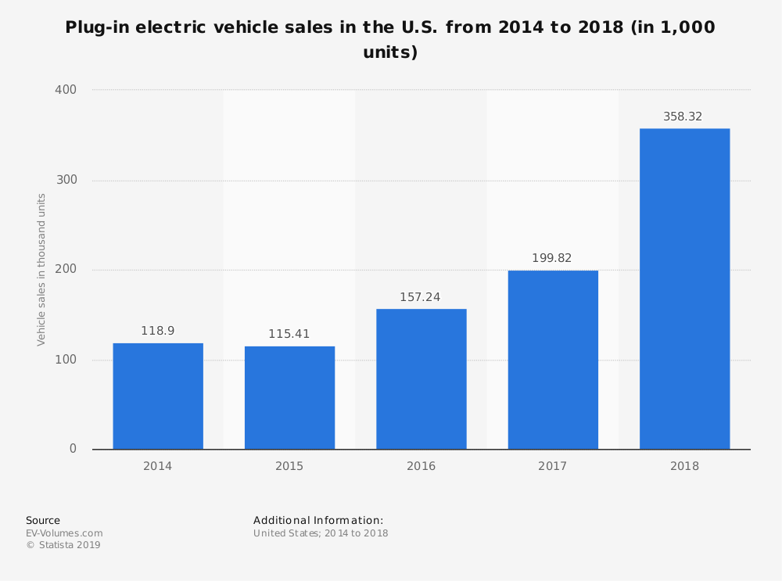
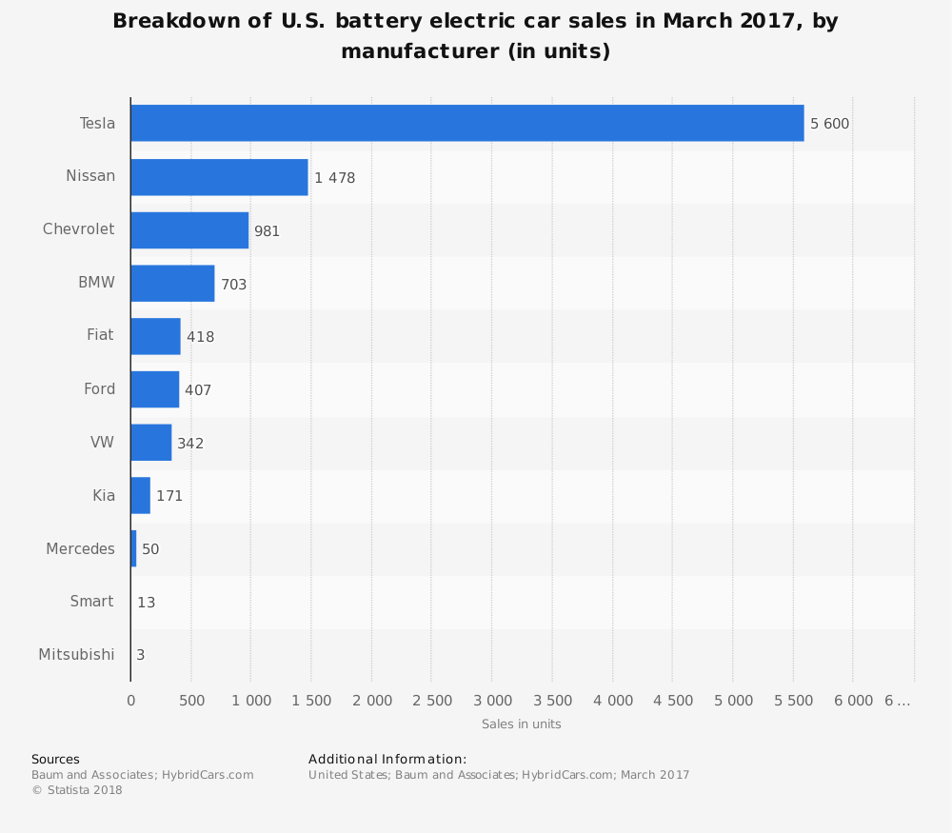
By 2022 Ford will have 40 different hybrid and fully-electric car models on roads all over the world. Ford, who is lagging behind in electric car sales, has refocused on the sustainability and necessity of electric cars. As shown in the graph, Ford is barely on the map for electric car sales, but the rate at which electric cars are being purchased is rising exponentially. Because Ford competes primarily on cost, if they can find a way to market very inexpensive electric cars, I believe Ford can rebuild shareholder confidence and continue the tradition of innovation that Ford is known for.
Finally, the threats that plague Ford start with the cutthroat competition that exists within the industry. Ford may have partnered with Lyft to get into the ride-hailing market, but Chevy is right there with them; owning 75% of Cruise, an autonomous ride-hailing service. Additionally, the influx of cheaper, more efficient, foreign hybrids makes competition even stronger. The more and more we talk about autonomy and app-based ridesharing, we see the trend that cars are no longer machines, but they are computers; thousands of them in each car. For the industry, this means that car manufacturers have to adapt and become technology companies. In this ever changing world, the company that is most flexible and reactive to the changing times is the company that will win.
The Ford Motor Company’s competitive strength has always been cost leadership. They have always tried to appeal to every customer possible by creating a car that everyone could afford, that was also very reliable. They started this by creating the assembly line to cut down on production costs, but shortly after, GM and Toyota closed the gap, making the cost leadership competitive advantage strategy obsolete. Ford began looking for other strategies that they could set themselves above the competition. Ford then decided to release the “One Ford” plan in 2008. This plan stands for One Team, One Plan, and One Goal. One Team stands for “people working together as a lean, global enterprise for automotive leadership, as measured by customer, employee, dealer, investor, supplier, union/council, and community satisfaction.” One Plan stands for “aggressively restructure to operate profitably at the current demand and changing model mix; accelerate development of new products our customers want and value; finance our plan and improve our balance sheet; work together effectively as one team.” Finally, One Goal stands for “an exciting viable Ford delivering profitable growth for all.” Ford designed this strategy to stand out as a family. They started to incorporate new product development and technology development, and try to do it as most cost efficiently as possible to maintain their primary cost leadership competitive advantage as well as their new strategy of differentiation. They are using this as an advantage by coming out with better designs for their F-series trucks. They are also incorporating several new technology based components such as Blind Spot Information System (BLIS) which is a cross-traffic alert system when you are backing out of a parking lot at a crowded store. They have come up with the Lane Keeping System which is a system designed to read the road and the lanes of the road. If you begin to drift into another lane, it will beep at you so that you can remain in your lane. It is a very handy piece of technology that Ford has produced that has increased their safety ratings. Another great piece of technology is Ford’s Pre-Collision Assist and Automatic Emergency braking. Ford was the first company to create this feature. What it does is it scans the road ahead for possible accidents or wrecks and if needed, it will break the car to help avoid a possible accident, especially if the driver is not paying attention. These along with countless other pieces of outstanding technology is what is setting Ford up for great achievement for a improved competitive advantage. Because not are they only producing amazing technology, they are able to produce it relatively inexpensive which consumers love. A huge competitive advantage is their safety ratings. In 2014, with the mustang, it got a three star safety rating compared to the Chevy Camaro (GM) which got a five star safety rating. Safety is one of the biggest driving factors for purchase by most people, especially families, because for most people, family is the most important thing in the world, and let’s be honest, getting in a car is one of the most dangerous things that we do everyday. So with Ford not having that high of a safety rating compared to GM and Toyota, it really hurt their sales. So what did Ford do? In 2015, they sat down and said that they are going to make safety a priority. They came out with several of the same types of cars and trucks, gave them a little bit of a design change, especially in the mustang, and these cars averaged about a four star safety rating, with a five star safety rating in the newly designed mustang. “Camaro sales total 11, 364 (up 3.8 per cent, from 10,944), while Mustang sales year to date total 17, 148 (up 66.6 per cent, from 10,291).” As you can see from this data, Ford’s sales of the new Mustang went above and beyond the sales of the Camaro. In 2014, many people bought the Camaro, not necessarily because its performance and features were better, but that they were similar to the Mustang, but the safety rating was two stars higher. But in 2015, with the Mustang evening out the competition, Ford killed GM by about six thousand more sales just on the Mustang model compared to the Camaro model. This boosted sales for Ford and has put them in a better competitive advantage in all of their models.
Ford has several resources and assets that provide them with a distinctive competency. The main ones however are their costs, fuel emissions, and their technology. Ford continues to have the lowest production costs even within the technology aspect, which in turn, creates lower priced cars that beats out a lot of the competition. They have become more environmentally conscious than their competition and have the lowest fuel emissions. This creates a competitive advantage with today’s society really focusing on how to preserve and protect the planet. Ford does this by producing a hybrid car that runs on both gas and on an electric battery. They also have created technology that recognizes when a car is sitting still for a certain amount of time, it will automatically turn off the engine, and then automatically restart it when you take your foot off of the brake. What this does, is that it lowers fuel emissions which please the environmentally conscious people. These assets are both rare and non-imitable which creates a temporary competitive advantage. Their ability to create this type of technology for as inexpensive as they do, remains one of the biggest advantages that Ford has.
From day one, Ford’s primary, generic strategy for competitive advantage was their cost leadership strategy. Their relative cost position was to be able to maximize production and minimize costs. They achieved this by developing the assembly line. However, once they did this, their competitive advantage was only temporary. However, still to this day, Ford continues to produce their cars and trucks cheaper than other companies which allows them to sell their cars and trucks at a cheaper price. They have also narrowed the gap on their safety features and technology as well. So they are able to produce a very similar car to GM and Toyota, have some of the same features, and even newer or better features for a smaller price. There cost position is one main reason on why they have a great competitive advantage. Ford produces cars that everyone can afford and they are some of the most fuel efficient, cost efficient, and now some of the safest cars ever made. They are relatively inexpensive to produce, compared to other companies. They are very reliable, and easy to learn how to use, and easy to fix if ever necessary. They are very durable and long-lasting as well. Ford has created a great cost position by being able to do this, which has led to a huge competitive advantage.
One of the main hindrances on a company’s success path is strategic issues and problems. These issues are the elephants in the room keeping your organization from reaching its goals and being the best company within an industry. There are two types of strategic issues external and internal. External influencers would include factors outside of your company such as the economy, political atmosphere, government policies, competition, and customers and suppliers while internal is comprised of things within such as employees and management, company culture, cash and resources, and research and development. For the sake of company analysis, we will be focusing on internal analysis as external problems tend to affect the entire industry and are for the most part out of Fords control. With this basic understanding of strategic issues, we can now dive deeper into Ford using the four specific internal criteria listed to find out some of the key problems the company is currently facing and do an in-depth analysis of the company’s current state of affairs.
While conducting research a quote stood out, "Every time Ford turns over a rock, they find more problems." This was very telling of what it can be like to conduct business in one of the largest, most rapidly changing, and cut throat industry’s out there which is the automotive industry.
First, we will go over one of if not the most important aspects of a business and that is the people running it, employees and management. This is one of Ford's stronger areas in comparison to the other factors. Ford offers their employees a strong wage compared to other manufacturers, really good benefits, and opportunity for advancement. Ford tries to have an inclusive family approach and boasts that from a first-year entry-level research assistant up to a managing director can bring an idea to the company to get it patented. If a group of engineers, lawyers, and researchers think an idea is worth pursuing, the company will then help that person get the patent. But it’s not just patents, if Ford sees value in your idea, it will help that employee turn it into a reality. Despite this being one of Ford's strongest areas it is not immune to problems, however. The extremely competitive and stressful environment is noted as a negative when it comes to the employees. Other complaints are very commonly heard about working at Ford such as long hours, inconsistent pay, and not receiving holidays or time off. The turnover rate can also be fairly high and is a key strategic issue because they are wasting resources interviewing and hiring people frequently. Ford will have to address these problems so that they don’t lose good employees and new people look forward to working at Ford.
Next, we will discuss something in close relation to employees and that is culture. Organizational culture encompasses values and behaviors that contribute to the unique social and psychological environment of a business. In the case of Ford Motor Company, organizational culture influences the firm’s drive toward higher performance to achieve its vision and stay true to its mission statement. A company’s organizational culture defines the values, customs and traditions that affect individual and group behaviors. Ford uses its corporate culture to maintain a high-performance workforce. As the fifth biggest player in the global automobile market, the company needs to maintain high productivity and effective support. When researching and reading employees comments about Ford’s culture there was an expected mix of good and bad. A significant case came out recently about sexual harassment in Ford plant in Chicago. Ford agreed to pay $10 million to victims and step up training for its workers, but significant damage to the brand and culture was already done. Ford took correct action however and recent culture change has been occurring due to the firing of the old CEO and the hiring of Jim Hackett. Leadership and the plans, policies, and procedures the leaders implement have a huge influence on the company’s culture. Ford is successfully turning around a negative workplace perspective and the culture seems to be improving with the right leadership in place.
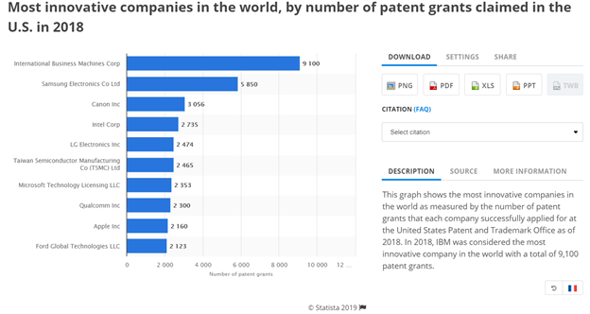
Thirdly we will get into the more financial aspect of the analysis with Ford's cash and resources. For this we will compare and contrast the capital of Ford with Toyota and General Motors to gain insight on how Ford delegates its assets and detect if there is any problems or major current issues preventing Ford from being the biggest of the big three.Ford Motor Co is one of the world’s most iconic companies and has been among the world's largest for decades. Their true leverage against competitors comes from their brand and their dedication to marketing. Ford has less resources than competitors like Toyota and General Motors so it has to be wise and pick it’s battles. It spends massive amounts of its resources in marketing and sponsorships (shown by the graphs) to keep the brand exciting, relevant, and hip. This tactic works phenomenally in the United States, but a problem becomes evident with Fords recourse and cash delegation when you observe how they are doing internationally. They lost money in every other region of the world last year and in most regions, the results were worse than a year earlier which led to a sharp drop in company-wide net income. This is obviously a huge issue Ford will have to address very soon and try and figure out a way to make their powerful brand spread overseas.
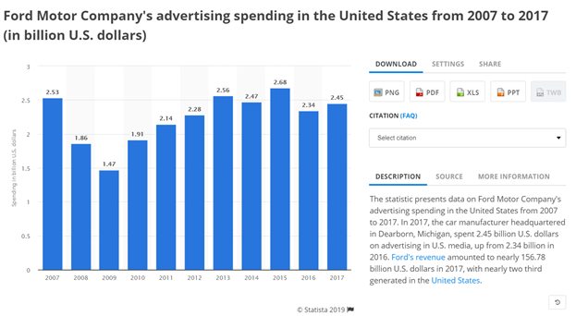
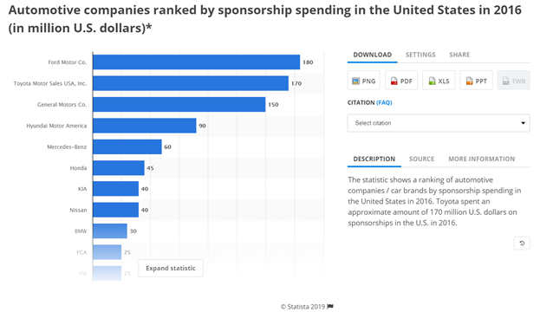

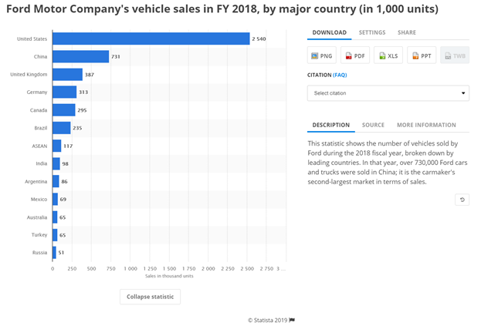
The last internal aspect we will discuss will be research and development. Seeing how ford stacks up in this category and seeing where they can improve will give us valuable insight on potential growth of the company. Research and development refers to the activities companies undertake to innovate and introduce new products and services. The goal is typically to take new products and services to market and add to the company's bottom line. Coming full circle, like employees and management, Ford does very well and invests a lot into trying to be innovative. When the new CEO took over this was a key direction he wanted to go in and he said "At Ford, we view ourselves as both a mobility and an auto company, as we drive innovation in every part of our business." The main ridicule when it comes to Fords research however has been maybe they are not innovating in the right area. Just because they are throwing money at innovation does not mean they are seeing the future correctly. It seems Ford has spent billions in developing a self-driving car, but in the process, it has been left in the dust in the electric car industry which could end up biting them in the end.
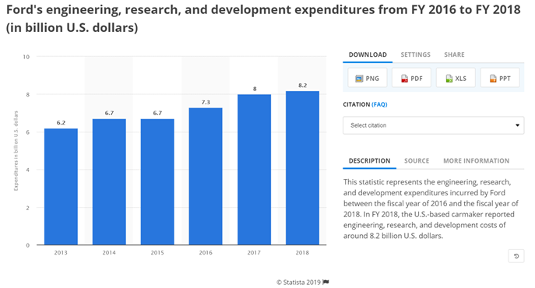
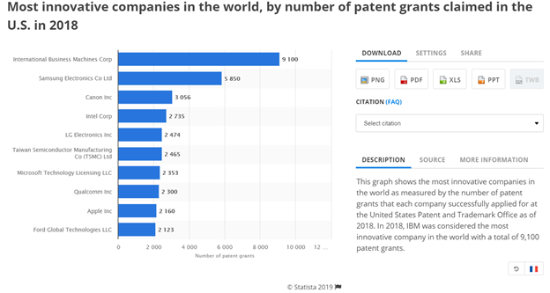
The analysis in this paper revealed that Ford sustains its success as an automotive empire and major global power through its unique, but effective business approach. Although the end goal of every car manufacturer is to maximize profit it is fascinating to see just how different the strategies can be. Ford does a lot of things differently than its competitors, but still sees results and is working towards constant growth. We broke down the company analysis into major key steps to evaluate the company’s current standing and see just how they are successful and to captivate what makes them Ford. First, we analyzed the present strategy, next a SWOT was conducted, after that we further assessed the company’s relative competitive strengths, then we discussed Fords cost position, all before concluding strategic issues and problems. Through our research we discovered that although flawed in some aspects Ford has many advantages and strengths that help it maintain its position as a top shark in the red ocean of the automotive industry.
Works Cited
Ferris, R. (2018, December 04). Once-venerable Ford faces an uncertain future. Retrieved from https://www.cnbc.com/2018/11/30/legendary-ford-faces-an-uncertain-future.html
Inside a Culture of Harassment at Chicago Ford Plants. (n.d.). Retrieved from https://news.wttw.com/2018/01/04/inside-culture-harassment-chicago-ford-plants
Isidore, C. (2019, January 24). Ford's woes overseas get worse. Retrieved from https://www.cnn.com/2019/01/23/business/ford-earnings/index.html
Lombardo, J. (2017, February 05). Ford Motor Company's Organizational Culture Analysis. Retrieved from http://panmore.com/ford-motor-company-organizational-culture-analysis
Miller, D. (2018, July 31). 3 Alarming Takeaways from Ford Motor Company's Tough Second Quarter. Retrieved from https://www.fool.com/investing/2018/07/31/3-alarming-takeaways-from-ford-motor-companys-toug.aspx
Muller, D. (2015, January 23). Ford to have one of largest R&D operations among automakers in Silicon Valley. Retrieved from https://www.mlive.com/auto/2015/01/ford_to_have_one_of_largest_rd.html
Murphy, M., & Murphy, M. (2016, September 11). Ford is solving problems by getting all its employees to think like inventors. Retrieved from https://qz.com/774651/ford-cars-are-innovative-because-employees-are-treated-like-inventors/
Singer, Drew. “Ford Mustang Sales Eclipse Chevrolet Camaro Sales In February.” GM Authority, 4 Mar. 2015,gmauthority.com/blog/2015/03/ford-mustang-sales-eclipse-chevrolet-camaro-sales-in-february/.

Sherman, F. (2019, March 08). What Are Internal & External Environmental Factors That Affect Business? Retrieved from https://smallbusiness.chron.com/internal-external-environmental-factors-affect-business-69474.html
“Employee Engagement.” Employee Engagement - Sustainability Report 2017/18: Ford Motor Company, corporate.ford.com/microsites/sustainability-report-2017-18/performance-data-reporting/people-society/engagement.html.
“Company.” Ford Corporate, corporate.ford.com/company.html.

Rowland, Christine. “Ford Motor Company SWOT Analysis.” Panmore Institute, 5 Feb. 2017, panmore.com/ford-motor-company-swot-analysis.
“Employee Experience Lessons From Ford Motor Co.” Keka, 30 Nov. 2017, www.keka.com/employee-experience-lessons-ford-motor-co/.

