Competitive Situation Analysis
General Motors Company
MGT 4380 11AM
Dr. Kim Boal
Team 4: Sofia Paredes, Haylee Berner, Dylan Hawkins, (Linna)Zihui Wu
Texas Tech University

TABLE OF CONTENTS
Introduction…………………………………………………………………………………….… 2
General Motors Current Performance …………………………………………………………… 2
Accounting ……………………………………………………….…………………........ 2
Financial Criteria …………………………………………...…………………….…….. 3
Marketing Criteria …………………………………….……………………………..….. 3
Compared to Other Manufacturers …………………...……….....…………………........ 4
Strategic Performance Indicators ………………………………………………………………....4
Market Share ……………………………………………………………………………...4
Sales Growth ……………………………………………………………………………...5
Stock Prices………………………………………………………………………………………….5
Net Profit Margin ………………………………………………………………………....6
Return on Equity ……………………………………………………………………...…. 7
SWOT Analysis: General Motors ………………………………………………………….…......7
Strengths……………………………………………………………………………......... 9
Weaknesses……………………………………………………………………………….10
Opportunities………………………………………………….......……………………. 12
Threats…………………………………………………………………………….……. 13
SWOT Analysis: Ford …………………………………………………………………...……. 15
Strengths………………………………………………………………………….…….. 16
Weaknesses……………………………………………………………………...……… 19
Opportunities………………………………………………………………………..….. 20
Threats………………………………………………………………………………….. 21
SWOT Analysis: Toyota …………………………………………………..………………...… 23
Strengths…………………………………………………………………………….….. 24
Weaknesses…………………………………………………………………………...… 27
Opportunities………………………………………………………………………..…. 27
Threats…………………………………………………………………………………. 28
GMs Resources and Capabilities………...………………………………………………..…… 29
Company Capability Profile …………………………………………………………….….…. 31
Competitive Strength Assessment …………………………………………………………..… 33
Relative Cost Position …………………………………………………………………..…….. 43
Organizational Life Cycle ……………………..…………………………………………..….. 45
Strategic Issues and Problems ……………………………………………………………….... 51
Recommendations………………..……………………………………………………………. 54
Conclusion …………………………………………………………………………………..... 55
References ………….…………………………………………………………….………....…56

INTRODUCTION
General Motors Company (GM) is an American multinational corporation whose headquarters reside in Detroit, Michigan. GM is one of the “Big Three” automakers of the world (GM, Ford, Fiat Chrysler) and has historically been one of the most successful with their design of, manufacturing, marketing, and distribution of vehicles and vehicle parts. General Motors has made it their goal to produce cars that portray modesty and class for a wide variety of consumers. Some of their more popular brands include: Buick, Cadillac, Chevrolet, and GMC. Simply put in the words of Alfred P. Sloan, GM’s CEO in the 1920s, “GM makes a car for every purse and purpose.”
CURRENT PERFORMANCE
General Motors Balance Sheet for 2018 and 2017:
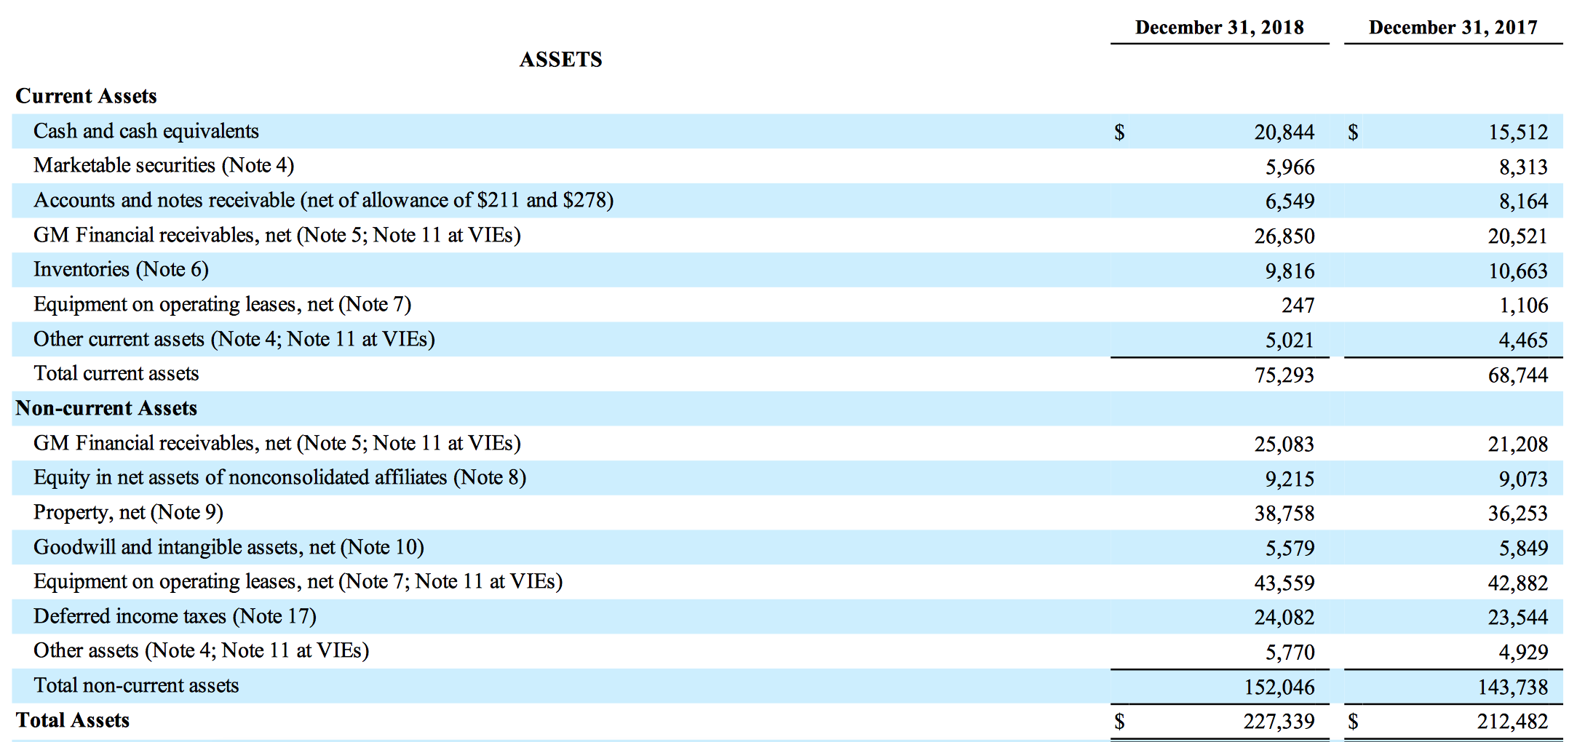
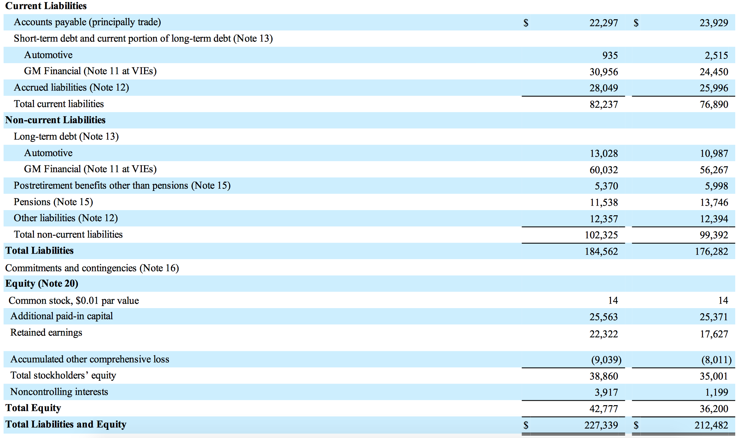
Financial Information:
In the past year, General Motors has continued to grow their current assets and their non current assets. For example their cash and cash equivalents have increased from $15,512 in 2017 to $20,844 in 2018 and that number should increase even more this year. However, with the increase in their assets this will only cause liabilities and equity to increase. For example, their long-term automotive debt in 2017 was $10,987 and in 2018 it was $13,028. For a company to do well it will need more assets than liabilities and equity, but for General Motors their assets equal their liabilities and equity which explains why their net profit margin stays close to zero.
Marketing Information:
General Motors produces and sells four main models of vehicles: Buick, Cadillac, Chevrolet, and GMC. General Motors works towards brand recognition and new technology to achieve a great marketing strategy. Further information is stated in the marketing strategy section of the paper.

Comparison Information:
General Motors is the largest automobile maker in the world today. Their main competition comes from the Ford Motor Company and the Japanese company, Toyota. Many different strategies are implemented into creating a space between the three companies. GM focuses on creating lasting relationships with their customers while Ford concentrates on getting the lowest price. Toyota also puts a great deal of time and money into the development of their vehicles. More comparison information can be found throughout the paper.

STRATEGIC PERFORMANCE INDICATORS

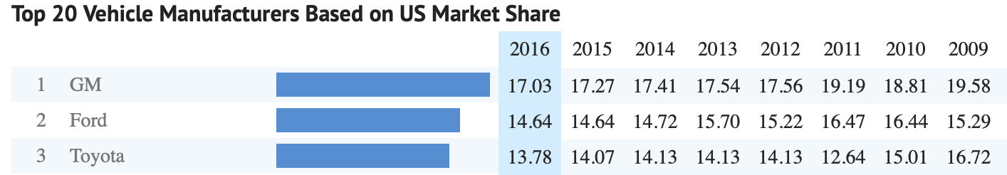
In the figure above is a comparison between GM and their competitors. You can see that GM holds the number one spot in the US for the vehicle manufacturer market share. This is mostly due to the fact that they have more brand within their company compared to Ford and Toyota. This is very beneficial to the organization because the more of the market share that they control, the more revenue the company will earn. According to the Boston Consulting Group (BCG), the correlation between market share and profit is called the experience curve. Companies who have a larger market share cumulate sales at a faster rate than their competitors leading to have more market power. The more market power a company has the more flexibility it has to price their products at a certain cost. Another correlation that the BCG found is how the quality of management directly ties to market share. Good managers will be able to achieve high shares within their market, control costs, and maximize the productivity within their company.
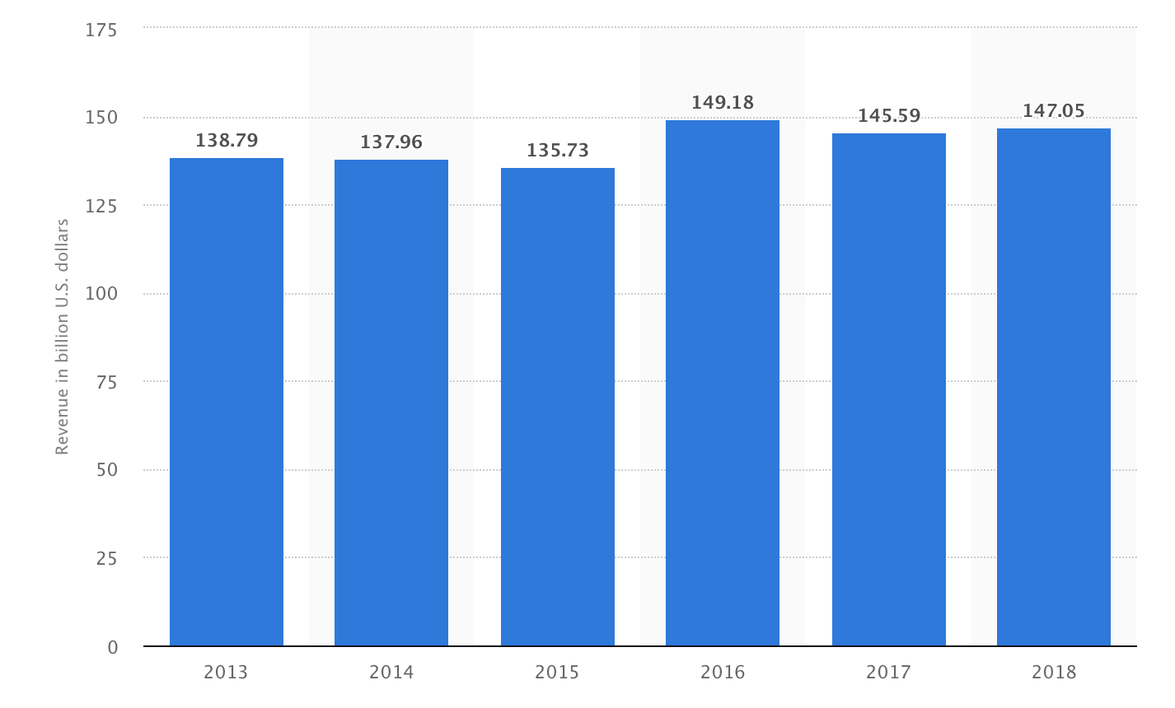
In this this figure one can see the sales growth for GM over the last five years. You can see that the company has stayed within the same range of profit, which is very good for GM keeping them in a stable position. Sales growth is very important to companies because it shows that the market conditions are doing well. It also shows that whatever strategy the company is using is working, but maintaining this stability can be very challenging according to Marketing91. If the sales growth is negative then the company needs to change their strategy because something is not working. Due to the fact that the market is always changing the company has to adapt with the changes or its growth will start to decline.
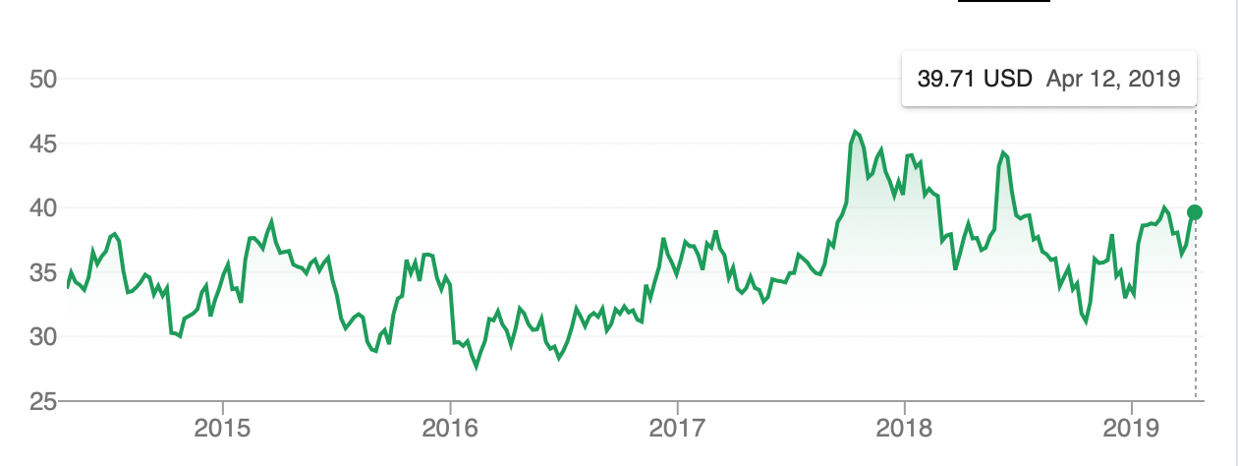
Above is the stock prices for GM over the last five years. There is no consistency between these numbers which is normal for any company who trades their stocks within the stock market. A healthy stock price represents a company’s financial health, the higher the stock price the better off the company is doing and vice versa. Even though GM’s stock prices have taken drastic falls they tend to rise up then fall creating a never ending cycle, they stay near or above the $30 per stock mark.
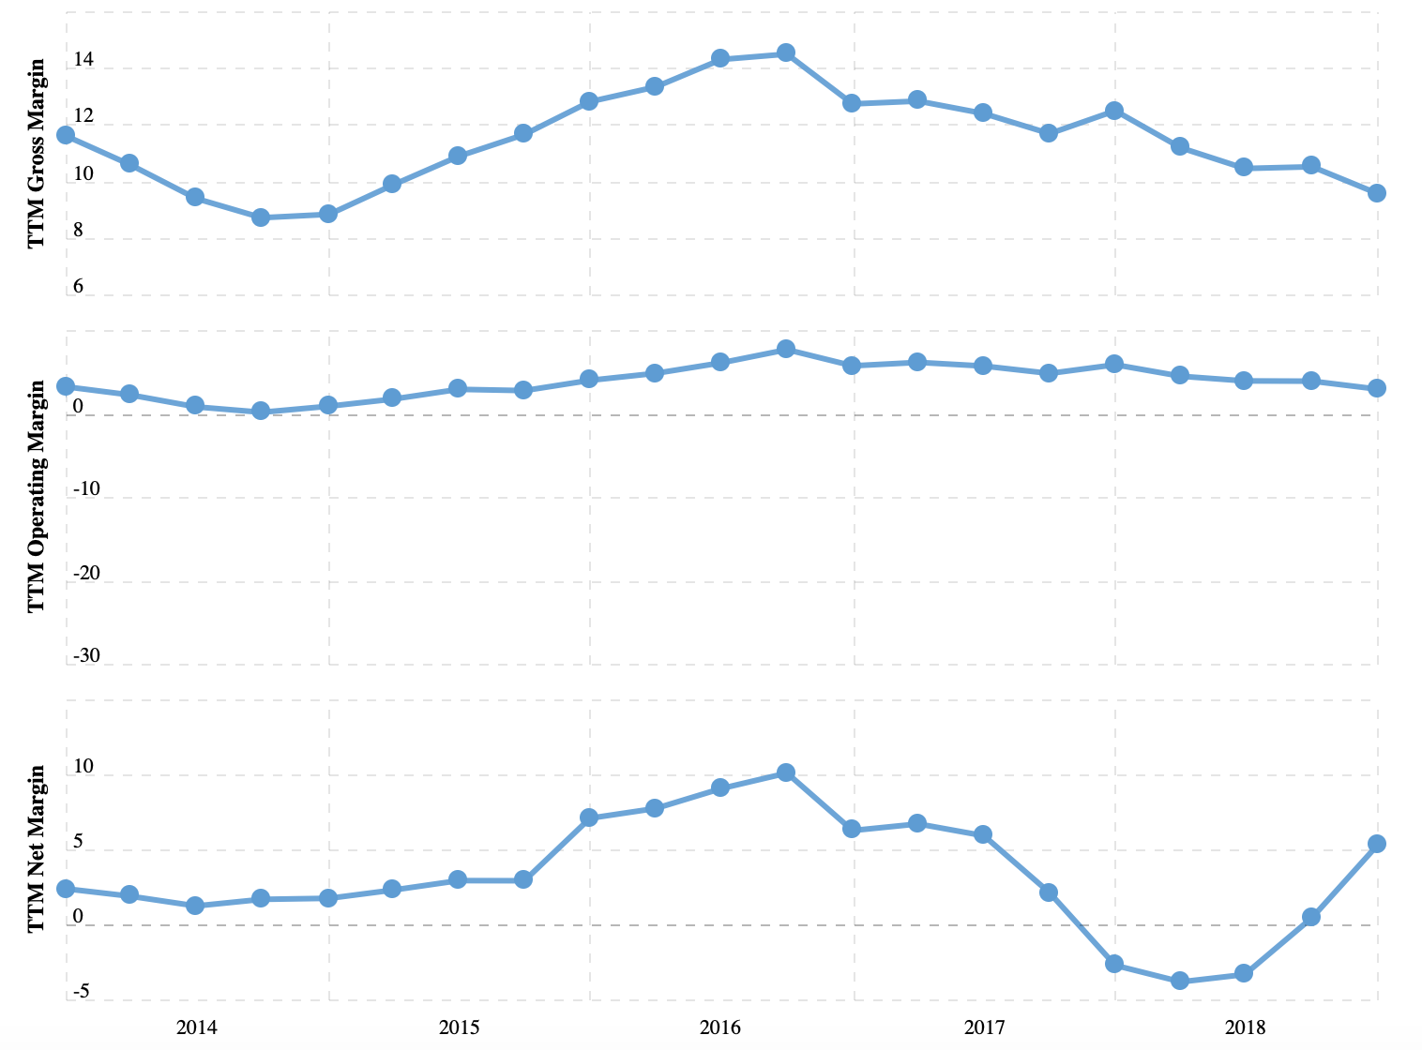

In this figure above you can see GM’s profit margins. The net profit is the percentage of a company’s total sales exceeds or is less than the company’s expenses. One can see that GM’s net profit margin stays near the zero mark which is not very good. GM needs to take steps to increase their profit margin in order for them to start earning more profit from their products. When a company has a higher profit margin the more control they have to purchase more goods and produce and provide better products (Hamel).

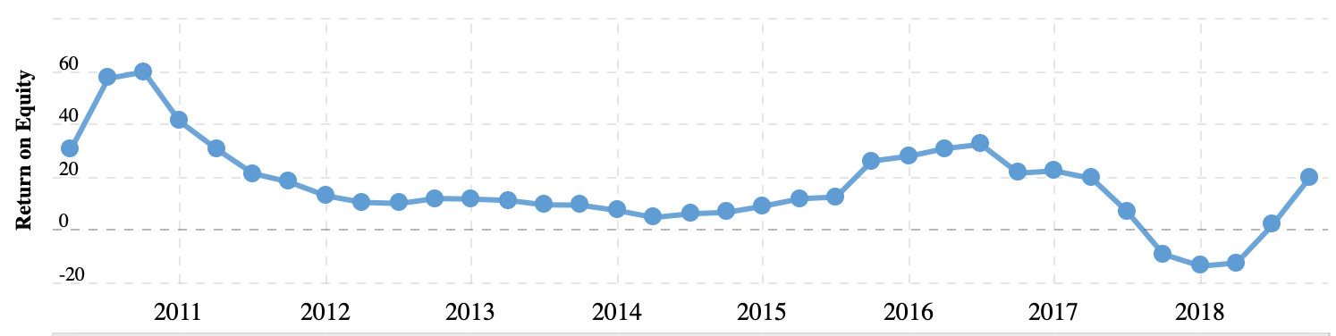
In the right side of the figure above you can see the current ROE for GM as of April 2019. In the past couple years you can see how the ROE took a big dive and is steadily increasing. When looking at ROE one needs to realize how important this is to a company. ROE shows much profit a company earned compared to the total amount of the shareholder equity that can be found on the company’s balance sheet. It also measures the company’s performance, therefore the higher the number is the better resulting in the company’s ability to raise more money for growth.

SWOT ANALYSIS: GENERAL MOTORS
The SWOT analysis is a model or tool that managers use to identify the most significant internal strategic factors (strengths and weaknesses) and external strategic factors (opportunities and threats). In our case, General Motors’ SWOT analysis points to business strengths and weaknesses that determine capabilities in addressing issues and challenges in the automotive industry. For example, the company’s organizational size and network reach support strategic implementation. However, General Motors must address issues related to competition and business bureaucracy. Decision makers must then utilize the SWOT factors to ensure proper “fit” between strategies and GM’s actual business conditions. Such “fit” facilitates streamlining, effectiveness, and the minimization of success barriers in strategic implementation. Thus, it is essential that General Motors address the internal and external strategic factors facing its business.
Below we have presented a SWOT analysis of General Motors Company in hopes of stressing the importance of managing appropriate strategies to maximize the benefits of business strengths in overcoming weaknesses, exploiting opportunities, and addressing threats. By doing this analysis, we are able to in which areas General Motors needs to address the strategic factors to gain competitive advantage.
General Motors SWOT Analysis
STRENGTHS | WEAKNESSES
Global presence  New vision and strategy  Strong brand portfolio  Strong presence in China  Knowledge of home market  Well performing brands | Brand dilution  Bureaucratic culture  Car recalls  Limited Diversification

OPPORTUNITY | THREATS
Positive attitude towards “green” vehicles  Increasing fuel prices  Changing customer needs  Growth through acquisitions  Growing global automotive industry | Increased competition  The rising U.S. dollar exchange rate  Increasing government regulations may raise the costs  U.S. automotive market is poised to slow down or even decline

Strengths: (Internal Strategic Factors)
This aspect of the SWOT analysis lists the internal strategic factors that support General Motors’ growth and development. These factors include organizational capabilities and potential in strategic implementation to address issues and opportunities in the automotive industry. General Motors Company has the following strengths:
- Global presence: GM was the leading auto manufacturer in terms of sales for 77 years until 2007. The business has grown its presence in the world and is now operating in 157 countries. We can thus say that GM is in a strong position to maintain its major position in the automobile market. For example, strong brands help ensure the company’s competitive advantage despite rising competition from large automobile manufacturers like Toyota. This strength also empowers the company to maintain competitive advantage based on extent of market reach and production capacity to address market demand. However, considering changes in the industry, General Motors must optimize its position. Optimization is key in keeping the company’s position in the global industry.
- New vision and strategy: GM has undergone major changes in the way it does business after the 2008 bailout. Daniel Akerson was appointed CEO and the company got a completely new management team. Akerson introduced new strategy and visions to the business. GM became smaller but leaner and is becoming more cost competitive
- Strong brand portfolio: GM currently sells a multitude of automobile brands that satisfy as many customers as possible. The most popular brands are Cadillac, Buick, GMC and Chevrolet that sell very well in USA and China. In 2012, Chevrolet reached a global sales record and sold 4.95 million units.
- Strong presence in China: China is the second largest market for GM in terms of vehicle units sold. It is also important to know that China is the largest automotive market. With that being said, GM’s early entrance into China and it’s partnership with local Buick brands are the main reasons behind GM’s strong presence in China.
- Knowledge of home market: GM is still one of the largest car manufacturer in the U.S. and currently holds more than 18% market share due to its extensive knowledge of the U.S. market and its consumers.
- Four well performing brands: GM’s Cadillac, GMC, Chevrolet and Buick are among the best-selling brands in the U.S. and China and brings in more than 80% of all General Motors sales. These strong brands are a strength that supports General Motors’ competitiveness in terms of customer loyalty and the attractiveness of its automobiles. For example, customers are more likely to have a positive response to GM products compared to relatively unknown new brands.
A strength not listed but important to mention since it will be elaborated on later is that General Motors has human resource expertise based on the company’s long history of automobile development and manufacture. This strength facilitates the development of new products that can directly compete against automobiles from other large firms, such as Tesla. In this aspect of the SWOT analysis of General Motors, business strengths sustain the company’s capabilities as a major competitor in the automotive industry.
Weaknesses: (Internal Strategic Factors)
The internal strategic factors that lessen General Motors Company’s organizational growth and development are considered in this aspect of the SWOT analysis. Some of these factors are organizational characteristics that limit employee contributions to the performance of the automotive business. In this case, General Motors has the following weaknesses:
- Brand dilution: GM controls 18 automobile brands that vary in quality and are sold in separate markets. With so many brands in sales, customers find it hard to identify which brand belongs to the GM family. This results in lower GM brand awareness.
- Bureaucratic culture: Before reorganization in 2008, GM was infamous for its rigid culture and structure. Since then, the company has made some cultural and structural changes but unfortunately it still isn’t as quick as its competitors in reacting to the constantly changing environment. Such bureaucracy is responsible for limitations in the company’s flexibility in responding to issues in the external environment. Although this bureaucracy is also based on General Motors’ organizational structure, top managers consider culture as a primary means of addressing the matter. On the other hand, limited presence in developing countries is a weakness that affects the company’s potential growth in these markets. For example, General Motors offers only Chevrolet automobiles in India. Also, there are no Cadillac automobiles in Argentina and Brazil. Moreover, General Motors suffers from limited business diversification.
- Car recalls: Product recalls have a negative impact on a brand’s image: In the recent past, GM has recalled a number of vehicles due to defective parts or after sales defects. These recalls were expensive and tainted GM’s reputation.
- Limited Diversification: The company has only two main businesses – its automotive business and GM Financial, a financial services business. Limited diversification exposes the company to greater market-based risks. This aspect of the SWOT analysis shows that General Motors’ potential global growth is hindered by its weaknesses.
Opportunities: (External Strategic Factors)
In this aspect of the SWOT analysis, external strategic factors that support General Motors’ business growth and development are identified. These factors can pave the way for the company to improve its profits and position in the automobile market. The following opportunities are significant in the case of General Motors:
- Positive attitude towards “green” vehicles: Today consumers are more aware of the negative effects caused by cars fueled by petrol and diesel. Thus, consumers are more likely to buy new hybrid and electric cars that emit less CO2. The demand for Hybrid Electric vehicles (HEV) is expected to grow at a strong rate considering strong concerns about the environment.This demand is set to benefit GM as it is investing heavily in developing plug-in hybrid electric vehicle technology.
- Increasing fuel prices: Increasing fuel prices open up large markets for GM’s hybrid and electric cars as consumers shift towards cheaper fuel types.
- Changing customer needs: General Motors is constantly introducing new car models. This will meet more customer needs for smaller and more fuel-efficient cars.
- Growth through acquisitions: GM has successfully acquired many car companies in the past. If GM chooses to continue doing this practice, it will gain new skills, assets and access to new markets.
- Growing global automotive industry: The global automotive industry has shown steady growth in the previous decade and is expected to follow a similar trend in the years ahead. GM, being one of the leading global automotive manufacturers is expected to benefit from this growth.
Threats (External Strategic Factors)
GM’s weaknesses point to possible inefficiencies in the organization. This element of the SWOT analysis model determines the internal strategic factors that serve as obstacles to business growth. General Motors’ main weaknesses are as follows:
- Fluctuating fuel prices: Due to increasing extraction of shale gas, future fuel prices should drop and make electric and hybrid cars less attractive. On the other hand, steeping fuel prices would make current GM models less attractive to cost conscious consumers, as they demand smaller cars that consume lower amounts of fuel.
- New emission standards: The automobile industry is globally influenced by various regulations and laws governing environmental and safety laws. Companies have to strictly comply to such laws which increases compliance costs for them. With this being said, a new wave for stricter regulations on vehicle emission standards may negatively affect GM’s finances. The corporate would have to invest large amount of money to comply with these new standards.
- Rising raw material prices: Rising prices for raw metals will lift the costs for auto manufacturers and result in squeezed profits for the companies.
- Intense competition: For 77 years from 1931 to 2007, GM led global sales of vehicles, but lost its position in 2008 due to increased competition of cheaper and better quality cars, especially from Japan and South Korea. To this day Gm is still subject to competition from many popular brands in all of its categories. Intense competition also impacts the market share of GM and its margins. Some of its competitors are Volvo, Honda Motor, Hyundai Motor, Nissan Motor and Volkswagen etc.
- Exchange rates: This threat is important to consider because GM has operations worldwide and thus it has currency exposures in many of its transactions. China is GM’s second largest market and the business earns huge profits there. Exchange rate fluctuations threaten GM’s profits if the dollar would appreciate against Chinese renminbi. Any fluctuation in the currency with respect to the Dollar has the potential to positively and negatively impact the transactions. This can directly affect revenues and profitability of GM.
Conclusion SWOT: GM
What this SWOT analysis is ultimately telling us is that General Motors is in a strong position in the automotive industry. For example, economies of scale, strong brands, and human resource expertise are major strengths that empower the company and its competitive advantage. General Motors can use these strengths to ensure positive business performance despite organizational weaknesses. These strengths can also address some of the threats and opportunities, such as competitive rivalry and expansion of market presence, respectively.
General Motors, however, needs to implement strategic reform for business resilience. Such reform must address the company’s weaknesses and threats, and exploit the opportunities available in the automotive industry. For example, an aggressive GM dealership strategy can expand the company’s global market presence. Based on the most significant internal and external strategic factors in this SWOT Analysis we recommend the following for General Motors Company:
GM should continue reforming the organizational culture to address the issue of bureaucracy and should grow the dealership network to expand GM’s market presence in developing countries. Finally, GM should increase its rate of innovation to improve competitiveness and protect the business from potential disruption in the automotive.

Ford SWOT Analysis
Ford Motor Company is one of the largest automobile manufacturers in the world. Apart from manufacturing it also provides financial services through Ford Motor Credit. It has Ford and Lincoln under its banner as well. It is headquartered in Dearborn, Michigan in the United States and has around 199000 employees working for them as of 2015. With that being said, Ford Motors is among the most renowned automotive brands of the world. Known as an innovative vehicle brand, the company has achieved a leading position in the automobile industry, like General Motors. Apart from research and development, marketing has also become a major focus area for Ford. The company has continued to grow its revenue for several consecutive years and now makes and sells a full line of Ford cars, trucks, sport utility vehicles (“SUVs”), electrified vehicles, and Lincoln luxury vehicles. In other words, Ford is aggressively focusing on reducing costs as well s allocating capital and resources to the markets with the highest potential. We have presented you with the following SWOT Analysis of the firm to better understand their capabilities.
STRENGTHS | WEAKNESSES
Brand image and equity  manufacturing capabilities and supply chain  Large product portfolio  Focus on innovation  Position in US and China markets  Financial position  Marketing capabilities | Product Fails  Emerging Markets  Product Recalls  Weak Position in Emerging Markets

OPPORTUNITY | THREATS
Expansion  Hybrid, electric and fuel cell  AI and autonomous driving  Digital marketing opportunities  Supply chain digitization  Electrical vehicles | Environmental Regulations  Global Economy  Intense competition  Regulatory threats  Rising costs of raw materials and labor

Strengths:
- Brand image and equity: Ford has got a strong brand image as an automotive brand focused on innovation, passenger safety and product quality. Brand image is an important strength in the vehicle industry and translates into high level of popularity and customer loyalty. Ford is considered a reliable brand whose popularity is quite high in the American market. High level of brand equity has led to consistent performance over the previous eight years. However, although Ford has a strong brand reputation globally with a presence in 62 countries, there is room for improvement. Both Forbes and Interbrand currently rank the Ford brand behind its international rivals Toyota, BMW, Mercedes-Benz and Honda.
- Strong manufacturing capabilities and supply chain: Ford has got strong manufacturing capabilities and a well managed supply chain. These are critical strengths for any vehicle maker. The brand has 61 manufacturing facilities all around the globe. Out of these 61, 31 are located in North America, 8 in South America, 16 in Europe as well as 2 in Middle East and 4 in Asia Pacific. Total 39 of its manufacturing facilities are a part of its zero waste fill program.
- Large product portfolio: Ford has a large product portfolio that includes SUVs, trucks, cars and luxury vehicles. the brand makes and sells a full range of Ford cars, trucks, sport utility vehicles (“SUVs”), electrified vehicles, and Lincoln luxury vehicles. Apart from that it also provides financial services through Ford Motor Credit Company LLC (“Ford Credit”), and is pursuing leadership positions in electrification, autonomous vehicles, and mobility solutions.
Focusing on one model in particular, Ford’s F-Series pickups outsold nearest competitor in this segment by more than 200,000 vehicles in 2017, taking a 31.8% share of the pickup vehicles market.
Figure 1. Best-selling pickup trucks in the U.S. 2015-2017
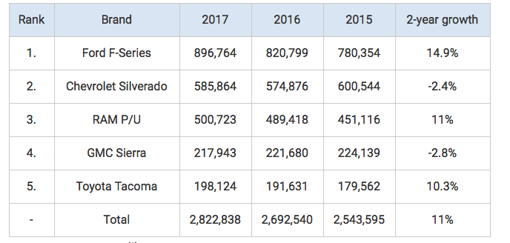
The company heavily invests in its F-Series product line, owning more than 100 patents related to pickups. Ford renews its F-150 models every few years and it is the most profitable and the most successful model for Ford to date, so the company makes every effort to provide the best quality vehicles with the most innovative technologies to assist drivers accordingly. The reason that the F-Series pickups give Ford an edge over its competitors is profitability.
Pickups are more profitable vehicles than compact cars or SUVs. In 2015, on average Ford was making at least $10,000 in profit from a single F-150 sold. Considering that Ford sold 896,764 units of these pickups in 2017, Ford’s F-150 profits should have totaled around $9 billion from these vehicles alone. By making so much profit from one line of vehicles the company can invest more in its other models and subsidize them in order to increase their market share. The reason why pickups are such a strength for Ford is because pickup trucks are now seen as luxury vehicles, having many of the same features inside as luxury cars. In addition, their style, safety, usefulness and comfort have elevated their status. Ford is the leader in the pickup trucks market in the U.S. and its brand association with such a symbolic vehicle strengthens its overall brand image and reputation.
- Strong focus on innovation: Ford has also retained a very strong focus on product innovation. Apart from a heavy spending on research and development, the brand has focused on R&D in several areas and most importantly electrical vehicles, autonomous driving and AI. The brand increased its R&D expenditure to 8 Billion dollars in 2017 from 7.3 Billion dollars in 2016. It is pursuing a leadership position in autonomous driving and electrical vehicles.
- Strong position in US and China markets: Ford has retained a strong position in both US and China markets. These two are the hottest markets for vehicle brands. In the US market, sales of Ford vehicles have remained consistent for the last three years at 2.6 million units. In China however, the sales fell from 1.3 million vehicles in 2016 to 1.2 million vehicles in 2017.
- Strong financial position: Ford’s financial performance has improved consistently over previous several years. Its total revenues grew from $149,558 million in 2015 to $151,800 million in 2016 to $ 156,776 million in 2017. The net income attributable to Ford Motor company also improved from $4.6 Billion in 2016 to $7.6 Billion in 2017.
- Strong marketing capabilities: Strong marketing and branding are also critical strengths of Ford leading to higher brand recognition and popularity in key markets. The brand has always marketed itself as an innovative and consumer friendly brand. It also spends a large sum sum on marketing and promotions of its products and brand. Its advertising expenses for 2017 were 4.1 Billion dollars.
Weaknesses:
- Product Fails: The brand image of the company gets a toll when they have to recall their cars due to fails or safety reasons. Ford had to recall approximately 271,000 2013–2014 Ford F-150 vehicles to replace brake master cylinders in May 2016. In May 2015 Ford had to recall vehicles due to the safety failures of the Takata airbags. These kinds of recalls harm the brand image of the company and reduce the faith of the customers on the brand.
- Emerging Markets: According to the breakup of the market share of Ford it is not doing well in the emerging markets. These markets have high potential returns and it needs to focus on it to increase its overall revenues and global market share.
- Product recalls: Frequent product recalls can taint a brand’s image and pose a major risk to its reputation. In 2018, Ford had to recall 550000 vehicles due to gear shift problems. This problem affects Ford Fusion and Ford Escape models. These models were recalled previously a few times too.
- Weak position in emerging markets: Ford’s position is not as strong in India as it is in China or US. Its total sales in India were only around 100K units. The brand would need to work upon making its position stronger in the emerging markets.
Opportunities:
- Expansion: Ford is investing $2.5 billion in new engine and transmission plants in the Mexican states of Chihuahua and Guanajuato. The completion of $2.6 billion manufacturing operations in Valencia, Spain. This will increase their daily production capacity by 40%. New plants could drive the revenue of the company to new heights.
- Hybrid, electric and fuel cell: With the focus shifting towards reducing emissions by using alternative fuels is a great opportunity for Ford. The demand is going to reach 7.5 million units at a CAGR of 19% by 2020.
- AI and autonomous driving: AI and autonomous driving are some hot areas that most vehicle brands are focusing upon to bring their autonomous driving vehicles first of all on the road. Ford is also investing in this areas as it presents a significant opportunity. Its plan is to begin production of fully autonomous vehicles for commercial use, such as ride hailing or package delivery, by 2021. The brand has advanced its capabilities a lot in this area during the recent years.
- Digital marketing opportunities: Digital technology presents significant opportunities for vehicle brands who can utilize it for better marketing as well as customer and supplier engagement. The brand can use digital channel to engage its customers as well as suppliers.
- Supply chain digitization: Supply chains in the vehicle industry are generally very complex and require efficient management. However, one important thing that vehicle brands must do is to digitally manage their supply chains. It enables them to save costs as well as ensure timely availability of raw materials. Digitally engaging the suppliers also help build stronger and more reliable relationships.
- Electrical vehicles: The demand and popularity of electrical vehicles and hybrids is growing all around the world. To speed up the design and development of battery electric vehicles, in 2017 Ford created “Team Edison,” a dedicated electric vehicle team to bring together technology, product development and advanced manufacturing to create leading-edge battery electric vehicles for customers around the world. The company recently announced a joint venture with Zotye, a pioneer in the Chinese all-electric vehicle segment. The sales of electric vehicles is poised to grow in near future which means focusing on this area will bring attractive returns for Ford.
Threats:
- Environmental Regulations: This industry is facing many regulations coming up for a protection of the environment. This is making the laws more stringent and the company has to adhere to them by making changes to their production schematics.
- Global Economy: The global economy is facing a slowdown and with 67 plants around the globe Ford needs to take care to keep the prices of the vehicles in check. Currency fluctuations will prove to be a game changer.
- Intense competition: Competition in the automotive industry has kept intensifying which means higher pressure related to product design, quality as well as innovation and marketing. Key competitors of Ford Motors with global presence include Fiat Chrysler Automobiles, General Motors Company, Honda Motor Company, Toyota Motor Corporation, and Volkswagen. So, there are a large number of competitors in the market and most of them have formidable technological and manufacturing capabilities. They also enjoy high level customer loyalty and have a large customer base. Overall, competition is one of the biggest threats before Ford Motors.
- Regulatory threats: From labor to passenger safety and product quality as well as environment, the number of laws in these areas and the level of legal scrutiny around the globe has increased. Any brand wants to avoid a tussle with law. Ford also remains cautious about legal liabilities and focuses on compliance in local markets throughout the globe. Legal hassles can be very costly and can even result in fines worth billions which was proved in the case of VW.
- Rising costs of raw materials and labor: In this decade the cost of raw materials and labor all around the world has grown. This has led to higher operational costs as well as higher costs of HR. Every brand needs skilled HR as well as good quality raw material for production. However, these have become costlier than ever creating pressures on the vehicle brands’ profit margins.
Conclusion SWOT: Ford Motors
Ford is among the most innovative global brands of the automotive industry. The brand has been performing well consistently for the past several years. Its revenues and net income have risen from 2016 to 2017. Now the brand is focusing on future of mobility to be among the first to enter autonomous vehicle market. The brand spends a large sum on research and development. It also has strong manufacturing capabilities. Overall, the brand is in a strong position to transition into the new blue ocean strategy. The main challenges that are making the task tough for Ford Motors are competition and the high level of legal and regulatory barriers. Ford must focus on the emerging markets to grow its presence there for faster growth. Managing prices of its products could also help it grow its customer base in the fast developing economies in Asia.
Toyota SWOT Analysis
Toyota Motor Corporation is the world’s leading automaker— often tied with Volkswagen for 1st-2nd place. In 2012, the company was the first automotive company to produce over 10 million vehicles in a single year. The company operates 4 different brands: Daihatsu, Hino, Lexus and Toyota. Toyota’s brand is the world’s 7th most valuable brand in the world and the most valuable automotive brand, worth $50.291 billion. Toyota’s main markets are Japan, United States, and China, where the company sells over 50% of its vehicles. Now however, Toyota operates in nearly 200 countries around the world and is known for making fuel-efficient, economical vehicles, including cars, trucks, people carriers and sports utility vehicles. It is often viewed as being at the forefront of alternative fuel vehicles but has also faced criticism in recent years for its lack of quality and potential safety risks. However, the company continues to hold a strong market position and must look forward in terms of leveraging its strengths for identifiable opportunities while addressing its weaknesses and perceived threats in the market and even internally.Toyota’s SWOT Analysis is as follows:
STRENGTHS | WEAKNESSES
Research and Development (R&D)  Brand Value  Market Position  Global Supply Chain  Rapid Innovation Capabilities | Recalls and Vehicle Failures  Weak Global Presence

OPPORTUNITY | THREATS
Growing Global Automotive Industry  Green Vehicle Technology | New Emissions Standards  Rise in Material Costs  Increasing Intense Competition  Natural Disasters

Strengths
1. Strong focus on research and development (R&D): Toyota’s focus on R&D has lead to some of the most innovative vehicles in the world. Toyota is famous for its innovative culture. The company’s goal on being ahead of its competition by introducing some of the most innovative vehicles in the market has proven to be a successful strategy. Toyota’s R&D initiatives, especially in producing environmentally friendly vehicle technologies, vehicle safety and information technology, provide it with some of the best strategic advantages.
The company operates one of the largest research facility network among the automotive companies to achieve the best possible results from its R&D expenditure. In total, 15 research facilities in 8 different countries, including Japan, United States, China, Thailand, Australia, Germany, France and Belgium.
Strong focus on R&D has helped the company in incorporating newer features to its existing range of products and also in bringing out latest technologies in the varied areas. The company's strong focus on R&D allows it to uphold the technological leadership in most of its product segments. It also enables Toyota to develop innovative products, leading to strong sales.
To demonstrate how dedicated Toyota is research and development, we have provided the following graph that depicts Toyota’s spending on R&D compared to other competitors.
Figure 1. Toyota’s and its competitors R&D spending (US$ billions)
Among the automotive companies, only Volkswagen spends more on R&D than Toyota. Nonetheless, Toyota uses its R&D budget the most effectively, spending just 3.6% of its total revenue on R&D, while Volkswagen spends 6.7%. This means that Toyota needs to spend less on R&D to generate the same amount of revenue than its key rivals. Huge, efficient R&D spending has allowed Toyota to gain a competitive advantage over its competitors and to become one of the largest automotive manufacturers in the world by researching and introducing the leading-edge technology and vehicles to the consumers.
2. Brand Value: Toyota Motors has one of the most valuable and one of the most recognizable automotive brands in the world. Toyota Motor Corporation was incorporated in 1937 and is still a highly recognizable brand to this day. According to Interbrand and Forbes, Toyota’s brand is the world’s 7th and 9th most valuable brand worth $50.291 billion and $44.7 billion, accordingly. In both lists, it is the most valuable brand out of all automotive companies.
3. Market Position: Toyota has a strong market position in different geographies across the world. The company's market shares for Toyota and Lexus brands, (excluding mini vehicles) in Japan was 45.5% in FY2012. Similarly, Toyota has a market share of 12.2% in North America, 13.4% market share in Asia (excluding Japan and China), and 4.3% market share in Europe. In addition, the company holds a 7% share of the Chinese market and a significant market share in South and Central America, Oceania, Africa and the Middle East regions. Such strong market position allows the company to gain competitive advantage and also expand into international markets.
4. Global Supply Chain: Toyota has an extensive production and distribution network. Toyota produces automobiles and related parts and components through more than 50 manufacturing companies in 27 countries and regions besides Japan. Like mentioned, Toyota has an extensive distribution network. While the company’s geographically well spread production base diversifies business risks, its extensive distribution network provides a wider reach, thus boosting revenues and creating competitive advantage.
5. Rapid Innovation Capabilities: When it comes to advanced operating system and functional strategies, Toyota will always be on the top. From widely practiced management system to lean manufacturing details, Toyota has set examples for the fellow companies. Toyota is giving serious competition to its contemporaries on this point as they have a high production capacity of producing cars, almost 10 million per year.

Weaknesses:
1. Recalls and vehicle failures: Toyota has undertaken numerous vehicle recalls in the last few years, which has hurt its financial performance and tarnished its brand. Along with the recalls, there have been lawsuits tied to vehicle failure, which have also caused the same financial and brand damage.
2. Weak global presence: The company does not have as strong of a presence in emerging markets despite the opportunity for growth here, including China or India where fuel-efficient, green vehicles would be welcomed. As such, other vehicle companies have gained a foothold and left Toyota at a disadvantage.

Opportunities:
1.Growing global automotive industry: The global automotive industry was severely affected by the economic downturn, with a decline in revenues being recorded in 2008 and 2009. However, 2011 saw a strong rebound which has continued into present time. Toyota, like their competitors are expected to benefit from this growth.

2. Green Vehicle Technology: Toyota will be able to continue to grow its green vehicle focus as consumers around the world are showing a greater interest in hybrid and electric vehicles due to the rising cost of petrol and emissions concerns. In staying attuned to consumer needs and changing tastes as well as specific local needs, Toyota could continue to introduce models that satisfy these needs. There is an opportunity to grow and expand into these emerging markets through acquiring other vehicle companies, which will add market share, market intelligence, sills and assets.

Threats:
1.New Emissions Standards: This could challenge Toyota in terms of continuing to make more investments in new technology to meet these new emissions standards. This would most likely mean less profit for Toyota in the short term.
2. Rise in Raw Material Costs: Raw material cost increases has been happening over the last few years and pushing Toyota and other vehicle manufacturers to find more innovative ways to construct the vehicles as well as to search for ways to expand the supplier network.
3. Increasing Intense Competition: As more vehicle manufacturers are making hybrid and electric vehicles and other manufacturers have reorganised and are becoming more competitive in terms of models and pricing, Toyota faces a threat that could push them off the scale.
Exchange rates: Like GM and Ford, Toyota has ties all around the world. Although this can be seen as an advantage, exchange rates pose a threat in the sense that when the revenues are sent back and forth from other countries to the US, converting the currencies has often resulted in lower profits for Toyota.
4. Natural Disasters: Toyota regularly faces the threat of natural disasters as many of its manufacturing plants are located in countries that often are subjected to many types of natural disasters that often lead to downtime for these facilities. This increases costs in terms of the downtime as well as regular repair work to the facilities. This reduces production volume and overall profitability.

COMPARING SWOT ANALYSIS:
Evaluating the SWOT analysis of all three companies we can conclude that each one has its own individual strengths, weaknesses (internal). However, most of them have similar opportunities and threats (external). The way each company chooses to react to each of these factors ultimately determines their competitive place in the industry. Both Ford and Toyota have approached the industry with a more blue ocean strategy by pushing for innovation. General Motors, although more in a red ocean, has still remained a fierce competitor among these strong rivals.
GM’s Resources and Capabilities
Resources and capabilities are the principal basis of strategy. General Motors has a large number of resources ranging from tangible to intangible resources. The company’s tangible resources include the firm’s financial resources as it has a large deposit of capital. General motors have plants all around the world and it has 110 of them which have received energy stars for energy efficiency. In addition, GM has technological resources as well as a patent of manufacturing the most environmentally friendly vehicles.
Some of GMs intangible resources include innovation resources and reputational resources. First innovation resources as GM has an astonishingly ability to come up with electric vehicles. Second, GM has reputational resources as it has good reputation in terms of different vehicle portfolio. In other words, everyone knows the brands General Motors owns and that brand power will bring sales to their company.
Yet another important resource to think about in a firm is HR; which over the years, has become more systematic and sophisticated and this is due to the department developing a more strategic way of thinking. The reason for including HR as part of the firm’s resources is their stability. Although most employees are free to move from one firm to another, the average stay with an employer for 4 or more years. So we are seeing companies with individuals who have devoted a significant amount of their lives to these companies and who have gotten the opportunity to learn the ins and outs of the firm and this is why HR is important in this sense because we are taking those developed set of skills, content knowledge, attitudes, and values and creating superior performers from the inside out.
General Motors’ HR Department has actually changed from a tactical to a strategic role back in 2001. In 2002, the head of the HR Department, Kathleen S. Barclay, implemented a strategy she called the 3Ts: Technology, Talent, and Transformation. This was just another way for GM to advance their transition into a more strategic approach. GM has also began hiring about 200 people a year from elite schools such as Berkley, Stanford, MIT, as well as attracting new women. So GM is really pushing to diversify while at the same time hire that superior talent in order to gain that competitive advantage over their competitions.
General Motor being one of the largest automotive companies, has developed a very intensive structure of dealing with its competitive forces, its SWOT analysis and also making sure that it maximizes the use of its resources, capabilities and core competence. It has maintained its position of being one of the top automobile manufacturers in the U.S. though it has had its fair share of obstacles. In other words, GM has integrated its resources, capabilities and core competence to increase value in the company. It has used its tangible and intangible resources to pursue its competence advantage.

COMPANY CAPABILITY PROFILE:
An organizational capability profile describes the skills, knowledge and resources that enable your company to provide quality products or services to customers. We have focused on two factors of GM in the profile (Managerial and Technological) because we believe these factors provide useful information for our company to obtain competitive advantage.
- Managerial Factors: General Motors Company uses its organizational structure to support managerial decisions. The company also streamlines the business through activities flowing through its corporate structure. The characteristics of the corporate structure determine some aspects of General Motors’ capabilities. In this regard, corporate managers must ensure that the structural characteristics of the business are aligned with strategic goals. General Motors must include flexibility as a defining factor to maintain competence and resilience despite tough competition from other firms like our competitors— Ford and Toyota.
With that being said, General Motors Company has a regional divisional organizational structure. This type of organizational structure involves grouping business activities according to geographical segments or areas of operations. For example, General Motors’ operations in Europe are grouped as one segment. This corporate structure type is usually employed when there are significant differences among regional markets. The following characteristics are important in thinking of General Motors’ organizational structure:
- Regional Segments (primary structural characteristic): Regional market conditions vary across the global market for automobiles. General Motors addresses such variation through managerial focus based on geographical divisions in its corporate structure. This structural characteristic enables the company to implement strategies that best suit regional conditions.
- Business-Type Divisions: Business-type divisions are a secondary structural feature based on the businesses of General Motors. For example, GM’s automotive business operations are grouped as one division. This characteristic of the organizational structure allows the company to effectively manage each business, considering that different businesses have different needs. Thus, top-tier managers are able to strategically align the business with General Motors’ mission statement and vision statement.
- Corporate Functional Groups: General Motors Company’s corporate structure has corporate functional groups as a secondary feature. The company uses these groups as a means to integrate all business operations. For example, all automobile and parts manufacturing operations of General Motors are integrated through a corresponding corporate group called Global Manufacturing. Through this structural characteristic, the company ensures consistency and continuity in overall organizational development.

Technical Factors: General Motors is using new, advanced software design technology to introduce the next generation of vehicle lightweighting. The technology is key to developing efficient and lighter alternative propulsion and zero emission vehicles.
GM is the first automaker in North America to use new generative design software technology from Bay Area-based software company Autodesk. It uses cloud computing and AI-based algorithms to rapidly explore multiple arrangements of a part design, generating hundreds of high-performance, often organic-looking geometric design options based on goals and parameters set by customer preference, such as weight, strength, material choice, fabrication method, and more.
GM is leading the industry into the next phase of vehicle lightweighting. The new design technology provides significantly more vehicle mass reduction and parts consolidation opportunities that cannot be achieved through traditional design optimization methods. By utilizing the innovative technology on future product designs GM is beginning to tap into a more blue ocean strategy.

COMPETITIVE STRENGTH ASSESSMENT
All of the company’s resources and assets are very valuable, but the category with the most value is GM’s technological skills. Technology has become such a huge part of the world and is growing at such a fast rate that the automobile industry has had trouble keeping up - until now. The biggest item on any automobile company’s agenda is how they can start producing cars that have lower emissions of greenhouse gases with their electric and hybrid vehicles. Many companies have teamed up with scientists and engineers to create affordable vehicles that will help stop every driver further pollute the earth. There hasn’t been very many companies that have released their electric cars, but many have announced they are working to get their models on the street in the future. According to Karl Utermohlen, by 2030 all electric vehicle sales will increase by 20-25% within the United States. The number is even higher in China. Another reason technology is so valuable to GM is because they are working on and testing vehicles that drive themselves. This is a very controversial topic, but there are many companies conducting research over this. Since GM already has cars operating themselves in San Francisco, California, Scottsdale, Arizona, and Michigan they are staying ahead of their competition. Some of the more simple reasons GM values their technology is because they want their drivers to be safe going from point A to point B. Looking back to the Ford Model T, the roof was barely there if one got in an accident there was nothing to keep the passengers safe. In today’s times, vehicles are equipped with sensors, air bags, automatic braking systems, and many other items that are there to keep the passengers safe. These are just a few of many reasons as to why these assets are non-substitutable and why they provide a very distinct competency. GM has to do well in this field because technology changes so fast, so if they fall behind it will make it hard for them to catch up and their competitors will surpass them. Based on research and comparing numbers and tactics GM has a strong rating within the automobile industry. They have had a hard time coming back from their faults in 2009, but ten years down the road they are pushing to stay on top of their market. These next paragraphs will take the reader through the key success factors and GM’s competitive variables.
- Quality/product performance
  - When looking at the quality of all three competitors according to JD Power in 2018 the rankings were Ford, then GM, then down the line came Toyota. Ford also won five awards overall compared to GM’s total of three. GM produces their cars for safety and affordability and with that sometimes they fall short on quality. GM owns four brands the ranking of lowest quality and pricing to the highest is Chevrolet, Buick, GMC, then Cadillac.
  - GM’s received other awards for performance from JD Power in 2018. The Chevrolet Traverse and Equinox were two of the top 10 ranked models. Ford only had one model that received an award in the top ten and that was the F-150, and Toyota did not receive any top tend awards for performance. Even though Chevrolet is GM’s lowest brand the consumers are very pleased with the vehicles they purchase and that is the main goal GM has for its automobiles that they produce.
- Reputation/image
  - GM in the 1980’s held 46% of the market share, and in the 1990s their share of the market declined to 35% and continued to fall. In 2018 their market share was at 17.7% and dropped down to 17.02% by the years end. Their decline over the past 40 years happened because there was a series of mistakes which led them to be bailed out by the government. Ever since that moment GM has worked to change their strategies and work to get back to where they used to be. It is unlikely for them to ever get back to where they were due to their competition, but they could get their market share back up into the 20% if they continue to work and make the changes that are needed. As of 2018 Ford holds only 14.44% of the market share, and Toyota holds 14.63%.
  - Since GM owns different brands their image is well known. Their brands that are actively owned consists of: Buick, Cadillac, Chevrolet, and GMC. They own more brands compared to their competitors Toyota (Lexus and Toyota) and Ford (Ford and Lincoln). Since they have numerous brands their image and reputation ranges from lower class vehicles to higher class vehicles and everything in between. All three of these companies want to reach every consumer possible, so offering these wide ranges of vehicles is a great opportunity, but whoever produces it for the lowest costs and the better safety is more likely to win the consumer over. Although all four GM brands offer basic vehicles, the most price friendly is Chevrolet. The standard Chevy Cruze starts at $19,000 brand new. The equivalent to the Cruze for Ford is the Fusion which is about $23,000 brand new. The Toyota Corolla is on average $19,500 brand new.
- Raw material access/cost
  - GM invests a lot of their capital in their raw materials. They want to get the best materials at the lowest costs possible, therefore they can make a larger profit. Their raw materials include: steel, aluminum, resins, copper, lead, and platinum metals. GM tends to not keep a lot of inventory lying around, they want to know what they have and be able to get it where it needs to go as quickly as possible. 12% of GM’s combined purchases in the years ended in December 31, 2018, 2017, and 2016 was with their two main raw materials suppliers, which is a risky factor. These assets are non-substitutable because without these there is nothing left to build a car with. The firm’s they buy these raw materials are from are substitutional, but if they are not having any problems with the firms they associate with then there is no need to find a substitute.
- Technological skills
  - In November of 2018 GM announced their plans to alter their product development and to continue to optimize their product portfolio. They are doing so in many ways of which include: further innovating their global product development workforce, hybrid and e-vehicles, car/ride sharing, autonomous technology, alternative fuel vehicles, hydrogen fuel cell technology, vehicle connectivity, and intellectual property. The reason behind wanting to evolve their global product development workforce is because they want their customers to have “world-class engineering” that design their vehicles, and this way they can improve the quality and speed within their market. Almost every vehicle manufacturer is focused on creating an electric vehicle, but the ones that are being produced right now do not have the long distance range that is needed for longer trips and are very expensive to produce. This detours the buyer from purchasing one of these vehicles, unless they will only use the product in moderate distances such as a day to day car this is only driven around their city. GM announced not only are they are investing in to further this technology and find a way to get that long range distance that many consumers need, but also introduce more electric vehicles. In 2018 GM had 7 models that feature a form electric fuel, the most popular of the 7 was the Chevrolet Bolt EV. The Car and Ride Sharing feature is a genius idea that they are wanting to get the word out and implement more in this coming year. It is a shared vehicle marketplace that their members can use that will provide them with vehicles on-demand. The companies that they have partnered with use this technology through other companies such as Uber and GrubHub. GM’s overall goal with their autonomous technology is to one day have “zero crashes, zero emissions, and zero congestion.” According to the National Highway Traffic Safety Administration (NHTSA), the number one reason for vehicle crashes is driver error. By having the vehicle drive itself with the occasional guidance of the driver these numbers could be reduced tremendously. GM is testing a few of these vehicles in certain cities to gather data on safety and regulations and they are hoping for a push to commercialize these vehicles on a larger scale. In January of 2018 they introduced the Cruise AV, and by 2020 they want to expand their hands-free driving vehicles to all Cadillac models. GM is at the top of the list when compared to their competitors in the self-driving industry. The Cruise AV has reached level four in its testing stage, which means the next fleet of vehicles to be tested will not have a steering wheel. By 2019 GM wants to have their cars put in larger cities to be used as commercial taxis, they received approval for this from the US Department of Transportation (USDOT). Ford was ranked at number four and they want their fleets to be more commercialized rather than for consumer use. Toyota announced their plan to have their first self-driving car in 2020. Since GM is so far ahead in research and testing of their two main competitors this will give them the upper hand here in the near future. As an alternative fuel option GM offers a variety of FlexFuel vehicles that can run on ethanol-gasoline blended fuels, this is to help lower emissions and reduce the costs. They offer this in many of their global markets. GM has been working on their hydrogen fuel cell technology for many years now, and they want to continue their work in this field as more of a long-term strategy. Not only is their research benefiting their automotive purposes, but the company has partnered with more non-traditional uses such as the US Military’s. Most vehicles nowadays have OnStar or some form of technology that can patch the driver through to a person at OnStar whether they need help with anything from navigation to help after a crash. They want to offer more connectivity for their drivers, this way they have an advantage on safety and leisure. Lastly, their intellectual property such as their patents, trademarks, and service marks play a huge roll in their business. By having these it allows them to sell or hold their information to themselves as they strive to stay ahead of their competitors.
- Manufacturing capability
  - There are more than 100 GM locations within the US, this does not include their automotive financing operations and dealerships. They have their assembly, manufacturing, distribution, office and warehouse operations in 33 countries. They also have their GM financial locations which there are about 26 out of 39 located within the United States. GM knows it is very important to have a highly operational manufacturing capability, without it it would have a very significant effect on the way they price their vehicles and their market share. It costs a lot of money to keep the employees paid because of the high fixed labor costs and the costs to run the plants. This is why many of the manufacturing locations are in lower cost countries. Ford operates in more than 65 countries with a total of 76 plants in all. This is a major disadvantage for Ford, because most of their plants are located within the United States. This is very good when it comes to the U.S.’s economy, but since they don’t have very many operations in the lower costs countries they are spending more money. Toyota on the other hand has operations in 170 countries. This gives Toyota a huge advantage on both GM and Ford. Most of Toyota’s cars that they produce are made overseas and sold over there, so this keeps their costs low and profits high. This is why they are GM’s main competitor.
- Marketing/distribution
  - In the recent years, GM has adopted a new strategic plan that they believe will lead them to becoming the “world’s most valued automotive company.” As stated previously, they plan to redefine the future of mobility with zero crashes, zero emissions, and zero congestion to strengthen the core of their business. GM wants to gain life long customers by producing the best quality at the best price. GM has a wide variety of products in the global market. Depending on what part of the world one is in, will depend on which products one sees and how it is marketed. For instance, in America there is the Chevy Cruze and the Chevy Silverado, but if you travel to Russia they do not produce a compact car, they only have their Tahoe and their sports cars. GM must market their cars to what their buyers need within that region. With that being said, their marketing tactics are different for every region. GM has spent between $4.0-$4.6 billion in the past three years according to their latest SEC filing. They market their products through many different outlets, such as commercials (radio and television), social media, and paper advertisements. GM’s goal is to catch their audience's attention whether it is a great price offer or showing their awards. In 2018, Ford announced their new distribution center in China. This will benefit them because the market overseas is larger than North America. In America, GM wants their brands to be placed together. This is a great marketing tool, because when one is shopping for a vehicle they can drive through all four brands to find the vehicle that is best suited for them. It is convenient and less time consuming for the purchaser. Toyota on the other hand likes to separate their two brands. They place their luxury brand, Lexus, in the more wealthy areas and the Toyota products in the middle to lower class areas this way they can target their two different market segments.
  - GM’s distribution is the same no matter where it is in the world. The vehicles are built the same through their assembly, and then distributed to where they will be sold. In June of 2018, GM broke ground on their new plant in Michigan that is aimed toward producing their more fuel efficient and electric vehicles. This is their biggest land purchase in 40 years according to GM Media. In March 2019, GM idled a plant in Lordstown, Ohio that left nearly 1,700 employees without jobs. This caused many problems for the company as they received backlash on all social media. This directly affects their marketing department, because now they have to find new ways to recover and promote their products. Their distribution runs the same as GM’s, but because of their recent launch GM will have to produce and market stronger to continue to reach their customers. Toyota’s distribution strategy is to “keep it simple.” They want to have their product at the right time and the right place, by distributing their products where they know their customers will purchase them.
- Financial strength
  - GM’s financial strength has been up and down within the past 40 years. After their bailout from their government the company reached an all time low, but has made a drastic comeback since then. As of 2018, the company’s debt level increased from US $75.12 billion to US $94.22 billion from the previous year. As they produced cash from their operations which brought their debt ratio to 18.39% according to Yahoo Finance. Based on this ratio, it is not high enough to cover their debt. Since GM’s equities is lower than their total debt they are considered a highly levered company. This is normal for many large-cap companies, but can be very dangerous if there is ever another economic fallout, which is most likely inevitable. According to GuruFocus, GM’s current financial strength is at a level five on a scale of one to ten, one being the lowest and in danger to ten being the highest and exceptionally safe. To increase GM’s cash flow they need to make improvements in the company’s debt management area as well as increase their efficiency in operations. Ford’s debt increased from $132,854 million to $142,790 million from 2017 to 2018, leaving their debt ratio at 13.84%. This is considerably lower than GM’s, therefore Ford is safer if there ever is a economic crash based on their liquidity. Ford’s financial strength is at a level four. Toyota’s debt to revenue ratio at 2.59% at the end of 2018, which puts them in a very good position. Toyota’s financial strength is at a level five. In summary, compared to GM’s competitors they are the least stable even though Ford is not as strong financially.

RELATIVE COST POSITION
- As stated in the article by Autoblog.com, General Motors plans to shut down three vehicle assembly plants and two powertrain plants in North America. Yet, this will only slim down the gap between capacity and demand for automobile sedans in North America. General Motors will continue to produce automobiles in four plants across North America, but those plants are only working at fifty percent capacity. In comparison, General Motors’ North American rivals, Ford and Fiat Chrysler will only have one production plant each after 2019. The reason for this is the American customer is primarily switching from the standard passenger vehicle to crossovers and even trucks. This is the reason that most North American plants are operating at less capacity than ever before and most crossover and truck production plants are operating at an overtime rate. The Japan company Toyota is also taking a hit on this switchover. They are currently evaluating their role in producing vehicles in the United States. Toyota currently has plans to build their signature sedan, the Corolla, in a $1.6 billion factory in Alabama. General Motors still has plants running in North America that produces smaller vehicles. One plant in Lansing, Michigan that produces Cadillac ATS and CTS and Chevrolet Camaros is only operating at thirty-three percent capacity. Another plant in Bowling Green, Kentucky that produces Chevrolet Corvettes is only operating at twenty-seven percent. A Ford production plant in Chicago plans to stop the production of the Ford Taurus. Ford will only have one plant in the United States which will produce the Ford Taurus along with the Ford Mustang and Lincoln Continental located in Flat Rock, Michigan. Flat Rock is only expected to be running at just forty-nine percent of its operating potential.
  - General Motors strives to have a great competitive advantage over their competitors. General Motors has developed a strong recognizable brand name over their competition. Their brand name has been a strong suit for years and the name can sell any vehicle on its own. They have also developed strong customer relationships. General Motors believes to sell more cars than their competition they need to develop a long lasting relationship with their customers. On the other hand, Ford has developed a strategy of market penetration to gain an advantage. They aim to sell more products to their current customers to grow their business. They do this by opening more dealerships around the world and increasing their sales volume. Toyota aims to be the best in innovation. They put quite a lot of time and money into their research and development to make sure they are ahead of competition. They try to stay ahead in environmentally friendly vehicles, technology, and vehicle safety. In all Toyota has fifteen research facilities across eight different countries.
  - When comparing three trucks from General Motors, Ford, and Toyota the prices were fairly similar. Each truck was a crew cab model of the three companies, Silverado 1500 Crew cab, F-150 Crew cab, and Tundra Crew cab. According to Kelley Blue Book, the price of the GM was $39,395, the Ford was $39,010, and the Toyota was $45,230. The Toyota seemed to be a little more expensive due to the fact that the Tundra model has a V8 engine in the truck compared to the V6 in the Silverado and the F-150.
- Organizational Life Cycle
  - In 1929, General Motors passed Ford Motor Company to become the leading American car manufacturer. General Motors added overseas operations in England in 1925, Germany in 1929, and Australia in 1931. By the year 1931, General Motors become the world’s largest manufacturer of motor vehicles. In 1941, General Motors was making forty-four percent of all the cars in North America. General Motors continued to hold forty to fifty percent of the U.S. car sales going into the 1950’s and 1960’s. General Motors purchased multiple different companies along the way as well, including a data systems corporation and an aircraft company. The company faced severe competition with the rise of Japanese automakers in the 1970’s and 1980’s. GM had to modernize to compete with the compact cars coming from Japan so they created the Saturn model. It showed early success, but General Motors was hit with heavy losses in the early 90’s causing General Motors to close many plants and fire thousands of their employees. General Motors, however, recovered by selling some of their other business ventures to solely focus on automobile manufacturing. General Motors took a loss in 2004 by getting surpassed by Toyota as the world’s largest automobile manufacturer. In 2008, General Motors, along with Ford and Chrysler, found themselves in a collapse of the automobile industry. President George Bush issued a relief fund to help the struggling car companies. However, General Motors filed for Chapter 11 bankruptcy in June of 2009. In 2010, General Motors discontinued the Pontiac and Saturn models. They were left with four main models which included Buick, Cadillac, Chevrolet, and GMC. In 2011, GM took back their title as the largest automaker in the world. In 2014, GM suffered a major setback when some of their car models had faulty ignition switches which caused near 120 deaths. Mary Barra, the CEO of GM, handled the situation very well and GM had record sales in the following years. Overall, the failures of General Motors put them in tough situations, but the degree to which they changed and made the company better put them where they are today. In my opinion, I do not think that General Motors or their competition will be going anywhere in the future. As long as a person is in need of a vehicle, General Motors will be there to provide those vehicles.

General Motors Company’s Marketing Mix (4Ps) Analysis
General Motors Company’s (GM) marketing mix helps enable the growth of the business in the automotive industry. A company’s marketing mix of 4Ps (Product, Place, Promotion and Price) specify the approaches and strategies that address the target market, based on the details of the marketing plan. General Motors’ case involves a multi-tiered approach that addresses differences in product lines and regional automobile markets. The company’s aim is to maximize sales and improve market presence. With a strong position in the market, General Motors serves as an example of marketing mix development that addresses opportunities in the automotive industry.

General Motors’ Products (Product Mix)
Each product line represents a group of outputs or products. The set of all the product lines is called the product mix. In General Motors’ case, the product mix shows limited business diversification. Nonetheless, the company offers a wide variety of products, such as different brands, types, and models of automobiles. The product lines in General Motors’ product mix are as follows:
1. Automobiles
2. Automobile parts
3. Commercial vehicles
4. Financial services

General Motors is popularly known for its automobiles. For example, the company offers GMC, Buick, Chevrolet, and Cadillac vehicles to target markets worldwide. However, the company also offers other products, such as parts for its various automobiles. The products under commercial vehicles are the ones that General Motors offers for commercial operations involving passengers. For instance, the company’s Chevrolet commercial vehicles include customized or specialized trucks and SUVs for business use. The first three product lines (automobiles, automobile parts, and commercial vehicles) are classified as automotive products. On the other hand, financial services compose the fourth product line. These services are offered under GM Financial, which operates as a subsidiary of General Motors.

Distribution in GM’s Marketing Mix
The virtual or physical locations of transactions are considered. Such locations are significant because they enable the company to reach target customers in specific markets, while also allow customers to access information and GM products available from the automotive business. The following places are used in the distribution of General Motors’ products and services:
1. Official websites
2. Dealerships
3. Automotive shows and exhibits

General Motors has official websites for its various business operations. Through these websites, customers can access information about products and locate dealers. Dealerships are General Motors’ partners authorized to display GM products and transact with customers. At dealerships, customers sign contracts for the purchase of automobiles and contracts for auto loans from GM Financial. Moreover, General Motors engages in automotive shows and exhibits. These shows and exhibits, involving popular automotive-specific organizations and audiences, allow the company to extend its market reach and potential distribution.

General Motors Company's Promotion
Promotional activities are considered in this aspect of General Motors’ marketing mix of 4Ps. These activities are also known as marketing communications tactics. The combination of these tactics is called promotional mix or marketing communications mix.
1. Advertising (primary)
2. Direct marketing
3. Personal selling
4. Sales promotion
5. Public relations

Advertising is the most significant tactic in General Motors’ promotional efforts. For example, the company advertises GM cars in a variety of media, including online media and traditional outlets like television and magazines. These advertisements allow GM to reach a large population of target customers in global, regional and domestic automobile markets. General Motors also uses direct marketing to address the specific needs of customers. For instance, direct selling supports the company’s aims of satisfying corporate customers through the sale of commercial vehicles. On the other hand, personal selling typically happens inside dealerships, where employees persuade customers to purchase automobiles from General Motors. Sales promotion is occasionally executed through discounts or freebies to attract customers to dealerships. In addition, public relations are applied in the form of sponsorships of charitable activities and events to promote GM brands and products.
The setting of price points and price ranges for the company’s products is the main concern in this aspect of the marketing mix. Pricing affects the perceived value of brands and products, and influences sales in price-sensitive markets. In this case, General Motors’ pricing strategies for its automotive products are as follows:
1. Market-oriented pricing strategy
2. Premium pricing strategy
General Motors’ objective in the market-oriented pricing strategy is to set competitive prices based on the prevailing prices of automobiles in the global market. For example, many GM automobiles are priced according to the price ranges of competitors. On the other hand, in the premium pricing strategy, General Motors sets relatively higher prices that correspond to premium branding. For instance, Cadillac automobiles are offered at higher prices. This high pricing supports a premium brand image for Cadillac, and helps maximize profit margins, especially when considering the company’s cost leadership strategy. Thus, this aspect of the marketing mix of 4Ps points to current market conditions and branding strategy as bases for pricing GM products.

Strategic issues and problems GM needs to address
General Motors Company (GM) has a corporate social responsibility strategy that supports business growth objectives in the global automotive industry. Archie Carroll’s theory of corporate social responsibility establishes the mutual influence of business and stakeholders, which are individuals or groups that have interests in the business or its outputs. In the case of General Motors, the CSR strategy is based on stakeholders’ interests in the manufacture, sale and use of GM automobiles. For example, the company must satisfy communities’ interests in the sustainability and minimization of the environmental impact of the business. Satisfying such interests contributes to General Motors’ fulfillment of its corporate responsibilities, leading to the achievement of corporate citizenship. As a major firm in the global market, the company must ensure that its corporate social responsibility strategy matches stakeholders’ expectations. The CSR strategy must also continually support business growth and the achievement of General Motors’ vision statement and mission statement.
The stakeholders in General Motors are varied because of the global reach of the automotive business. Nonetheless, the company’s corporate social responsibility strategy is applied throughout the organization, based on common interests identifiable among these stakeholders. For example, the CSR approach involves sustainability programs that address relevant concerns of customers and communities regarding the environmental impact of General Motors’ operations. The resulting unified corporate social responsibility strategy facilitates GM’s corporate citizenship through suitable programs that benefit stakeholders and the business alike. The company believes that its corporate responsibility initiatives are satisfactory, although improvements are needed.
Challenges GM is facing: Car sales in the U.S. had a boom period thanks to all the individuals and businesses who deferred buying new vehicles during the Great Recession. But car sales are now probably past a cyclical peak, not only in the U.S. but in China as well, and there is too much global auto-assembly capacity chasing that demand. Another problem is demand for small and mid-size cars in the U.S. has plunged, and consumers haven’t been flocking to buy GM’s hybrid Chevy Volt.
Another issue involves re-allocating resources in the face of fundamental market shifts. When and how are the best ways to do it? These are questions that don’t get asked enough. It’s important because companies build assets and capabilities to deliver products and services to a market of consumers that values them at some point in time. But markets and tastes shift, and changing assets and company processes is hard. Given the shift in immediate U.S. demand from small and medium-size sedans to light trucks and SUVs and the long-term need for GM to make the transition to electric and self-driving cars, I think that GM is smart to act now while its cash flow can sustain the shutdown of these facilities and reinvestment in new products.
Strategic marketing problems and opportunities:
After filing for bankruptcy and failing to appeal the prospective customers, From the 1990s to the mid 2000s, GM focused in selling sports utility vehicles (SUVs) which were not only huge but also, gas guzzlers. On the other hand, they compromised on fuel economy and safety. They also could not orchestrate with the company’s marketing policy. On the other hand, for example, Toyota a Japanese car company, were very concerned about the environment and backed hybrid development. They invested lot of money in Research and Development (R&D) so that their customers don’t have to be dependent on the gasoline when they can safely utilize the other means of alternative energies. Public opinion suggests that Toyota is a green company. Neither GM nor any of its brands are taken as providing green alternatives like fuel economy, safety or environmentalism. Most of GM subsidiaries like Chevy, Buick, Pontiac, Saab and Saturn-have not had uniform marketing strategies, if any, and few members of the buying public know what point of sale GM differentiates itself from. On the other hand, Toyota, Honda, Nissan, BMW, Mazda, Porsche have a distinctive brand image. For instance the following brands have these attributes. As analysed by The Economist, Toyota as (green and quality), Honda (green, quality and great engines), Nissan (design), BMW (performance), Porsche (iconic sports cars) and Mazda (Japanese performance, fun-to-drive) have the following brand identities. GM is now reconsidering and producing some fuel efficient and environmentally friendly cars. But as I mentioned above, in consumer’s mind, it has been written that only Japanese and European car manufactures can have answer to the ever changing environment of the world. GM lost that opportunity long ago and in trying to play the catch-up with their competitors.
Why people are not buying GM products:
The following complaints from customers who have GM cars for several years----
Too expensive for repairing the engine and transmission problems
- I have personally owned three GM vehicles, and every single one has run into a very expensive engine and transmission problems. My two Chevrolet minivans had intake manifold problems. Then, one of the minivans had engine gasket failure ($2,900 repair). Latest in the saga is that my 8-year old Saturn Aura had transmission failure due to failed wave plate ($3,700 repair). There is a technical service bulletin (TSB 14404) out there for this well known manufacturing defect. But GM gave a runaround, did not fix it, and did not want to reimburse for repairs.
- Ignition switch fiasco threatens the brand images that GM cars have potential safety problems.
- Most people are preferring the fuel efficient and small/ medium size cars. They would like to buy the car that more environmental friendliness. GM vehicles have a great market share in Asian countries, people are likely to buy more small size and fuel efficient cars.
RECOMMENDATIONS
After looking at all of the aspects of this competitive analysis, there are a few recommendations for GM as they continue strive to reach non-customers. The first recommendation would be to get out in the different regions where they produce their vehicles and talk to people who own a GM vehicle. They should discuss with those people: what GM could do better, what do the customers want/need in their vehicles, how that change could affect them? They also need to interview people who have not owned their vehicles and the people who previously owned a GM vehicle and ask them: why they switched, why have they never thought about a GM product, what could they change about their products to get them to consider purchasing a GM vehicle? By getting out in the different demographics that GM caters to the company could easily figure out what needs to be adjusted and what they need to improve therefore they could reach more and more people as their research goes on.

CONCLUSION
In conclusion, doing a competitive analysis helps organizations integrate factors of industry analysis, which has enabled General Motors’ executives to unlock the power of their organization’s data and answer important questions related to manufacturing, warranties, inventory optimization, customer intelligence, labor efficiency, supply chain logistics, competitive environment, and many more areas. By exercising this automotive analysis of their firm, GM executives are able to respond to changing economic conditions immediately, make decisions based on real-time data inflow, and utilize predictive analytics to make calculated decisions about the future of the organization. All this ultimately contributes towards decreasing risk and increasing profitability. By doing completing this extensive analysis, we were not able to evaluate which areas GM has taken full advantage of both internal factors, as well as valuable external factors. We were also able to realize the underlying source of problem areas, and determine detailed next steps for reaching project objectives. Ultimately, GM’s Strategy Analysis has shown us how GM has been empowered to maximize their efficiency and make data-driven decisions related to production, demand, supply, labor, and more with confidence to ultimately lead them towards a more blue ocean strategy.

References
Advanced Software Design Technology Leads GM into Next Generation of Vehicle Lightweighting. (2018, May 03). Retrieved from https://media.gm.com/media/us/en/gm/news.detail.html/content/Pages/news/us/en/2018/may/0503-lightweighting.html
AWARD-WINNING DEPENDABILITY. YEAR AFTER YEAR AFTER YEAR AFTER YEAR†. (n.d.). Retrieved from https://www.chevrolet.com/
Bahadir, S. C., Bharadwaj, S. G., & Srivastava, R. K. (2015). Marketing mix and brand sales in global markets: Examining the contingent role of country-market characteristics. Journal of International Business Studies, 46(5), 596-619.
Banikapoor, /. (2016, May 16). Distribution: Keeping it simple, the 'Toyota' way! Retrieved from https://mpk732t12016clustera.wordpress.com/2016/05/16/distribution-keeping-it-simple-the-toyota-way/
Bhasin, H., BhasinI, H., & Facebook. (2018, January 13). SWOT Analysis of Ford motor company - Ford SWOT analysis. Retrieved from https://www.marketing91.com/swot-analysis-ford/
Bhasin, H., BhasinI, H., & Facebook. (2018, December 11). What is Sales Growth? Types of Sales growth and Importance. Retrieved from https://www.marketing91.com/sales-growth/
Britannica, T. E. (2019, January 23). General Motors. Retrieved from https://www.britannica.com/topic/General-Motors-Corporation
DeNisco-Rayome, A. (2019, January 16). Dossier: The leaders in self-driving cars. Retrieved from https://www.zdnet.com/article/dossier-the-leaders-in-self-driving-cars/
Ford Motor Company. (n.d.). Retrieved from https://autoalliance.org/companies/ford-motor-company/
Ford – New Cars, Trucks, SUVs, Crossovers & Hybrids | Vehicles Built Just for You‎. (n.d.). Retrieved from https://www.ford.com/
Francis, A. (2018, August 08). SWOT Analysis of Ford Motor Company. Retrieved from https://www.mbaknol.com/business-analysis/swot-analysis-of-ford-motor-company/
General Motors Company|Company Profile. (n.d.). Retrieved from http://www.vault.com/company-profiles/auto/general-motors-company/company-overview.aspx
General Motors - revenue in 2018 | Statistic. (n.d.). Retrieved from https://www.statista.com/statistics/225349/revenue-of-general-motors/
General Motors Profit Margin 2009-2018 | GM. (n.d.). Retrieved from https://www.macrotrends.net/stocks/charts/GM/general-motors/profit-margins
General Motors ROE 2009-2018 | GM. (n.d.). Retrieved from https://www.macrotrends.net/stocks/charts/GM/general-motors/roe
GM Breaks Ground on $65 million ACDelco and Genuine GM Parts Processing Facility. (2018, June 20). Retrieved from https://media.gm.com/media/us/en/gm/home.detail.html/content/Pages/news/us/en/2018/jun/0620-burton.html
Hamel, G. (2016, October 26). What Does Net Profit Margin Ratio Measure? Retrieved from https://smallbusiness.chron.com/net-profit-margin-ratio-measure-24448.html
Hanssens, D. M., Pauwels, K. H., Srinivasan, S., Vanhuele, M., & Yildirim, G. (2014). Consumer attitude metrics for guiding marketing mix decisions. Marketing Science, 33(4), 534-550.
Jurevicius, O. (2019, January 10). Toyota SWOT analysis (6 Key Strengths in 2019). Retrieved from https://www.strategicmanagementinsight.com/swot-analyses/toyota-swot-analysis.html
Kissinger, D. (2018, September 08). General Motors' Organizational Structure for Flexibility in Regional Markets. Retrieved from http://panmore.com/general-motors-organizational-structure-flexibility-regional-markets
Liu, Y., Li, K.J., Chen, H., & Balachander, S. (2017). The Effects of a Product’s Aesthetic Design on Demand and Marketing Mix Effectiveness: The Role of Segment Prototypicality and Brand Consistency. Journal of Marketing, 81(1), 83-102.
Login. (2018, April 28). Retrieved April 16, 2018, from https://media.ford.com/content/fordmedia/fna/us/en/news/2018/04/24/ford-launches-single-distribution-channel-in-china--names-new-le.html
Murphy, C. B. (2019, March 12). Why Do Companies Care About Their Stock Prices? Retrieved from https://www.investopedia.com/investing/why-do-companies-care-about-their-stock-prices/
New Cars, Trucks, SUVs & Hybrids | Toyota Official Site. (n.d.). Retrieved from https://www.toyota.com/
Pratap, A. (2019, March 08). Ford Motors SWOT Analysis. Retrieved from https://notesmatic.com/2018/09/ford-motors-swot-analysis/
Ratings Article. (n.d.). Retrieved from https://www.jdpower.com/cars/ratings/quality/2018/2018-us-initial-quality-study-results
Ratings Article. (n.d.). Retrieved from https://www.jdpower.com/cars/ratings/quality/2018/infographic-2018-us-apeal-study-key-stats
Reuters. (2018, November 28). Even if GM does close all 5 of those plants, it'll still have too many. Retrieved from https://www.autoblog.com/2018/11/28/gm-too-many-factories-production-demand/
Robert D. BuzzellBradley T. GaleRalph G.M. Sultan. (2014, August 01). Market Share-a Key to Profitability. Retrieved from https://hbr.org/1975/01/market-share-a-key-to-profitability
SEC Filings. (n.d.). Retrieved from https://investors.gm.com/sec-filings?field_nir_sec_form_group_target_id[]=471&field_nir_sec_date_filed_value=2019#views-exposed-form-widget-sec-filings-table
Top Vehicle Manufacturers in the US Market, 1961-2016. (2018, April 18). Retrieved from https://knoema.com/floslle/top-vehicle-manufacturers-in-the-us-market-1961-2016
U.S. market share of automobile industry. (n.d.). Retrieved April 15, 2019, from https://www.statista.com/statistics/249375/us-market-share-of-selected-automobile-manufacturers/
Utermohlen, K., & Utermohlen, K. (2018, March 29). The Future of Technology in the Automotive Industry. Retrieved from https://towardsdatascience.com/the-future-of-technology-in-the-automotive-industry-11081c8a1999
What Investors Should Know About Ford Motor Company's (NYSE:F) Financial Strength. (2018, January 22). Retrieved from https://finance.yahoo.com/news/investors-know-ford-motor-company-153034283.html
What Investors Should Know About General Motors Company's (NYSE:GM) Financial Strength. (2018, May 22). Retrieved from https://finance.yahoo.com/news/investors-know-general-motors-company-212314483.html
Why is return on equity such an important measure for a company? (n.d.). Retrieved from http://www.thebull.com.au/experts/a/10275-why-is-return-on-equity-such-an-important-measure-for-a-company-.html
Young, J. (2017, June 01). General Motors Company's Marketing Mix (4Ps) Analysis. Retrieved from http://panmore.com/general-motors-company-marketing-mix-4ps-analysis
2019 Chevrolet Silverado 1500 Crew Cab Work Truck New Car Prices | Kelley Blue Book. (n.d.). Retrieved from https://www.kbb.com/chevrolet/silverado-1500-crew-cab/2019/work-truck/?vehicleid=437179&intent=buy-new&category=pickup#survey
(n.d.). Retrieved from https://www.gurufocus.com/term/rank_balancesheet/TM/Financial-Strength/Toyota-Motor-Corp
(n.d.). Retrieved from https://abcnews.go.com/Business/story?id=7721675&page=1
(n.d.). Retrieved from https://www.cliffsnotes.com/cliffsnotes/subjects/management/in-what-countries-does-toyota-produce-and-market-cars

