Industry Analysis
General Motors Company
MGT 4380 11AM
Dr. Kim Boal
Team 4: Sofia Paredes, Haylee Berner, Dylan Hawkins, (Linna)Zihui Wu
Texas Tech University

TABLE OF CONTENTS

Company History…………………………………………………………………………………2
General Motors Today………………………………………………………………………….....3
PEST Analysis…………….………………………………………………………………….…...4
Political……………………………………………………………………………….…...4
Economic…………………………………………………………………………………..4
Social………………………………………………………………………………………5
Technological……………………………………………………………………………...5
Define the Industry…………….………………………………………………………………….6
Demand and Competition…………...…………………………………………………………….6
Analyzing industry attractiveness………………………………………………………...6
Applying Porter’s Five Forces……….…………………………………………………………...6
Competition from substitutes……………………………………………………………...7
The threat of entry………………………………………………………………………...8
Rivalry between established competitors………………………………………………..8.
Buyer and supplier power………………………………………………………………..8
The overall attractiveness of the market………………………………………………...9
Forecasting Industry Profitability……….……………………………………………………….10
Identifying industry structure…………………………………………………………….10
Forecasting industry profitability………………………………………………………..11
Developing Strategy……...………………………………………………………………………12
Identifying key success factors………..………………………………………………………...12
SWOT Analysis………….………………………………………………………………………13
Strengths………………………………………………………………………………..13
Weaknesses………………………………………………………………………………14
Opportunities…………………………………………………………………………….14
Threats………………………………………………………………………………….15.
GMs Resources and Capabilities………...………………………………………………………16
Recommendations………………..…………………………………………………………….18
References ………….…………………………………………………………………………19

General Motors Company (GM) is an American multinational corporation whose headquarters reside in Detroit, Michigan. GM is one of the “Big Three” automakers of the world (GM, Ford, Chrysler) and has historically been one of the most successful with their design of, manufacturing, marketing, and distribution of vehicles and vehicle parts. General Motors has made it their goal to produce cars that portray modesty and class for a wide variety of consumers. Some of their more popular brands include: Buick, Cadillac, Chevrolet, and GMC. Simply put in the words of Alfred P. Sloan, GM’s CEO in the 1920s, “GM makes a car for every purse and purpose.”
Company History
General Motors Company was founded in 1908 by William C. Durant. Originally acting as a holding company for Buick, the firm slowly took over and bought out other model lines such as Pontiac, Cadillac, and Oldsmobile. GM remained based in Detroit and was reincorporated and named General Motors Corporation in 1916. GM dominated the U.S. auto market throughout the 20th century with the addition of these car lines. In the 1960s, GM held 48.3% of the overall U.S. market share. Unfortunately, GM began to lose market share in the 1970s and all the way through to the early 2000s as Japanese companies such as Toyota and Honda emerged as international competitors.
In recent history, General Motors Company was in a state of complete turmoil back in 2009 as they “survived on Federal loans” until it either “restructured its debt or faced bankruptcy reorganization.” According to Yahoo Finance, the company was trading its stock at a low $1.09 on May 15, 2009, the lowest of the major players traded publicly, trailing behind Ford Motor Company’s $5.49. (See Figure A for GM 2009 Stock Prices)
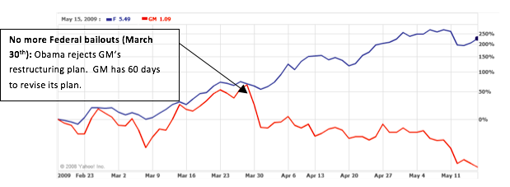
Figure A: http://finance.yahoo.com/echarts?s=F#chart19:symbol=f;range=3m;compare=gm;indicator=volume;charttype=line; crosshair=on;ohlcvalues=0;logscale=on

General Motors Today
As of 2015, GM holds around 17-18% of the U.S. market share which is incredible despite their recent struggles. In addition to that, GM earns over 60% if its revenue solely from the U.S. market. This corporation’s strong position in the United States offers it a competitive advantage over its competitors. As seen in Figure B, GM is currently trading at $39.53, a great improvement from just a few years ago.
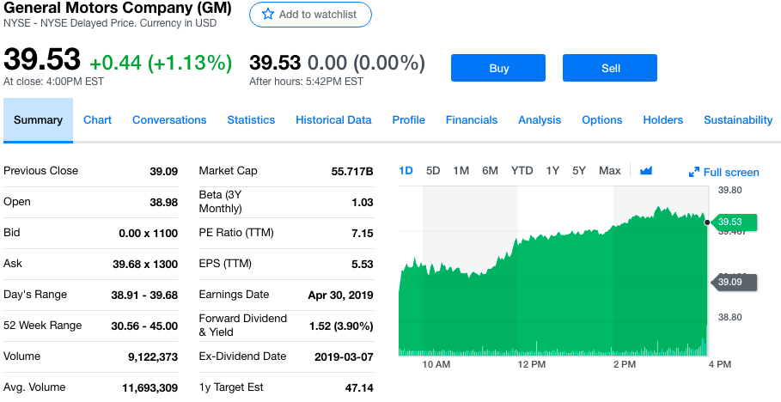
Figure B GM 2018 Stock Prices: https://finance.yahoo.com/quote/GM/
Not all news is good for GM. Recently, General Motors was forced to lay off almost 4,000 salaried workers as part of their cost-cutting plan. In November 2018. This will cause the decline of 15% of salaried and contract workers and shutter seven plants, including five in North America. General Motors justification for such actions are the 6 billion dollars saved in costs.

PEST Analysis

The PEST Analysis is a strategic tool to analyze the macro environment of an organization. PEST stands for political, economic, social, technological that impact the macro environment of a company. Below we have analyzed General Motors Company using the PEST model.
- Political factors that impact General Motors Company
Political factors play a significant role in determining the factors that can impact General Motors Company’ long term profitability in a certain country or market. To achieve success in such a dynamic Auto manufacturers-major industry across various countries is to diversify the systematic risks of political environment. General Motor Company should look at these factors before deciding the location: intellectual property protection, trade regulation and tariffs, pricing regulation, taxation, bureaucracy and interference in Auto Manufacturers, etc.
2) Economic factors that impact General Motor Company
General Motors Company can use country’ economic factor such as growth rate, inflation and economic cycle determine the aggregate demand and aggregate investment in economy. Economic actors that General Motors Company should consider : types of economic system in countries of operation-what type of economic system there is and how stable it is; efficiency of financial markets- does General Motors Company needs to raise capital in local market?
3) Social factors that impact General Motor Company
Society’s culture and way of doing things impact the culture of an organization in an environment. Shared beliefs and attitudes of the population play a great role in how marketers at General Motors Company will understand the customers of a given market. Social factors that leadership of General Motors Company should analyze for PEST analysis are: demographic and skill level of the population; Entrepreneurial spirit and broader nature of the society; education level as well as well education standard in the General Motors Company’ industry.
4) Technological factors that impact General Motors Company
Technology is fast disrupting various industries across the board. How technological trends and conditions affect firms. The following technological external factors are notable in this external analysis of General Motor Company:
- Rising fuel efficiency in automobiles
- Increasing development of electric vehicles
- Increasing implementation of self-driving vehicle technology

The external factors in General Motors’ remote or macro-environment identify many opportunities to grow the automotive business. For example, the company can grow based on product development and innovation. This PEST analysis indicates the importance of reform in General Motors’ growth and expansion strategies in the global market. 1. Increase R&D investment to support product development and enhancement, especially to address demand for electric and hybrid vehicles. 2. Expand the dealership network in developing countries to exploit high growth potential in these markets. 3. Improve sustainability programs to address environmental concerns and related issues, and to strengthen General Motors’ corporate image and brand image.

Define The Industry

The automotive industry consists of companies competing across the world to develop, manufacture, market, and sell motorized vehicles. It is considered one of the biggest economic markets related to revenue. Vehicles are made and sold everyday across the world. Automotive companies, such as General Motors, aim to bring the best vehicles to markets around the world. They aim to connect with a market that will constantly need vehicles in their customer’s daily routines. Competition is vast in the automotive industry and every company has their own advantages over each other. Over the years, safety, luxury, and fuel efficiency have become a big aspect in the automotive industry. People around the world will always need motorized vehicles and a company like General Motors will always try to push ahead of the competition to get more of their vehicles out on the roads.

Demand and Competition

Demand of motorized vehicles is a demand everyone in the world needs. Vehicles are large part of the daily routine of many people, whether if someone is a driver, or if they need a vehicle to reach their place of work. Demand of vehicles are higher in more populated countries such as China and Japan. General Motors has a great presence in these foreign markets as well in other populous environments. General Motors offers a wide range of vehicles needed by different markets. They offer trucks, SUVs, and smaller impact cars. They try to reach as many people as they can with their wide range of vehicles.

General Motors has a variety of competitors. However, in the United States their biggest rival is Ford Motor Company. As the two biggest and well known automotive companies, they go head to head in getting their vehicles to the people. Some key factors that factor into whether or not a customer will want to purchase their vehicles over the competition is safety, luxury, and fuel efficiency. An example of this is different daily commutes to work or regularly traveling play a role into whether someone will buy a 40 MPG car over a 15 MPG car. Different factors affect different people, and whoever can connect to the right market of people with their vehicles will have a big advantage over their competition.

Analyzing Industry Attractiveness

The industry attractiveness for motorized vehicles is actually very low in the United States. This is due to the production and cost of each vehicle is very high. It is not cheap to make vehicles and there is a wide range of vehicles each company produces. Even though most people need a vehicle to function, the United States’ market is simply too big for everyone to afford them. A smaller market that needs vehicles constantly would be much more attractive to a company like General Motors, but General Motors cannot simply pick and choose a smaller market. Everyone will always need vehicles. General Motors will continue to make vehicles for large markets even if that means their profit margins are weak. Their competitors are also in the same market, so if General Motors can beat out their competition in anyway they can appeal to different people across the United States.
Applying Porter’s Five Forces
Competition from substitutes
For General Motors there are many substitutes, many of which would be considered their competitors. There will always be other options when choosing a vehicle, whether it’s cheaper, more efficient, or more eco-friendly. General Motors uses this to excel passed their competitors, by making versatile cars with different options so it can fit with the needs of their customers.
The threat of entry
There are many threats of entry to consider when looking at the automobile industry. When General Motors first entered the market there were not as many threats as there are today since they were one of very few other manufacturers. Nowadays, they have more feats to worry about. They have plants all over the world and when entering into the global market they have more to worry about when compared to keeping it in the United States. In international markets they have to make sure they are following the rules of the the host country’s government and make sure they are abiding the legal barriers. Another threat that General Motors faces when building in another country is differentiation. In America, you see more trucks and bigger vehicles that are needed for our everyday lives. When they are producing vehicles for eastern hemisphere, they will need more compact cars to fit their environment. By doing so, they are setting themselves apart from the competition by differentiating their products depending on their environment.
Rivalry between established competitors
General Motors main competitors are Ford and Toyota. These two companies offer the same products in the same market. They are all globalized companies who cater their customers in that part of the market. There is a major rivalry between the three considering they all want to be the number one company. General Motors tries to set themselves apart from these two firms by trying to make the most versatile vehicles at the lowest price. They need to have everything that the customer wants and needs in their vehicles, while making it better than their competitors substitute and for the lowest price where they can still make money.
Buyer and supplier power
General Motors has to look at what the consumer is willing to pay and how low they can set their prices to make a profit off of their products. There are four factors to look at when looking at the buyer’s price sensitivity. The first consists of the importance of the product. Vehicles play a very important role in the world, and have become essential in our everyday lives. The second is the product differentiation, they need to have the best product at the lowest price so it stands above their competition and keeps their customers coming back everytime they need a new vehicle. The third is the competition between buyers and sellers. The car industry is a very competitive industry, so the more intense the the competition gets, the lower the prices for their suppliers needs to be. The final factor deals with the quality of the product. The better the quality of the product, the more loyalty the firm will see from their buyers. For General Motors this can be anything from the interior of the car to the exterior. They need to be up to date with technology and what their buyers want in their everyday ride.
The supplier holds a lot of power in the car industry. There are a lot of raw materials that are needed to build cars, and to keep them safe. General Motors has to find the best supplier to give them their materials they need at a price that is affordable for them and their customers.
The overall attractiveness of the market
In the United States, the attractiveness of the market for General Motors is low. Since this company offers many different options for their vehicles, it is very expensive to produce each car. The market for vehicles is very large, and as mentioned earlier it is not possible to enter into a smaller market, because most humans need their vehicle to function. General Motors does very well for being in such a difficult market.

Forecasting Industry Profitability
Identifying industry structure
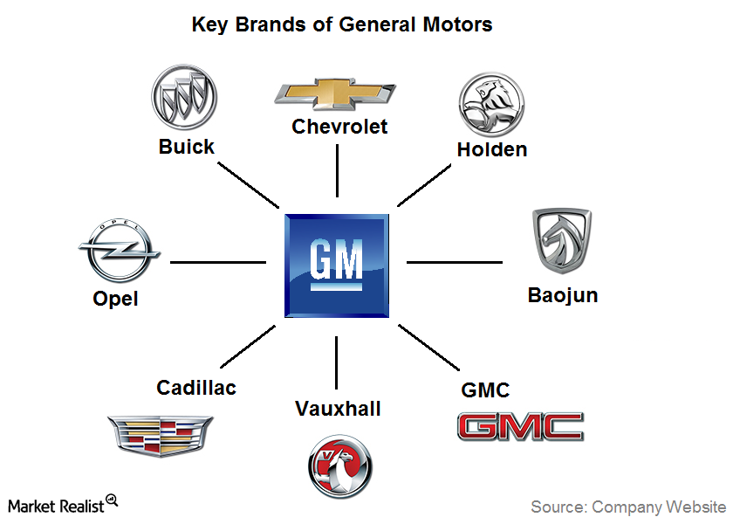
General Motors Company’ organizational structure type and characteristics

General Motors Company has a regional divisional organizational structure. This type of organizational structure involves grouping business activities according to geographical segments or areas of operations. The following characteristics are notable in General Motors’ organizational structure:
- Regional segments
- Business type divisions
- Corporate functional groups

Regional Segments: General Motors addresses such variation through managerial focus based on geographical divisions in its corporate structure. This structural characteristics enables the company to implement strategies that best suit regional conditions. General Motors’ organizational structure has the following regional segments:
- GM North America
- GM Europe
- GM International Operations
- GM South America
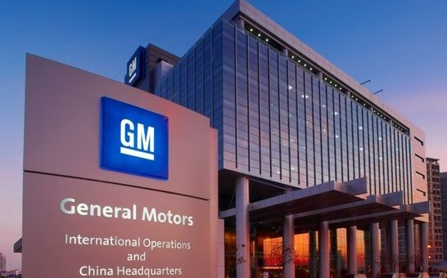
Business-type divisions: are a secondary structural features based on the businesses of General Motors. For example, GM’s automotive business operations are grouped as one division. This characteristics of the organizational structure allows the company to effectively manage each business. For example:
Automotive vehicles
GM financial (auto financial services)

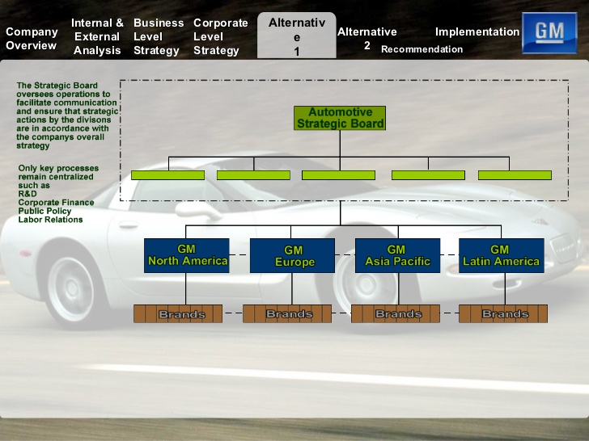
Corporate Functional groups:General Motors Company’s corporate structure has corporate functional groups as a secondary feature. The company uses these groups as a means to integrated all business operations. For example, all automobiles and parts manufacturing operations of General Motors are integrated through a corresponding corporate group called Global Manufacturing.
An advantage of General Motors’ regional divisional organizational structure is the flexibility of the business in responding to regional market variations. For example, each regional segment can implement a set of strategies suited to the conditionals of the regional market under consideration. These advantages optimize the company’s effectiveness in growing the sales of its automobiles in the global market.

Developing Strategy

General Motors has a simple strategy that leads to competitive advantage. General Motors low cost strategy leads to their low costs of vehicles. Compared to a luxury brand of vehicles, such as BMW and Volkswagen, General Motors offers lower price vehicles that appeal to customers who cannot afford the luxury of vehicles. General Motors focuses on manufacturing processes to really gain an appeal with their brand, features, and image. Another way General Motors reaches their customers is opening numerous dealerships. They want their customers to have easy access to buy a vehicle. Some of their competitors like Range Rover only have dealerships in bigger, more populated cities. For example, the closest place to Lubbock to buy a Range Rover is either Dallas or Albuquerque, and for General Motors, they have multiple dealerships across the Texas panhandle. General Motors uses this to generate a higher accessibility for its customers, and if they keep expanding their distribution networks they will continue to gain a competitive advantage over their competition.

Identifying Key Success Factors

Key Success Factors are the strategy elements, product and service attributes, operational approaches, resources, and competitive capabilities that are essential to surviving and thriving in the industry. Factors for the success of General Motors moving forward will be their ability to stay ahead of the curve and produce more and newer electric only vehicles along with getting more customers to use their financing with GMAC.

General Motors SWOT Analysis

STRENGTHS | WEAKNESSES
Global presence  New vision and strategy  Strong brand portfolio  Strong presence in China  Knowledge of home market  Well performing brands | Brand dilution  Bureaucratic culture  Car recalls

OPPORTUNITY | THREATS
Positive attitude towards “green” vehicles  Increasing fuel prices  Changing customer needs  Growth through acquisitions  Growing global automotive industry | Increased competition  The rising U.S. dollar exchange rate  Increasing government regulations may raise the costs  U.S. automotive market is poised to slow down or even decline

Strengths:
- Global presence: GM was the leading auto manufacturer in terms of sales for 77 years until 2007. The business has grown its presence in the world and is now operating in 157 countries.
- New vision and strategy. GM has undergone major changes in the way it does business after the 2008 bailout. Daniel Akerson was appointed CEO and the company got a completely new management team. Akerson introduced new strategy and visions to the business. GM became smaller but leaner and is becoming more cost competitive
- Strong brand portfolio. GM currently sells a multitude of automobile brands that satisfy as many customers as possible. The most popular brands are Cadillac, Buick, GMC and Chevrolet that sell very well in USA and China. In 2012, Chevrolet reached a global sales record and sold 4.95 million units.
- Strong presence in China. China is the second largest market for GM in terms of vehicle units sold. It is also important to know that China is the largest automotive market. With that being said, GM’s early entrance into China and it’s partnership with local Buick brands are the main reasons behind GM’s strong presence in China.
- Knowledge of home market. GM is still one of the largest car manufacturer in the U.S. and currently holds more than 18% market share due to its extensive knowledge of the U.S. market and its consumers.
- Four well performing brands. GM’s Cadillac, GMC, Chevrolet and Buick are among the best-selling brands in the U.S. and China and brings in more than 80% of all General Motors sales.
Weaknesses
- Brand dilution. GM controls 18 automobile brands that vary in quality and are sold in separate markets. With so many brands in sales, customers find it hard to identify which brand belongs to the GM family. This results in lower GM brand awareness.
- Bureaucratic culture. Before reorganization in 2008, GM was infamous for its rigid culture and structure. Since then, the company has made some cultural and structural changes but unfortunately it still isn’t as quick as its competitors in reacting to the constantly changing environment.
- Car recalls. Product recalls have a negative impact on a brand’s image: In the recent past, GM has recalled a number of vehicles due to defective parts or after sales defects. These recalls were expensive and tainted GM’s reputation.

Opportunity
- Positive attitude towards “green” vehicles. Today consumers are more aware of the negative effects caused by cars fueled by petrol and diesel. Thus, consumers are more likely to buy new hybrid and electric cars that emit less CO2. The demand for Hybrid Electric vehicles (HEV) is expected to grow at a strong rate considering strong concerns about the environment.This demand is set to benefit GM as it is investing heavily in developing plug-in hybrid electric vehicle technology.
- Increasing fuel prices. Increasing fuel prices open up large markets for GM’s hybrid and electric cars as consumers shift towards cheaper fuel types.
- Changing customer needs. General Motors is constantly introducing new car models. This will meet more customer needs for smaller and more fuel-efficient cars.
- Growth through acquisitions. GM has successfully acquired many car companies in the past. If GM chooses to continue doing this practice, it will gain new skills, assets and access to new markets.
- Growing global automotive industry: The global automotive industry has shown steady growth in the previous decade and is expected to follow a similar trend in the years ahead. GM, being one of the leading global automotive manufacturers is expected to benefit from this growth.
Threats
- Fluctuating fuel prices. Due to increasing extraction of shale gas, future fuel prices should drop and make electric and hybrid cars less attractive. On the other hand, steeping fuel prices would make current GM models less attractive to cost conscious consumers, as they demand smaller cars that consume lower amounts of fuel.
- New emission standards. The automobile industry is globally influenced by various regulations and laws governing environmental and safety laws. Companies have to strictly comply to such laws which increases compliance costs for them. With this being said, a new wave for stricter regulations on vehicle emission standards may negatively affect GM’s finances. The corporate would have to invest large amount of money to comply with these new standards.
- Rising raw material prices. Rising prices for raw metals will lift the costs for auto manufacturers and result in squeezed profits for the companies.
- Intense competition. For 77 years from 1931 to 2007, GM led global sales of vehicles, but lost its position in 2008 due to increased competition of cheaper and better quality cars, especially from Japan and South Korea. To this day Gm is still subject to competition from many popular brands in all of its categories. Intense competition also impacts the market share of GM and its margins. Some of its competitors are Volvo, Honda Motor, Hyundai Motor, Nissan Motor and Volkswagen etc.
- Exchange rates. This threat is important to consider because GM has operations worldwide and thus it has currency exposures in many of its transactions. China is GM’s second largest market and the business earns huge profits there. Exchange rate fluctuations threaten GM’s profits if the dollar would appreciate against Chinese renminbi. Any fluctuation in the currency with respect to the Dollar has the potential to positively and negatively impact the transactions. This can directly affect revenues and profitability of GM.

GM’s Resources and Capabilities
Resources and capabilities are the principal basis of strategy. General Motors has a large number of resources ranging from tangible to intangible resources. The company’s tangible resources include the firm’s financial resources as it has a large deposit of capital. General motors have plants all around the world and it has 110 of them which have received energy stars for energy efficiency. In addition, GM has technological resources as well as a patent of manufacturing the most environmentally friendly vehicles.
Some of GMs intangible resources include innovation resources and reputational resources. First innovation resources as GM has an astonishingly ability to come up with electric vehicles. Second, GM has reputational resources as it has good reputation in terms of different vehicle portfolio. In other words, everyone knows the brands General Motors owns and that brand power will bring sales to their company.
Yet another important resource to think about in a firm is HR; which over the years, has become more systematic and sophisticated and this is due to the department developing a more strategic way of thinking. The reason for including HR as part of the firm’s resources is their stability. Although most employees are free to move from one firm to another, the average stay with an employer for 4 or more years. So we are seeing companies with individuals who have devoted a significant amount of their lives to these companies and who have gotten the opportunity to learn the ins and outs of the firm and this is why HR is important in this sense because we are taking those developed set of skills, content knowledge, attitudes, and values and creating superior performers from the inside out.
General Motors’ HR Department has actually changed from a tactical to a strategic role back in 2001. In 2002, the head of the HR Department, Kathleen S. Barclay, implemented a strategy she called the 3Ts: Technology, Talent, and Transformation. This was just another way for GM to advance their transition into a more strategic approach. GM has also began hiring about 200 people a year from elite schools such as Berkley, Stanford, MIT, as well as attracting new women. So GM is really pushing to diversify while at the same time hire that superior talent in order to gain that competitive advantage over their competitions.
General Motor being one of the largest automotive companies, has developed a very intensive structure of dealing with its competitive forces, its SWOT analysis and also making sure that it maximizes the use of its resources, capabilities and core competence. It has maintained its position of being one of the top automobile manufacturers in the U.S. though it has had its fair share of obstacles. In other words, GM has integrated its resources, capabilities and core competence to increase value in the company. It has used its tangible and intangible resources to pursue its competence advantage.

Recommendations

Since their troubles after the last recession General Motors has been able restructure their core brands and provide for the needs of their customers. I would recommend General Motors must continue in this direction to save; keeping up-to-date with the latest technologies, listening to consumer demands, and producing cars which meet the needs of today’s driver. I would also recommend they continue to stay in the global market, this keeps the company very diverse and helps them stay one step ahead of the competition.

References

Bhasin, H. (2018, January 13). SWOT Analysis of General Motors - GM SWOT analysis. Retrieved from https://www.marketing91.com/swot-analysis-general-motors/

Britannica, T. E. (2019, January 23). General Motors. Retrieved from https://www.britannica.com/topic/General-Motors-Corporation

Dockalikova,I., & Klozikova, J.(2014, November). MCDM methods in practice: Determining the significant of PEST Analysis Criteria. In European Conference on Management, Leadership & Governance.

Gaba, V.,& Joseph,J. (2003). Corporate structure and performance feedback: Aspirations and adaptation in M-form firms. Organization Science, 24(4), 1102-1119.

General Motors to Lay Off Almost 4,000 Salaried Workers: Source. (2019, February 04). Retrieved from https://www.news18.com/news/auto/general-motors-to-lay-off-almost-4000-salaried-workers-source-2024435.html

General Motors Fast Facts. (2019, January 14). Retrieved from https://www.cnn.com/2014/04/08/us/general-motors-fast-facts/index.html

Grant, R. M., & Jordan, J. (2015). Foundations of strategy. Hoboken: Wiley.

Jurevicius, O. (2016, December 08). General Motors SWOT analysis. Retrieved from https://www.strategicmanagementinsight.com/swot-analyses/general-motors-swot-analysis.html

