Amazon’s Company Situation Analysis
NAICS Code: 454110

By: Patricia Martinez, Bryan Arias, and Shavena Smith

Introduction
Looking over the past 20+ years in the internet era it has opened opportunity and growth for multiple businesses to arise. Amazon having been established in 1994, gradually over the years has risen to the top ranks as the most used online e-commerce business in the United States. With the company selling an array of products such as books, furniture, electronics, beauty and health products, clothes, shoes, whole foods, and more it shows how diversified it is as an online retail seller. By providing products and services at ease, Amazon sustains a competitive advantage and superiority among its major competitors by specializing in providing what other companies cannot. Amazon considers itself as a completely customer-centric company. It has distinction of being one of the first large companies over the internet. From 19994 to 2019, Amazon has become one of the most prestigious and strategic e-commerce stores in the world. Originally, Amazon started off as solely a bookstore. They were extremely popular as a new online bookstore but after realizing that they wouldn’t last long in the industry with Barnes & Noble as a large competitor, they diversify their products and services into the Amazon that we know today. Amazon has developed a mission statement from the origin of the company that they still adopt to this day: “We strive to offer our customers the lowest possible prices, the best available selection, and the utmost convenience.” In modern day, there is nothing that Amazon does not do. Amazon has come this far because they value change and are open to adaptability.
Financial Strength
Amazon thrives off satisfying their customers at their best ability possible. Most companies focus their strategy on positioning themselves in their industry, gain a competitive edge and increase profits, or even trying to expand their demographics. Differently, Amazon’s overall strategy focuses on customers. Jeff Bezos calls it customer obsession: “There are many ways to center a business. You can be competitor focused, you can be product focused, you can be technology focused, you can be business model focused, and there are more. Obsessive customer focus is by far the most important. Even when they don’t yet know it, customers want something better, and your desire to delight customers will drive you to invent on their behalf.” This is how Amazon strives, gained the trust of many consumers across the country, and became the top leader in online retailing. Amazon is focused like a laser on customers. Instead of starting with an idea for a product and trying to convince executives that customers will "love the idea," Amazon works from the perspective of the customer to come up with ideas that will legitimately generate value. For example, Prime was created because it was understood within Amazon that customers wanted to buy quality products for less money, and customers wanted to receive products as fast as possible. Prime appeared to be a solution that would meet both of these customer needs. Amazon’s idea of appealing to customer’s needs works out for them in the long run as they excel in their performance and financial strength.
Amazon is the exception to nearly every rule in business. Rising from humble beginnings as a Seattle-based internet bookstore, Amazon has grown into a propulsive force across at least 5 major industries: retail, logistics, consumer technology, cloud computing, and most recently, media & entertainment. Notably, Amazon’s $13.7B purchase of grocery chain Whole Foods last year shook up the grocery industry, highlighting Amazon’s increasingly deep push into brick-and-mortar retail.
Of course, the company has had its share of missteps — the expensive Fire phone flop comes to mind but Amazon is also rightly known for strokes of strategic genius that have launched it ahead of competitors in promising new industries. This was the case with the launch of cloud business AWS in the mid-2000s, as well as the more recent consumer hit Amazon found with its Echo device and Alexa AI assistant. Today’s Amazon is far more than just an “everything store;” it’s a leader in consumer-facing AI and enterprise cloud services. And its insatiable appetite for new markets means competitors must always be on guard against its next moves. As the United States’ biggest online retailer, the company accounts for about 4% of all retail and about 44% of all e-commerce spending in the US. While the company has been publicly traded for more than two decades, its market capitalization has swelled in recent years.
Wall Street banks like Morgan Stanley expect Amazon to continue growing at a rate that no company its size has ever done before, estimating 16% average compound growth in sales through 2025. Morgan Stanley analysts have also set a price target at $2,000/share — or a market capitalization exceeding $1T — within the year. If Amazon is able to satisfy these lofty goals, it will be “the most aggressive expansion of a giant company in the history of modern business.”
Below are Amazon’s liquidity ratios over the past five years, representing overall growth and a constant strive to appeal to customers.

 |  | Dec 31, 2018 | Dec 31, 2017 | Dec 31, 2016 | Dec 31, 2015 | Dec 31, 2014
 | Current ratio | 1.10 | 1.04 | 1.04 | 1.08 | 1.12
 | Quick ratio | 0.80 | 0.70 | 0.74 | 0.71 | 0.74
 | Cash ratio | 0.60 | 0.54 | 0.59 | 0.58 | 0.62

Ratio | AMAZON
Current ratio | Amazon.com Inc.’s current ratio deteriorated from 2016 to 2017 but then improved from 2017 to 2018 exceeding 2016 level.
Quick ratio | Amazon.com Inc.’s quick ratio deteriorated from 2016 to 2017 but then improved from 2017 to 2018 exceeding 2016 level.
Cash ratio | Amazon.com Inc.’s cash ratio deteriorated from 2016 to 2017 but then improved from 2017 to 2018 exceeding 2016 level.

As time goes on, Amazon continues to outdo itself and improve as new products and ideas that appeal to customers come out. The annual growth rate is a representation of this.

Competitive Growth
Being the company that it is today, Amazon has grown substantially over the past five years. Comparing Amazon’s (AMZN) stock with Walmart’s (WMT) and Alibaba’s (BABA) stock growth over a 5 year period (April 16, 2014 to April 16, 2019) it is interpretable that Amazon’s stock price has grown from $303.83 U.S. dollars to a whopping $1,863.04 (with respect to change). In statistical terms, this $1559.21 increase represents over a 610% growth in value over a 60 month time span. 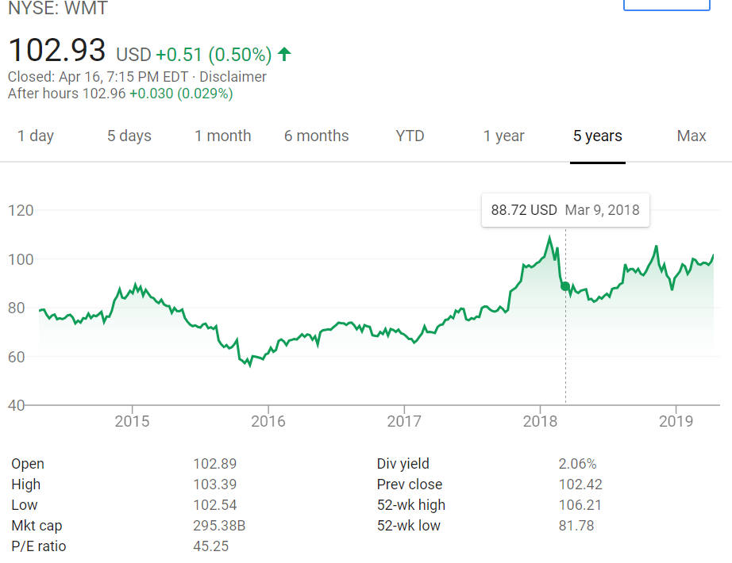

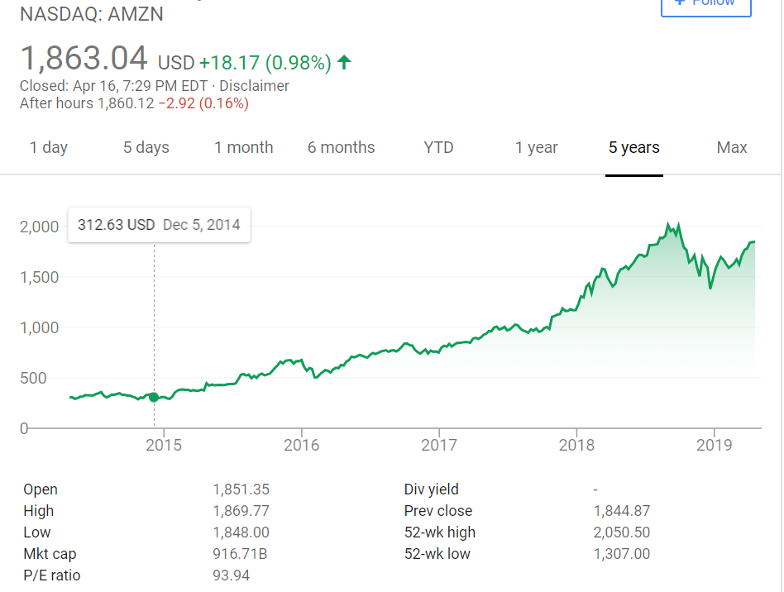
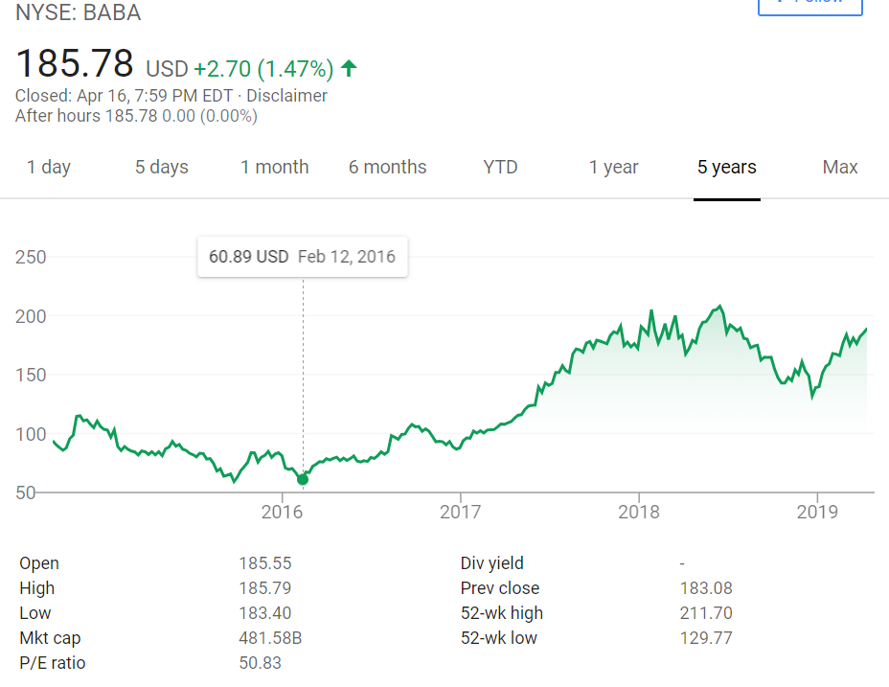
Customer Loyalty
Looking into Amazon’s Customer Loyalty, the company does an outstanding job in retaining Amazon Prime subscriptions, Audible subscriptions (parent company), and keeping their customers content. Amazon’s C.E.O. Jeff Bezos not wasting any resources, he values the customer as the primary focus of the company. Customer loyalty being time consuming to earn and gain, it is essential, that is what makes customers come back and spend their money on goods and services.
Estimated Market Share Analysis from Statista

In a recent forecast analysis from “Statista” it portrays that Amazon by the year 2021 will have a 50% market share of all e-commerce sales in the United States. Looking at the “50%”, what it means in layman’s terms is that out of all the companies in the online industry, Amazon will be its largest online retail competitor. With Amazon having a high customer retention and a well established customer loyalty it wouldn’t be surprising if Amazon reached 50% before the year 2021.
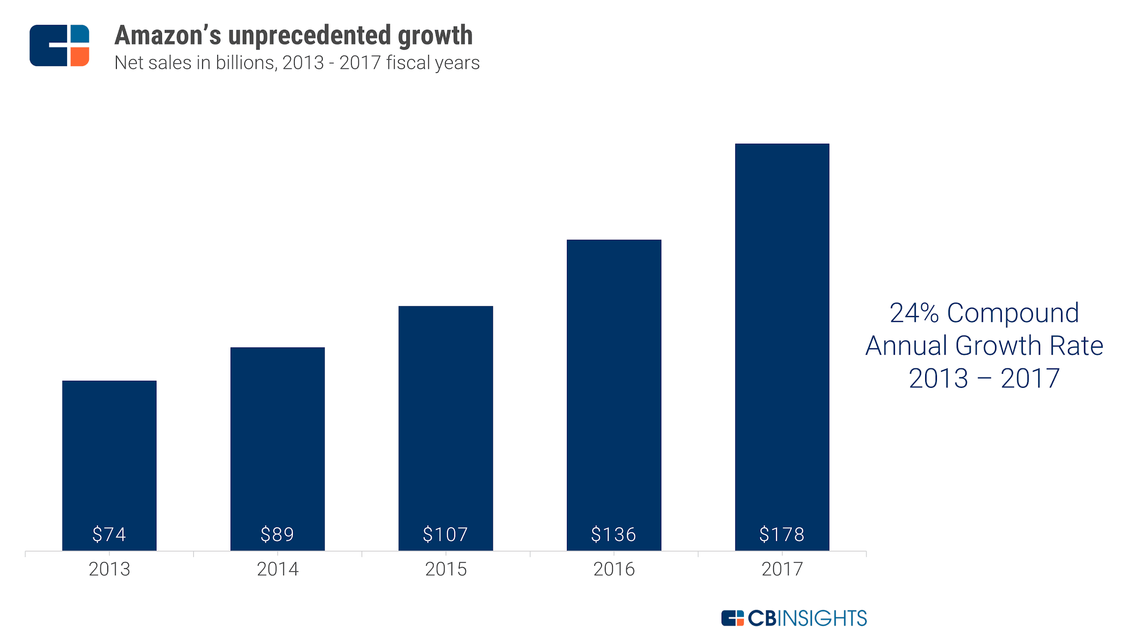
Furthermore, the Cash Flow Statements from 2015-2018 reflect a surge in cash held at year end in a span of three years.
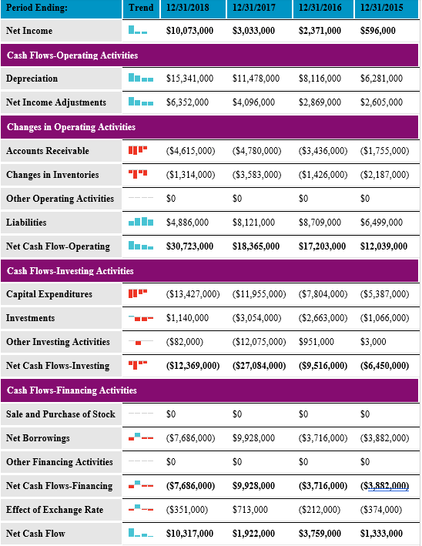
Even though Amazon presents to have strong financial strength and a focused goal to be customer-centric, they still face the occasional risks involved in maintaining such a prestigious stature. Amazon’s biggest risk to their business at the moment are competitors. Even though Amazon is not focused on profit, they take pride in being the “go to” e-commerce retailer in the United States. Amazon must anticipate what their competitors, such as Walmart, must do ahead of time say that they do not fall behind in their shadow. To compete better with Amazon and its other competitors, Walmart has decided to make a bigger dent in the influence of online retailing. Walmart stores are drawing in traffic, and those same stores form the foundation of the company's grocery pickup and delivery initiatives. Grocery, along with an expanded online product selection, drove U.S e-commerce sales greatly in the fourth quarter of their last fiscal year. Amazon is still the king of online retail, but Walmart represents a legitimate threat to the market leader. Walmart, along with Target, another traditional retailer that's embraced e-commerce, are becoming viable alternatives to Amazon. Amazon still has a much broader product selection, but the gap is starting to get smaller. Some retailers, like department stores, struggled this holiday season. Walmart was not one of them. The company's focus on low prices and an ever-expanding assortment of convenient online initiatives drove customers to its stores and to its websites. Expect more of the same this year. Walmart is not seen as beating Amazon’s profits or market share any time soon, but they are on the way there. If Amazon does not incorporate new and unique innovative idea, then they could possibly be in some serious trouble.
Strategic Moves
For the year of 2019, no one can actually predict what new innovative idea Amazon will implement but guesses can be made to prepare for it. Possible big moves for Amazon to incorporate include but are not limited to:
1. Purchasing a delivery service
2. Enter the fitness industry
3. Acquire a dollar general
4. Offer rental services
5. Partnering with a furniture store
Amazon would greatly benefit from all of these possible elements to incorporate in the next year. Purchasing a delivery service would only double Amazon’s profit, making shipping faster and appealing to customers. This would further undercut competitors and put Amazon a competitive advantage that they have never been at before. Apart from this, it is known that the sports industry brings in a lot of money. If Amazon were to enter the fitness industry, they would buy out a brand such as Under Armor or Nike or even make a large private brand themselves. Customers would save money and get the fitness equipment they need at a one stop shop. Differently, Amazon could also acquire a dollar general. In order to expand its reach past the customers it already has and get closer to being everything for everyone, Amazon could make a move to acquire Dollar General. The acquisition would help Amazon reach a larger portion of the population and increase its presence in rural markets, where it would face less competition from larger retail chains. With this in mind, Amazon would have a section on the website where everything's a dollar; the best way to appeal to customers on a budget. For the best results and increase in market share, Amazon could incorporate a rental service in their business plan. People would rent an expensive tool or anything of that nature to use for a few times at a couple days instead of people committing to buying something that they would only use a few times. Finally, a major issue that Amazon has is shipping large things such as bed frames. Amazon wants to make it quick and easy for people to buy whatever they want, when they want. Furniture poses a unique problem since it is heavier, bulkier and harder to ship than a box of cereal or a TV. To break into this market, Amazon will need to acquire a company with a proven track record of delivering furniture to incorporate more options and satisfy more needs for customers.
SWOT Analysis
Amazon leads the online retail industry, indicating business success in addressing issues shown in the company’s SWOT analysis. The SWOT Analysis identifies the internal strategic factors (strengths and weaknesses) and external strategic factors (opportunities and threats) that influence the business. A SWOT analysis of Amazon shows the strengths that the company uses to overcome its weaknesses and the threats to its e-commerce business, and points to the need to ensure strong brand image. Amazon also has other concerns, such as cybercrime and imitation, as shown in this SWOT analysis of the e-commerce company.
Amazon’s e-commerce success relies on its notable strengths which computes the internal strategic factors that the company uses to grow its business. The strengths that support Amazon’s ongoing growth is its strong brand, extensive product mix, and its highest revenues in the industry. By having the strongest brand in the online retail market, it’s responsible for the rapid growth of the business in its early years. Also, having an extensive product mix makes it easy for customers to maneuver around the company’s website which supports attractiveness. Lastly, having the highest revenues in the industry enables the company to invest into new business ventures. Amazon may have its strengths, but it also has its weaknesses that challenges its e-commerce business. The weaknesses that impose difficulties in growing Amazon’s business is the limited penetration in developing markets, easily imitable business model and limited brick-and-mortar presence. Amazon may have high revenues, but they generate most of them from developed countries, such as the U.S. As soon as other firms become fully established in develop markets, this will be tough for Amazon to penetrate and compete in those markets. As for their business model, it’s easily imitable like creating an online retail website that sells almost everything just like them. Lastly, their limited brick-and-mortar presence also limits the ability to attract customers to product types that are more sellable in physical stores. A solution for Amazon to overcome the negative effects is to maintain a competitive advantage online and offline.
Companies will have their strengths and weaknesses, but they also have to take into consideration of their opportunities and threats to the company. There are a variety of opportunities available to Amazon that are related to the e-commerce market. Amazon’s opportunities are penetrating developed markets, expand their brick-and-mortar business, and boost measures to reduce counterfeit sales. Amazon has the opportunity to penetrate developing markets. By this move, it should establish the company’s presence before other large online retail firms take root. This gives Amazon the advantage of a stronger competitive edge. By expanding their brick-and-mortar stores, Amazon will be able to improve competitiveness against large retailers with significant brick-and-mortar presence. Lastly, Amazon has an opportunity to improve its technological measures and organizational policies which addresses the counterfeit sales that are against customer expectations. Amazon faces a number of significant threats in the online retail market and they must address these threats in the online retail industry environment. Amazon’s threats are cybercrime, imitation, and aggressive competition with large retailfirms. Cybercrimes threatens every online retail company and Amazon must keep sharp measure to counteract these attacks. A way Amazon can do that is by intensifying its network security efforts. Another threat Amazon faces is the issue of imitation and it can reduce the company’s market share. Lastly, the threat of aggressive competition, such as Walmart, continue to improve their online retail presence. A solution to this aspect, is Amazon needs to strengthen its marketing efforts and competitiveness.
Looking into Amazon’s competitive strengths, some of the things that make the company such a powerhouse are its adaptability to get into niche markets, their selling of broad range items, and the easability of shopping for the modern shopper. Amazon utilizing its resources in technology, warehouses, and people it provides a distinctive competency to all its competitors and parent companies. By setting itself apart from other competitors such as Ebay, Walmart, and Alibaba, Amazon relies on the creation and development of new blue ocean strategies. In doing so, Amazon creates competitive advantages by the penetration of uncontested markets and in the making of competitors irrelevant while decreasing costs. While some analysts and people can view this as a strength, it can also be looked upon in an ethical manner, one in which if the company has too much power. Capitalistically speaking its good for Amazon in the making of profits but when comparing its business strategies with other small (mom and pop) companies it is difficult for them to compete with such a large competitor. That is why Amazon has recently implemented a proposal for business owners to sell their products on Amazon’s website for a small fixed monthly fee.
Current Overlap
With Amazon’s being such an increasingly successful company, competitors must be able to start predicting their next moves before they lose their business. Even though Amazon is considered a Fortune 500 company, they use a small business approach considering that retail is a huge component of a small business. Amazon has been known to push out “mom-and-pop” stores because they can give what others small businesses cannot plus more. Amazon has the evident advantage of being an e-commerce store because people do not need to leave their homes to get what they need. This ties in with one of Amazon’s core capabilities, which is being able to leverage technology’s every aspect to its advantage. By this, it helps the online marketplace to not only reach the pinnacle of technical expertise but also in the process of making it smoother and efficient. The typical millennial would rather stay at home and get what they need online rather than driving to their local brick-and-mortar retailer. There is no reason to go anywhere other than Amazon. For a lot of companies to stay relevant and in the fast lane with Amazon, they must sign an agreement to put their products on Amazon- abiding by their rules and services. Amazon keeps itself in a high margin, with this in mind, competitors must be on their “A-game” so they will not fall off. It didn’t matter what they sold, Amazon created a consistent user experience that is and still is the best and has no signs of slowing down. With these strategic success factors, Amazon’s profitability will be hard to deter.
Amazon Space Chart
In Amazon’s Space Chart (portrayed below) it shows two of Amazon’s most noticeable features, its aggressiveness and its competitiveness. The company being the conglomerate that it is, it faces constant changes on a daily basis. For the company to stay afloat it uses a medium defensive and conservative stance.
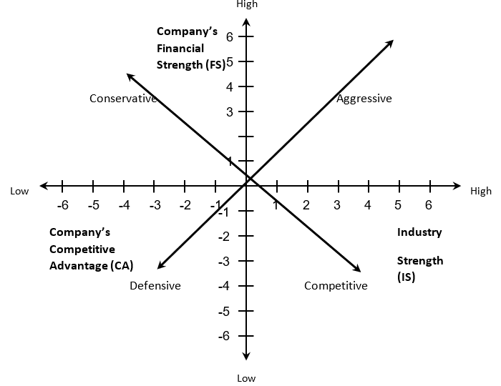
Conclusion
Amazon is a leader in many areas and aspects. As presented, Amazon stands head and shoulders above its competition. With the way online shopping is growing Amazon is expected to grow in its market share only more, while other large retailers are doing their best not to go bankrupt like Sears, Toys R Us, and more. Being an era of internet, it is essential to keep up with the change in today’s world, because if not constantly changing one can suffer losses or worse get bankrupt and have to foresee liquidation. Amazon sustains a competitive advantage and superiority among its major competitors by specializing in providing what other companies cannot. Amazon will continue to go by their mission statement: “We strive to offer our customers the lowest possible prices, the best available selection, and the utmost convenience.” Amazon has come this far because they value change, open to adaptability, and they focus on their customers.

