Amazon

Competitive and Industry Analysis

By: Patricia Martinez, Bryan Arias, and Shavena Smith

Introduction
In many ways, Amazon is the spectacle of a successful business that many companies aspire to be. Even more, Amazon is considered the face of the e-commerce phenomenon. Amazon sells diverse products, including: books, furniture, electronics, beauty and health products, clothes and shoes, whole foods, and much more. By providing products and services at ease, Amazon sustains a competitive advantage and superiority among its major competitors by specializing in providing what others cannot.

Background
Amazon considers itself as completely customer-centric company. It has distinction of being one of the first large companies over the internet. From 1994 to 2019, Amazon has become one of the most prestigious and strategic e-commerce stores in the world. Originally, Amazon started off as solely a bookstore. They were extremely popular as a new online bookstore but after realizing that they wouldn't last long in the industry with Barnes & Noble as a large competitor, they diversified their products and services into the Amazon that we know today. Amazon has developed a mission statement from the origin of the company that they still adopt to this day: “We strive to offer our customers the lowest possible prices, the best available selection, and the utmost convenience.” In modern day, there is nothing that Amazon does not do. They have come this far because they value change and are open to adaptability.

Chief Business and Economic Characteristics

Looking at Amazon as a whole entity, the company has gained dominance in a variety of different kinds of industries. Most known for its e-commerce, Amazon has also excelled in industries such as cloud computing, streaming media, and other digital content. When comparing Amazon to other technology-based companies, one thing that separates Amazon from the other competitors is that the company offers products and services that correlate with one another. Using Amazon Prime as an example, it's a monthly to yearly subscription which grants a person an array of benefits such as access to free 2-day shipping on orders, Amazon Music, and Prime Video.
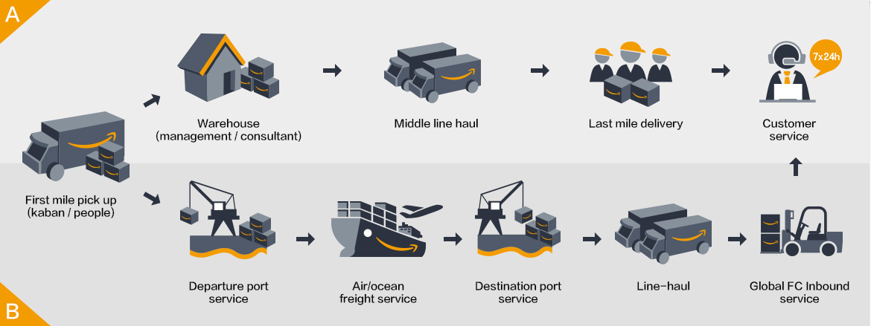
Being the conglomerate that it is, Amazon relies heavily on a set of systems and logistics in its everyday day to day operations. Several internal strengths that can be found within the company is that they are exceptionally well in their cost leadership, efficiency towards their delivery networks, and their customer orientation. Analyzing Amazon’s cost leadership thoroughly, the company does a remarkable job differentiating itself by creating strategic alliances with other companies to offer superior customer service. In doing so, this helps create a strong value chain because Amazon is able to lower the inventory replenishment time. On top of that, its fulfilment centers help the company create a more structured distribution network in more remote locations making it easier for deliveries and sales of products.

Identify/assess driving forces for change
Three distinguishable driving forces that allow Amazon to stay afloat are accepting its failures as the price of innovating, working everyday like it’s your first day in business, and probably most important giving their customers what they want before they know they want it.
Being able to innovate can be challenging enough with R&D and testing, but this is where Amazon embraces failure as a learning experience. Having failed with its production and selling of the “Fire Phone” it gave the company a new perspective to improve from that failure.
Working everyday like it’s your first day in business primarily means that everyone working should be driven and hungry like any other startup company. Having over half a million (500,000+) employees to date, Amazon can’t be stagnant in its weekly operations. If so, the company can get left behind and lose sales by lack of performance in production and shipping. This is where Amazon’s mindset picks up, the company always operates with a sense of urgency in their work, by making decisions quickly it saves time and resources.
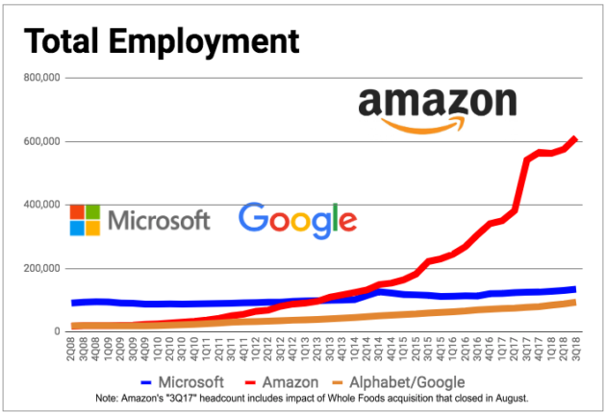
.

Competitive Forces
In order to evaluate the strength of competitive forces, we must look at Porter’s five forces of competitive framework. These five forces consist of three horizontal competition: competition from substitutes, competition from entrants, and competition from established rivals; and two vertical competition: the power of suppliers and the power of buyers. This framework helps view the profitability of an industry indicated by its rate of return on capital relative to its cost of capital.
The first horizontal competition is competition from substitutes, which is prices customers are willing to pay for a product depending on the availability of the product. This is the market where you can’t get the best of both worlds. Meaning, there are not many substitutes that offer the convenience and low pricing. Amazon is what you call an Internet-based substitute. It is known as the online company that proves an alternative because it’s different and the customer can gain a price advantage. Our competitor, Walmart, is known for their low-pricing, but there are times where you won’t find certain products that you’re looking for. Amazon has also lowered their prices and put their products into bulks to seem the better substitute between the alternatives. It has also changed to where you buy Amazon Prime for a certain fee per month to receive a 2-day shipping in order to receive your product faster.
The next horizontal competition is competition from entrants, which is when a firm earns a return on capital in excess of its cost of capital it will act as a magnet to firms outside the industry. Amazon faces some external factors that support the strong intensity, which are low switching costs, high availability of substitutes, and low cost of substitutes. The low switching costs explain that customers can easily decide to buy from either Walmart, Amazon or other competitors. The factors that increase the influence of substitutes against the company are the high availability of substitutes and the low costs of their product.

Key Success Factors
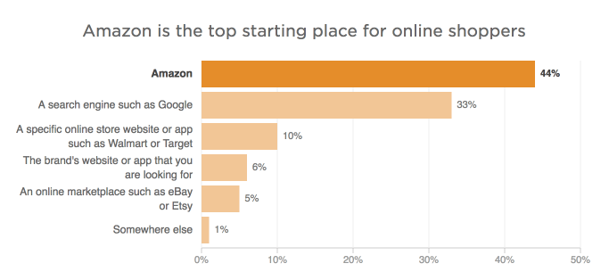
With Amazon’s being such an increasingly successful company, competitors must be able to start predicting their next moves before they lose their business. Even though Amazon is considered a Fortune 500 company, they use a small business approach considering that retail is a huge component of a small business. Amazon has been known to push out “mom-and-pop” stores because they can give what others small businesses cannot plus more. Amazon makes its own labels and brands that local, small businesses cannot even compete with. Some of Amazon’s independent brands and labels include: Lily Parker, relaxed and distressed denim tops and jeans; Stone & Beam, Furniture (with a three-year warranty), lighting, décor, and betting for the entire home; AmazonBasics, tech accessories, household supplies, bed and bath products, luggage furniture, kitchen accessories, etc. Amazon compete with small businesses as they take on the “small business approach” by observing which products sell well, then introducing private label- brands to try and reach for some of the markets. Amazon’s strategically incorporates their search engine by listing their private-label brands over name-brands. When a customer looks up “dog food” in the search bar, the Amazon brands will be listed first and a more convenient price then the name-brands will be listed after, at obviously more expensive prices. In the figure below, it is seen that people typically prefer to shop at Amazon rather than other online stores.
This represents that Amazon benefits from their innovation of their search engine as customers will more likely buy the cheaper Amazon label-brands than the more expensive name brands. Additionally, Amazon also has the evident advantage of being an e-commerce store because people do not need to leave their homes to get what they need. The typical millennial would rather stay at home and get what they need online rather than driving to their local brick-and-mortar retailer. There is no reason to go anywhere other than Amazon. For a lot of companies to stay relevant and in the fast lane with Amazon, they must sign an agreement to put their products on Amazon- abiding by their rules and services. Amazon keeps itself in a high margin, with this in mind, competitors must be on their “A-game” so they will not fall off. With these strategic success factors, Amazon’s profitability will be hard to deter.
Competitive Moves
In order to competitors to have any advantage over Amazon, they must strategize for themselves and Amazon. What can they do differently from Amazon? How can they apply cost and differentiation advantages? How can they appeal to their customers in a better way? What imitation strategies can they implement? And finally, how will Amazon be ahead within a year? This is not an easy process, differentiating on how to better your business, increase profitability, and grow clientele. An even harder evaluation is guessing how your competitors plan to grow their business so you can prepare for it and not fall behind their shadow. In 2017-2018, Amazon made headlines with the innovative idea of incorporating a whole foods store, that way customers can get food delivered to their door without even having to leave the comfort of their homes. For the year of 2019, no one can actually predict what new innovative idea Amazon will implement but guesses can be made to prepare for it. Possible big moves for Amazon to incorporate include but are not limited to:
1. Purchasing a delivery service
2. Enter the fitness industry
3. Acquire a dollar general
4. Offer rental services
5. Partnering with a furniture store
Amazon would greatly benefit from all of these possible elements to incorporate in the next year. Purchasing a delivery service would only double Amazon’s profit, making shipping faster and appealing to customers. This would further undercut competitors and put Amazon a competitive advantage that they have never been at before. Apart from this, it is known that the sports industry brings in a lot of money. If Amazon were to enter the fitness industry, they would buy out a brand such as Under Armor or Nike or even make a large private brand themselves. Customers would save money and get the fitness equipment they need at a one stop shop. Differently, Amazon could also acquire a dollar general. In order to expand its reach past the customers it already has and get closer to being everything for everyone, Amazon could make a move to acquire Dollar General. The acquisition would help Amazon reach a larger portion of the population and increase its presence in rural markets, where it would face less competition from larger retail chains. With this in mind, Amazon would have a section on the website where everything's a dollar; the best way to appeal to customers on a budget. For the best results and increase in market share, Amazon could incorporate a rental service in their business plan. People would rent an expensive tool or anything of that nature to use for a few times at a couple days instead of people committing to buying something that they would only use a few times. Finally, a major issue that Amazon has is shipping large things such as bed frames. Amazon wants to make it quick and easy for people to buy whatever they want, when they want. Furniture poses a unique problem since it is heavier, bulkier and harder to ship than a box of cereal or a TV. To break into this market, Amazon will need to acquire a company with a proven track record of delivering furniture to incorporate more options and satisfy more needs for customers.
With Amazon being so diverse and appealing to their customers every need, competitors such as Walmart and eBay must work hard to keep up. Walmart has everything that customers could need, similar to Amazon, ranging from food to furniture to clothes and toys. One of the main things that sets these two apart is the e-commerce aspect. Amazon is currently ruling the online retailing with a market share higher than its competitors.

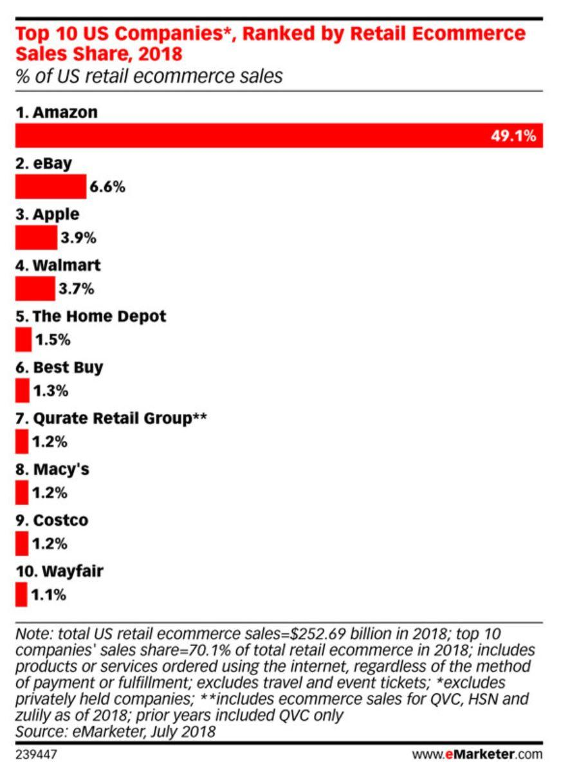

Walmart, being mindful of this, has decided that instead of being disrupted by the growth of online retail, they will ride the e-commerce wave to higher sales and fatter profits. To compete better with Amazon and its other competitors, Walmart has decided to make a bigger dent in the influence of online retailing. Walmart's stores are drawing in traffic, and those same stores form the foundation of the company's grocery pickup and delivery initiatives. Grocery, along with an expanded online product selection, drove U.S e-commerce sales greatly in the fourth quarter of their last fiscal year. Walmart expects grocery pickup to be available at 3,100 U.S. stores by the end of fiscal 2020, with groceries set to be delivered out of 1,600 U.S. stores. That's up from 2,100 pickup and 800 delivery locations at the end of fiscal 2019. Full-year U.S. e-commerce sales rose 40%, and the company expects 35% growth in fiscal 2020. Walmart's annual e-commerce sales now sit around $16 billion, so a 35% increase this year represents about $5.6 billion of additional revenue. Walmart is still well behind Amazon in terms of total online sales, but it's growing quite fast and is expected to continuously grow. Amazon generated about $123 billion in online sales in 2018, excluding revenue related to third-party sales. Amazon grew those first-party sales by just 13% year over year in the fourth quarter. Differently, Walmart is already the largest grocery retailer in the U.S., but that's not stopping it from aggressively pursuing online grocery. The company is not only disrupting the grocery industry, but it's disrupting itself as well. That's a sign that Walmart recognizes which way the wind is blowing. The company can't afford to dawdle as Amazon ramps up its own grocery efforts. Amazon is still the king of online retail, but Walmart represents a legitimate threat to the market leader. Walmart, along with Target, another traditional retailer that's embraced e-commerce, are becoming viable alternatives to Amazon. Amazon still has a much broader product selection, but the gap is starting to get smaller. Some retailers, like department stores, struggled this holiday season. Walmart was not one of them. The company's focus on low prices and an ever-expanding assortment of convenient online initiatives drove customers to its stores and to its websites. Expect more of the same this year. Walmart is not seen as beating Amazon’s profits or market share any time soon, but they are on the way there. If Amazon does not incorporate and new and unique innovative idea, then they could possibly be in some serious trouble.
Similarly, to Walmart, eBay must deal with how to stay relevant in the shadows of Amazon. With eBay already being an e-commerce-based retail store, they cannot just choose to sell more products online, like Walmart. eBay must actually think of cost and differentiation strategies that will set them apart from Amazon and make customers want to shop there instead of with their other competitors. The first change that will be incorporated is price matching; eBay wants its sellers to compete on price with its new Price Match Guarantee. This is the first time it will offer price matching on 50,000 items in the US with chosen competing retailers, including Walmart and Amazon. eBay also has promised guaranteed delivery. eBay customers will be offered delivery in three days or less on approximately 20 million items listed on eBay.com. eBay wanted its customers to know exactly when their products would arrive to create happier customers and more sales. Further, eBay is a less chosen place to shop by some customers because some products are falsely advertised and not authentic. For example, a customer could order a pair of new Nike shoes for $120 on eBay but when the product finally arrives, it is only a picture of the Nike shoes. So, the customers have been scammed and shorted their money. To combat this, eBay Authenticate was launched as an advancement in safe shopping. Sellers and buyers could use a paid service to have products reviewed by a professional authenticator before the items are shipped. Offering great prices and improving customer confidence has been a newfound want for eBay. With these new changes, eBay will climb the market share and gain clientele in no time; of course, this is not enough to completely outdo Amazon, but they are setting a good pace to get there eventually.

Amazon 2015 to 2018 Financials
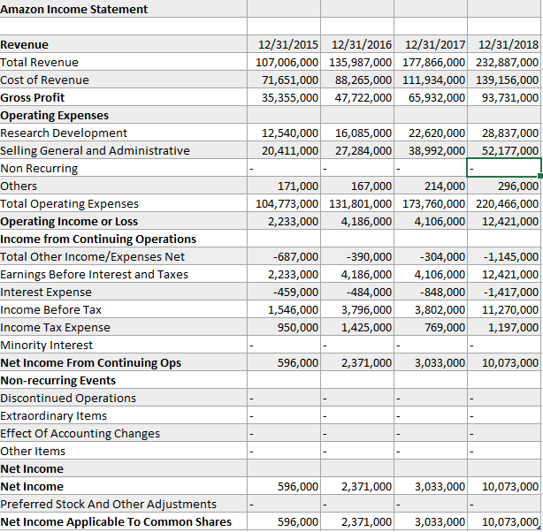
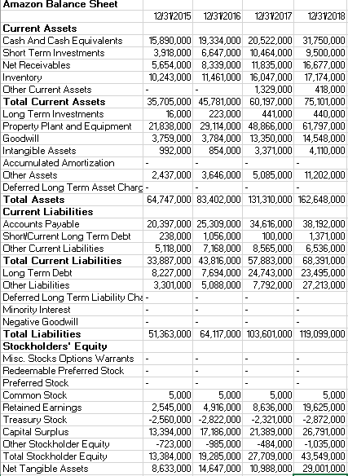
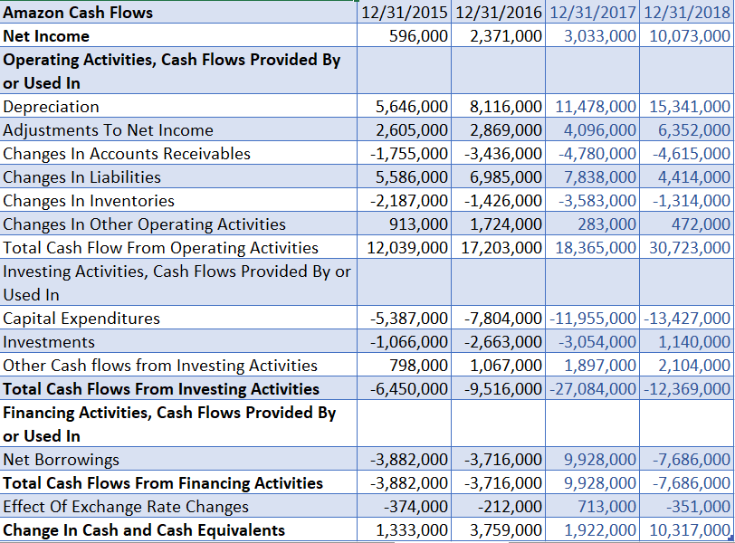

Conclusion
Amazon is a leader in many areas and aspects. As presented, Amazon stands head and shoulders above its competition. With the way online shopping is growing Amazon is expected to grow in its market share only more, while other large retailers are doing their best not to go bankrupt like Sears, Toys R Us, and more. Being an era of internet, it is essential to keep up with the change in today’s world, because if not constantly changing one can suffer losses or worse get bankrupt and have to foresee liquidation.

