Group 6:
Blake Hardy
Preston Womack
Mason Fletcher

Ford Motor Company Market Analysis
MGT 4380-S01
Feb, 20th 2019

Getting to Know Ford Motor Company
Ford Motor Company is a multinational automaker founded by Henry Ford in 1903. The company is headquartered in Dearborn, Michigan. Through Henry Ford’s innovative implementation of the assembly line and vertical integration automobiles were made cheaper and quicker to produce. This made Ford’s automobiles more affordable to the average consumer. Ford quickly became one of the most well-known automakers in the US market. They have since expanded operations internationally. The company has also expanded into other businesses, such as financing. Today, Ford has over 212,000 employees at 90 plants and facilities worldwide.

Industry Description and Outlook
The automotive industry is one of the largest industries globally. Each market is highly competitive. In the major producing countries, the markets are primarily controlled by a select few large corporations as most independent automakers have dwindled. Following the recession in 2008 - 2009, the automotive industry began to grow rapidly up through 2016. The industry then started to decline beginning in 2017 after most efforts to attract new consumers had been exhausted. The large expansion and intense competition of the industry resulted in an increase in auto loan delinquency rates as many risky borrowers were permitted loans they were unable to repay. In recent years, more benefits have been provided to steer customers toward leasing. The industry saw no growth in 2018 and the recent trade talks have only further complicated things for automakers. The rise in auto prices as well as interest rates has deterred the average consumer from purchasing a new automobile. The marketing strategy for automobiles has shifted focus more towards upper class individuals with disposable income. The automotive industry remains a leader in innovation. Due to the emergence of new technology and the decreasing cost of batteries many automakers have started working toward electric and hybrid vehicles. Car sales have declined in recent years while sales in trucks, hybrids, and electric vehicles are on the rise. Many experts show concern about the infrastructure needed to support a large expansion of electric vehicles however, manufacturers show no signs of slowing down. The industry is thought to contract even further in 2019 as these companies continue the race into this emerging market.

Target Market/ Size/ Trends
With more people every day being able to afford motor vehicles it is important that companies have the flexibility to conform to several different lifestyles. To expand their horizons even further, Ford does business in 62 different countries. With this many people living in different conditions, having different hobbies, and families it is even more important to have a variety of different vehicle options. In each section of the world it is vital to note the lifestyle of those who live there. This can help determine what kind of transportation vehicle would most likely thrive in its environment. In the United States light weight trucks (F-150/ F-series) are being seen more as luxury vehicles. However, in more compact countries the F-150 would be seen as too big to be practical for use.
Every day it seems technology is becoming more and more advanced. These new innovations are always being implemented into our everyday lives, including our vehicles. From high-tech safety features to a steering wheel that warms itself all manufacturers are incorporating new things that are now coming standard in most cars.
With the number of new car/ truck sells in the united states being around 17 million for each of the past few years it is easy to see just how big the market can be for automobiles. With Ford Motor Company being the second largest U.S.-based automaker, it is no surprise that they have the top selling vehicle in the U.S.

Competitive analysis
Key competitors:
- Fiat Chrysler Automobiles
- General Motors Company
- Toyota Motor Corporation
- Honda Motor Company
- Volkswagen Group
- Hyundai Motor Company
- Nissan Motor Company

Direct competitors
With Ford Motor Company being a part of the automotive industry, they have to compete with countless other businesses that are all striving for their product(s) to pierce the markets. This statement pertains to all the different markets that are under the umbrella of ‘automotive industry’. For example, light weight trucks, sedans, SUVs, and sports cars, are just a few of the many markets Ford has under their belt. This allows a wide range of consumers to recognize the Ford brand and what it stands for. With the entering of several different markets comes an endless number of competitors, including ones that have already been in the market and newly developed ones. Fiat Chrysler for instance, owns many different companies that all have different ‘specialties’ in the different markets. Fiat chrysler owns Dodge who can be compared to Ford on almost all levels of their vehicles. General Motors is the same way with owning Chevy, who also has a set of vehicles in several different markets. For direct competitors it is easiest to compare Ford Motor Company to other major automaker companies that own smaller brands inside their own. This list includes Fiat Chrysler Automobiles, General Motors, Toyota Motor Company, Renault-Nissan-Mitsubishi Alliance, and many others. The graph below, “Car Sells in the United States Between 2017 and 2018, by Manufacturer”, shows the number of sales of the major automakers in the US. This can also be seen as a decent list of the competitors that Ford Motor Company deals with with producing vehicles in the different markets.

Indirect competitors
The definition of an indirect competitor can seem very flexible when compared person-to-person. In some cases it can seem that a company with several different products can be an indirect competitor of itself. For example, the Ford explorer might compete with a larger vehicle such as an F-series. They aren’t part of the same market, but can still be substituted for the other. In this example however, Ford is still able to make the sale of one of their vehicles. If another company was brought into play the Ford explorer could be compared to a Chevy Silverado 1500, or even a smaller car like the Dodge Charger. Both of these other vehicles are in separate markets and owned by separate companies. The purchase of either of those would prevent Ford from making a sale leaving them labeled as indirect competitors. A different way to look at indirect competitors is what would keep someone from purchasing a vehicle of their own. The first thing that comes to mind for some would be a taxi such as Uber, or Lyft. These companies help individuals who already have vehicles by connecting them to those who would like to be chauffeured around. This leaves the user(s) of these app without the need of investing in their own cars. From a different view however, the drivers of these apps may invest in a newer car to receive a higher satisfaction rating in order to receive more passengers. In this case Uber and Lyft would be aiding Ford Motor Company in their sales.

Competitor’s strength/ weakness
Strengths
General Motors strength is rooted in the company's ability to accurately and effectively utilize the economies of scale. This allows them to effectively implement their generic strategy (known as Porter’s model). This empowers them to have a large market reach. Another of their strengths is their production capacity which allows them to address/meet market demands. Due to their longevity in the market they also have great strength in their human resource. Their employee competence allows the development of new technology. GM also has joint ventures with China which is an emerging market. It also maintains a strong brand portfolio consisting of 10 different brands: Chevrolet, Buick, GMC, Cadillac, Opel, Vauxhall, Holden, Baojun, Wuling, Jiefang
Toyota’s strength stems from their focus on Research and Development which has led to some of the most innovative automobiles in the world. They have 15 research facilities in 8 countries including Japan, United States, China, Thailand, Australia, Germany, France and Belgium where they focus on 3 specific and key R&D areas; basic research, leading edge technology, and product development. Toyota also has great brand awareness, between 7th-9th most valuable brand in the world and number 1 amongst the automotive industry.
Brand Value: Ford’s brand value stands at $19.771 billion according to the report done by Brand Finance. It ranks 46th in the list of Brand Finance report. Research and Development Ford is allowed a big budget to work on new technology. Ford’s market share was 7.2% in 2015
Wide portfolio of products

Weakness
GM has a dependency on the U.S market to generate majority of its revenue, 61%. This is because their most popular vehicle models are trucks or SUVs in the U.S. This is a problem because they are only sold in the United States. While GM has its portfolio of small to mid-size cars, trucks and SUVs have higher profit margins than their car models.
Toyota’s weakness may also be why it has done so well, the company enforces a strict global hierarchy meaning all regional heads must report back to the organization’s global headquarters in Japan.
Ford’s weakness is their product failures: In 2016 a quarter million F-150 series were recalled due to brake master cylinder issue. 2015 Takata airbag recall. They also have poor performance in emerging markets.

Barriers to entry
When it comes to starting up an automotive company it seems relatively straight forward from the outside. Many people of the public fail to see however the years of research and development that goes into designing not just the looks of a vehicle, but every aspect of it. Every inch of a car that you buy from a dealership has been designed, scraped, and redesigned countless times till the final result is finally agreed upon and signed off for mass production. With all the designing required to produce an automobile it is important that a company have the correct funding. Sponsorships, loans or some other kind of currency helps to employ the researches and supply them with the materials and technology needed to produce a prototype. Usually in the starting phase the business starts out with a small amount to its name. After the first few prototypes are produced and testing is successful the production of the vehicle will commence. It can be several years before the new company turns a profit, but if done well it will definitely happen. The biggest barrier to entry when it comes to the automotive industry is having the proper funding to complete the needed research and testing. It is also extremely important to make note of who and where your target consumer is so that all regulation are met.
The second barrier is the proper channels of manufacturing and distribution of needed materials. This is in regards to all the raw materials and machinery needed to produce a vehicle. Having channels that can efficiently provide and/ or deliver what is needed for the company to continue production is an element that cannot be overlooked. Ford Motor Company itself gets their materials from just over 100 different manufacturers and distributions.

Projections
According to the National Automobile Dealers Association, with the strong number of new car sales at the end of 2018 the quantity of sales for the year 2019 is projected to be just under 17 million in the United States. This is about a 1% decline in the number of automobiles sold in the states, compared to the previous year. This outcome is predicted due the new tax cuts signed in 2018. This put more money in the pockets of consumers which resulted in an significant increase in automotive sales at the end of the year. This increase in sales before 2019 is why the NADA sees the number of new car sales decreasing.
The new age of automobiles is also underway. Tesla, with its fully electric cars, has shown tremendous growth in the past couple of years. Other automobile companies have also started producing their own versions of full electric cars, but do not seem to have the same sales results as Tesla. Other alternatives such as Hybrids have been introduced in previous years to offer a more ‘green’ approach to driving. Ford has recently stated that in 2020 they plan to be releasing a F-series hybrid. Along with this new version of the best-selling truck in America will be other fully-electric, autonomous, and hybrid cars.

Regulations
Regarding the automotive industry, it is important to note that not just any car can be built and sold on the market. To have the ability to mass produce and sell vehicles to the public each vehicle must be up to regulations with the National Highway Traffic Safety Administration (NHTSA), Federal Motor Vehicle Safety Standards (FMVSS) and also with the Environmental Protection Agency (EPA). All of these groups are active to ensure that any and all vehicles on the roads of the United States are in compliance with each of the rules and regulations that would apply to them. This includes but is not limited to regulations pertaining to lights, brakes, mirrors, body paneling, tire size, suspension, airbags, seatbelts, durability, emissions and sometimes even exhaust noise. Though many car enthusiasts tend to bend these rules a bit, they are strictly there to keep individuals safe when operating these motor vehicles.

Competitive Landscape
Ford focuses on bringing quality products that people want to the markets in which they believe they can win. Ford’s vision statement is “people working together as a lean global enterprise for automotive leadership.” Ford aims to be a top player in the international automotive market while maintaining their lean operations. Ford’s mission statement is “One team. One plan. One goal.” This statement emphasizes teamwork while reinforcing Ford’s dedication to consistency and quality in production.

Key success factors
Ever since 1903 when Ford Motor company was founded, they have been making a name for themselves. The Ford name would be one that could be associated with large scale automobile manufacturing, innovation, and affordability. “Ford has a strong presence in the commercial vehicle segment with its legacy F-series trucks. In recent years, auto demand in North America has been primarily driven by pickup trucks. This has helped the company to maintain its market share in North America.” (Why F-Series Trucks Are Important to Ford’s Success Story.) With the Ford truck the top selling truck in America for the past 41 consecutive years it is crucial that the quality and performance of their vehicles hold up to previous standards. With success being related to the Ford name it helps the company to persuade previous Ford vehicle owners to come back and invest in new vehicles in the future.
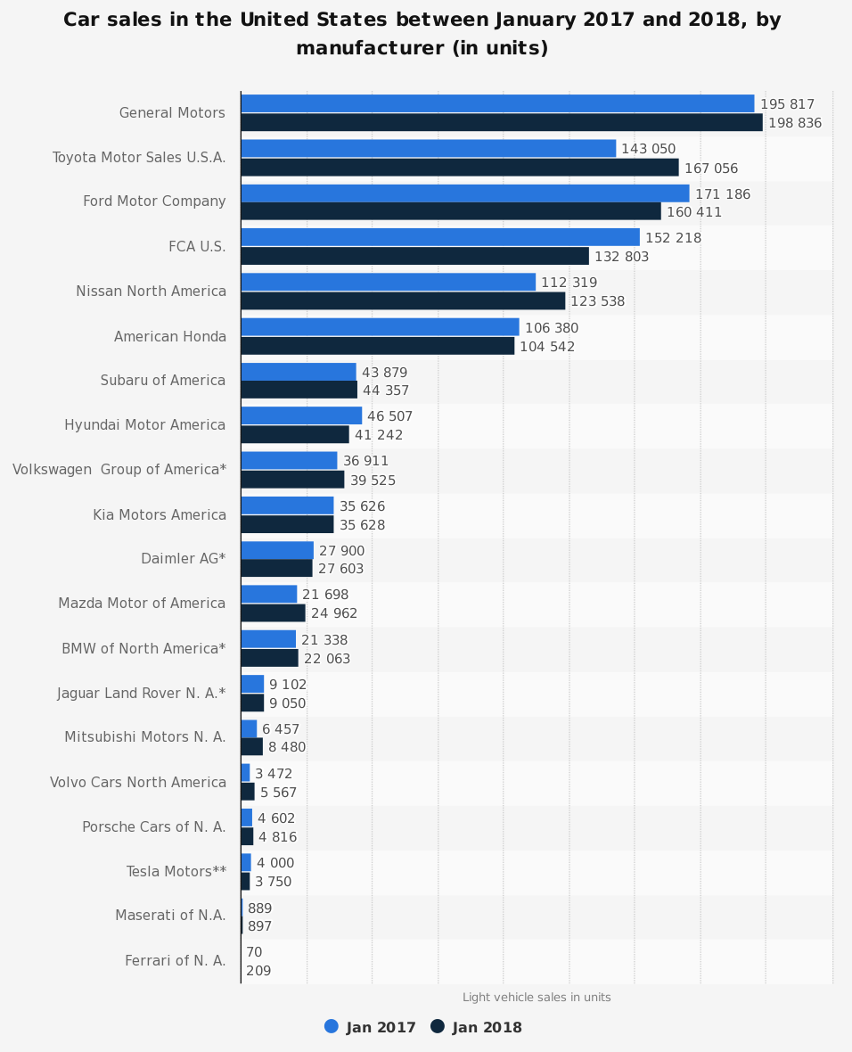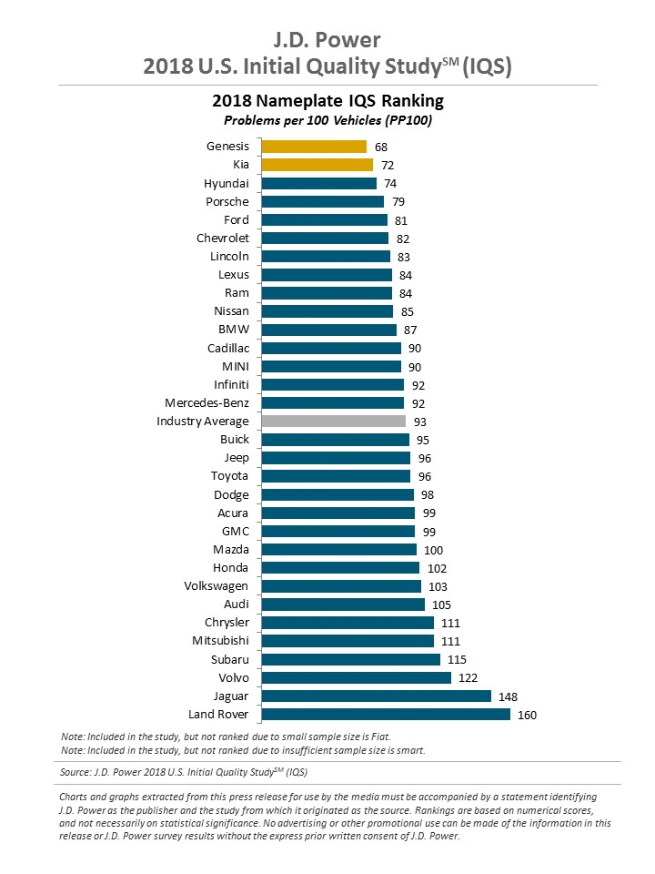
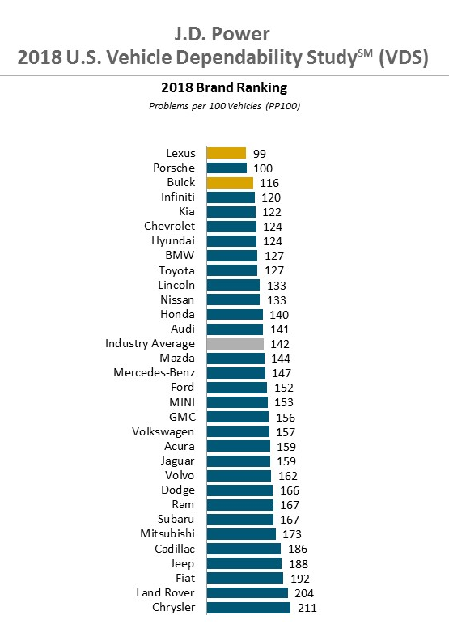
Work cited

Binder, Alan K., and John Bell Rae. “Automotive Industry.” Encyclopædia Britannica, Encyclopædia Britannica, Inc., 2
Aug. 2018, britannica.com/technology/automotive-industry/The-modern-industry.

Britannica, The Editors of Encyclopaedia. “Ford Motor Company.” Encyclopædia Britannica, Encyclopædia Britannica,
Inc., 3 Jan. 2019, britannica.com/topic/Ford-Motor-Company.

Lambert, Fred, et al. “Ford Says Electric Vehicles Will Overtake Gas in 15 Years, Announces All-Electric 300-Mile SUV,
Hybrid F-150, Mustang, and More.” Electrek, Electrek, 10 Jan. 2017,
electrek.co/2017/01/03/ford-new-electric-cars/.

Parker, John. “Why F-Series Trucks Are Important to Ford’s Success Story.” Market Realist, 2 Mar. 2016,
marketrealist.com/2016/03/f-series-trucks-important-fords-success-story.

“Top-Selling New Vehicles in the US in 2018.” WTOP, WTOP, 4 Jan. 2019,
wtop.com/consumer-news/2019/01/top-selling-new-vehicles-in-the-us-in-2018/.

“2018 Automobile Industry Outlook | Prevedere BI Insights.” Prevedere,
prevedere.com/insights/webinars/2018-automobile-industry-outlook/.

“2019 Automotive Industry Outlook - Webinar.” Prevedere,
prevedere.com/insights/webinars/2019-automotive-industry-outlook-webinar-thank-you/.

“Company.” Ford Corporate, corporate.ford.com/company.html.

