Group 6:
Blake Hardy
Preston Womack
Mason Fletcher
Ford Motor Company Competitive Analysis
MGT 4380-S01
April, 17th 2019

Industry and Competitive Analysis: Key Questions 2
About the Industry 2
What Influences Change in the Industry? 3
Identify Your Competitors 4
Ford’s Top 3 Competitors 4
1. General Motors Company 4
2. Toyota Motors 5
3. Chrysler 7
Secondary Competitors 7
1. Daimler 7
2. BMW 8
3. Tesla 8
Who Is Selling What You Sell? 9
What Is the Geographic Competition? 10
What Price Points Exist in the Market? 11
Who Are Your Competitors Targeting? 12
SWOT Analysis 14
Ford SWOT 14
GMC SWOT 16
Toyota SWOT 17
Income Levels 19
Online or Storefront 20
Determine Where You Can Add Value. 21
Summary 21
Citations 22

Industry and Competitive Analysis: Key Questions
- What are the chief business and economic characteristics of the industry environment?

- What forces are driving changes in the industry and how important will these changes be?

- What competitive forces are at work in the industry and how strong are they?

- Which companies are in the strongest/weakest competitive position and why?

- Who will likely make what competitive moves next?

- What are the keys to competitive success?

- All things considered, how attractive is the industry and how good are the prospects for above-average profitability?

About the Industry
The automotive industry as a whole can be seen as “highly capital and labor intensive”, as Competitive Analytics puts it. This basically means that the majority of the industry is highly dependent on labor, raw/ imported material, and advertising. Along with the buying and selling of cars is the actual manufacturing part of the industry. This part actually contains a lot more business than many think. The cost of parts to make up a vehicle would cost 300-400% more than the sticker price the dealerships are asking for the vehicle. The manufacturing part of the automotive industry involves such mills as steel, aluminum, rubber, and plastic to name a few. The auto part manufacturers within the automotive industry do their best to make many of the original parts that go into vehicles as well as some of the aftermarket parts such as air filters, and oil filters. Along with the original equipment manufacturers is other manufacturers that pick up the slack of parts that the big automakers can’t always produce. They also may take some of the OEM parts and redesign them in order to profit off of the sale of them when wanting to to be replaced. A lot more goes on in the automotive industry the more you dig down. Especially when getting into the equipment designed and used to build the vehicles themselves. And the Industry is always evolving while it adopts dismisses and redesigns new aspects of its automobiles as generations introduce new technologies and ideas.

What Influences Change in the Industry?
When it comes down to redesigning and adapting to the new generations to come there is no better way than to consult the younger generation themselves. They are the ones that are going to be directing the industry ‘norm’ for the next few years to comes. The new technology and user interfaces that are designed and used by the average individual of the next generation is a good way for automotive companies to set off in the right direction when redesigning their vehicles. Another element that is guiding the automotive industry is the drastic increase of vehicle renting or sharing. This is of course referring to services such as Lyft and Uber that offer customers to call a driver who has offered there car up for a means of quick transportation to a designated area. With these types of services the number of car sales has slowed for some automakers. One way Ford is combatting this is by offering up there own car-sharing service called GoDrive. They are not however the only automotive company getting in on the taxi service trend. BMW and Daimler have their own services as well. The biggest influencer in recent years has been the introduction and advancements of fully electric automobiles! This was especially evident when Tesla entered the market and showed everyone that it was in fact possible to go completely green on vehicle emissions. With automakers getting in on the electric trend other trends such as driverless capabilities or autopilots have been put into development. These ideas are just in reach with the research that is being poured into new computers, chips and other technologies that are being integrated into next gens automobiles.

Identify Your Competitors

Ford’s Top 3 Competitors

1. General Motors Company
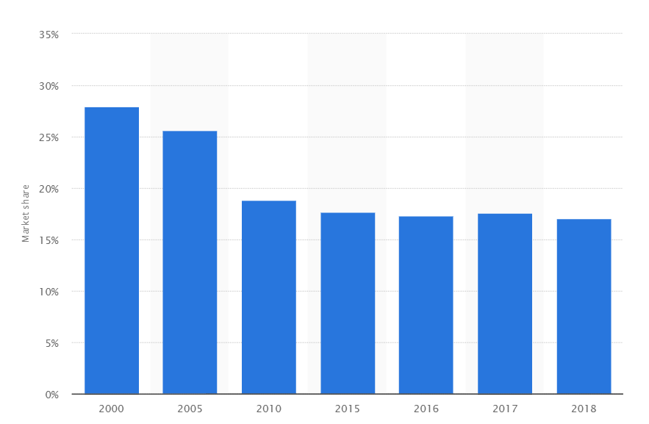
Under the umbrella of the company known as General Motors (GM) the corporation holds the companies Chevrolet, Buick, Cadillac, Holden, and Wuling. They are competitors because these companies sell similar products to Ford’s product line. GM and Chevrolet both sell alternatives to Ford’s pick up truck lines, their SUV lines, and different mid size cars. Most of the competition occurs within the United States. GM’s income for 2016-2018 (In millions) was $1,570 in 2018, $1,085 in 2017, and $657 in 2016. GM also holds the largest market share in the US.
Figure 1

2. Toyota Motors
In the United States Toyota holds the second largest market share, but in the world market they hold the number one market share percentage, as of 2018 . Toyota is one of the only non-US based automotive companies that makes a full size pickup truck that competes with Ford and other US companies. Toyota also competes with their mid size sedans and SUV Crossover with vehicles like the Toyota Camry, Corolla, Rav4, Sequoia, and Highlander. Toyota produced 10.2 million vehicles in 2016. Toyota maintains its advantage through the large investment of their Research and Development teams. Through this they are able to remain up to date with the emerging cutting edge technologies like hybrid cars. Toyota’s product mix is: Toyota automobiles, Lexus automobiles, Welcab series, Marine products, Spare parts/accessories, and Engines
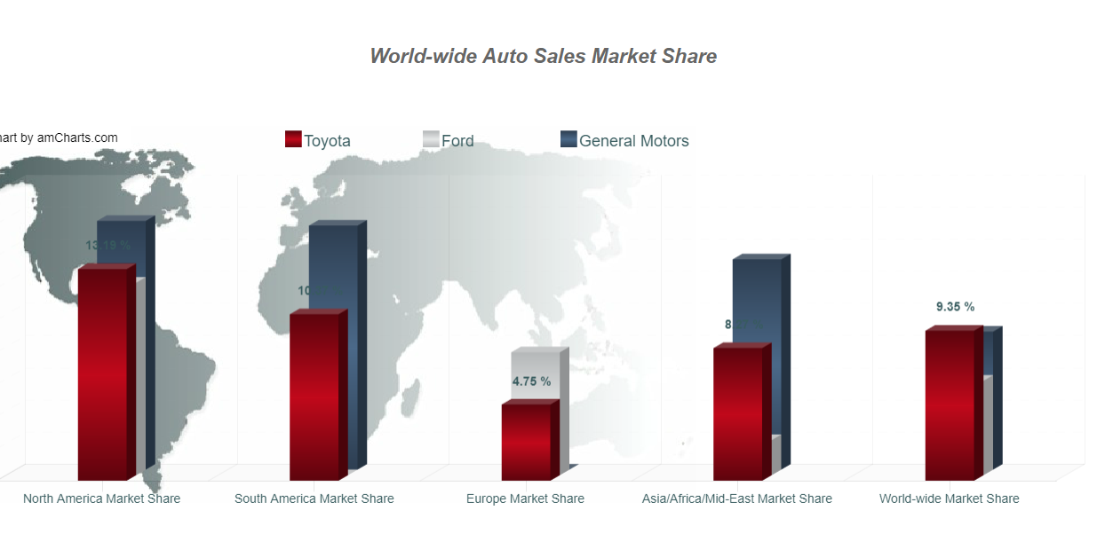
Figure 2
Figure 3

3. Chrysler
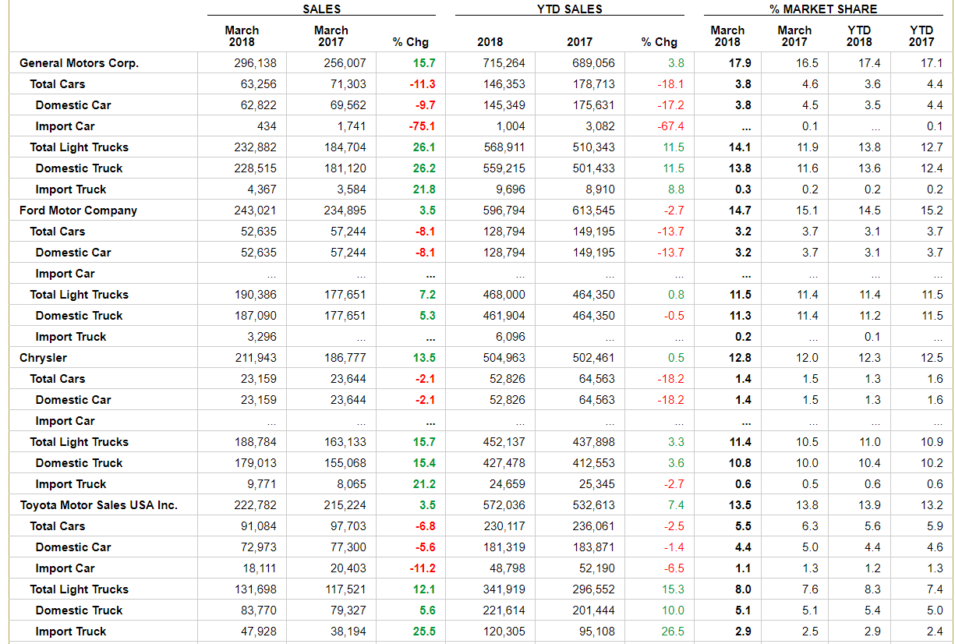
Chrysler (known as Fiat Chrysler Automobiles [FCA]) is considered one of the “Big Three” in the US automotive industry. Chrysler is owned by Fiat, the company has long held Dodge and Jeep as subsidiaries. Chrysler is able to compete with Ford’s truck lines with the Ram truck lines. Chrysler and dodge both can compete with fords mid size sedans with their own product lines.
Figure 4

Secondary Competitors
- Daimler
This german automobile company possesses some very iconic luxury car brands. The most well known to our country being Mercedes-Benz or Mercedes-AMG. This branch of Daimler can be classified as a secondary competitor to Ford because they represent a much higher luxury vehicle than Ford’s Lincoln brand. With competitive vehicles to Ford’s sedan, sports car, and soon its truck models, Mercedes is able to offer a high quality vehicle than is produced by the American company, Ford. When customers are looking for a more high class vehicle to roll up to functions in Ford is most certainly beaten out of the running by there secondary competitor, Daimler, with vehicles that offer a much comfortable ride as well as massage seats to name a few amenities.

- BMW
BMW group contains a few more secondary competitors to Ford that when compared, can make Ford look low class. Along with the BMW brand itself, BMW group owns Rolls-Royce. This extremely luxurious automaker is one of the most common names you will hear when talking about upper class chauffeur vehicles. This cars allow their passengers to take part in countless different relaxation options including TV, Massage chairs, mood lighting, privacy windows, and the occasional champaign beverage. The still comfortable brand of BMW offers cars and crossovers that have the space, looks, and amenities that Ford can offer, but with the ability to have a sports car feel when it comes to speed and handling. One of the key features that helps with this is the wider wheels and tires that come on most BMW models.

- Tesla
As Ford begins to dip into the new field of fully electric cars they begin to adopt new competitors at the same time. The biggest name in fully electric cars, today, is Tesla. They have made the dream a reality by offering sedans, and a crossover to the automotive industry. This brand can also be classified as a luxury automaker, giving them a leg up on luxury sales compared to Ford. Tesla has since been working on several other vehicles that will compete with Ford’s Mustang, F-series trucks, and minibus/ vans. To dip into some of the hype, Ford has announced that they will be working on and releasing the first fully electric f-series truck. Whether or not they will beat tesla to the release of it is simply a test of time. All-in-all, Tesla has set the bar pretty high when it comes to fully electric vehicles. Even other automakers like Toyota are struggling to keep up with the advancement in technology that they have introduced into the automotive market.

Who Is Selling What You Sell?
The automotive industry is an oligopolistic market with large barriers to entry. The actions of one automaker have a significant influence on the actions of others due to the small number of competitors. Ford has manufacturing operations all over the world. According to OICA statistics, the top 10 automakers control over 70% of the global market share. There are 14 major corporations (see image on pg.12) that control a combined 62 auto brands globally. These companies along with companies such as Mclaren, Mazda, Subaru, Ferrari and Tesla make up most of the global auto market.

What Is the Geographic Competition?
Ford competes in over 200 markets worldwide. All Ford products are localized and made to fit the conditions of the environment in which they are sold. The United States is the world’s largest car market and where the bulk of Ford’s sales take place. The US market is controlled primarily by the “Big Three” automakers. The “Big Three” consists of Ford, Chrysler, and General Motors. These companies mostly compete on cost and function. The “Big Three” dominated the US market up until the 1970s when the entrance of foreign automakers began affect their market share. Toyota, Honda, and Nissan have grown their market share because of their ability to deliver products at lower prices. These companies compete more on cost and style rather than function. Toyota is the largest of the foreign competitors in the US market.
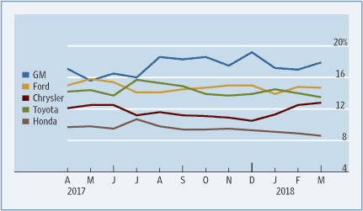
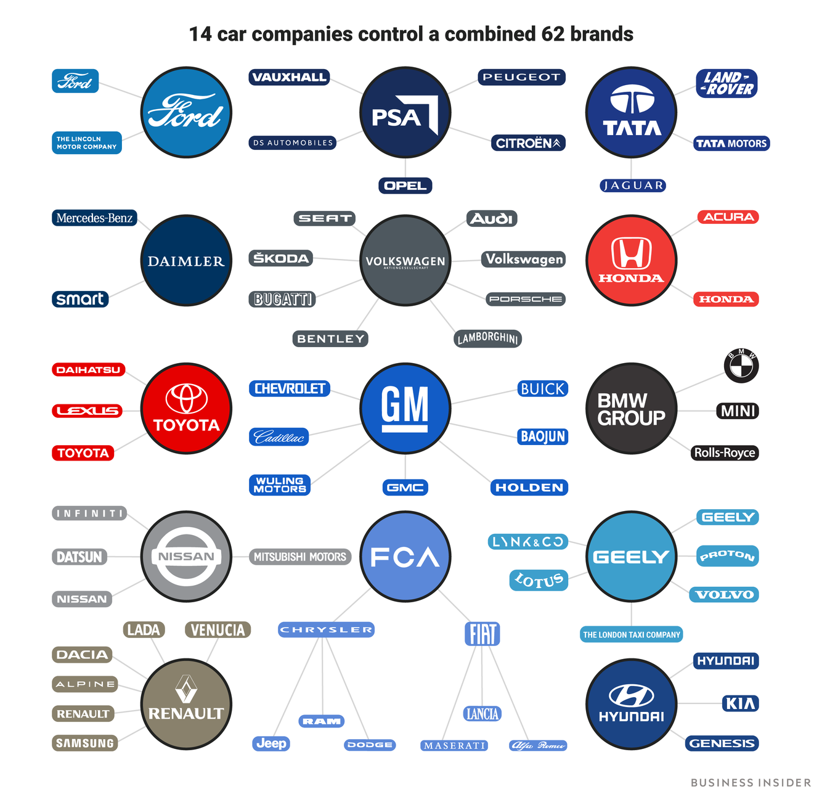

What Price Points Exist in the Market?
Prices and product features vary in the automotive industry. This makes marketing and advertising even more important. Automakers subdivide their markets and charge customers varying prices depending on demand elasticity. Ford takes into account costs incurred as well as the profit margin. Competitor price has a large influence on Ford’s pricing strategy. Market analysis and recent financial reports also play a large role in pricing.

Who Are Your Competitors Targeting?
General Motor’s has a wide range of product mixers that covers a large part of what makes the automotive industry operate smoothly. The first is the numerous brands in the automobile sales such as GMC, Buick, Chevrolet, and Cadillac vehicles that target markets worldwide. With each of these brands carrying a number of different styles and options, it is possible for General Motors to cover a wide range of customers looking for vehicles to fit their everyday lifestyle, and/ or hobbies. GMC and Chevrolet for instance is a company that is geared toward a working individual that needs a durable set of wheels. Their automobiles can be seen as rugged and tough enough to withstand some of the abuse that drivers might put it through. Other brands General Motors owns such as Buick, and Cadillac are geared towards the more business, or family style automobiles. These brands will have a slightly more elegant look to their body styles, as well as nicer materials incorporated into the body work of the vehicle. With these different brand names, General Motors is able to cover a range of customer’s needs when it comes to automobile features and capabilities. In order to manufacture these vehicles, numerous amounts of parts are needed. General Motors also has many companies producing these OEM parts so that all branches of their corporation can operate smoothly and produce the vehicles needed to keep up with modern times and technology.

Another branch of General Motors is GM Financial. This branch is one of the largest employers where their headquarters is located, in Fort Worth, TX. This company is a global provider of loans, leases, floorplans, and even insurance for countless car dealerships.

Toyota’s promotion strategy covers all the tactics of marketing communications. This element pertains to how the firm communicates with their target market. Toyota uses the following promotional activities, arranged according to significance: Personal selling is done through the dealership and potential/actual buyers, advertising is utilized through mainstream media such as TV, radio, and other forms but also social media like instagram or ads on social media sites, public relations is done by the company sponsoring worthwhile or charitable organizations like the Toyota TogetherGreen program that supports environment initiatives, sales promotion toyota-thon, direct selling sells directly to corporate clients.

Ford Motor Company’s marketing mix supports the firm’s ability to connect with its target customers. Ford is the second largest U.S.-based automaker, third largest market share in the US, and the fifth in the world. With this position, a comprehensive marketing mix is critical to maintaining its performance.

Many companies like Subaru, Honda, and Kia attract customers by connecting with the aspect of having a family friendly vehicle. Some elements that help portray this family vehicle are safety ratings, vehicle sensors, driving assist, and many other things that would, in a way, provide a safer means of transportation for your loved ones.

SWOT Analysis

Ford SWOT
Strength
Ford’s strength is derived from their brand, global operations, as well as their R&D. Market share in cars and light trucks was 14.8% in August 2015, making it number two to General Motors. Their strong brand image is due to the fact they are one of the top players in the global market. This results in Ford having a strong customer loyalty leading to product attractiveness. Their strong supply chain also allows for operation globally. The R&D allows for greater innovation and design and implementation of new and cutting edge technology. Ford’s brand value stands at $19.771 billion according to the report done by Brand Finance. It ranks 46th in the list of Brand Finance report. Research and Development Ford is allowed a big budget to work on new technology.

Weakness
Ford has a limited scope on their global production this limits them in their market expansion and market utilization. Ford’s weakness is their product failures: In 2016 a quarter million F-150 series were recalled due to brake master cylinder issue. In 2015 Ford also had a recall on their Takata airbag. They also have poor performance in emerging markets. They have also had to shut down some of their plants within Europe and as of March 2018 have decided to remove many of their cars from their product line; that being most of their midsize sedans. Heavy dependence on U.S. and European markets. Ford also tends to have higher than average cost of production compared to those of their competitors.Blue collar/middle-class brand, makes it hard to market it to luxury buyers. While Ford has a good R&D their innovation process is quite slow, leading to slower adoption or utilization of emerging trends.

Opportunity
Ford has an opportunity to expand their market share by penetrating with more dealerships, improving their market strategy, and increasing innovation and making it more efficient. They can also capitalize on their supply chain through expansion and enhancing their economies of scale which will result in a reduction of their production costs. The fluctuating prices of oil and gas is a constant issue, this weakness can be turned into an opportunity by innovating new technology that no longer relies on the combustible engine but instead uses renewable energy or cleaner forms of energy.

Threat
The greatest threat to Ford would be from their competitors, their competitors hold a larger market share both globally and domestically. In the case of Toyota and GM their marketing campaign out performs Ford’s. Secondary competitors, such as Tesla, and alternatives, like Google, Uber, Lyft, and other ride sharing companies or emerging self driving cars, are existing as well as up and coming threats to Ford.

GMC SWOT
Strength
General Motors strength is rooted in the company's ability to accurately and effectively utilize the economies of scale. This allows them to effectively implement their generic strategy (known as Porter’s model). This empowers them to have a large market reach. Another of their strengths is their production capacity which allows them to address/meet market demands. Due to their longevity in the market they also have great strength in their human resource. Their employee competence allows the development of new technology. GM also has joint ventures with China which is an emerging market. It also maintains a strong brand portfolio consisting of 10 different brands: Chevrolet, Buick, GMC, Cadillac, Opel, Vauxhall, Holden, Baojun, Wuling, Jiefang

Weakness
GM has a dependency on the U.S market to generate majority of its revenue, 61%. This is because their most popular vehicle models are trucks or SUVs in the U.S. This is a problem because they are only sold in the United States. While GM has its portfolio of small to mid-size cars, trucks and SUVs have higher profit margins than their car models.

Opportunity
Like most companies the greatest opportunity GM has is increasing their presence in emerging and developing countries. One way this can be done is by offering options other than Chevrolet in these countries. By utilizing there other subsidiaries GM can increase their product reach. By doing so they will increase their corporate revenue.

Threat
Government regulations could lead to GM having to overhaul their entire current automotive standards, government also pushing public transport and other alternatives. New and emerging technology can also be a threat if GM is not continually innovating and staying up to date on the current technology.

Toyota SWOT
Strength
Toyota’s strength stems from their focus on Research and Development which has led to some of the most innovative automobiles in the world. They have 15 research facilities in 8 countries including Japan, United States, China, Thailand, Australia, Germany, France and Belgium where they focus on 3 specific and key R&D areas; basic research, leading edge technology, and product development. Toyota also has great brand awareness, between 7th-9th most valuable brand in the world and number 1 amongst the automotive industry.

Weakness
Toyota’s weakness may also be why it has done so well, the company enforces a strict global hierarchy meaning all regional heads must report back to the organization’s global headquarters in Japan.

Opportunity
As with all the major automotive companies expanding and increasing their presence within developing and emerging countries is a key opportunity to seize. Countries like India and China are great examples of emerging countries the companies need to start expanding into. With Toyota having highly fuel efficient cars like the Prius, Toyota can increase their focus on fuel efficiency and began developing and incorporating new technology to aid with fuel efficiency.

Threat
Market threat by new companies that have lower cost production and automotive costs from companies in countries like Korea and China. Rapid innovation creep from major competitors like GM and Ford leading to them being overtaken through innovation.

Income Levels
A common theme seen in marketing within the auto industry today is a shift in strategy aimed at high wealth consumers. As prices and interest rates continue to rise, the demand for new cars has begun to fall. The gap between the price of a new and preowned car is at its largest in over a decade and more people than ever are buying used vehicles. In order to combat this problem automakers are making a more active effort to pinpoint consumers with disposable income. In order to satisfy the needs and wants of all their customers Ford has launched a number of different product lines aimed at different levels of income. In 1922, Ford purchased Lincoln Motor Company. Under the Lincoln brand Ford began competing in the luxury car market. Ford uses a differentiated targeting strategy to offer specific products to specific customers.This strategy includes a mix of geographic, demographic, and psychographic segmentation variables. Ford has been a long time favorite among low income blue collar customers because of their low prices.

Online or Storefront
Car shopping can be a painstaking process and consumers are always in search of ways of making that process easier and more efficient. In today’s cyber fueled society almost all companies are turning toward internet stores and now even an automobile can be just a click away. Tesla began leading the charge into online vehicle sales when they announced that they would shift all sales to online and begin closing down some of their brick and mortar stores. This action led many automakers into building online stores of their own. In 2018, Ford launched their online store known as Ready Shop Go. The website allows you to search available inventory and see pricing details. You can also apply for financing, sign up for a lease, and schedule a test drive. Online shopping allows the customer to view more vehicles while spending less time at the dealership. In March of 2019, Ford began pilot testing an online program for used Ford vehicles known as Find Your Ford. This program aims at consolidating dealer listings into one place so users can narrow listings by features. It is thought that many dealerships will close over the years to come and as technology shifts the market, Ford continues to stay at pace with the competition.

Determine Where You Can Add Value.
One way Ford is trying to add value to their company is by focusing their resources on what is making the company the most. This of course is related to what the public finds most attractive in the car industry. Lately it has been seen that more people are buying bigger trucks and SUV’s over the smaller compact sedans. With this being the case, Ford has announced that they are dropping all production on the majority of their sedans and compact cars in order to produce more of what the public wants. Other resources that would otherwise be ‘wasted’ on the declining sales of sedans could now be put to even better use. The technology or electric powered vehicles being a common one in today’s news.

Summary
The automotive industry as a whole as a vast number of different branches within itself. All the parts work together in order for numerous manufacturers to provide products and services that keep up with today’s trends. Many of the main automotive companies that we know such as Ford, Fiat-Chrysler, and General Motors, all strive to produce the most fitting vehicle for the public they can. This requires lots of research and development before they can become a reality. Many companies even play off of other’s ideas to create a possibly new market or amenity that could help them in long run against their competitors. Many markets within the industry are focused on by specific companies. Ford, for instance doesn’t focus to much on the high luxury portion of the automotive industry like Mercedes-Benz does. However, Ford does have their more luxury like brand, Lincoln, to make up for this gap. They do excel in the truck and SUV’s departments of the industry also, making great competitors for sub companies like Chevrolet and GMC. Along with the entire manufacturing of vehicles is the parts that go into them. The automotive industry also includes all manufacturers and material mills that help produce parts or the OEM’s. Automakers put lots of resources into making as many parts as they can from the lights to the seats to the wheels.
With the constant advances in technologies being incorporated into the manufacturing process and put into vehicles themselves, the automotive industry will always be fluctuating and continue to compete among the countless different automakers it contains.

Citations
The Wall Street Journal, Dow Jones & Company, www.wsj.com/mdc/public/page/2_3022-autosales.html.
“Automotive.” Competitive Analytics, competitiveanalytics.com/automotive.
“Car Sales Market Share by Country, Manufacturer and Quarter.” CSIMarket, csimarket.com/economy/Market_Share.php.
“General Motors - Vehicle Sales Market Share in the U.S. 2018 | Statistic.” Statista, www.statista.com/statistics/239607/vehicle-sales-market-share-of-general-motors-in-the-united-states/.
Gould, Skye. “These 14 Companies Dominate the World's Auto Industry.” Business Insider, Business Insider, 15 Feb. 2018, www.businessinsider.com/biggest-car-companies-in-the-world-details-2018-2.
“U.S. Market Share of Automobile Industry.” Statista, www.statista.com/statistics/249375/us-market-share-of-selected-automobile-manufacturers/.
Bhasin, Hitesh. "Marketing Mix Of Ford Motor Company". Marketing91, 2019, https://www.marketing91.com/marketing-mix-of-ford-motor-company-ford-marketing-mix/.
"Competition In The Global Automobile Industry". Academicwritersbureau.Com, 2019, https://www.academicwritersbureau.com/samples/221-competition-in-the-global-automobile-industry.
"Competitive Market Analysis And Positioning - Strategic Management: Ford". Sites.Google.Com, 2019, https://sites.google.com/site/buad467ford/home/competitive-market-analysis.

