Bailey Anderson, Angela Chavez, Tucker DeVinny
Dr. Kim Boal
MGT 4380-093
12 April 2019
Competitive Analysis: American Airlines
Introduction:
Knowledge is power in all cases, but particularly for this one, in the business world. Chances are there are pre-existing ideas and companies selling the same or similar service or product you are. The world is constantly evolving and that signifies that current industries are constantly evolving as well. Determining the correct strategies and implementing them in a way that makes your company more attractive to consumers than other companies is critical to an ever-moving business. Creating an edge over competitors is part of maintaining a stable business and staying ahead of the game. Part of having the ability to create an edge over competitors is knowing more than your competitors… meaning, knowing about your competitors and knowing more about the industry than they do. This is where a competitive analysis comes in. A competitive analysis is “identifying your competitors and evaluating their strategies to determine their strengths and weaknesses relative to those of your own product or service” (Parsons). Keeping up-to-date information on competitors and knowing their next potential moves could save your company from undergoing failure. It is necessary to formulate a plan to block competitor’s threats which can only be done by remaining knowledgeable and by going with the motion of the world. The world will continue to flourish, grow, and evolve politically, economically, socially, and technologically. Even if a competitive analysis does not directly correlate with those factors, they are inevitable and the more knowledge a company knows about its competitors, the more likely they are to be able to apply preventative maintenance and enhance their company in a well-rounded manner.
American Airlines competes with United and Delta Airlines in which emphasizes the importance of formulating a competitive analysis for the purpose of their utmost potential. Below, are the results of SWOT analyses for each competitor identifying their strengths, weaknesses, opportunities, and threats through research. A company must recognize its competitors' strengths in order to identify what they need to improve on. On the other hand, it is detrimental to know their weaknesses so American Airlines can seek potential opportunities to dive into where rivals may fall short. As for opportunities them self, American Airlines needs to stay aware of who and where their competitors are networking with to beat them or make better strategic moves. Finally, it is necessary to research their potential threats. Knowing how competitors may be ‘attacked’ and acting faster and smarter than them will only keep American Airlines ahead and thriving. Keeping the data, numbers, facts, and golden chances aligned with the goals will place American above United and Delta Airlines, and ultimately, they will remain at the top of the power chain in the airline industry.
American Airlines SWOT Analysis:
First, it is important to complete a SWOT Analysis for American Airlines which allows investors and business partners to analyze the fundamental pillars of a company. It allows the firm to identify the strengths and weaknesses a company faces, as well as possible opportunities and threats they could encounter in the future. One of American Airline's top strengths is their loyalty flyer program, AAdvantage, offered in order to keep their consumer base. Customers are more likely continue to fly with a company they have good experiences with, and with American Airlines having a mileage program to help their customers save money, they are set to maintain their market share of 15.66% domestically in 2017 (Statista). The AAdvantage program offers rewards to use towards flight upgrades, hotel bookings, and car rentals. Miles in this program are earned through American Airlines flights or any of its partners, which include the OneWorld Alliance. By American Airlines offering an extensive way to offer and selection of resources to flyers, they can retain frequent flyers’ use of their services. This establishes a strong sense of brand loyalty and keeps them thriving in their industry.
American Airlines also makes customer satisfaction a top priority, which is seen in their One Team, One Plan 2019 strategy for their workforce. The plan specifically outlines the desire to "create a world-class customer experience". In this section, they emphasize growing in safety and reliability, enhancing customer value domestically as well as with global joint partners, and best their "likelihood to recommend" scores in company history. Along with keeping their customers content, American Airlines is strengthened by the number of amenities and innovations they offer to passengers. American Airlines is continuously improving its services and technology to ease the flight experience of customers. Through the years, they have installed self-service kiosks to check luggage efficiently and offer TSA precheck as a ticketing option to speed flyers along to their gates. The technological advancements extend to onboard flights as well with the amount of free entertainment available. American Airlines allows customers to have access to plenty of movies, TV shows, music, and more by simply downloading their free app. American Airlines' strengths focus on AAdvantage and put customer satisfaction as a top priority in which they have implemented several strategies to gain lead amongst competitors.
A weakness of American Airlines is having a limited number of aircraft suppliers. The main supplier American Airlines has for aircrafts and aircraft servicing is The Boeing Company. Because they are limited in suppliers, this could cause delays in maintenance and acquiring aircrafts. By relying too heavily on one main supplier, issues can arise if any recall or issue were to occur in a model of aircraft used. This is what we saw happen with the Boeing 737 MAX failures within the past year. The issues with this highly used aircraft resulted in American Airlines canceling many large domestic and international flights. According to American Airlines' newsroom page, until the Boeing 737 MAX is recertified through the Federal Aviation Administration, flights scheduled to use this specific plane will be canceled or replaced with a different aircraft through August 19th of this year. American Airlines stated that "approximately 115 flights will be canceled per day" (AA Newsroom). Not only is this a large setback on its own, but because American Airlines must work to reroute flights, the planes used to substitute for the 737 MAX will affect several other flights, leading to more cancellations and a difficult time flying. The events leading up to these cancellations are an unpredictable risk that was taken by American Airlines relying heavily on limited aircraft suppliers. This stresses the consumer and the company as well, as they must take on the responsibility for Boeing. American Airlines must directly contact and respond to the numerous passengers that are going to be affected by these cancellations and offer possible costly compensations or risk losing customers in the process. American Airlines has room to grow in this aspect by branching out or improving the contract they have with Boeing.
American Airlines also struggles in its profitability ratio, as it is not as to the level of their competitors, United Airlines and Delta. According to the Nasdaq stock market, as of the end of 2018, American Airlines' reported profit margin is at a mere 3% compared to 19% for the year ended in 2015. Delta and United Airlines are recorded to have a profit margin of 9% and 5% respectively. Their profit margins have decreased since 2015 as well, but not to the extent that American Airlines' has. While American Airlines did have the highest total revenue in 2018 at $44.5 billion, their competitors were trailing behind relatively close within $3 billion away. American Airlines also spends more on their expenses, leaving them with a net income of $1.4 billion. Delta and United Airlines both ended 2018 with a net income of $3.9 billion and $2.1 billion respectively. Long-term profitability strategies need to be improved in order to keep American Airlines competing with other airlines and intriguing possible stockholders (NASDAQ).
An opportunity American Airlines can expand from is the growth in the United States' Airline Industry. Since 2015, the industry has increased in revenue but 4.2% and is expected to grow by 5% in the next 5 years. This consumer trend along with the number of locations American Airlines provides service to provides a great opportunity for the company. American Airlines thrives off providing large hubs in major airports located in Dallas-Fort Worth, Los Angeles, Miami, and many more in the United States. These hubs allow for customers to fly domestically and internationally to smaller cities which other airports don't offer. For example, the Lubbock airport does not offer a flight directly to Austin, so you would have to fly to the Dallas-Fort Worth Airport to take a connecting flight to Austin. When buying tickets through American Airlines, the connecting flights are sold together making it easy for consumers to keep track of their travel information through one purchase. By having these hubs, they are able to provide travelers with access to the majority of cities within the United States. According to Forbes, in terms of domestic connectivity and hub dominance, American Airlines controls 84% of Dallas Fort-Worth International Airport and 90% of Charlotte Douglas International Airport. By offering these services, it increases American Airlines' possibility of expansion in its market share, therefore, growing its profitability.
Another opportunity for growth stems directly from the state of the economy. Through the years following the recession, a booming economy increases customer spending, which in turn allows rational consumers to be able to afford to spend their money on products and services that will provide them with higher personal satisfaction. The lower inflation rate in the past years, not reaching over 3% since 2012, creates more stability and confidence in the market. This consequently influences buyers to spend money to keep the economy circulating. The increase in potential spending along with the right marketing contributes to an increase in revenue for the airline and travel industry. When the economy thrives, industries will continue to thrive. As new customers enter American Airlines' market, the benefits mentioned in the strengths portion will increase the retention rate of flyers.
While American Airlines brings in more revenue than its stated competitors, the external threats that they must overcome are also expanding to them specifically as well as the airline industry. Like other airlines, American Airlines' operating expenses are largely made up of fuel expense. According to Forbes in 2018, fuel cost made up about one-third of American Airlines' operating expenses. The price of oil can't be controlled by the airline industry, so the profitability of the company is sensitive to the change in oil prices. American Airlines forecasts a "30.1% year-over-year increase in consolidated 2018 fuel expense or an increase of $2.3 billion" (Reed). This external factor can be extremely costly to the company, but it is an unavoidable risk they must adjust to. American Airlines combats risk by not partaking in fuel hedging, the process of buying fuel in bulk at the current market (Trefis Team). While it can be beneficial, it can also be incredibly risky if the price of oil goes down, allowing competitors to have lower oil expenses and profit more. An increase in expenses subsequently decreases the net income for the year, thus declining the price-to-earnings ratio and lowering American Airlines’ price per share inversely to the trend of oil prices. This affects the valuation to American Airlines to the eyes of their current and potential stockholders.
Another prominent threat to American Airlines in more recent times in the rapid growth of Low-Cost Carriers in the industry. Although American Airlines has made accommodations to ticket pricing with their basic economy seats to compete with airlines like Spirit and Frontier Airlines, the latter do not have the same ratio of costs to sales. The no-frills airlines are able to keep their total costs minimal and their customers know what to expect when purchasing their tickets for cheap and accommodate to the lower level of service. "Spirit Airlines reported a 20% increase in total passenger miles flown in 2016 compared to the previous year" and are increasing in the number of locations they offer flights to (Martin). While American Airlines can easily beat out Spirit Airlines in terms of quality, they are capturing the portion of the market that values cost more and are willing to endure sub-par amenities and comfort. Losing a portion of the market share will affect not only American Airlines but its competitors, as the overall generated industry revenue is forced to be split among more airlines than before. Southwest Airlines is the world's largest Low-Cost Carrier who has had a consistent profit margin of 11% since 2015, which is showing more growth than American Airlines.
United Airlines SWOT Analysis:
United Airlines, or United Continental Holdings, Inc., is a commercial international airline that competes in business, luxury, and leisure travel for commercial flyers. Their target market consists of the middle class as well as higher income individuals and corporate travel. United Airlines has the slogan of "fly the friendly skies", as they base their goals on the customer experience. In 2010, they changed their name from UAL Corporation to United Continental Holdings following a merger with Continental Airlines. United Airlines is ranked fourth in the world for airline companies by revenue according to Forbes in 2018.
As a large company that is able to provide international travel, United Airlines requires outstanding strengths to remain competitive in the industry. One of their strengths is that they are able to benefit from the alliance they founded called Star Alliance. This alliance consists of 28 airlines throughout the globe. The connections they have allowed their customers to have access to more destinations compared to smaller airlines. As discussed earlier in American Airlines' portion, having a strategic alliance allows companies to extend the reach of their services while still benefiting from customer loyalty that has been established.
United Airlines excels in its efficiency to run in a timely manner. In a recent report by the Official Aviation Guide, the world's largest network of air travel data, United Airline was one of two to earn a four-star rating in "on-time performance" from the period of June 2017 to May 2018. United Airline's annual on-time performance during that year was recorded at 80.7% (CAPA). This rating shows current and potential customers that the company has a reliable track record, allowing consumers to feel more comfortable trusting them with their time and money. Good experiences like this create brand loyalty and maintain United Airlines' market share. In 2015, United Airlines accounted for a chunk with 10% share of the market, however, they were still behind American Airlines and Delta. The company's ability to be consistent in the service they offer can be a deciding factor for first-time flyers deciding on which airline to use.
United Airlines faces similar weaknesses to other airlines, but weakness specific to the company is their public relation issues within the past couple of years. United has been faced with a blow to their positive public image following the circulated video of a customer being badly mistreated onboard their flight and the news of the death of a pet improperly stored on the plane. These instances caused extensive backlash aimed towards United Airlines, the likelihood of travelers to consider booking United fell from 35% to 18% following the cabin altercation (CAPA). The airline is also weakened by the fact that United Airlines outsources for customer care management, aircraft fueling, maintenance, and other services. These can be costly for the company and can unnecessarily increase expenses. In one case it can save the company money by servicing regional pilot and crew who require less pay, but this, in turn, caused tension and concern with the already hired United pilots. If the workers aren't content with the company, they are less likely to trust and work efficiently for the company, possibly causing their service quality to suffer. United Airlines also caused a strain in relations to their works when there was supposedly a replacement bonus plan in which they wanted to "to get rid of bonus program that rewarded employees for meeting certain targets in favor of a lottery system, with bigger prizes but fewer recipients" (Josephs). Just as relations with customers, keeping positive relations with employees are the foundation of being successful in any industry.
Like American Airlines, United Airlines also benefits from the use of hubs but uses this opportunity provided by large airports in a way that avoids a conflict of interest. United Airlines dominates the domestic connectivity at O'Hare International Airport (Chicago) at 50% and Denver International Airport at 53%, which is the highest share of the airlines available at those hubs in 2018 (Reed). United Airlines used the hubs to their advantage by "rebanking”, revising the flights scheduled at hubs, at George Bush Intercontinental Airport (Houston) and O’Hare International Airport (Chicago). This strategic planning resulted in United Airlines increasing revenue for passengers flying from medium or big cities to small cities by 10% at each airport and a 20% revenue increase in Houston for connecting flights between small cities (Bart). United Airlines planned to expand on the opportunity granted by these large airports by “rebanking" in Denver in early 2019 with hopes to acquire similar results to Houston and Chicago (Reed). Although Denver International Airport is comprised of many Low-Cost Carriers as well as Ultra Low-Cost Carriers, United Airlines owns most of the domestic seat share, showing that its services can withstand the competition of airlines that compete on cost.
Opportunities in the commercial airline industry usually benefit a wide range of individual airlines. As stated in the SWOT analysis for American Airlines, the economic growth seen in the United States in the last few years also allows United Airlines to profit. To review the economics discussed, a stable economy gives consumers more confidence in the market, thus allows them to spend more money to circulate and keep the economy afloat. Because United Airlines classifies itself as more of a luxury airline than American Airline and Delta, the increase in willingness for consumers to spend in today's economy can cause an increase in first-time customers. Rational consumers ideally would be more inclined to upgrade to a supposedly better-quality airline to achieve higher satisfaction from traveling. This rationale would introduce people to other airlines' market shares depending on how much they are willing they are to spend on plane tickets relative to the state of the economy. People are more likely to pay more when they feel confident in the economy, therefore would be willing to pay for a slightly more expensive airline like United Airlines.
United Airlines, like American Airlines and Delta, face the threat of increasing competition from the Low-Cost Carriers. However, United Airlines prices its tickets slightly higher than one of its main competitors on average. According to MONEY in 2017, an average roundtrip on United Airlines costs $234; Delta costs $238; American Airline costs $227 (Leonhardt and Renzulli). While American Airlines doesn't beat out United Airlines by much, for frequent flyers the difference can accumulate. Considering the loyalty programs offered, there is a call for intense competition between the companies. United Airlines markets themselves as more of a high-end, luxury airline, so they risk missing out on the lower-income and middle-class portion of the market. United Airlines isn't competing on price point so, in order to stay competitive, they must rely on their quality of service and level of customer satisfaction.
United Airlines is also threatened by the unpredictability of changes in fuel prices. Companies within the airline industry as very sensitive to the price of oil per barrel because fuel expenses make up a large portion of overall operating expenses. With the amount of fuel that is required to be purchased per year, even a slight upcharge and drastically affect their net income if the right precautions aren’t taken to counteract it. The Chicago Tribune reported that United Airlines’ fourth-quarter profit from 2018 decreased by 20% due to higher fuel and labor costs. Fuel alone for United Airlines increased by 27% from the previous year (The Associated Press). As this is an unavoidable risk that must be taken by all airlines, United Airlines must rely on strategic planning to avoid falling behind when fuel prices begin to rise.
American Airlines vs. United Airlines:
Evaluating the SWOT analyses between American and United Airlines’ determines the differences between the two competitors. American and United have a similar strength- partnering with other airlines. American Airlines partners with OneWorld alliance which provides benefits that work alongside AAdvantage. United is in a strategic alliance with Star Alliance. These are highly impactful to the attractiveness for each company, but they are similar in competitive advantage. American Airlines, in this case, has a bigger pull due to the benefits of AAdvantage and its rewards system. American Airlines has also delegated time, research, and money into customer satisfaction by providing up-to-date technology that delivers more efficient services and is something that United has not yet incorporated. United Airline’s other strength is their efficiency in timing and providing customers with accuracy when planning their travels, but American Airlines still has United beat.
American Airlines struggles because they have a limited amount of aircraft suppliers, an issue that United does not have. In this case, United has an advantage over American. American Airlines also suffers from its profitability ratio, which is lower than United Airlines as well. Oppositely, United Airlines has had issues with public relations. This can easily negatively outweigh other airlines because most consumers will care about their airline's reputation and the way they interact with their people. Customers and employees were affected by this, and ultimately, United put themselves at risk to lose both.
Comparing opportunities, both American and United, have the ability to expand. American is looking to expand more inside the United States, and United is trying to expand its clientele by offering better quality economy, as stated prior. In this case, each airline can be successful, but it will depend on the strategies used to see which airline potentially gains an advantage over the other. The other opportunity for American which lies in the increase in stability of the economy is another advantage over United. The supplemental benefits they have added with the intent of customer satisfaction will set them aside from United and persuade customers to start or remain flying with American. Again, American Airlines has a competitive advantage with opportunities when compared to United Airlines.
Both competitors have similar threats. They both have a threat of losing profit due to an increase in the cost of fuel, which cannot be controlled. With that being said, it places all airlines at even playing the field when it comes to the cost of fuel. The other influential threat is the entrance of low-cost airlines. American Airlines can attempt to avoid this by its AAdvantage rewards program. It will make flying with them more affordable and result in maintaining customer loyalty. United, as stated, will have to keep their quality and service up to par as their focus is more on quality and luxury rather than price affordability. Each company can potentially avoid these risks and remain in the competition if they apply their own unique strategies and delivery.
Delta Airlines SWOT Analysis:
Delta Airlines was founded in 1924 in its headquarters of Atlanta, Georgia. They provide air transportation to passengers and cargo in the United States and internationally. They have recently adjusted their target market to focus more on business travelers, but still provide services to low- and high-income consumers. The company sells tickets through their website, mobile app, telephone reservations, and through travel agencies. Delta was also named “Best Airline in 2019” according to Forbes.
Analyzing facts and numbers, Delta has several strengths: revenue premium, airline hub, multiple hubs, high customer engagement, their focus on business travelers, and operating strategy. Delta is "credited to be the world's second-largest passenger airline…[and] has carried around 160 million passengers recording 277.6 billion passenger kilometers" (Bhasin). Delta's revenue premium is around 107% putting them above the industry average and stipulates that Delta is many customers choice of airline. As for the airline hub, Delta operates in the biggest single airline hub in the world in Atlanta. Supplementary, they have multiple hubs in New York and Seattle. This significantly increases its business internationally as their 49% stake in Virgin and their acquired stake in Northwest Airlines has provided more flights to London and China. Delta also has high customer engagement and provides large discounts for travelers in their frequent flyer programs, specifically with foreign travelers. Their benefits for foreign travelers are a significant key to maintaining international relationships. This ultimately results in loyal customers. Another great focus is on business travelers. This is where they have the potential to rack up profit, due to frequent fliers. Delta has delivered personalized services to business travelers which are a large percentage of their loyal customers. Focusing on a different aspect, Delta has an operating strategy as well. They have implanted strategies such as vertical integration and purchasing used airplanes in order to reduce costs, increase profit, and improve efficiency (Bhasin). Delta’s overall strengths strongly influence the competition but are also similar to other airline’s competitive advantages.
Delta’s weaknesses are poor margins, unnecessary investments, and brand switching. Low margins are a common weakness of many airlines. Delta's unit revenues decreased significantly meanwhile; fuel prices increased. The combination of the two reduced their margins and now the airline will have to implement the correct strategies to get out of this fallout. Another weakness of Delta is that they have made many unnecessary investments in several shore up systems purchasing a 200 million USD data center. Trying to improve their company, this only resulted in various outages and the potential to lose its reputation in the United States. The last main weakness is brand switching. Delta is a high-cost airline and consumers are naturally going to be more drawn to low-cost airlines. This is a significant weakness and has influenced their business drastically as the price is a huge factor when attracting consumers (Bhasin). There may be fewer weaknesses than there are strengths but determining if the strengths outweigh the weaknesses and identifying what their next strategic moves should be is critical for Delta to remain a stable competitor.
Currently, the main opportunity the airline has is its growing demand for business travel. As stated earlier when identifying their strengths, we determined they focus much of their business on providing benefits for business travelers. This attracts consumers to which would be applicable. Delta is currently growing more in Asia than anywhere else and ultimately, has the opportunity to create a wider scale for business in that area (Bhasin). Once they have done that, their demand for business travel will potentially continue to increase and they will have the possibility to expand to more places internationally. As a start, they can focus on business travel, but could possibly expand even more on foreign travelers specifically enhancing their pool of customers.
The main threats for Delta Airlines are competition and low-cost airlines. As per competition, Delta has fierce competitors such as Lufthansa, Air France, Air India, Singapore Airlines, and American Airlines. These airlines remain in a Red Ocean and offer the same service. Each airline has its own advantages and disadvantages, but these airlines are all competing internationally. Delta, and other airlines, including American Airlines, must depict what sets each one aside from the rest and be knowledgeable in a wide range of factors to survive. Another threat to Delta is low-cost airlines. Again, touching on if strengths outweigh weaknesses, Delta could lose business to low-cost airlines (Bhasin). They have high quality and high prices, but consumers may choose to do business elsewhere for a more affordable price. Identifying the relationship between their unique selling proposition and their value proposition and adjusting their strategies when necessary will determine if they will be able to stay above water in the Red Ocean.
American Airlines vs. Delta Airlines:
Analyzing Delta Airlines and comparing their influential factors to ours was our next step to a complete competitive analysis. Every airline has certain strengths that could possibly put their company ahead of all the competition. One thing that American Airlines prides themselves on is their loyalty flyer program that allows customers to earn miles through purchasing flights or everyday items with their reward credit card. Accumulated miles can be used towards purchasing tickets at a huge discount or on other travel-related things as in car rentals or hotel rooms. On the other hand, Delta Airlines does not have a loyalty program that is as in-depth as American Airlines but specializes in its high customer engagement and focuses on business travelers. Specializing in certain groups of flyers can help corner the market and help increase their revenues. Another aspect that helps American Airlines stands out among competitors is their customer satisfaction. In-flight amenities including free Wi-Fi, food, beverages, and entertainment systems continue to help boost customer satisfaction every year. Offering these amenities helps provide a more high-class, enjoyable, and quality experience when on board flights. Delta uses a different tactic to help increase their profits with their operating strategies. Delta began to purchase used planes to help reduce major costs and increase their profits.
Weaknesses can play a major role in the airline industry. Each high-cost carrier airline has a few unique weaknesses, but many are shared between each company. A common weakness that American Airlines and Delta share is the inconsistency of oil prices. Profits for every airline depends on the nature of oil and gas prices. As the price of oil continues to grow, profits for each company grows smaller each year. American Airlines has a more unique weakness with their number of suppliers. Boeing is their sole supplier of aircrafts which can lead to major problems. With only having one supplier of aircrafts, recalls can be detrimental to business. Due to two Boeing 737 MAX plane crashes, American Airlines had to recall their supply of new planes canceling numerous flights through August 19th (AA Newsroom). Because of a limited number of suppliers, American Airlines must work to reroute canceled flights and substitute in different aircrafts to cover the damage. Delta Airlines worked around this problem with four major suppliers of aircrafts including Boeing, Bombardier, Embraer, and McDonnell Douglas fleets. Poor profit margins are a very common weakness in the airline industry. Both Delta and American Airlines have seen a drastic decline in their profit margins with the rising of oil prices and the entrance of competing Low-Cost Carrier airlines. Since 2015, American Airlines' margins fell from 19% to 3% in 2018 while Delta only fell from 11% to 9% in the same years. Delta has had a major issue with brand switching while trying to compete with low-cost carrier (LCC) airlines. Delta is a high-cost carrier airline trying to compete with the prices of LCC airlines which is making a major impact on the profits of the company. American Airlines has been taking steps for this problem offering basic economy tickets at a much lower price but only allowing one small carry-on bag per person.
Many opportunities in the airline industry are shared between each airline. Since the economy has grown over the years following the recession, there has been a huge increase in the number of people willing to spend their money on air travel. This has boosted Delta and American Airlines’ profits drastically. In the United States, American Airlines has major opportunities with the number of large hubs spread out across the country from Dallas-Fort Worth to Los Angeles to Miami and numerous more. Delta is based out of Atlanta and has most of their larger hubs along the west coast as well as New York. A major opportunity for Delta is their focus and demand for business travel. As the business world grows all over the world, Delta has been making efforts to capitalize on the growing demand for business travel across the world.
Delta and American Airlines struggle with most of the same major threats. External factors play a major role in the threats of these airline companies and can hurt profits dramatically. The entry of low-cost carrier airlines has hurt profits for both Delta and American Airlines because customers are looking for the cheapest flights while being willing to endure sub-par amenities and comfort. This is taking away numerous customers from high-cost airlines and dropping profits very quickly. With the inconsistency of oil and gas prices, American Airlines is, particularly at risk. According to Forbes, the cost of fuel makes up about a third of American Airlines' operating costs. Since the price of oil is very unpredictable, profits for American Airlines are unpredictable posing a huge threat to business.
Analysis of the Competition:
The airline industry is an intense and competitive business to be a part of. Every airline has been making numerous changes in their competitive strategies trying to surpass competing airlines. Part of Delta’s competitive strategy was to mainly focus the most capacity at their most profitable hubs. This created a large profit for Delta, especially at their Atlanta hub. American Airlines president, Robert Isom, recognized what Delta executives were doing and decided to follow the same path. According to Forbes, American is cutting unprofitable routes and adding capacity in the three most profitable hubs: Dallas-Fort Worth, Charlotte, and Washington National. American is also investing $20 million in Dallas for a new satellite concourse with fifteen regional jet gates. American is trying to cut out long and expensive flights where profit margins are very low and costs are high to add more regional, cheaper flights that can create more profit without the unnecessary expenses. One problem that American faces is regional jets are more expensive to operate on a per-seat basis. American should upgrade to more mainline services to help maximize profits in the most productive hubs.
One major thing that puts American Airlines ahead is their use of the most up-to-date technology on and off the planes to deliver more efficient services that competition has not incorporated yet. This state-of-the-art technology makes flying much easier for passengers with frequent updates for flight information. American Airlines provides in-flight technology including free Wi-Fi and entertainment systems such as movies or music help create a competitive advantage over competitors. As previously stated, customer satisfaction is a top priority for American Airlines. American uses these strategies to create a world-class experience for flyers hoping to create customer loyalty with their efforts.
United Airlines is following in the same footsteps as Delta and American Airlines. United has been an airline that is much more appealing to the high-income consumers which has created a major issue in their profit margins. Recently they, along with American, have introduced Basic Economy fares for more price-sensitive travelers. Creating this new fare brings a whole new market for United and will result in a higher annual profit. They have implemented this strategy to minimize their threats and advance their opportunities. United is trying to widen its customer base to decrease its weaknesses and remain in competition with American and Delta.
Combining the efforts of all three companies, they are equally trying to manifest existing and new strategies from their competitors. The individual companies are trying to attack their competitor’s weaknesses, enhance their strengths, and seize their threats to provide a platform of opportunities for their own company—a Red Ocean.
Conclusion:
Each company in an industry has a unique set of strengths, weaknesses, opportunities, and threats, and some similar as well. Evaluating and analyzing an individual company's influential factors is keen on developing a complete competitive analysis. In every industry, especially in a Red Ocean, company's need to be aware of their competitor's strategies and statistics in order to truly gain advantage and survive.
Ultimately, American Airlines brings in more annual profits than both United and Delta. The combination of meeting the needs of their customers and employees while providing efficiency gains an obvious advantage over competitors numerically. Although, Delta and United have their own strengths and opportunities, which hence, keeps them in the competition. Each company has its own set of threats and weaknesses as well. Being knowledgeable and navigating above and through competitor's shortcomings will provide a platform for potential opportunities as well. If these competitors can apply their unique advantage successfully, they will remain profitable, but as previously stated, American Airlines is the current leading airline. To remain ahead, American will need to continue thinking smarter and evolve with the industry and the world.

Comparison of Price-to-Earnings Ratio Between American Airlines, Delta, and United Airlines
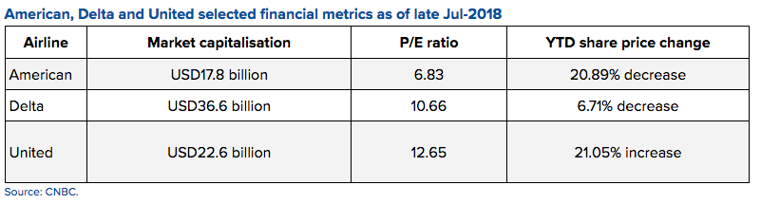
American Airlines Income Statement
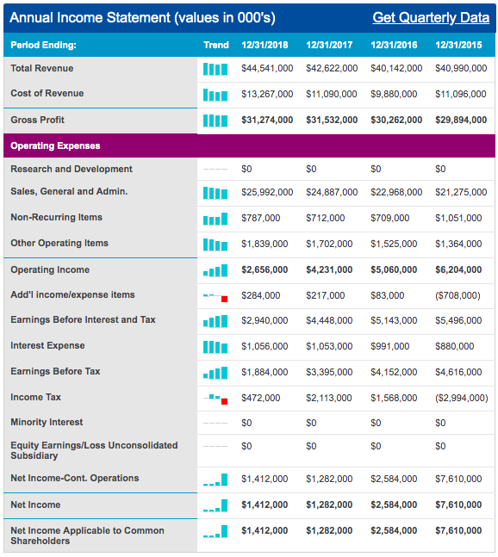

Delta Income Statement
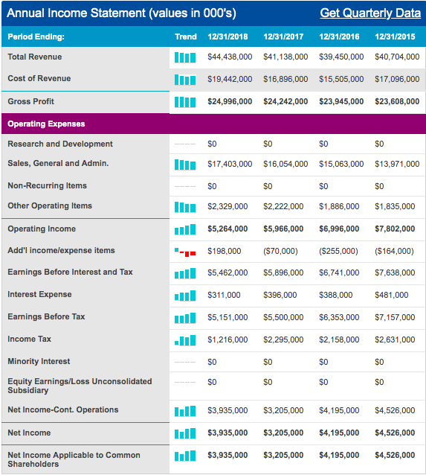

United Airlines Income Statement
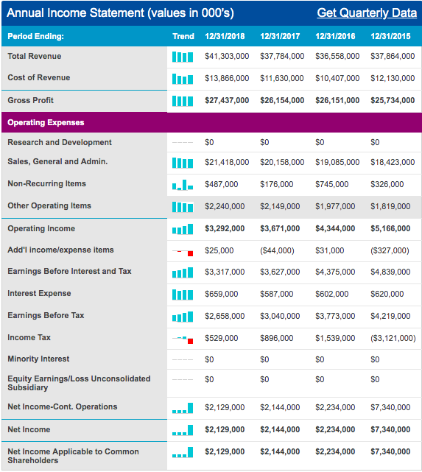
United States Inflation from 2012-Present
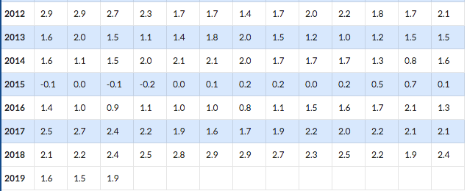

Market Share of Airlines in 2015
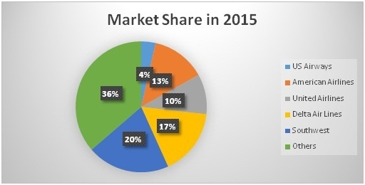

Works Cited
“AAL, DAL, UAL Income Statement.” NASDAQ.com, www.nasdaq.com/symbol/aal/financials?query=income-statement.
American Airlines. “An Update on the Boeing 737 MAX.” American Airlines Newsroom, 14 Apr. 2019, news.aa.com/news/news-details/2019/The-Latest-Information-About-737-MAX-Operations/default.aspx.
Bhasin, Hitesh, et al. “SWOT Analysis of American Airlines - American Airlines SWOT Analysis.” Marketing91, 23 Apr. 2018, www.marketing91.com/swot-analysis-american-airlines/.
Bhasin, Hitesh, et al. “SWOT Analysis of Delta Airlines - Delta Airlines SWOT Analysis.” Marketing91, 23 Apr. 2018, www.marketing91.com/swot-analysis-of-delta-airlines/.
CAPA. “United Airlines SWOT: Positive Direction after Years of Upheaval.” CAPA - Centre for Aviation, CAPA - Centre for Aviation, 9 Aug. 2018, centreforaviation.com/analysis/reports/united-airlines-swot-positive-direction-after-years-of-upheaval-430133.
“Delta Aircraft Seat Maps, Specs & Amenities.” Delta Aircraft Seat Maps, Specs & Amenities: Delta Air Lines, www.delta.com/us/en/aircraft/overview.
“Historical Inflation Rates: 1914-2019.” US Inflation Calculator, 10 Apr. 2019, www.usinflationcalculator.com/inflation/historical-inflation-rates/.
Jansen, Bart. “United Airlines Sees Payoff from 'Rebanking' Hub Schedules.” USA Today, Gannett Satellite Information Network, 23 July 2018, www.usatoday.com/story/travel/flights/todayinthesky/2018/07/18/united-airlines-rebanking-hub-schedules-houston-chicago-pays-off/796251002/.
Josephs, Leslie. “United Airlines: Profitable but Plagued by Public Relations Disasters.” CNBC, CNBC, 21 Mar. 2018, www.cnbc.com/2018/03/15/united-profitable-but-plagued-by-public-relations-disasters.html.
Martin, Hugo. “American Airlines Unveils 'Basic Economy' Fare to Compete with Low-Cost Carriers.” Los Angeles Times, Los Angeles Times, 18 Jan. 2017, www.latimes.com/business/la-fi-american-basic-economy-20170118-story.html.
Reed, Ted. “Surging Oil Prices Will Add $2.3 Billion To American Airlines' 2018 Costs.” Forbes, Forbes Magazine, 26 Apr. 2018, www.forbes.com/sites/tedreed/2018/04/26/surging-oil-prices-will-add-2-billion-to-american-airlines-2018-costs/#4116c2b44c4e.
Reed, Ted. “American Airlines Has Hubs At Three of Top Four Most-Connected U.S. Airports, Survey Says.” Forbes, Forbes Magazine, 18 Sept. 2018, www.forbes.com/sites/tedreed/2018/09/18/american-airlines-has-hubs-at-three-of-five-most-connected-u-s-airports-survey-says/#95a39866166d.
Parsons, James, et al. “Competitive Analysis Definition - Entrepreneur Small Business Encyclopedia.” Entrepreneur, www.entrepreneur.com/encyclopedia/competitive-analysis.
Press, The Associated. “United Airlines' Profit Shrinks, but Tops Expectations.” Chicagotribune.com, 16 Jan. 2019, www.chicagotribune.com/business/ct-biz-united-revenue-predictions-20190116-story.html.
Talty, Alexandra. “Delta Named Best Airline In 2019.” Forbes, Forbes Magazine, 19 Mar. 2019, www.forbes.com/sites/alexandratalty/2019/03/19/delta-named-best-airline-in-2019/#3a5dfb0f6f91.
Team, Trefis. “How Sensitive Is American Airlines' Price To Crude Oil Prices?” Forbes, Forbes Magazine, 7 June 2018, www.forbes.com/sites/greatspeculations/2018/06/07/how-sensitive-is-american-airlines-price-to-crude-oil-prices/#67071d041388.
“These Are The Best U.S. Airlines for Your Money Right Now.” Money, money.com/money/4695479/best-us-airlines-2017/.

Synopsis of Articles
- NASDAQ:
Financial Statements for American Airlines (AAL), Delta (DAL), and United Airlines (UAL).
- An Update on the Boeing 737 MAX
American Airlines sent out a newsletter informing flyers about the measures the company is taking as a result of the issues with the specific plane model.
- Marketing91 SWOT Analysis of American Airlines
This article identifies the strengths, weaknesses, opportunities, and threats relating to American Airlines. Is details the company’s mission and dives into the strengths and weaknesses of the corporation. It expands on possible competitive advantage points it believes the company is thriving on. The article also discusses the distribution strategy internationally and domestically.
- Marketing91 SWOT Analysis of Delta Airlines
This article identifies the strengths, weaknesses, opportunities, and threats relating to Delta Airlines. It determines the many different factors that impact Delta and give the ability to compare it to other competitors. It expands on specific points that have the potential to pull or deter Delta from surviving in the Red Ocean.
- CAPA
The Centre for Aviation generalizes a SWOT analysis of United Airlines as of 2018.
- Delta Aircraft Seat Map, Specs, & Amenities
This page is Delta’s home website. It has various information about Delta Airlines including what they stand for and offer. The website also includes ways to book and the aircraft used.
- Historical Inflation Rates
United States 2012-2019 inflation rates per month.
- United Airlines Sees Payoff from “Rebanking” Hub Schedules
Jansen Bart discusses the success that United Airlines achieved from revising the flight schedules in Houston and Chicago. Their revenue drastically grew in these two cities for domestic flights.
- United Airlines: Profitable but Plagued by Public Relations Disasters
Leslie Josephs reports on the public relations nightmare that United airlines endured and its effect on the profitability of the airline. She also discussed tensions between works and the upper management from talks of outsourcing work and changes in employee bonus plans.
- American Airlines Unveils “Basic Economy” Fare to Compete with Low-Cost Carriers
Hugo Martin discusses American Airlines’ approach to combatting Low-Cost Carriers be offering basic economy fares. These types of fares are modeled after the no-frills airlines with additional upgrades available for purchase. He also explains the rise of Spirit Airlines and how rapidly they are progressing.
- Surging Oil Prices Will Add $2.3 Billion To American Airlines’ 2018 Cost
Ted Reed analyzes the effect of change in oil prices on American Airlines. He includes American Airlines' forecast on how the increasing price will directly affect their expenses. He believes it's time to adapt and counteract the costs by increasing revenue.
- American Airlines Has Hubs At Three of Top Four Most-Connected U.S. Airports, Survey Says
Ted Reed's article on Forbes discusses the impact of airport "hubs" at the ten main airports in the United States. He focuses on domestic connectivity throughout multiple mainline airlines. He lists the statistics of the percentage of domestic flights contributed and who has control at each of the major airports by each airline.
- Entrepreneur Competitive Analysis Definition
This page provided a basic, but the informative definition of competitive analysis. The Encyclopedia gave an overview of what a competitive analysis includes and a list of important questions that should be answered within. Overall, this page gave a brief overview of what is needed in a well-rounded competitive analysis.
- United Airlines’ Profit Shrinks, But Tops Expectations
This article details how the higher fuel and labor cost affected United Airlines’ quarterly profits. Even with a drastic drop in profit, United was still able to reach the earnings per share that they previously forecasted.
- How Sensitive Is American Airlines’ Price To Crude Oil Prices?
They analyze how sensitive American Airlines’ stop is to changes in the price of oil. Because American Airlines does not hedge fuel, they are very susceptible to an inverse relationship between price per share and oil price per barrel.

